Hi this is news news news with funny koalas

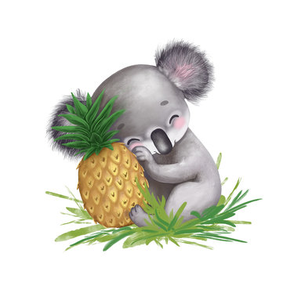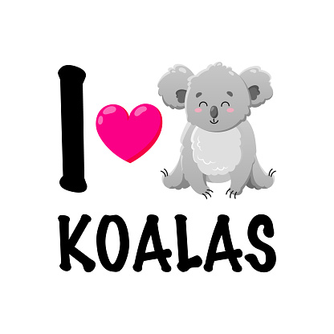
Facts about silly animals: they are VERY silly
They like to jump about and have fun
Koalas are found in the eucalyptus forests of eastern Australia. They have grey fur with a cream-coloured chest, and strong, clawed feet, perfect for living in the branches of trees!

Cuddly critters, koalas measure about 60cm to 85cm long, and weigh about 14kg.
When an infant koala – called a joey – is born, it immediately climbs up to its mother’s pouch. Blind and earless, a joey uses its strong sense of touch and smell, as well as natural instinct, to find its way.

