! The missing treasure !
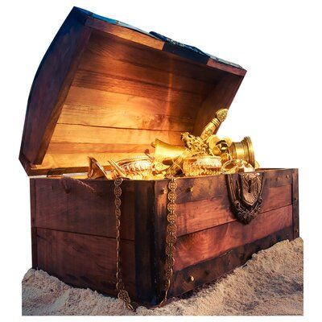
Many centuries ago, there was the most beautiful, breath-taking rubies and gold. Thousands of people tried to find it and keep it for themselves, but never succeeded. Fortunately that will all change today…….

The sun rises with a happy smile and the birds sing a song, today will be the perfect day to find the treasure for my village. I head downstairs and eat the BIGGEST breakfast I have ever had! I had a full breakfast menu!: pancakes, waffles, eggs sausage and bacon, and cereal! I was going to need all the food I could get since I would have to be travelling through lakes, mountains, fields and jungles. I went upstairs and took a shower because I won’t be able one have one for an extremely long time. After that, I went over to my room and packed my bag for the journey, I had a map, four bottles of water and energy drinks, snacks, spare clothes and many more. I took a deep breath and headed out my front door, this is the start of a dangerous and fascinating trip I will never forget….

