# 

New Born:

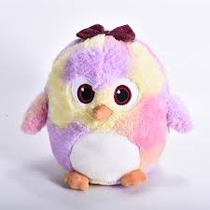Small penguin toy.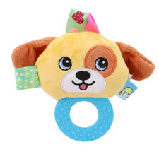 Rattleshake toy puppy with a teething bit to bite.

1 year old

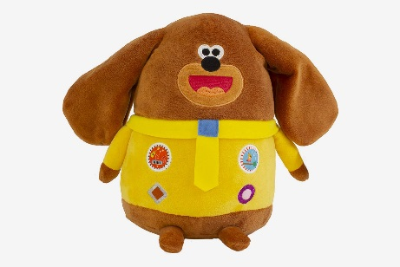 hey dugee toy ready to play.

2 year old

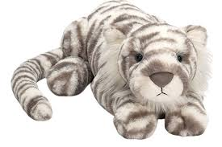big polar tiger toy.