Why climate change is affecting the world!

Tens of millions of people around the world are already facing the impact of climate change.
Burning fossil fuels like coal ,oil and gas releases carbon dioxide and other greenhouse gases in to the air that have been quickly warming up the surface of the Earth. For several decades, climate has been a global crisis that will impact ever single person and living being on this planet. Now, according to the latest UN climate report, we have less then ten years to cut global imitations in half.

10 simple ways to help stop climate change.

1.Make you voice heard by those in power.
2.Eat less meat and dairy.
3.Cut back on flying.
4.Try and walk to places instead of driving.
5.Reduce you energy use, and bills.
6.Respect and protect green spaces.
7.Invest you money responsibly.
8.Cut consumption-and waste.
9.Talk about the changes you make.
10.Use less hot water.

What will happen to the world if we do not help stop climate change?
If we do not take further action to stop climate impacts were already experiencing, the planet is likely to see global temperatures rising by 2-4 degrease{3-7 fern height}by the end of the century.

10 things that harm the environment!

Driving too much.
Buying fast fashion.
Throwing out items in good condition.
Buying single-use items.
Drinking bottled water.
Using tampons and pads.
Using utilities at 6:00 pm.
Using pesticides and weed killer.
Eating a lot of meat.
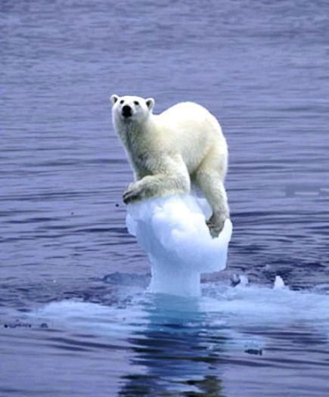
Buying more food than you need.

If you want this type of stuff to happen to poor animals and humans like this do some of the things above to help!

