
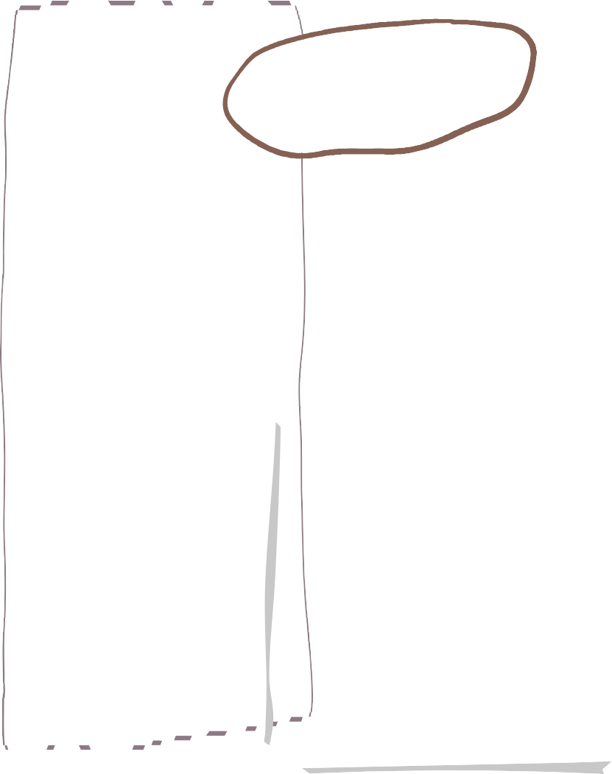

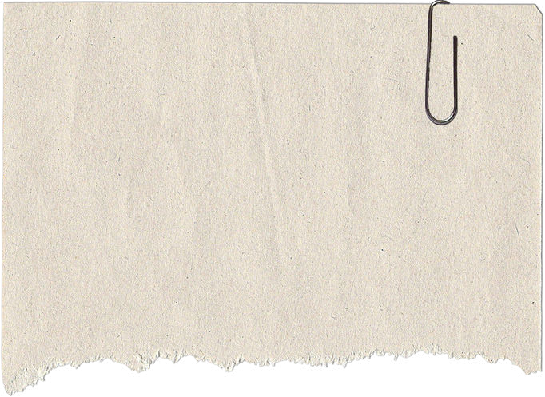
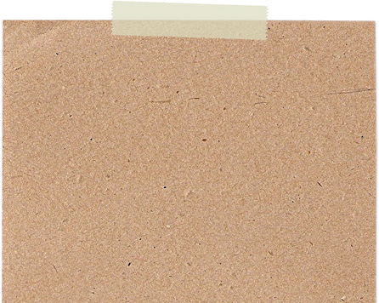
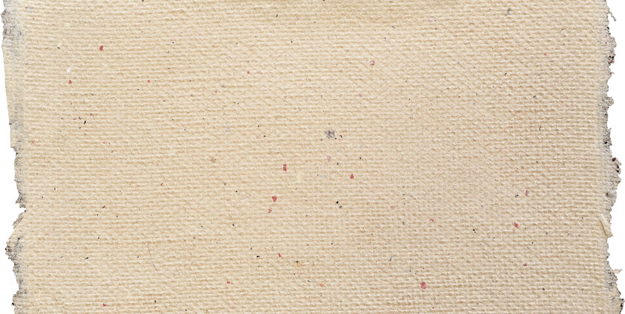
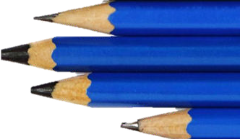
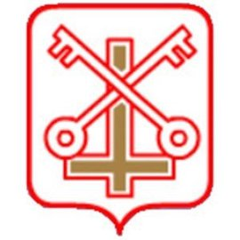

Autumn 1 in Year 6
Music and Art

Maths
English

We are reading…

. Within English lesson we will be studying two text types. These are, ‘classic fiction’ and ‘biographies.’
Within these units we will be focusing on reading the text and comprehending what we have read which will lead into writing and planning opportunities.
The children will know how to answer a range of questions on what they have read and how to write for a particular audience.
Along with daily English lessons the children will also take part in a guided reading session each day
The children will also focus on a range of spelling and grammar topics this half term.

This half term, children will be further developing their numerical knowledge. We will be focusing on place value and the four number operations – addition, subtraction, multiplication and division.
The children will be working on their mental arithmetic strategies. These include:
Using formal methods to add and subtract numbers, multiplying numbers by 10,100 and 1000 and using a formal method to multiply a 3 digit number by a 2 or 3 digit number.

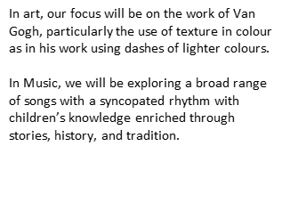

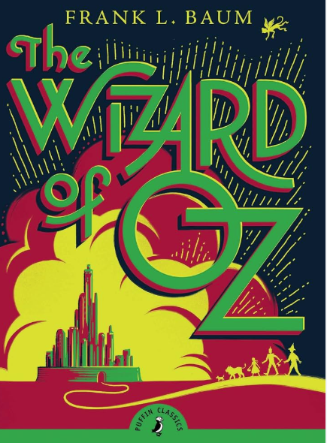
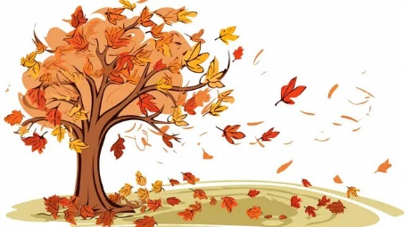

In science we will be developing our knowledge on living thigs and their habitats. We will be looking at classification keys and studying the scientist Carl Linneaus.
In geography we will be focusing on maps. We will recognise an increasing range of OS symbols and locate features using 6 figure grid references.
Science &
Geography


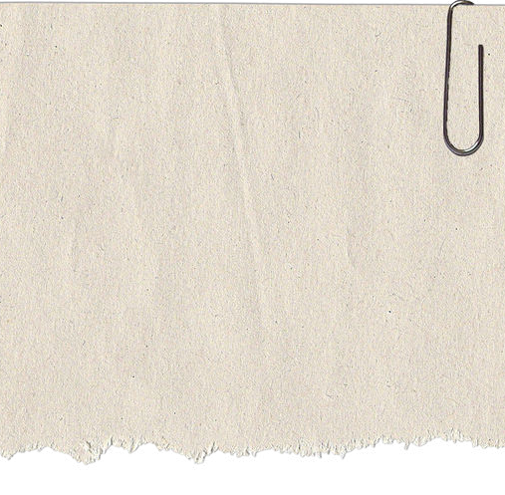

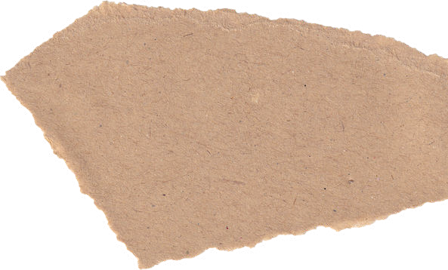
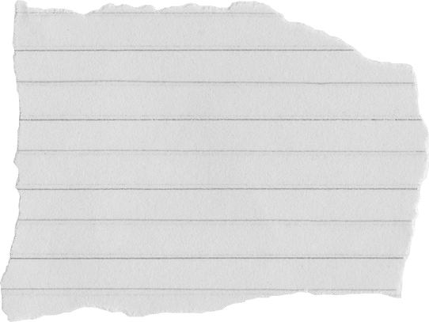
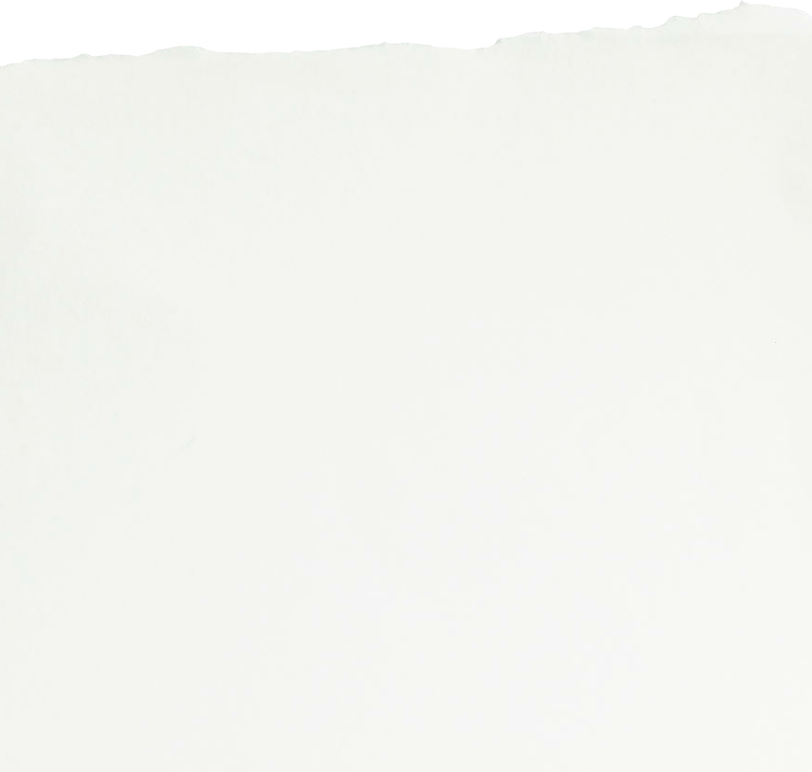
Homework and Spelling
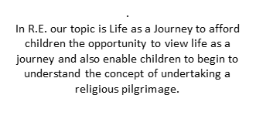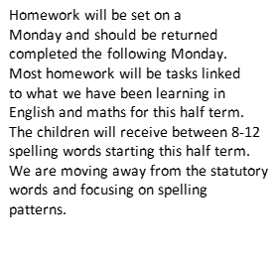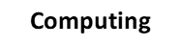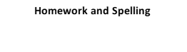.

R.E.
Computing
Homework will be set on a
Monday and should be returned completed the following Monday. Most homework will be tasks linked to what we have been learning in English and Maths for this half term.
The children will receive between 8-12 spelling words starting this half term.
We are moving away from the statutory words and focusing on spelling patterns.

This half term we will be developing our knowledge on 3D modelling. We will be using a piece of software called Tinkercad to create our own 3D designs. We will also be learning how to stay safe online.

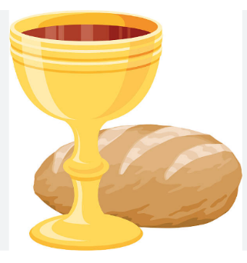



P.E.
Home reading
Please listen to your child read for at least 15 minutes every day. Reading books should be brought into school each day. When your child finishes a book they must complete the quiz using Accelerated Reader. It is important to bring your book and record into school each day then take it home at 3:30.

This half-term, we will be improving our invasion game knowledge through hockey. We will also be taking part in dance lessons. The children will have their P.E. lessons on Tuesday and Thursday. Your child should come to school in full PE kit on that day. They will need shin pads and a gum shield on Thursday for hockey.

Our Value This Half Term:

PSHE

