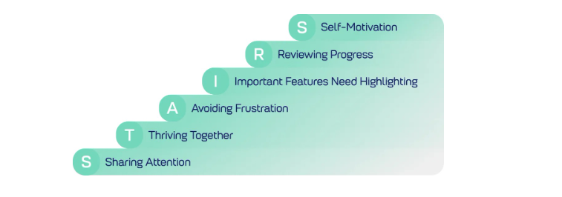
We use the STAIRS approach (EEF, 2025) to engage our children with high quality interactions with adults. These stages support the children to build vocabulary and share in back-forth conversations.

