

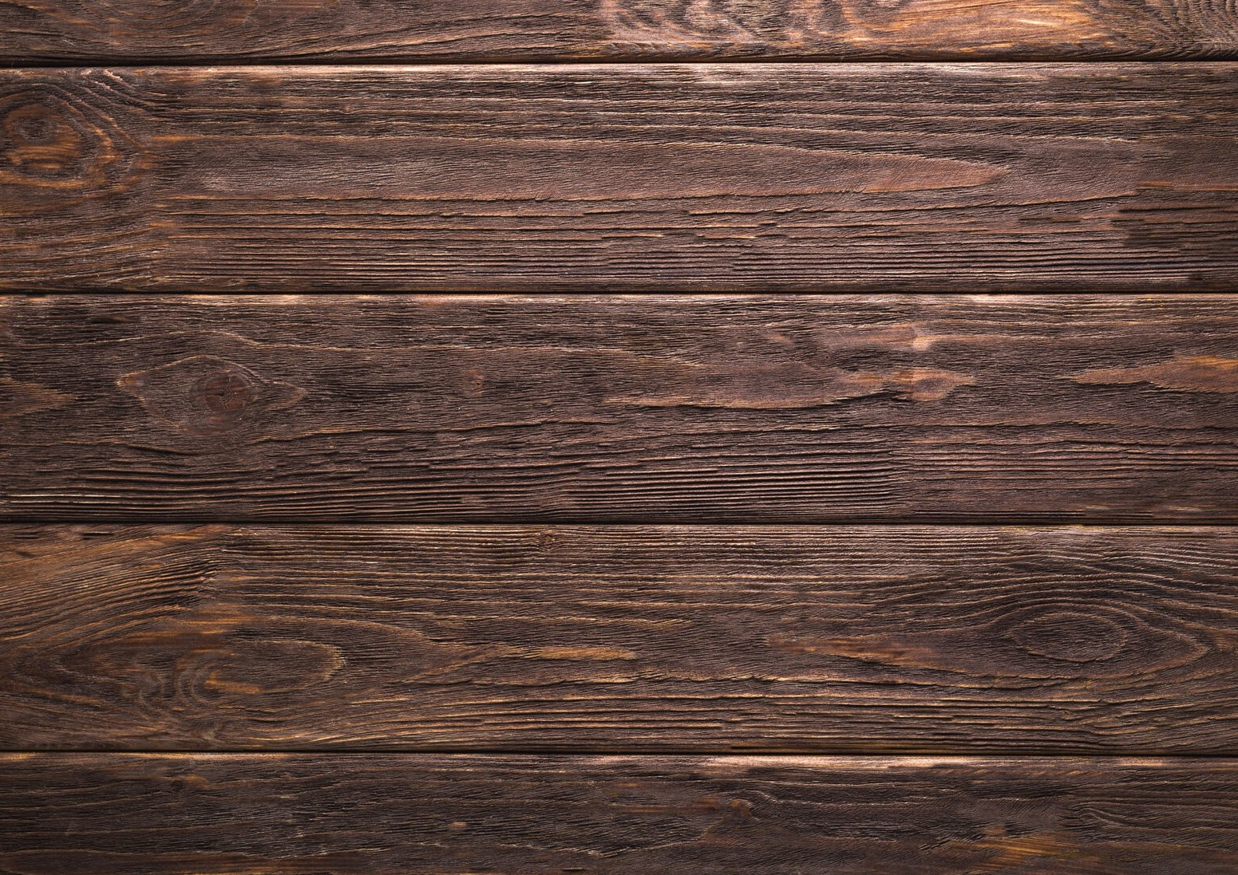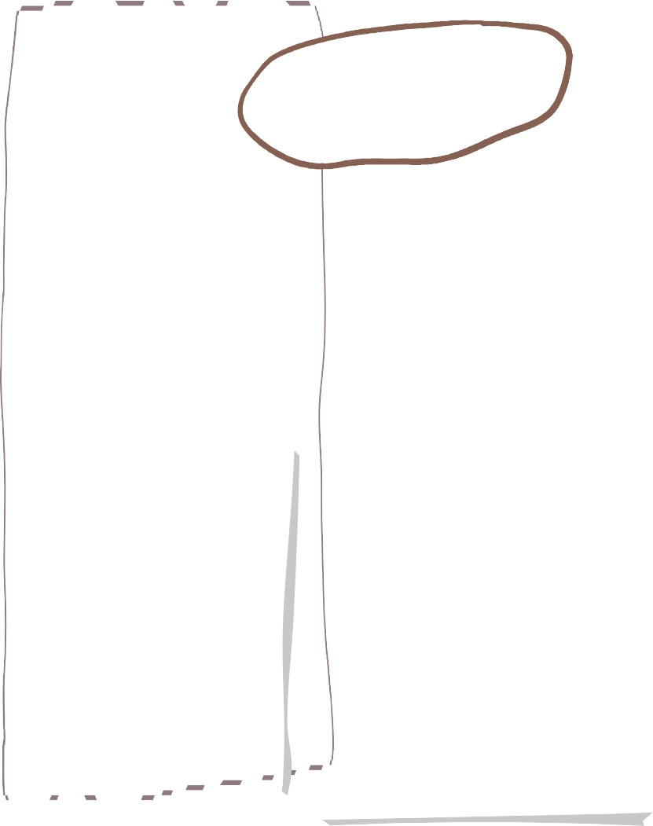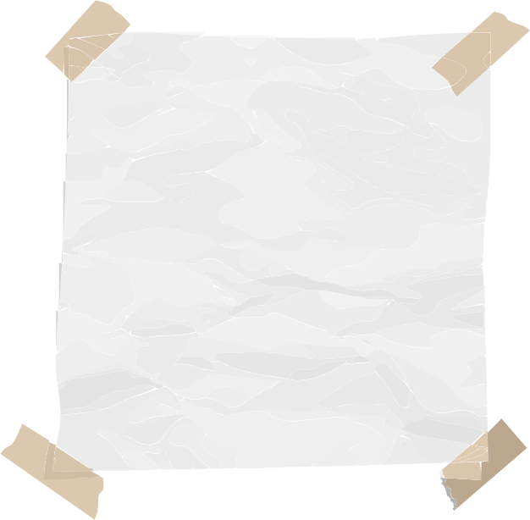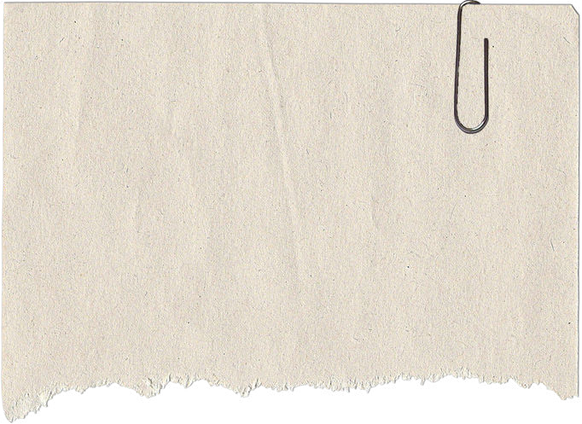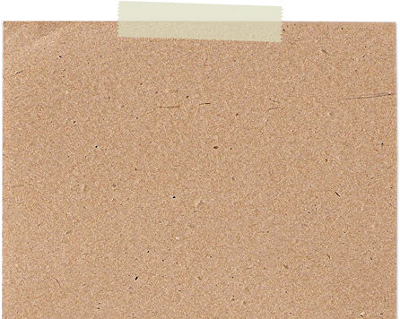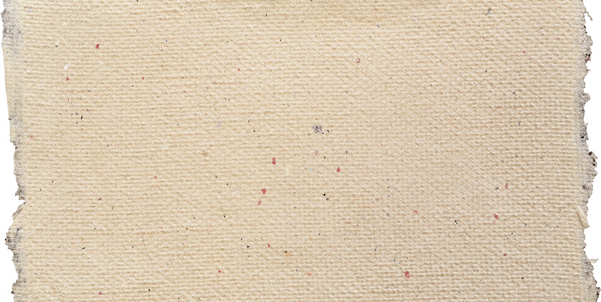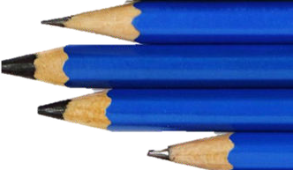

**Autumn Term in Reception**

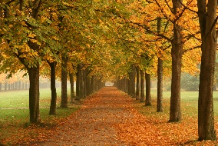

**Understanding of the World**

**Maths**

**English**

We will be starting to learn our new sounds with RWI and Fred the Frog. We will be looking carefully at how to write the letters giving the children some rhymes to help.

We will be reading our key texts and doing lots of work around them including role play, writing and retelling the stories.

**We are reading…**

We will be looking at:

* Matching and Sorting
* Measure and Patterns
* It's Me 1,2,3
* Circles and Triangles
* 1,2,3,4,5
* Shapes with 4 sides

We will be exploring all about ourselves and our bodies.

We be looking at our houses that we live in and learning about our families.

We will be looking at the seasonal changes that happen in Autumn.

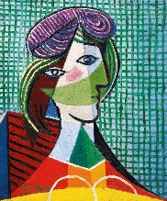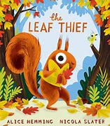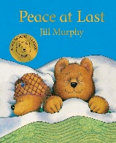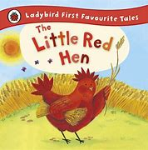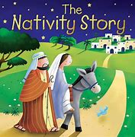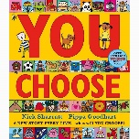

**Expressive Arts and Design**

We will be exploring how to draw ourselves.

We will be looking at the Art work of Picasso.

We will be developing our own piece of

Artwork based on

Picasso

**Important Info**

**PSHE**

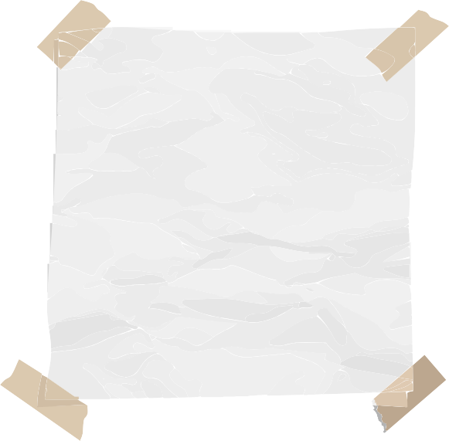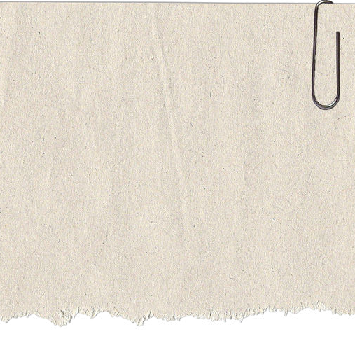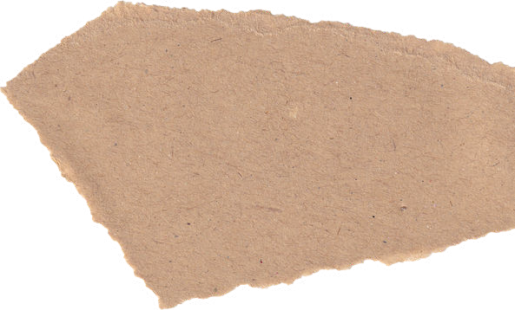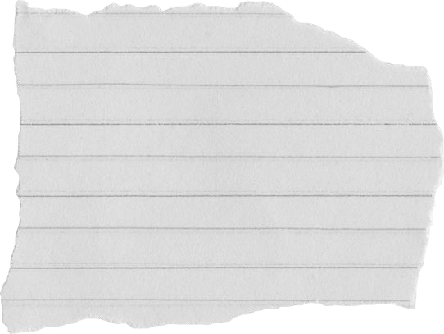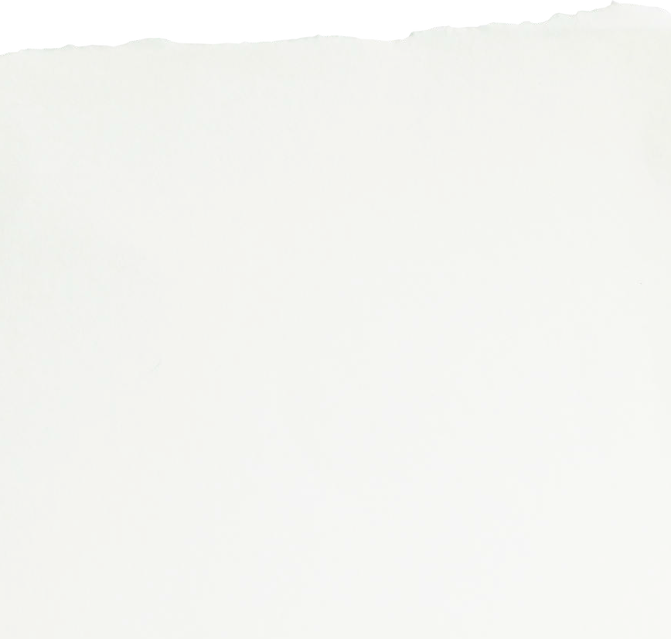

**PE**

E

PE is on FRIDAYS

Forest School is on THURSDAYS

All children need wellies, waterproofs and spare clothes to keep in school

In PE we will be learning how to

-Jump

- Hop on both feet

- Underarm throw

-Overarm throw

- Catching

- Climbing

Pupils will learn about different types of families and who is special to them.

We will be talking about friends and what qualities they have.



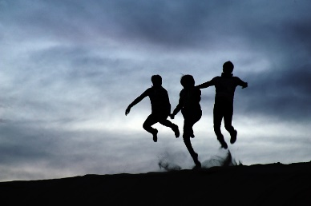

**Contact**

If you need to talk to one of us please:-

Catch us on the door before school or after school.

Send a note on Dojo

Send a message via the office.

**Homework**

A reading book will be sent out on a Friday and needs to be back in by the following Wednesday

A piece of maths homework will be sent out on Friday which will be linked to learning throughout the week.

They will get a little green book with the sounds that they have been learning for the week.

After half term I will be sending some options for the children to do some optional homework. More details to follow.

**Homework**