**History in EYFS**

Our EYFS learning environment provides consistent opportunities for History. The ‘topic’ focus for both nursery and Reception classes are led by the children’s interests so this will be different year upon year. However, the characteristics of effective learning and the early learning goals have History learning in them

Characteristics of effective learning support the development of working historically from the EYFS stage ready for moving up to KS1.

**P&E** – Lead imaginative play using their own experiences.

**AL** – Children lead their own play in the home corner and experience things they have done at home.

**C&TC** – It is important to open the children up to different experiences from the past – Old kitchen – Seaside from the past – Lead the children into asking their own questions.

**P&E** – the children will be exploring objects that are familiar to them

**AL** – Explore the museum loans and then experience the resources in independent challenges

**C&TC** – Asking questions such as what do you think it is? Let’s have a look and see if we are right

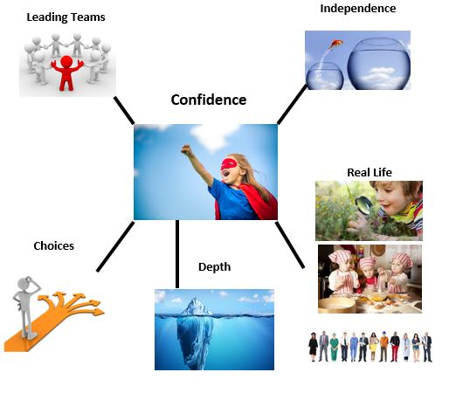

**P&E** – Give them as much choice in resources as they can so they can experience things about history.

**AL**- Children have a choice of books that they can retell to their friends

**C&TC** – Give children as much choice as we can so they have the opportunity to create critical thinkers

**P&E** – the children can use dinosaurs/toys to explore the ways they used to live and use language to do with the past.

**AL** – The children can bring things in from home and talk about them with their classmates and teachers.

**C&TC** – The children can talk about their own lives and look at similarities and differences between themselves and others.

|  |  |  |
| --- | --- | --- |
| **Playing and Exploring** | **Active Learning** | **Creating and Thinking Critically** |
| * •Showing curiosity about objects, events and people * •Using senses to explore the world around them * Pretending objects are things from their experience | * Showing high levels of energy, fascination | * Making links and noticing patterns in their experience * Making predictions * Testing their ideas * Developing ideas of grouping, sequences, cause and effect |

The different areas of learning and development- both prime and specific areas, allow for history topics and learning to be covered within them.

|  |  |  |
| --- | --- | --- |
| **Speaking** | **Maths – Shape Space and Measure** | **Understanding of the World** |
| * Can retell a simple past event in correct order (e.g. went down slide, hurt finger). * Uses talk to connect ideas, explain what is happening and anticipate what might happen next, recall and relive past experiences. | * Understands some talk about immediate past and future, e.g. ‘before’, ‘later’ or ‘soon’. * Anticipates specific time-based events such as mealtimes or home time. * Uses everyday language related to time. * Orders and sequences familiar events | * Developing an understanding of growth, decay and changes over time * Looks closely at similarities, differences, patterns and change. * Notices detailed features of objects in their environment.   **ELG**  Past and Present  Children at the expected level of development will:  - Talk about the lives of the people around them and their roles in society; - Know some similarities and differences between things in the past and now, drawing on their experiences and what has been read in class; - Understand the past through settings, characters and events encountered in books read in class and storytelling. |

|  |  |  |  |
| --- | --- | --- | --- |
| Year Group | Chronology | Historical Enquiry | Vocabulary |
| Nursery | • Retell past events in correct order  • Use talk to connect ideas, explain what is happening and anticipate what might happen next, recall and relive past experiences  • Remembers & talks about significant times or events for family & friends  • Begin to make sense of own life-story & family’s history | Can they talk about how things have changed? Can they talk about something that has happened in the past? Can they listen to stories and retell them? | Next  After that  Difference  Same  Old  New |
| Reception | • Use talk to organise, sequence and clarify thinking and events  • Compare & contrast characters from stories, including figures from the past  • Comment on images of familiar situations in the past | Ask questions to find out more & to check understanding of what has been said  • Understands questions such as who, why, when, where & how  • Understands a range of complex sentence structures including tense markers | Same  Different  old  new  First  Change |

|  |  |  |
| --- | --- | --- |
| **Toys** | **Seaside** | **Ourselves/Family** |
| Children could experience toys now and toys from long ago.  They could look at similarities and differences between the toys now and the toys then.  **Vocabulary**   * Differences * Similarities * Old * New * Past * Present * Order | Children could experience what seaside holidays looked like in the olden days.  The children will look at different pictures from the past.  Vocabulary   * Change * Similarities * Differences * Blackpool Tower * Beach hut * swimsuits | Children could discuss their family and their childhood.  They could look at differences between themselves now and themselves as babies.  **Vocabulary:**   * Changes * Similarities * Difference * Past * Present * Before * After |

As part of continuous provision the children should be given opportunities to practise history skills

**Some examples are**

Pictures of different stages of life and the children put them in order – youngest to oldest.

Opportunities to talk about experiences that have happened in the past – Show and tell/News

Opportunities to play with old toys/ experience fossils or bones.