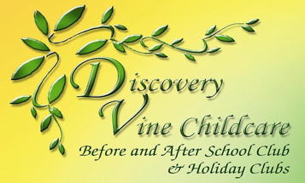

Discovery Vine Holiday Club
Holiday Activities & Food (HAF)

The HAF provision is funded by the Government and is for children who are eligible for benefits-related free school meals. Discovery Vine has agreed to offer this provision alongside its existing holiday clubs to enable more children to access the activities it provides for primary school aged children.

Each child can access 16 hours of free holiday club provision which equates to 4 x 4-hour sessions. The club will run in the Christmas holidays from Monday 19th to Thursday 22nd December 2022 with two 4-hour HAF sessions per day; 9.00am – 1.00pm & 1.00 – 5.00pm. Lunch will be provided in the morning session & afternoon tea in the afternoon session.

For more information please visit: www.getstuckin.org.uk

Discovery Vine are operating 3 Holiday Clubs this Christmas at:

- Cottam Primary School, Haydocks Lane, Cottam PR40NY
- Fulwood St Peter’s C E Primary School, Meadowfield, Fulwood PR29RE
- Longsands Community Primary School, Longsands Lane, Fulwood PR29PS

If your child is eligible for benefits-related free school meals and you would like to book a free place please complete the child registration form (if not already registered with Discovery Vine) and booking form and email it to jane@discoveryvine.co.uk or post it to 14 Dukes Meadow, Ingol, Preston PR2 7AR.

For further information about the activities we provide, an itinerary of the activities planned for this Christmas, our prospectus and our policies and procedures please visit our website at: www.discoveryvine.co.uk
Please phone Jane on 01772 731808 if you have any further questions.

