
14 Dukes Meadow
Ingol
Preston
Lancashire
PR2 7AR

01772 731808
Dear Parent

Thank you for your interest in Discovery Vine Out of School Club. Please find attached a child registration form and a booking form for the Before and After School Club at Fulwood St. Peter’s Church of England Primary School. A copy of our childcare prospectus and policies and procedures can be found on our website at www.discoveryvine.co.uk.

This information can also be accessed by downloading and registering with our phone app - once downloaded, please click on ‘join app’ and complete the form.

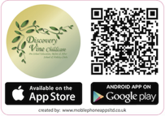

Please ask if you prefer a printed copy of our prospectus and/or policies.

Completed forms can be returned to the above address, handed in to the school office marked for the attention of Discovery Vine or emailed to lynda@discoveryvine.co.uk

Once we receive your forms we will confirm your child’s place in writing and send an ‘All About Me’ booklet to fill in for your child. We will also send you a Direct Debit mandate form if you have chosen to pay this way.

Please contact us if you need further information.
Lynda Garbutt

