
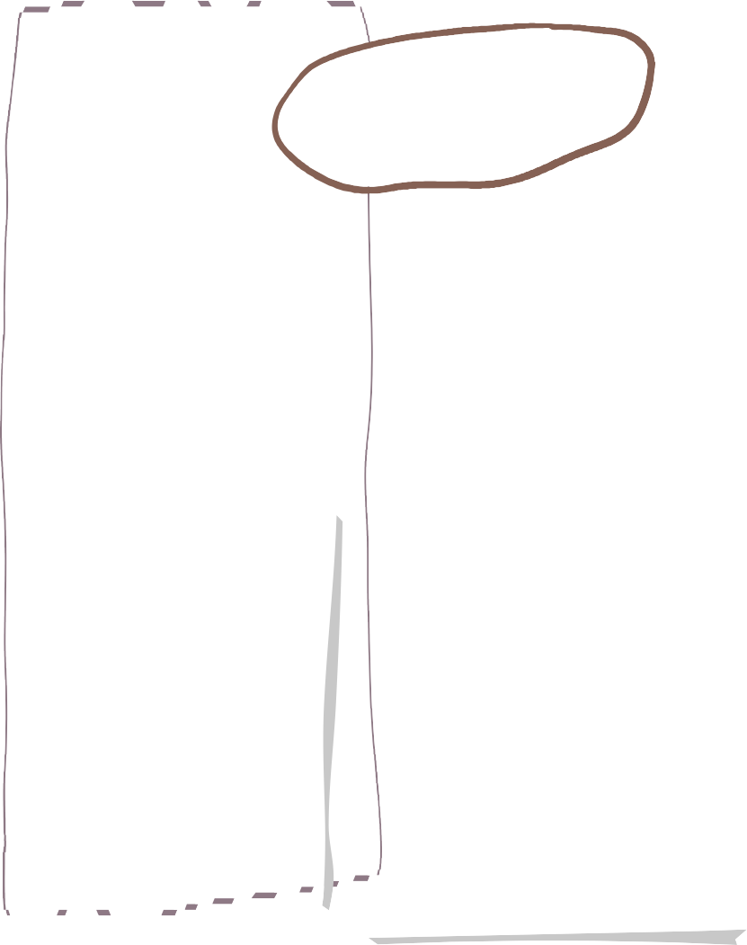







Spring Term in Reception

Understanding of the World
Maths
English

We will be continuing to learn new phonics sounds and getting better at reading new words using Fred talk.

We will be reading our key texts and doing lots of work around them. We will be working on independent writing of words and simple sentences.

We are reading…
We will be looking at:

- Alive in 5
- Mass and Capacity
- Growing 6,7 and 8
- Length height and time.
We will be exploring old and new toys and looking at what is the same and what is different about the,.

We will be looking at the seasonal changes that happen in Winter.

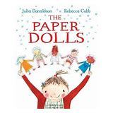

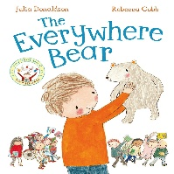
Expressive Arts and Design

We will be learning about beat and rhythm.

We will be designing our own topping for our pancakes and then chopping it up themselves.




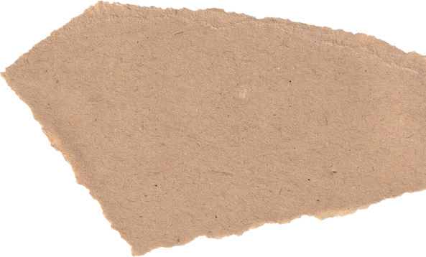


Important Info
PSHE
PE
E
PE is on FRIDAYS

Forest School is on THURSDAYS

All children need wellies, waterproofs and spare clothes to keep in school
In PE we will be learning how to
- Throwing
- Moving in different ways.
- Listening to instructions.
- Catching
Pupils will learn about a sense of community.
- Who do they belong to?
- What do we have to do for each other.




Contact
If you need to talk to one of us please:-

Catch us on the door before school or after school.

Send a note on Dojo

Send a message via the office.

Homework
A reading book will be sent out on a Friday and needs to be back in by the following Wednesday

A piece of maths homework will be sent out on Friday which will be linked to learning throughout the week.

They will get a little green book with the sounds that they have been learning for the week.

We have 3 simple rules in Reception
- Ready
- Respect
- Safe
Please reinforce this with your child regularly.
Rules

