

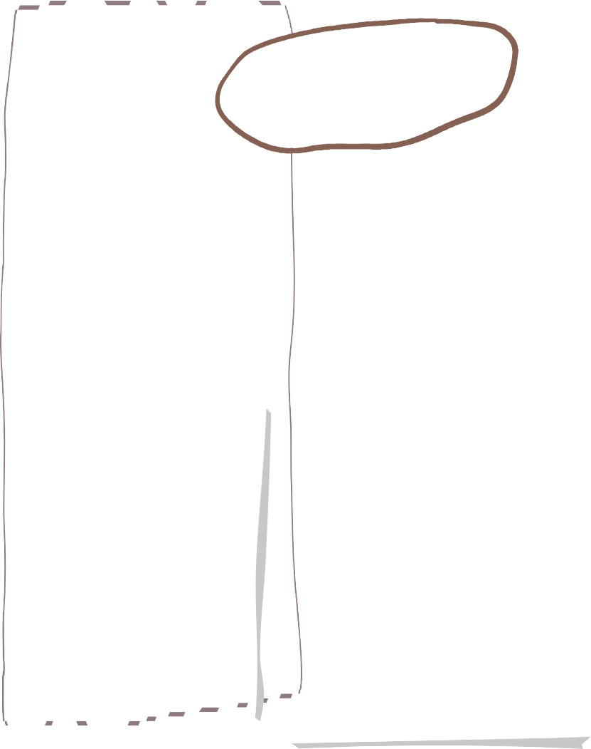

**Summer Term in Reception**



**Understanding of the World**

**Maths**

**English**

We will be continuing to learn new phonics sounds and getting better at reading new words using Fred talk.

We will be reading our key texts and answering questions about what we are reading.

We will be thinking about our school value of kindness by improving our listening skills.

**We are reading…**

We will be looking at seasonal changes of spring and summer.

Investigate flowers and plants that grow in our local area.

Explore shadows.

Identify and explore sounds.

Investigate different animals and their habitats.

We will be looking at:

* Building 9 and 10
* 3d shapes
* To 20 and beyond
* Sharing and grouping

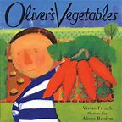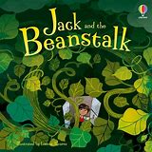

We will be learning to sing our favourite songs looking carefully on how we are using our voice.

We will be investigating lines and looking at the artist Bridget Reilly.

**Expressive Arts and Design**

**Important Info**

**PSHE**



**PE**

E

PE is on FRIDAYS

Forest School is on THURSDAYS

All children need wellies, waterproofs and spare clothes to keep in school

In PE we will be learning how to

* Throwing
* Moving in different ways.
* Listening to instructions.
* Catching
* Pupils will be learning about their bodies and how we keep healthy.
* Being unique and what makes us special.
* How to keep safe.





**Contact**

If you need to talk to one of us please:-

Catch us on the door before school or after school.

Send a note on Dojo

Send a message via the office.

**Homework**

A reading book will be sent out on a Friday and needs to be back in by the following Wednesday

A piece of maths homework will be sent out on Friday which will be linked to learning throughout the week.

They will get a little green book with the sounds that they have been learning for the week.

**KINDNESS**

**English** – Showing kindness by listening to each other’s ideas and responding in an appropriate way.

**Understanding of the World** – Showing kindness for our environment.

**PSHE** – Showing respect for people’s uniqueness.

**Our School Values**