

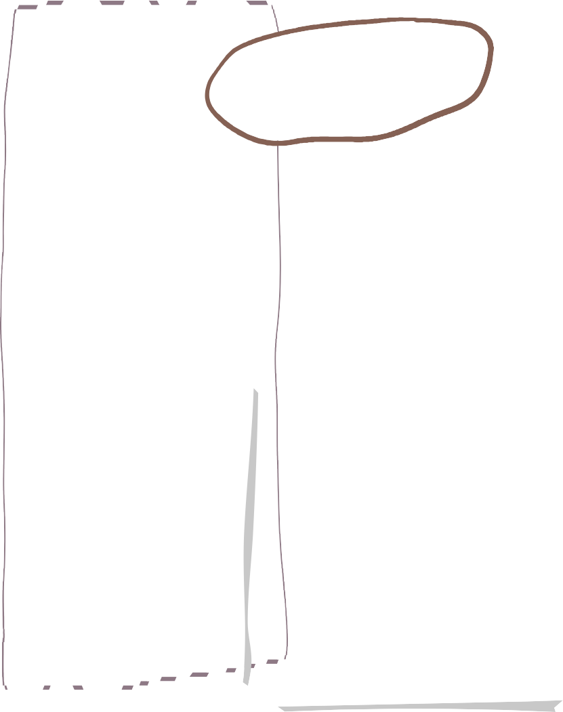


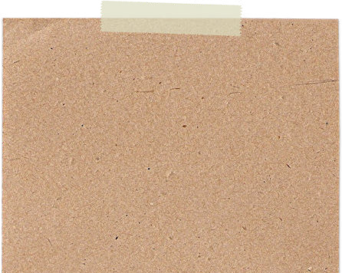

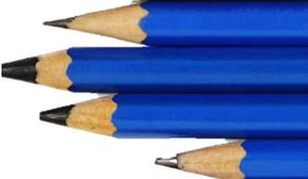
English

Maths

Art/DT

Summer Term in Year 2

We are reading…
In English we are still working on the children’s comprehension skills. We will be answering questions from the text and talking about character’s thoughts and feelings. We will also having a go at using inference3 to answer questions. This is the skill that Year 2 children find the hardest!!
In our English lesson we are looking at stories from the seaside particularly the Lighthouse Keeper stories and Katie Morag. We will be doing lots of different kinds of writing during this topic.
RE

In RE we will be learning:-

- Why did Jesus welcome everybody?

- What do Christians believe happened at Pentecost and Ascension?
In Maths this term we are learning about:-
- Fractions
-Time
- Statistics
- consolidating everything we have learnt

Art/DT

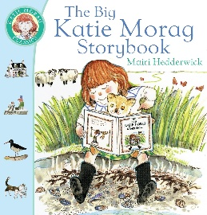
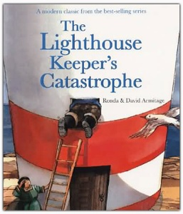
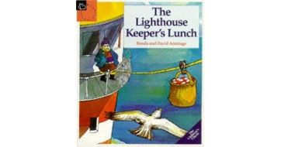
In Art this term we will be looking at the artist Andy Goldsworthy and doing some natural art in the school environment. We will also be looking at using different skills involving paper to make a fairground.
In DT we will be making puppets to use to tell stories to younger children. We will be looking at what a puppets have and then designing our own puppet. We will then learn how to sew them together.


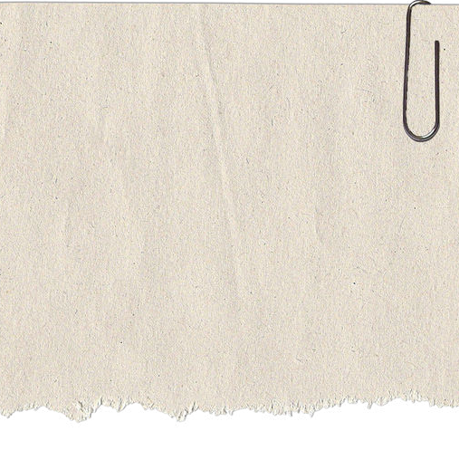

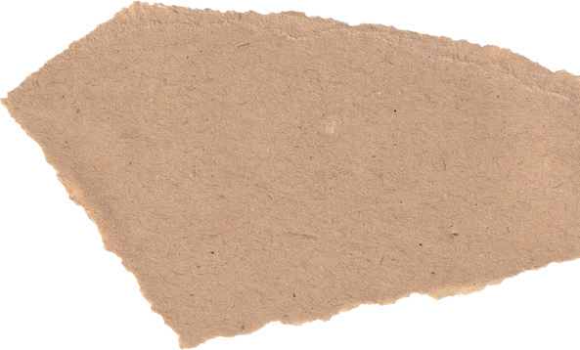

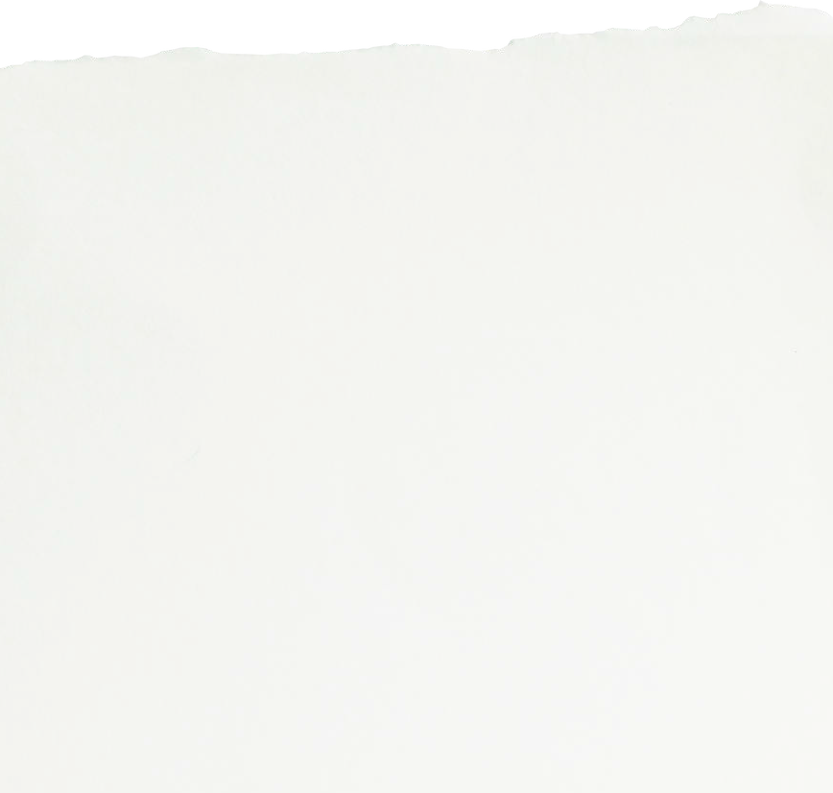
History
PSHE
PE
E
In PSHE the children are looking at 'Living in the wider world-Belonging to a community.' We are currently looking at ways to show respect and develop our understanding of the importance of respecting others, even when they may be different. The children have looked at what being part of a community is and how it feels to belong to a community, they will share ideas of groups that they belong to.

Our topic in History is how Seaside holidays have changed from the past. We will looking at pictures/resources and building up a picture of what it used to be like compared to now.
In PE for the first half term we are lucky to have Coach Callum in to teach us football.

We will also be completing a unit looking at the skills and rules for rounders.

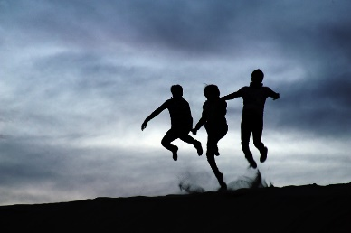



Contact
If you need to talk to one of us please:-

Catch us on the door before school or after school.

Send a note on Dojo

Send a message via the office.

Homework
A reading book will be sent out on a Friday and needs to be back in by the following Wednesday

A piece of maths homework will be sent out on Friday which will be linked to learning throughout the week.

They will have spellings each week which will be linked to our phonics.

Science
.
In Science this term we be looking at plants. We will be planting some seeds and bulbs and comparing how they grow. We will be growing them in different conditions and seeing what affect this has.

