**Art and Design Intent, Implementation & Impact Statement**

At Gagle Brook School we believe in the unlimited potential of every child. As a result of this, we have carefully designed a curriculum which is underpinned by the 4 Streams.

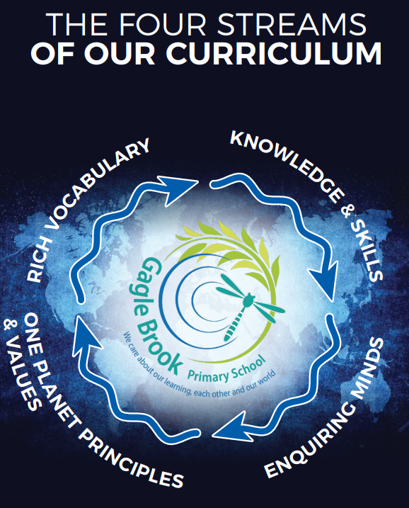

We have carefully chosen our four Streams because they are unique to our school context and setting:

* **Knowledge and skills:** It is our intent that our pupils will develop mastery across the curriculum as a result of a carefully sequenced curriculum which builds progressively on knowledge and skills.
* **Rich language:** Our intent is for all children to acquire knowledge, develop their vocabulary and have tools to communicate their ideas and learning effectively, both orally and in writing. To do this, our curriculum is planned to include high quality texts, real life and hands on experiences and creating a range of opportunities for all children to be immersed in and engaging with language.
* **Enquiring minds:** Our intent is for every child to be a passionate and active learner, underpinned by our value of ‘Excellence’. We provide children with real-life experiences and use AfL strategies within lessons to encourage them to be active learners, who take pride in and can talk about their work and learning.
* **One Planet Principles and Values:** Our intent is for all children to grow and develop into eco-citizens who are well-rounded, take care of themselves, other people and the world they live in. We want them to grow up being the best version of themselves and understand local and global issues which affect the future of our planet. To do this, we encourage the children to work with and support environmental and sustainability causes in the community.

**Our Values: Our intent is for all children to embrace and develop a shared set of ACHIEVE Values: Ambition, Collaboration, Honesty, Inclusivity, Environmental care, Valiance and Excellence, which underpin everything we do. This will encourage our children to be the best version of themselves and strive to achieve potential in an ever-changing and modern world**.

**Intent for our Art and Design Curriculum:**

At Gagle Brook School, our four Streams underpin our curriculum intent enabling our pupils to achieve the following in Art and Design:

* Develop their own sense of belonging as part of a community when learning about the work of an artist in places that are significant to them.
* Develop a line of enquiry, asking and answering questions.
* Have knowledge of a range of art and design skills which they can practice and apply to create their own work of art.
* Develop an understanding of how art impacts people and reflects moods and feelings.
* To make links and extend learning across other areas of study and within other aspects of our curriculum.
* A fully comprehensive and empathetic view of artwork in which they experience.
* To use subject specific vocabulary with confidence, both orally and through focused activities such as planning and evaluating.
* To evaluate their own artwork and the artwork of others from different times and cultures.

Our intent is to allow our pupils the experiences required to understand art and design concepts by acting as artists and working to find out about other artists, art skills and how to evaluate artwork. Therefore, we aim to offer opportunities for pupils to develop their understanding through the use of researching, practising, inviting visitors and artwork which encourage them to acquire knowledge and develop an understanding with subject rich vocabulary.

**Implementation:**

The National Curriculum is the starting point of our curriculum design. It has been used to drive our curriculum design, to ensure the aims of the National Curriculum are met, and it has been used to inform the choices we have made about the content that we teach at Gagle Brook School.

Each year group focuses on different art and design skills, which is built upon as they progress through the school. Each year group has an opportunity to focus on various art skills, design skills and artists. We have planned cross curricular links within our curriculum design, where appropriate, to make links and apply art knowledge and skills. For example, when focussing on foreground silhouettes, the children will be learning about The Great Fire of London in History. This way pupils can learn about ways in which the artist can use their art skills to recreate and tell the story of what happened, whilst applying their art skills.

Within our curriculum, we have developed a skills document that demonstrates a progression of the skills that need to be taught across each year group. Each skill area has clear progression planned for across each year group, developing on the previous year’s skills. These are used to inform, plan and assess in art and design:

* Colour- The use of colours and how we mix colours to create specific colours on a colour wheel.
* Drawing- To use a range of tools for drawing and to use a range of light and dark to create pattern, texture and shade.
* Texture- To work on different scales to create foregrounds and backgrounds and use collages to recreate textures.
* Form- The use of designing and creating 3D models using a range of materials.
* Pattern- To create a range of patterns; repeated, natural, regular and irregular.
* Printing- To print using a variety of objects.
* Work of an artist- Research the work of an artist and express their opinion about that work and use their work as inspiration.

The use of subject specific vocabulary and artistic terms will be planned for and modelled by teachers within lessons. Vocabulary obtained from these lessons will be made available for pupils to refer to throughout the art lesson and on art displays or word mats.

Wherever possible, teachers will plan opportunities for learning art through trips to the local area, art monuments or museums. At Gagle Brook, we believe it to be important for pupils to be exposed to these experiences in order to develop their curiosity, deepen their understanding of art concepts and apply this in art & design lessons and other contexts. Teachers are also encouraged to introduce the various replicas or models of high-quality art to encourage pupils to engage in an enquiry-based approach through levels of questioning:

* What do I already know? – What do you notice?
* What can I infer? – Based on previous knowledge.
* What do I want to know?
* How will I create my own art?

Pupils are encouraged to observe these primary and secondary sources, identifying if they relevant to the topic they are focussing on.

**Impact**

Our intended impact is that by the time our pupils leave Gagle Brook School, they will have developed:

* A wide range of knowledge about art and design, art skills and artists from all over the world.
* Critical thinking skills to develop their own art designs using a range of questions and opportunities to practise to develop their understanding of the art skill.
* An ability to evaluate, reflect and improve their work and the work of others, by having a sound understanding of the intended art outcome.
* A respect for aspects of art and design and the range of social, cultural, religious and ethnic diversity, in Britain and the wider world, and how this has changed or influenced present day.
* An interest in art and design and an enthusiastic approach to learning, which develops their curiosity within art and design.