

2

L Graham

L Graham

Headteacher

August 2024

n/a

August 2027

Gagle Brook School & Southwold School

# Introduction

Collective Worship should be a time of reflection. It contributes to pupils’ spiritual, moral, social, cultural and emotional development by encouraging the children to develop an appreciation that goes beyond the material world, fostering a concern for others and providing a forum for exploring shared values. Collective Worship is important as it helps children become familiar with the language and silence common to many forms of public worship as they are all likely to attend at some point in their lives, a funeral, a wedding or a baptism. It provides the opportunity for our pupils to gain an awareness of worship practices of faiths other than their own. Collective Worship offers opportunities for co-operation and the fostering of strong relationships between our school and the local communities around us. Local faith leaders are utilised as a resource and we are invited to play a part in their places of worship in our local area. It contributes towards our schools’ statutory obligation to provide opportunities for pupils’ spiritual and moral development and helps to equip young people to understand more about themselves, foster a sense of the aesthetic and to cope with life-changing moments.

Within our school, our ACHIEVE Values encourage our pupils and community to care for themselves, others and their community.

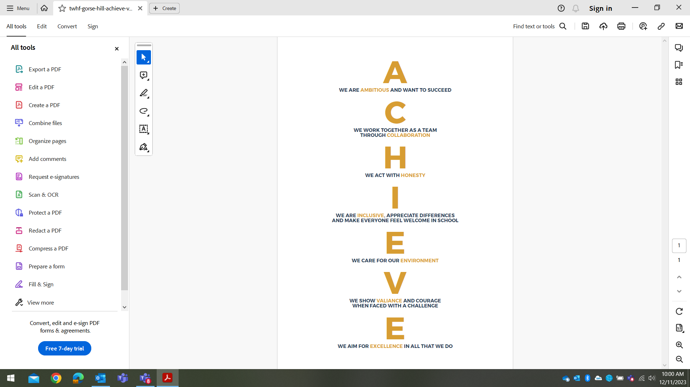

In addition to our ACHIEVE Values, we also actively promote British values though our school vision, ethos, agreed rules, curriculum and teaching. As such, we promote tolerance of, and respect for, people of all faiths (or those with no faith), cultures and lifestyles. We prepare children and young people positively for life in modern Britain by supporting them through our words, actions, and influence, not just within school, but also within the wider community.

Collective Worship should aim to:

* Give expression to, reaffirm and practice the values of the school community and promote British values of respect for the law, democracy, equality and tolerance of different faiths and religious and other beliefs.
* Promote kindness and empathy.
* Strengthen and support the school community and individual members.
* Provide an experience that promotes the social, moral, spiritual and cultural development of pupils
* Provide an opportunity for personal and shared reflection and response to fundamental questions of life
* To consider spiritual and moral issues
* Celebrate and give thanks for achievements within the school, local and international community and occasions of significance, including festivals
* Foster a respect for self and engender a concern for the needs of others.

# Collective Worship

Collective Worship can be related to the day-to-day life, aspirations and concerns of the pupils and the school, and must preserve the integrity of all its members. They can come together to affirm and celebrate experiences of worth to them all. It offers all pupils an opportunity to worship through engaging in relevant, meaningful experiences and provides opportunities for the pupils’ spiritual, moral, social and cultural development.

As an Academy school the funding agreement states that each pupil must take part in a daily act of collective worship / reflection unless their parents have withdrawn them. The collective worship / reflection must be mainly of a broadly Christian character but can reflect the religious backgrounds represented in the community. The following principles apply:

**Aims for the school:**

* All pupils take part in a daily act of collective worship or reflection.
* Share common values and aims
* Celebrate achievement and special times
* Explore together the world in which we live
* Develop a community spirit

**For the pupils, opportunities to:**

* Take part in Collective Worship or reflection which may be held at any time during the school day, either on or off the school premises.
* Consider the whole person
* Explore own beliefs
* Develop their own spirituality
* Reinforce common ethos and values
* Reinforce positive attitudes
* Develop a sense of community spirit
* Encourage participation and response
* Reflect on what is considered worthy

# The Organisation of Collective Worship

Senior leaders normally lead assembly, but sometimes local clergy or other representatives of local religious groups are invited into the school.

* We conduct assemblies in a dignified and respectful way. Children are expected to behave in an appropriate way as this time is a period of calm reflection
* We take themes of our assemblies that link to our school’s ACHIEVE Values and of the Christian and other faiths, and we often reflect the festivals and events of the religious calendars. At other times, themes may relate to world events or specific calendar events.
* Each week, there is a ‘Thought of the Week’ to encourage reflection.

# Withdrawal



Parents have the right to withdraw their children from Collective Worship / reflection. This school expects that withdrawal will only be made following discussions with the head teacher followed by written confirmation of withdrawal. The school will make arrangements to supervise withdrawn children but no additional or set work will be followed during this time.