**MFL Intent, Implementation & Impact Statement**

At Gagle Brook School we believe in the unlimited potential of every child. As a result of this, we have carefully designed a curriculum which is underpinned by the 4 Streams.

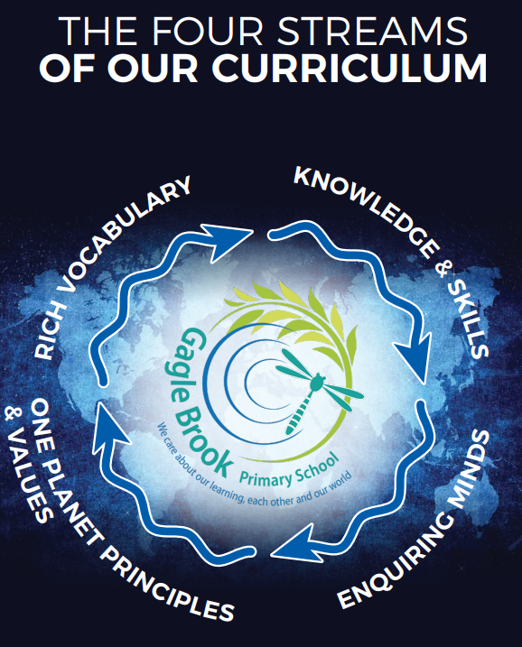

We have carefully chosen our four Streams because they are unique to our school context and setting:

* **Knowledge and skills:** It is our intent that our pupils will develop mastery across the curriculum as a result of a carefully sequenced curriculum which builds progressively on knowledge and skills.
* **Rich language:** Our intent is for all children to acquire knowledge, develop their vocabulary and have tools to communicate their ideas and learning effectively, both orally and in writing. To do this, our curriculum is planned to include high quality texts, real life and hands on experiences and creating a range of opportunities for all children to be immersed in and engaging with language.
* **Enquiring minds:** Our intent is for every child to be a passionate and active learner, underpinned by our value of ‘Excellence’. We provide children with real-life experiences and use AfL strategies within lessons to encourage them to be active learners, who take pride in and can talk about their work and learning.
* **One Planet Principles and Values:** Our intent is for all children to grow and develop into eco-citizens who are well-rounded, take care of themselves, other people and the world they live in. We want them to grow up being the best version of themselves and understand local and global issues which affect the future of our planet. To do this, we want our children to work with and support environmental and sustainability causes in the community.

**Our Values: Our intent is for all children to embrace and develop a shared set of ACHIEVE Values: Ambition, Collaboration, Honesty, Inclusivity, Environmental care, Valiance and Excellence, which underpin everything we do. This will encourage our children to be the best version of themselves and strive to achieve potential in an ever-changing and modern world**.

**Intent for our MFL Curriculum:**

At Gagle Brook School, our four Streams underpin our curriculum intent enabling our pupils to achieve the following in MFL:

* To provide children in Key Stage 2 with a foundation in French
* Value different cultures and languages
* Motivate and foster pupils’ curiosity to deepen their understanding of the world
* Develop pupils’ understanding of ‘the three pillars’ (phonics, grammar and vocabulary) of language learning in French
* Develop language skills in order to acquire, apply and transfer to other languages
* Enable pupils to express their ideas and thoughts in another language
* To make connections in their learning and to know more and remember more each year leading to enjoyment in this subject

Gagle Brook School is located in an area of rich diversity of language and culture. It is our intent to allow our pupils the experience required in order to understand what it is to learn to communicate in another language as language learners. Therefore, we aim to offer opportunities for pupils to develop their understanding through the four strands of language skills – speaking, listening, reading and writing – which encourage them to acquire knowledge and the confidence to learn about the architect of language.

**Implementation:**

The National Curriculum is the starting point of our curriculum design. It has been used to drive our curriculum design, to ensure the aims of the National Curriculum are met, and it has been used to inform the choices we have made about the content that we teach at Gagle Brook School.

French is taught through a careful sequence of lessons based on ‘Language Angels,’ developing the skills and confidence to apply it in real-life situations and prepare pupils for life in a modern world. Each Key Stage 2-year group have a weekly lesson that provides opportunities to develop the language, through vocabulary, writing and speaking experiences.

Learning is sequenced with regular opportunities to revisit and build upon prior knowledge to support deeper understanding, and to encourage children to apply their knowledge. Where appropriate, cross- curricular links are made to make learning experiences more meaningful and to give context to the knowledge acquired and skills taught. For example, in Year 3, the children learn about France for their geography topic. Key vocabulary in French is displayed to support learning and to scaffold responses from the children. As a staff, we strive to encourage a passion for language learning and continue to develop each child’s personal values to prepare them for their future lives.

**Impact**

Our intended impact is that by the time our pupils leave Gagle Brook School, they will have developed:

* A secure foundation of learning in French so that children can converse at a basic level
* An ability to express their ideas and thoughts in another language
* Knowledge of what makes up learning a language (the architect)
* The language skills to apply and transfer to other languages
* Respect and value for the diversity of languages in the world
* An excitement and confidence to learn other languages