**Art and Design Intent, Implementation & Impact Statement**

At Gagle Brook School we believe in the unlimited potential of every child. As a result of this, we have carefully designed a curriculum which is underpinned by the 4 Streams.

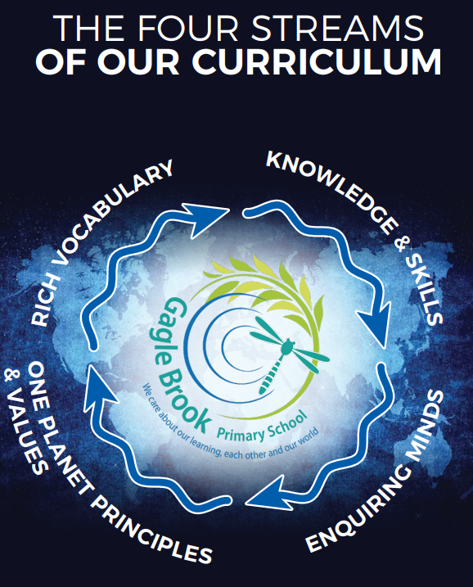  
We have carefully chosen our four Streams because they are unique to our school context and setting:

* **Knowledge and skills:** It is our intent that our pupils will develop mastery across the curriculum as a result of a carefully sequenced curriculum which builds progressively on knowledge and skills.
* **Rich language:** Our intent is for all children to acquire knowledge, develop their vocabulary and have tools to communicate their ideas and learning effectively, both orally and in writing. To do this, our curriculum is planned to include high quality texts, real life and hands on experiences and creating a range of opportunities for all children to be immersed in and engaging with language.
* **Enquiring minds:** Our intent is for every child to be a passionate and active learner, underpinned by our value of ‘Excellence’. We provide children with real-life experiences and use AfL strategies within lessons to encourage them to be active learners, who take pride in and can talk about their work and learning.
* **One Planet Principles and Values:** Our intent is for all children to grow and develop into eco-citizens who are well-rounded, take care of themselves, other people and the world they live in. We want them to grow up being the best version of themselves and understand local and global issues which affect the future of our planet. To do this, we want our children to work with and support environmental and sustainability causes in the community.

**Our Values: Our intent is for all children to embrace and develop a shared set of ACHIEVE Values: Ambition, Collaboration, Honesty, Inclusivity, Environmental care, Valiance and Excellence, which underpin everything we do. This will encourage our children to be the best version of themselves and strive to achieve potential in an ever-changing and modern world**.

**Intent for our Mathematics Curriculum:**

At Gagle Brook School, our Golden Threads underpin our curriculum intent enabling our pupils to achieve the following in Mathematics:

* Become fluent in the fundamentals of mathematics so that they develop conceptual understanding and the ability to recall and apply knowledge rapidly and accurately.
* Solve problems by applying their mathematics to a variety of problems with increasing sophistication, including in unfamiliar contexts and to model real-life scenarios.
* Reason mathematically by following a line of enquiry, and develop and present justifications, arguments or proofs using accurate mathematical language to communicate with clarity.
* Have an appreciation of number and number operations, which enables mental calculations and written procedures to be performed efficiently, fluently and accurately to be successful in mathematics.

**The Mastery Model of Learning:** Mathematics is an important creative discipline that helps us to understand and change the world we live in. We want all pupils at Gagle BrookSchool to experience the beauty, power and enjoyment of mathematics and develop a sense of curiosity about the subject. At Gagle BrookSchool, we foster positive ‘can-do’ attitudes, believe all children can achieve in mathematics, and teach for secure and deep understanding of mathematical concepts so that they can be applied across different contexts and in real life situations. We use mistakes as an essential part of learning and provide challenge through rich and sophisticated problems before acceleration through new content.

**Implementation:**

The National Curriculum is the starting point of our curriculum design. It has been used to drive our curriculum design, in order to ensure the aims of the National Curriculum are met, and it has been used to inform the choices we have made about the content that we teach at Gagle Brook School.

In Early Years and Year 1, maths is taught through carefully planned adult-focused activities alongside a continuous provision approach based upon the relevant Early Learning Goals (EYFS) or the National Curriculum Statements (Y1). In Years 2 – 6, maths learning is planned from the National Curriculum statements, which are grouped into units and divided into manageable steps using the ‘Can Do Maths’ road maps to create a coherent mathematical journey through the learning at each stage. Learning is sequenced into small, manageable chunks that progressively build on prior learning.

**Impact**

Our intended impact is that by the time our pupils leave Gagle Brook School, they will have developed:

* Mathematical fluency based on rapid and accurate recall and conceptual understanding.
* A love of mathematics, including number, geometry and reasoning, and a desire to develop their mathematical knowledge and skills further in their next phase of education.
* A confidence in their ability to solve a variety of mathematical puzzles and problems that they may experience in everyday life.