**PE Intent, Implementation & Impact Statement**

At Gagle Brook School we believe in the unlimited potential of every child. As a result of this, we have carefully designed a curriculum which is underpinned by the 4 Streams.

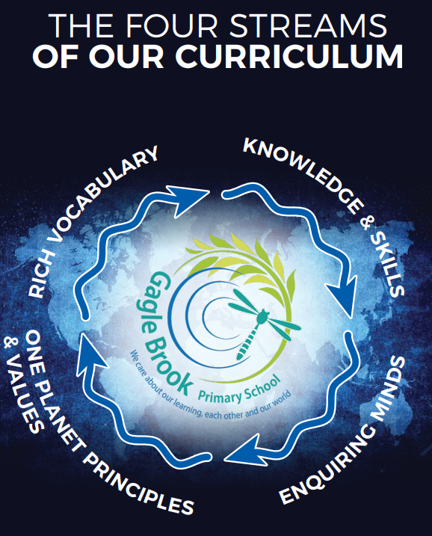

We have carefully chosen our four Streams because they are unique to our school context and setting:

* **Knowledge and skills:** It is our intent that our pupils will develop mastery across the curriculum as a result of a carefully sequenced curriculum which builds progressively on knowledge and skills.
* **Rich language:** Our intent is for all children to acquire knowledge, develop their vocabulary and have tools to communicate their ideas and learning effectively, both orally and in writing. To do this, our curriculum is planned to include high quality texts, real life and hands on experiences and creating a range of opportunities for all children to be immersed in and engaging with language.
* **Enquiring minds:** Our intent is for every child to be a passionate and active learner, underpinned by our value of ‘Excellence’. We provide children with real-life experiences and use AfL strategies within lessons to encourage them to be active learners, who take pride in and can talk about their work and learning.
* **One Planet Principles and Values:** Our intent is for all children to grow and develop into eco-citizens who are well-rounded, take care of themselves, other people and the world they live in. We want them to grow up being the best version of themselves and understand local and global issues which affect the future of our planet. To do this, we want our children to work with and support environmental and sustainability causes in the community.

**Our Values: Our intent is for all children to embrace and develop a shared set of ACHIEVE Values: Ambition, Collaboration, Honesty, Inclusivity, Environmental care, Valiance and Excellence, which underpin everything we do. This will encourage our children to be the best version of themselves and strive to achieve potential in an ever-changing and modern world**.

**Intent for our PE Curriculum:**

At Gagle Brook School, our four Streams underpin our curriculum intent enabling our pupils to achieve the following in PE:

* Be curious about our bodies, how they work and how we look after them.
* Ask questions and think critically.
* To develop and transfer skills across different sports.
* To apply skills within competition.
* To reflect on their performance and skills learnt.
* To embed sportsmanship and our ACHIEVE values during our lessons and in the wider community.

At Gagle Brook School, we intend for our PE curriculum to be inclusive, challenging and supportive of every child. Our PE curriculum focuses on the development of the fundamental physical skills such as agility, balance and co-ordination improving both the children’s fine and gross motor skills. We intend for all our children to have the opportunities to apply these progressive skills in engaging and fun activities as well as competitive environments such as sports tournaments and fixtures. We focus on developing the emotional, social and cognitive skills by developing an ethos of healthy competition and co-operative learning. Through PE, we intend for all children to develop many non-physical skills such as creativity, resilience, perseverance, communication and confidence that can be applied in all aspects of life. As a school we are committed to develop every child’s physical and social development that will support their physical health and mental well-being.

**Implementation:**

The National Curriculum is the starting point of our curriculum design. It has been used to drive our curriculum design, to ensure the aims of the National Curriculum are met, and it has been used to inform the choices we have made about the content that we teach at Gagle Brook School.

At Gagle Brook School, we follow the PPP (Primary PE Planning) scheme of work and enhance it to include sport specific skills. We strive to ignite curiosity and excitement in our children that naturally extends their learning. All pupils receive two hours of PE a week which encourages them to be physically active. Through our lesson structure and differentiated activities, every child has opportunities to take part and be successful where effort, participation and development is supported. We teach the National Curriculum via PPP’s progression of skills. This ensures that skills and knowledge are built on year by year and sequenced appropriately to maximise learning for all children. We strive to ensure all children progress from their personal starting point by developing a range of gross and fine motor skills such as; balance, co-ordination, agility and overall fitness. During our PE lessons, we encourage children to reflect on their performance of skills through an enquiry-based approach asking questions such as:

* What was I doing well already?
* What do I need to do to progress further?
* What goals can I set myself?
* How am I going to achieve this goal?

To further the children’s knowledge and understanding of skills our fully trained and experienced sports coaches spend time analysing both professional athletes and children performing a skill inspiring them to do their best. During KS2, children will have a series of structured swimming sessions to ensure that they are confident in the water.

**Impact**

Our intended impact is that by the time our pupils leave Gagle Brook School, they will have developed:

* A positive understanding and attitude towards the importance of participation in physical activity and leading a healthy lifestyle.
* A secure understanding of how our bodies work.
* A respect for others when competing.
* The ability to acquire new skills, knowledge and understanding to perform in a range of physical activities with confidence and competence.
* An interest in physical activities and sport.
* To use a level of creativity and imagination in their techniques, tactics.
* An ability to support, challenge, analyse and evaluate their own and other’s performances.
* A range of fundamental physical skills.
* A passion for a range of sports that they can continue into later life.
* The ability to swim at least 25 metres before the end of Year 6 and a knowledge of how to remain safe in and around water.