**Phonics Intent, Implementation & Impact Statement**

At Gagle Brook School we believe in the unlimited potential of every child. As a result of this, we have carefully designed a curriculum which is underpinned by the 4 Streams.

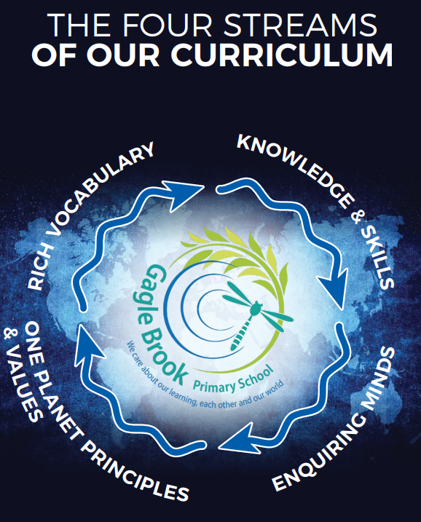

We have carefully chosen our four Streams because they are unique to our school context and setting:

* **Knowledge and skills:** It is our intent that our pupils will develop mastery across the curriculum as a result of a carefully sequenced curriculum which builds progressively on knowledge and skills.
* **Rich language:** Our intent is for all children to acquire knowledge, develop their vocabulary and have tools to communicate their ideas and learning effectively, both orally and in writing. To do this, our curriculum is planned to include high quality texts, real life and hands on experiences and creating a range of opportunities for all children to be immersed in and engaging with language.
* **Enquiring minds:** Our intent is for every child to be a passionate and active learner, underpinned by our value of ‘Excellence’. We provide children with real-life experiences and use AfL strategies within lessons to encourage them to be active learners, who take pride in and can talk about their work and learning.
* **One Planet Principles and Values:** Our intent is for all children to grow and develop into eco-citizens who are well-rounded, take care of themselves, other people and the world they live in. We want them to grow up being the best version of themselves and understand local and global issues which affect the future of our planet. To do this, we want our children to work with and support environmental and sustainability causes in the community.

**Our Values: Our intent is for all children to embrace and develop a shared set of ACHIEVE Values: Ambition, Collaboration, Honesty, Inclusivity, Environmental care, Valiance and Excellence, which underpin everything we do. This will encourage our children to be the best version of themselves and strive to achieve potential in an ever-changing and modern world**.

**Intent for our Phonics Curriculum:**

At Gagle Brook School, our four Streams underpin our curriculum intent enabling our pupils to achieve the following in Phonics:

* Build on their growing knowledge of the alphabetic code, mastering phonics to read and spell as they move through school.
* Be equipped to tackle any unfamiliar words as they read.
* Read confidently for meaning and regularly enjoy reading for pleasure.
* See themselves as readers for both pleasure and purpose.
* Be taught fidelity to the Little Wandle Letters and Sounds Revised programme

**Implementation:**

* We teach a synthetic phonics programme. We start teaching phonics in Nursery/Reception and follow the [Little Wandle Letters and Sounds Revised progression](https://wandlelearningtrust.sharepoint.com/sites/WTSA2/Shared%20Documents/Forms/AllItems.aspx?csf=1&web=1&e=dA5Kg8&cid=c07c4b6e%2D7eff%2D4834%2Db0a2%2De34e77f1195a&FolderCTID=0x0120002B68E4606EDEEB42917E483D1520364F&id=%2Fsites%2FWTSA2%2FShared%20Documents%2FLetters%20and%20Sounds%2FLetters%20and%20Sounds%20Revised%2FSigned%20off%20files%2FProgramme%20Overview%5FReception%20and%20Year%201%2Epdf&parent=%2Fsites%2FWTSA2%2FShared%20Documents%2FLetters%20and%20Sounds%2FLetters%20and%20Sounds%20Revised%2FSigned%20off%20files).

* We model the application of the alphabetic code through phonics in shared reading and writing, both inside and outside of the phonics lesson and across the curriculum.

* We have a strong focus on language development for our children because we know that speaking and listening are crucial skills for reading and writing in all subjects.

**Foundations for phonics in Nursery**

We provide a balance of child-led and adult-led experiences for all children that meet the curriculum expectations for ‘Communication and language’ and ‘Literacy’. These include:

* sharing high-quality stories and poems
* learning a range of nursery rhymes and action rhymes
* activities that develop focused listening and attention, including oral blending
* attention to high-quality language.

We ensure Nursery children are well prepared to begin learning grapheme-phoneme correspondences (GPCs) and blending in Reception.

**Daily phonics lessons in Reception and Year 1**

We teach phonics for 30 minutes a day. In Reception, we build from 10-minute lessons, with additional daily oral blending games, to the full-length lesson as quickly as possible. Each Friday, we review the week’s teaching to help children become fluent readers.

Children make a strong start in Reception: teaching begins in Week 2 of the Autumn term. We follow the [Little Wandle Letters and Sounds Revised expectations of progress](https://wandlelearningtrust.sharepoint.com/sites/WTSA2/Shared%20Documents/Forms/AllItems.aspx?csf=1&web=1&e=dA5Kg8&cid=c07c4b6e%2D7eff%2D4834%2Db0a2%2De34e77f1195a&FolderCTID=0x0120002B68E4606EDEEB42917E483D1520364F&id=%2Fsites%2FWTSA2%2FShared%20Documents%2FLetters%20and%20Sounds%2FLetters%20and%20Sounds%20Revised%2FSigned%20off%20files%2FProgramme%20Overview%5FReception%20and%20Year%201%2Epdf&parent=%2Fsites%2FWTSA2%2FShared%20Documents%2FLetters%20and%20Sounds%2FLetters%20and%20Sounds%20Revised%2FSigned%20off%20files):

* Children in Reception are taught to read and spell words using Phase 2 and 3 GPCs, and words with adjacent consonants (Phase 4) with fluency and accuracy.
* Children in Year 1 review Phase 3 and 4 and are taught to read and spell words using Phase 5 GPCs with fluency and accuracy.

**Daily Keep-up lessons ensure every child learns to read**

* Any child who needs additional practice has daily Keep-up support, taught by a fully trained adult. Keep-up lessons match the structure of class teaching, and use the same procedures, resources and mantras, but in smaller steps with more repetition, so that every child secures their learning.
* We timetable daily phonics lessons for any child in Year 2 or 3 who is not fully fluent at reading or has not passed the Phonics screening check. These children urgently need to catch up, so the gap between themselves and their peers does not widen. We use the Little Wandle Letters and Sounds Revised assessments to identify the gaps in their phonic knowledge and teach to these using the Keep-up resources – at pace.
* If any child in Year 3 to 6 has gaps in their phonic knowledge when reading or writing, we plan phonics ‘catch-up’ lessons to address specific reading/writing gaps. These short, sharp lessons last 10 minutes and take place at least three times a week.

**Teaching reading**

We teach children to read through reading practice sessions three times a week. These:

* are taught by a fully trained adult to small groups of approximately six children
* use books matched to the children’s secure phonic knowledge using the Little Wandle Letters and Sounds Revised assessments and book matching grids on pages 11–20 of [‘Application of phonics to reading’](https://www.littlewandlelettersandsounds.org.uk/wp-content/uploads/2021/11/LS-KEY-GUIDANCE-APPLICATION-OF-PHONICS-NEW-PD03-1.pdf)
* are monitored by the class teacher, who rotates and works with each group on a regular basis.

Each reading practice session has a clear focus, so that the demands of the session do not overload the children’s working memory. The reading practice sessions have been designed to focus on three key reading skills:

* decoding
* prosody: teaching children to read with understanding and expression
* comprehension: teaching children to understand the text.

In Reception these sessions start in Week 4. Children who are not yet decoding have daily additional blending practice in small groups, so that they quickly learn to blend and can begin to read books.

In Year 2 and 3, we continue to teach reading in this way for any children who still need to practise reading with decodable books.

**Home reading**

The decodable reading practice book is taken home to ensure success is shared with the family. Reading for pleasure books also go home for parents to share and read to children.

**Assessment**

Children’s progress in phonics is continually reviewed through assessment. This is used to monitor progress and to identify any child needing additional support as soon as they need it.

[**Assessment for learning**](https://www.littlewandlelettersandsounds.org.uk/wp-content/uploads/2021/03/LS-KEY-GUIDANCE-GETTING-STARTED-ASSESSMENT-FINAL.pdf) is used:

* daily within class to identify children needing Keep-up support
* weekly in the Review lesson to assess gaps, address these immediately and secure fluency of GPCs, words and spellings.

[**Summative assessment**](https://www.littlewandlelettersandsounds.org.uk/resources/my-letters-and-sounds/assessment-tools/) is used:

* every six weeks to assess progress, to identify gaps in learning that need to be addressed, to identify any children needing additional support and to plan the Keep-up support that they need.
* By SLT and scrutinised through the Little Wandle Letters and Sounds Revised assessment tracker, to narrow attainment gaps between different groups of children and so that any additional support for teachers can be put into place.
* The [Little Wandle Letters and Sounds Revised placement assessment](https://www.littlewandlelettersandsounds.org.uk/resources/my-letters-and-sounds/assessment-tools/) is used with any child new to the school to quickly identify any gaps in their phonic knowledge and plan provide appropriate extra teaching.

**Statutory assessment**

Children in Year 1 sit the Phonics screening check. Any child not passing the check re-sits it in Year 2.

**Ongoing assessment for catch-up**

Children in Year 2 to 6 are assessed through:

* their teacher’s ongoing formative assessment
* the Little Wandle Letters and Sounds placement assessment the appropriate half-termly assessments.

**Impact**

Our intended impact is that after the quality teaching of Phonics, this results in children who:

* Master phonics to read and spell as they move through school.
* Are confident readers and developing this a crucial life skill.
* See themselves as readers for both pleasure and purpose.
* Develop resilience and perseverance.
* Develop a love for reading, a rich vocabulary and this will in turn promote their literacy skills and influence their writing as they move through the school and beyond.