Gagle Brook Primary School – Reception Autumn Term 2 2023
Big Question: Hidden behind the picture is…? |  |  |  |  |  |  |  | With a focus on Art and History
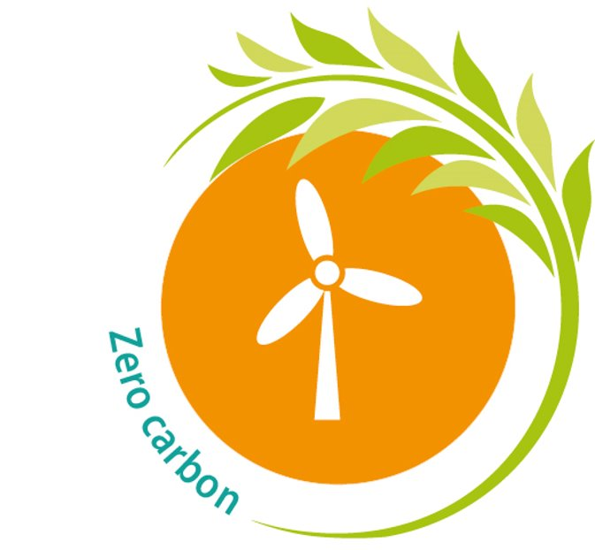  Our Focus Texts for this term:  The Colour Monster  The Colour Thief  Mixed  The mixed-up chameleon  How the Crayons saved the rainbow  The day the crayons that quit  Elmer  Colour me happy Colour me sad  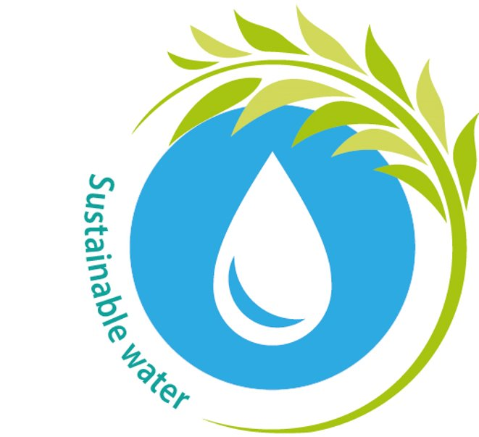  Elmer’s Christmas  Other books and stories we will enjoy in class:  The Rainbow Fish  Autumn Themed stories  Guy Fawkes Story  The Dot  Mouse Paint  The Diwali Story  The day the crayons came home  A range of Elmer Stories  We all belong  The Jolly Christmas Postman  The Crayons Christmas  Science Linked Books:  The Nutcracker  Dogger  Old Bear  Non-Fiction  The Usborne Book of Famous Artists  Sir Captain Tom  Big Dreams little People |  |  |  |  |  |  |  | This term our curriculum focus will be Art and History.  Our topic will be based around what can be hidden behind a given picture. We will be using many pictures as a stimulus for our work linked to a variety of stories and celebrations that people enjoy.  The children will be enjoying many stories linked to art and colour and then using their own imaginations to produce their own art creations and talking about their ideas for their own stories.  In Writing tasks, the children will be using their sounds to write down simple words to tell us their own ideas while working on writing their name from memory using the correct letter formations.  We will use Tales Toolkit to help us to create our own stories and characters based around our imaginary lands and place, I cannot wait to see what places we might visit using our imaginations.  Key dates for the diary:  30th Oct Start of Term Two: Start of new ‘enquiry question’: Hidden behind the picture is…?  1st Nov Reception Trip to Pizza Express  13th – 17th Nov Anti-bullying week  13th Nov World Kindness Day at Gagle Brook / Odd socks day!  13th – 17th National Nursery Rhyme Week  18th Nov Children in Need  23rd Nov EYFS Communication and Language Workshop 9.15am (More info to follow)  25th – 3rd Dec National Tree Week  8th Dec Christmas Jumper Day  14th Dec Nursery and Reception ‘A Christmas Wish’ - 9.00am  20th December End of Term
Knowledge & Skills | Enquiring Minds |  |  |  | Language Rich |  |  | Values & One Planet Principles
Our learning is carefully sequenced to ensure that the children consolidate the knowledge and skills previously learnt and new skills are built upon in small, incremental steps. The children will take their learning deeper before covering new content.  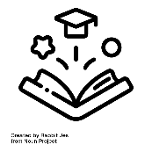 | 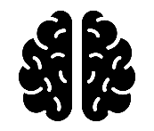  We care about our learning and the children will demonstrate this through having enquiring minds and asking questions. There are no limits to curiosity, questioning and challenge, whether children are actively learning inside or in our extensive outdoor classroom environment whilst building resilience, independence and a ‘can do’ attitude. |  |  |  | We will provide the children with a school environment which is rich in opportunities for exploring language and acquiring new language skills. Key vocabulary will be taught and displayed in the classroom and children will make use of this within their learning. We will immerse children in high quality texts across the curriculum and continue our ‘Reading for Pleasure’ ethos. |  |  | Our values and one planet principles sit at the heart of our school community. Each term we choose a key figure who represents our values, and the children learn about them. This term the children will learn about Beatriz Milhazes and what makes her such a significant individual.  Our Value this term is: Equality  Our Key Figure this term is: Beatriz Milhazes  Our One Planet Principles are:  Sustainable Water  Zero Carbon
Prime Areas of Learning
Communications and Language |  |  | Personal, Social and Emotional Development |  |  | Physical Development |  |  | As Successful Learners…
This term we will continue to develop the children’s skills through whole class discussions and circle times, introducing new vocabulary and encouraging children to share their ideas. The children will be using their imagination and words to explain their idea.s We will have a focus on children taking turns in listening and talking to each other.  We will work as a class to continue our storytelling involving the characters within a story, the setting, creating a problem and a solution with a focus on our themed stories weekly particularly involving characters from the past and colour.  Our role play and small world play will transform over the term from being a house of many celebrations and finally landing in snowy lands where the children can get cozy and celebrate Christmas in their own Christmas House!  Our goals for the term are to join in with repeated refrains and predict key events and phrases in rhymes and songs. We will also use our imagination and use pretend talk when in role as a character or playing with my friends.  Our rhyme this term is The Grand Old Duke of York including some actions. |  |  | Using books, stories, and weekly Jigsaw sessions we will help children to understand their own emotions and how their actions can affect others around them and what methods the children can use to support themselves when they are feeling emotional due to a variety of reasons.  Our topic for this term is “Celebrating Difference” where the children will be thinking about how everyone is unique and special in their own way and celebrating how we are all different.  This term we will also be focussing on our “One Planet Principles” of Sustainable Materials where we will be talking about what materials are good to use compared to others. |  |  | Opportunities for physical development will be continuing throughout the school day as children ride bikes, create obstacle courses, run, hop, skip and climb outside or whilst they carefully arrange small loose parts to create patterns and pictures.  Their painting skills, using tools and techniques will be developed in class too. Fine Motor opportunities are also planned to include ‘Dough Gym’ and Squiggle while you Wiggle’.  There will be daily letter formation lessons as part of our phonics sessions, plus an additional weekly session to work on the pencil control and correct formation of letters. Please can parents continue to support with this at home using the phonics sheets we will be sending home, and the letter formation rhymes I gave out at parents evening.  Our PE day is each Wednesday where children will continue to have PE with Mr Latham. The focus will be Gymnastics this term. Children will start to develop their skills in a range of movements and gymnastic moves. Children will be linking movements together to form a simple sequence. |  |  | As successful learners we will continue to learn with others.  We will be encouraged to feel safe in our learning and feel that “we can”.  We will be involved in reviewing and improving our learning.  We will be encouraged to have fun and enjoy our learning.  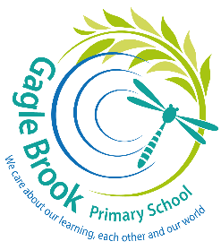
Specific Areas of Learning
Literacy |  | Maths |  | Understanding the World |  |  | Expressive Arts and Design
We will continue to develop a real love of books both fiction and non-fiction by reading and sharing books linked to our weekly themes in class.  Our daily phonics lessons will continue to focus on reinforcing phonic knowledge and using the sounds we have already learnt. We will be using these sounds to now begin to blend 3 sounds together to read words and write down simple words. We will be focussing on using the correct letter formation and developing confidence with reading CVC words and writing initial sounds. Children will read daily in school in Read, Write Inc Phonics sessions as well as individual reads alongside an adult in school. We ask that children read daily at home too. Reading Diaries will be checked each Monday for reading awards so please ensure all reads are recorded ready for this.  Please can you ensure your child has their reading book and diary in school daily and all share at home books are returned before Wednesday so we can change them in school either each Wednesday or Thursday.  This term we will be focusing on writing using our sounds we know both inside and outdoors and name writing so please support your child at home to write their name from memory and using the correct letter formation, if you need any guidance please speak to us.  We will continue to use Tales Toolkit when we are storytelling using the children’s own ideas. |  | This term we will be continuing to learn our numbers using a range of activities and Number Blocks. We will working on subitising to 6. We will be using 10 frames to represent numbers to 10 using a variety of equipment. We will continue to use Numicon to show numbers instantly recognising the shapes rather than counting the holes. We will be comparing numbers to 6 using the language “bigger than”, “smaller than”, “more than”, “fewer than”, “the same as”, “equal to”. We will be ordering quantities of objects and Numicon and talking about the order and why. Each day we will orally count in 1s from 1 to 20 and 10 to 0. Children will be given support with writing the digits from 0 – 9 ensuring they are forming the digits correctly during our Maths sessions.  During our shape sessions we will teach children to name common 2D shapes (circle, triangle, rectangle and square) and common 3D shapes (cone, cylinder, cube, cuboid, and sphere) and to describe their properties using informal and mathematical language (e.g. sides, corners, and faces). This term we will be learning about height and teaching the children to use a variety of words to describe height, including ‘tall’, ‘short’, ‘taller than’ and ‘shorter than’. We will be having fun with making and exploring patterns where children will make their own AB patterns using different resources plus looking for mistakes in patterns that have been made. |  | We are excited to continue with our weekly Understanding the World session.  We will be looking at a range of celebrations such as Diwali, Remembrance Day, Bonfire Night, Hannukah and Christmas. We will be focusing on looking at the season of Autumn and watching this change throughout the term.  As Scientists, we will be learning about using talk to explain what has happened and why.  As Historians, we are going to talk about events in the past through stories such as Rama and Sita, Guy Fawkes, and Remembrance Day. We will also investigate Fire Engines Police Cars, Toys, and Christmas traditions in the past. We will describe special times and events we have shared with our families and friends.  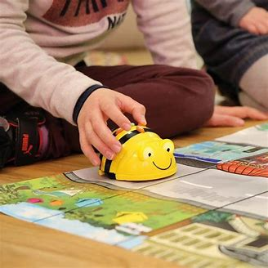  As Geographers, we are going to explore maps and tracks in stories and using them in our play.  We are also going to be investigating technology in our everyday lives. This term we will focus on using simple software to make something happen, using buttons while exploring the Beebots.  During RE we will be using the Christmas Story to enable us to reflect on being able to be thankful for things and also what happened in the Christmas story and talking about the events as a class. |  |  | Our Art focus for this term is all about artwork by the artist Kandinsky and Mondrian.  We will be exploring colour, colour mixing and lines to make our own Kandinsky and Mondrian inspired artwork.  The children will be taught different printing / paintings techniques and will be given time to explore these using different paints and textures using a range of tools.  We will also be making a special class canvas linked to Remembrance Day.  We will finish off the term exploring our clay skills where we will be developing our skills to pull, push and poke the clay to make our own Monster face tiles.  We hope to be able to share all our art with you during our learning showcase at the end of term.  We will sing daily, so the children build up a broad repertoire of songs and rhymes that they are familiar with. Our rhyme of the term will be The Grand Old Duke of York and we will be learning a range of Autumn, Diwali and Christmas songs.
 |  |  |  |  |  |  |  |  | Values for life
The value for term 2 is: Equality

Our key figure this term is:
Beatriz Milhazes

