**Writing Intent, Implementation & Impact Statement**

At Gagle Brook School we believe in the unlimited potential of every child. As a result of this, we have carefully designed a curriculum which is underpinned by the 4 Streams.

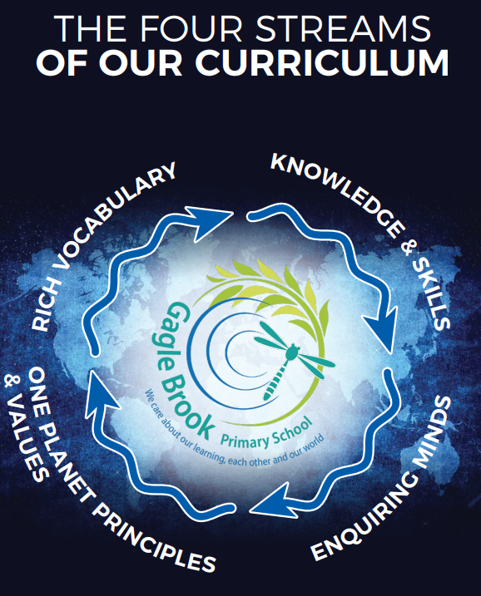

We have carefully chosen our four Streams because they are unique to our school context and setting:

* **Knowledge and skills:** It is our intent that our pupils will develop mastery across the curriculum as a result of a carefully sequenced curriculum which builds progressively on knowledge and skills.
* **Rich language:** Our intent is for all children to acquire knowledge, develop their vocabulary and have tools to communicate their ideas and learning effectively, both orally and in writing. To do this, our curriculum is planned to include high quality texts, real life and hands on experiences and creating a range of opportunities for all children to be immersed in and engaging with language.
* **Enquiring minds:** Our intent is for every child to be a passionate and active learner, underpinned by our value of ‘Excellence’. We provide children with real-life experiences and use AfL strategies within lessons to encourage them to be active learners, who take pride in and can talk about their work and learning.
* **One Planet Principles and Values:** Our intent is for all children to grow and develop into eco-citizens who are well-rounded, take care of themselves, other people and the world they live in. We want them to grow up being the best version of themselves and understand local and global issues which affect the future of our planet. To do this, we want our children to work with and support environmental and sustainability causes in the community.

**Our Values: Our intent is for all children to embrace and develop a shared set of ACHIEVE Values: Ambition, Collaboration, Honesty, Inclusivity, Environmental care, Valiance and Excellence, which underpin everything we do. This will encourage our children to be the best version of themselves and strive to achieve potential in an ever-changing and modern world**.

**Intent for our Writing Curriculum:**

At Gagle Brook School, our Streams underpin our curriculum intent enabling our pupils to achieve the following in Writing:

* Write for a range of purposes and take enjoyment in writing both fiction and non-fiction.
* Develop a skill set that enables our pupils to be successful writers.
* Develop a rich vocabulary that is applied to speech and writing.
* Enable pupils to communicate their ideas

Our writing curriculum aims to empower all children to acquire the skills and knowledge they need to use the English language confidently, appropriately and accurately to the best of their ability. Our intent is for all children to acquire knowledge, develop their vocabulary and can communicate their ideas and learning effectively, both orally and in writing. We want all children to be exposed to a breadth of genres, based on quality texts, ensuring pupils are equipped to succeed in written outcomes. We aim to incorporate our school values through our chosen texts and during our lessons. We believe that for children to succeed, lessons must be exciting and engaging for both boys and girls, purposeful and closely linked to a range of high-quality texts and/or current learning themes. Our English curriculum is carefully planned and sequenced in units to build on prior learning. We want the children to see themselves as a writer and celebrate their success.

**Implementation:**

The National Curriculum is the starting point of our curriculum design. It has been used to drive our curriculum design, to ensure the aims of the National Curriculum are met, and it has been used to inform the choices we have made about the content that we teach at Gagle Brook School.

Our curriculum is based around high quality texts, real life and hands on experiences. The focus of teaching is on developing skills which are progressive throughout the school, with children focusing on one skill at a time, then applying this to independent writing. When teaching, our teachers model writing using the ‘I do, we do, you do approach as a basis to impart knowledge and develop secure writing practices from. When writing, children will need to think about the audience, purpose and effect of their writing so children are taught to apply their skills across a variety of text types. All children have opportunities to write across a wide variety of genres as they progress through the school. Where possible, the teaching of reading and writing are linked through a text or animation. Our curriculum provides us with a range of opportunities to develop the language and vocabulary with our children, through high quality texts, drama, word of the week, vocabulary rich working walls and a range of speaking and listening activities.

**Impact**

Our intended impact is that by the time our pupils leave Gagle Brook School, they will have developed:

* An enjoyment in writing both fiction and non-fiction, and for a range of purposes.
* A skill set that enables them to be successful writers through life.
* A rich vocabulary that is applied to speech and writing.
* Strong written communication skills.