Gagle Brook Primary School – Year 1 2023- Term 2
Big Question: Hidden behind the picture is...? |  |  |  |  | Let’s get creative  With a focus on: Art and History.
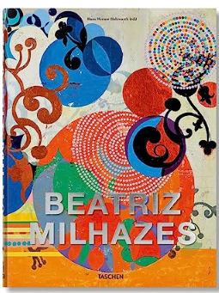 |  |  |  | Next term our “Big Question” is “What’s hidden behind the picture...” with a link to Art and History. We will continue to make links to the One Planet Principles of “Zero Carbon” and “Sustainable Water” and thinking about our value “Unity”.  The children will take part in PE twice weekly. PE will take place on Wednesday and Thursday afternoons. Outdoor learning will take place on Monday afternoons.  Key dates for the diary:  30th Oct Start of Term Two: Start of new ‘enquiry question’: Hidden behind the picture is…?  13th – 17th Nov Anti-bullying week  13th Nov World Kindness Day at Gagle Brook  18th Nov Children in Need  25th – 3rd Dec National Tree Week  8th Dec Christmas Jumper Day  12th Dec- YR1/2 Nativity performance  20th December End of Term
At Gagle Brook, learning will be driven by:

At Gagle Brook we pride ourselves on providing a rich varied curriculum for the children and this is led by a big question each term. The big question this term is ‘Hidden behind the picture is...?’ The children participate in a hook day to excite them about their new learning, and we provide a variety of cross curriculum learning opportunities
Knowledge & Skills | Enquiring Minds |  | Language Rich |  |  |  |  |  | Values & One Planet Principles
Our learning is carefully sequenced to ensure that the children consolidate the knowledge and skills previously learnt and new skills are carefully, steadily built upon in small, incremental steps. The children will take their learning deeper before covering new content.  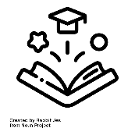  We use topic webs and knowledge organisers to map out knowledge and skills in our learning. | 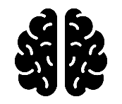  We care about our learning and the children will demonstrate this through having enquiring minds and asking questions. There are no limits to curiosity, questioning and challenge, whether children are actively learning inside or in our extensive outdoor classroom environment whilst building resilience, independence and a ‘can do’ attitude. |  | We will provide the children with a school environment which is rich in opportunities for exploring language and acquiring new language skills. Key vocabulary will be displayed in the classroom and children will make use of this within their learning. We will immerse children in high quality texts across the curriculum and continue our ‘Reading for Pleasure’ ethos. We will also surround them with language rich opportunities for dialogue, with a focus on back and forth communication. |  |  |  |  |  | Our values and one planet principles sit at the heart of our school community. Each term we choose a key figure who represents our values and the children learn about them. This term the children will learn about Baroness Floella Benjamin DBE and what makes her a significant individual.  Our Value this term is:  Equality  Our Key Figure this term is:  Beatriz Milhazes  Our One Planet Principle is:  Sustainable Water and Zero Carbon
Core Learning Skills |  | As Successful Learners… | Core Learning Skills
As Writers and Readers… |  | As successful learners we will continue to learn with others.  We will be encouraged to feel safe in our learning and feel that “we can”.  We will be involved in reviewing and improving our learning.  We will be encouraged to have fun and enjoy our learning.  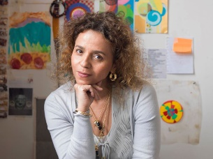  My challenge is how to work with geometry and life. I'm in favour of life, we need it!”  Beatriz Milhazes | As Historians… |  |  |  |  | As Theologists… |  | As Technologists…
This term our core texts are ‘Katie’s Picture Show’ and other related books such as ‘Katie and The British Artists’. We will use these to drive our writing skills. We will start the term with writing a set of instructions for Katie, consolidating our core writing skills – using the correct punctuation and showing a good understanding of sentence structures - and building new writing techniques. Later in the term we will also complete a unit on Fiction writing, ensuring the breadth of our writing curriculum opportunities. We will be focusing our skills on writing a diary entry in role as Katie. Our focus is always on developing ourselves as readers who write and writers who read, and we will draw on our reading when writing.  At Gagle Brook we emphasise the importance of reading widely and are passionate about reading. This term the children will explore a variety of texts linked to our core texts, giving contextual knowledge and developing their reading skills using ‘Look, Clue, Think, Word’.  We follow the Read, Write Inc Spelling programme in Year 1 and give opportunities for children to access the Read, Write Inc Phonics programme where appropriate. |  |  | The UK and the World  We are learning:  - Can I explain who Williiam Morris is?  - Can I investigate the UK in the 1800s?  - Can I explain where William Morris lived?  - Can I describe transport now and then?  - Can I explain how a car have developed?  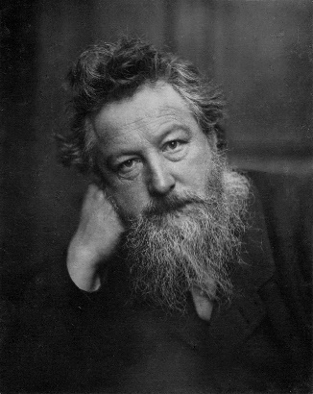 |  |  |  |  | Gifts and Giving  We are learning:  To understand beliefs and teachings.  To understand practices and lifestyles.  To understand how beliefs are conveyed.  To reflect.  To understand values.  - Looking after each other  - The Good Samaritan  - Raksha Bandhan  - Langar  - The Monkey King  - Be my guest |  | We always begin our computing learning by discussing our SMART rules.  This term we will begin with the topic of self-image and identity. The children will be able to explain how other people may look and act differently online and offline.  They will be able to give examples of issues online as well as examples of how they might get help. We will then look at the theme of privacy and security. We will be able to explain how passwords can be used to protect information, accounts and devices. We will understand what is meant by ‘private’ and ‘keeping things private’ and be able to describe and explain some rules for keeping personal information private. Finally, we will investigate algorithms through the use of Bee Bots.
As Mathematicians… |  |  | As Scientists…
We will begin the term by exploring number and place value. We will use a range of strategies and manipulatives to secure our understanding of number and place value. We will be exploring number up to 100 by using number lines and additional manipulatives to form estimations.  We will then learn to add and subtract numbers using concrete objects, pictorial representations, and mentally, including using our number bonds to add numbers up to 20.  Later in the term we explore geometry with relation to shapes. Building on our previous knowledge of shape, sides, length and similarities between shape to deepen our understanding.  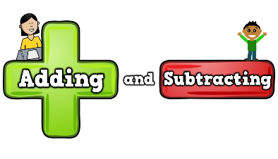  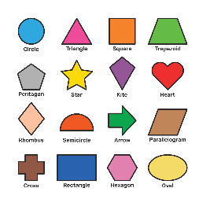 |  |  | Working Scientifically  We are learning:  To work scientifically.  To investigate, observe and record in a logical way.  To engage safely in practical investigations or experiments. |  |  |  |  |  | Uses of everyday materials  We are learning:  Living Things Habitats; Exploring different animals that are local to us and how their habitats differ, why they differ and what we can do to help sustain all habitats.  Seasonal Change: Are there areas of the playground that are wet, dry, hot cold. How do they differ. Why do they differ?
 |  | PHSE
Celebrating difference
Can I identify similarities between people in my class?
Can I identify differences between people in my class?
Can I say what bullying is and how it might effect people?
Can I say who I could go to if I was feeling unhappy or being bullied?
Can I say what it feels like to make a new friend?
Can I understand how differences make us all special and unique?
 |  |  | As Artists… |  |  |  | As Athletes… |  |  |  | As Musicians…
 |  |  | We are learning:  To develop our printing skills with a focus on Henri Rousseau – Tiger.  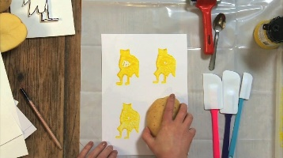 |  |  | Gymnastics Unit 1  - Can perform various shapes Perform basic jump (straight jump, Star jump.  - Perform a tuck rock and a tuck roll and rocket roll with pointed toes.  - Perform a tuck rock and a tuck roll and rocket roll with pointed toes.  - Perform a bunny hop- hands first then feet Perform a basic sequence (roll, jump and roll)  - Moving on and off and landing with control.  - Can I create a short performance using the gymnastic skills I have learnt? |  |  |  |  | We are learning:  To perform musically.  To listen with concentration.  To experiment with sounds using the inter-related dimensions of music.  To describe music.  We will be introducing beat and making beats as a whole class.
 |  | Values for life
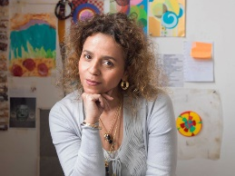
The value for term 2 is: Equality

Our key figure this term is:
Beatriz Milhazes

