Gagle Brook Primary School – Year 2 Autumn Term 2 2023-24
Big Question: Hidden Behind the Picture is…? |  |  |  | With a focus on: Computing
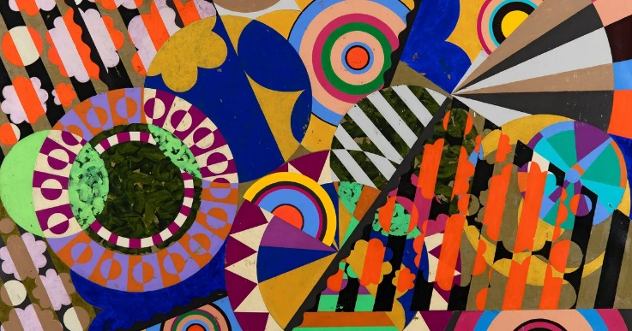  Key vocabulary we will learn this term:  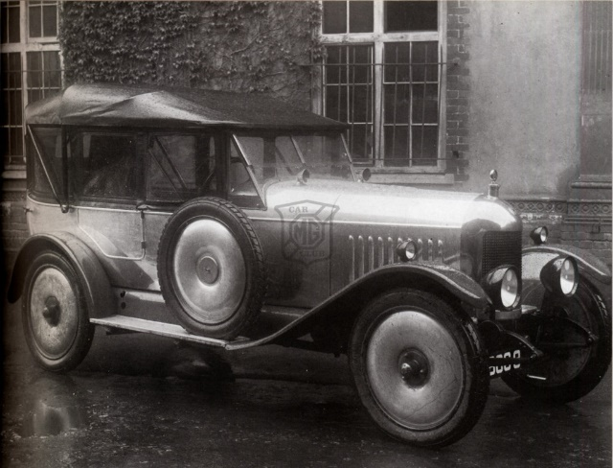 |  |  |  | This term promises to be an exciting term with our big question: Hidden Behind the Picture is…? The children will be taking part in lots of art and craft activities and learning about the history of motoring. We will be combining our knowledge of these topics to create a piece of whole class artwork at the end of term.  The children will take part in regular Learning in Nature sessions every other week which will link into our science learning on habitats and living things. The children will be having PE on Mondays and Thursdays each week.  Key dates for the diary:  30th October - Start of Term 2  2nd November - Artist dress up day  13th-17th November - Anti-Bullying Week  13th November - World Kindness Day  18th November - Children in Need  8th December - Christmas Jumper Day  12th December - KS1 Christmas Production  20th December - End of Term 2
At Gagle Brook, learning will be driven by:
Knowledge & Skills | Enquiring Minds |  | Language Rich | Values & One Planet Principles
Our learning is carefully sequenced to ensure that the children consolidate the knowledge and skills previously learnt and new skills are carefully steadily built upon in small, incremental steps. The children will take their learning deeper before covering new content.  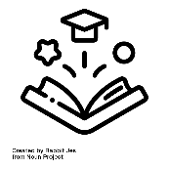 | 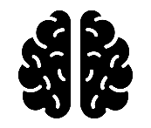  We care about our learning and the children will demonstrate this through having enquiring minds and asking questions. There are no limits to curiosity, questioning and challenge, whether children are actively learning inside or in our extensive outdoor classroom environment whilst building resilience, independence and a ‘can do’ attitude. |  | We will provide the children with a school environment which is rich in opportunities for exploring language and acquiring new language skills. Key vocabulary will be displayed in the classroom and children will make use of this within their learning. We will immerse children in high quality texts across the curriculum and continue our ‘Reading for Pleasure’ ethos. | Our values and one planet principles sit at the heart of our school community. Each term we choose a key figure who represents our values, and the children learn about them.  Our Value this term is:  Equality  Our Key Figure this term is:  Beatriz Milhazes  Our One Planet Principle is:  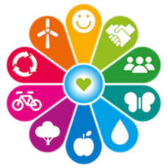  Sustainable Water  Zero Carbon
Core Learning Skills |  | As Successful Learners… | Core Learning Skills
As Writers and Readers… |  | We will be immersing ourselves into the One Planet Living Principles so children can understand the impact they can make on the planet through the decisions they make.  Beatriz Milhazes is a Brazilian artist known for her paintings with bright colours and layered shapes.  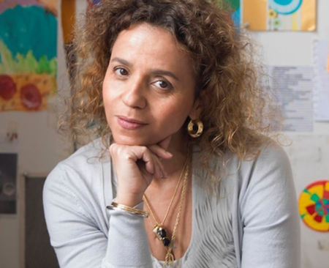 | As Historians… | As Theologists… |  | As Technologists…
This term our core text is ‘Katie’s Picture Show’. The children will have a go at writing their own stories inspired by a piece of artwork thinking about what it might be like to explore a new world.  Guided Reading, spellings, handwriting and grammar will continue to be taught as part of the English curriculum.  At Gagle Brook we emphasise the importance of reading widely and are passionate about reading. This term the children will explore a variety of texts linked to our core texts, giving contextual knowledge and developing their reading skills using ‘Look, Clue, Think, Word’. |  |  | William Morris  Children will:  - Learn about William Morris and his contributions to the history of motoring.  - Learn about where he came from and identify this on a map.  - Compare modern cars to older cars, thinking about what is the same and different. | This term is focused around Christmas Celebrations, linking this to the Christian story of the birth of Christ and thinking about how Christmas is celebrated both in England and in other countries. |  | We always begin our computing learning by discussing our SMART rules – focusing on the ‘M’ rule (meeting). We will also be looking at Online Bullying.  Children will also be learning about Digital Painting and will:  - Explore different digital drawing tools.  - Have a go at drawing digital paintings inspired by traditional artists.  - Use different shape, line and fill tools.  - Compare digital art to paintings.
As Mathematicians… |  |  | As Scientists…
For the start of the term, we will start by continuing with our Addition topic, which works to equip children with a variety of different methods of adding numbers up to 100.  We will then look at Subtraction where, similarly to the addition topic, children will learn a variety of methods of subtracting numbers, including using number lines and bridging to ten.  Next, we will look at Geometry which will look at naming and describing 3D shapes.  To end the term, we will then start some work on Multiplication and Division using arrays and grouping. |  |  | Working Scientifically  We are learning:  - To ask questions and plan investigations  - To answer questions through gathering evidence | Thinking Scientifically  We will be learning:  - What a habitat is and what types of habitats there are.  - The difference between things that are living, dead or have never been alive.  - About food chains and how they start with plants, including learning about consumers, prey and predators  - About why the length of day changes throughout the year  - About the changes that will happen as winter sets in
 |  | PHSE

Celebrating Difference
Boys and Girls
Why Does Bullying Happen?
Standing Up For Myself and Others
Gender Diversity
Celebrating Difference and Still Being Friends
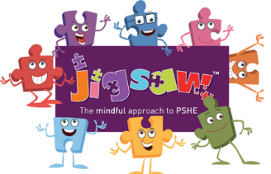

 |  |  | As Artist and Design Technologists… | As Athletes… | As Musicians…
 |  |  | We are:  Learning about Henri Rousseau and using inspiration from his work to create our own animal strong prints.  We are going to learn about different printing techniques using a variety of tools and textures. | We will play a variety of ball games such as handball and bench ball to develop our ability to work as a team.  We will also do gymnastics, learning about types of rolls and jumps and putting sequences of movements together. | - Finding the pulse and beat of a piece of music  - Adding rhythm and pitch on top of a beat  - Start by listening, singing and playing then progress to composing and performing
 |  | Values for life
The value for Term 2 is:
Equality
Our key figure this term is:
Beatriz Milhazes

