Gagle Brook Primary School – Year 4 Autumn Term 2 2023-24
Big Question: Hidden behind the picture is? |  |  |  | With a focus on: Art & History
Key vocabulary we will learn this term:  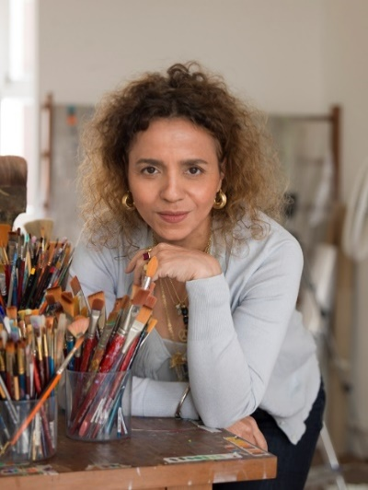  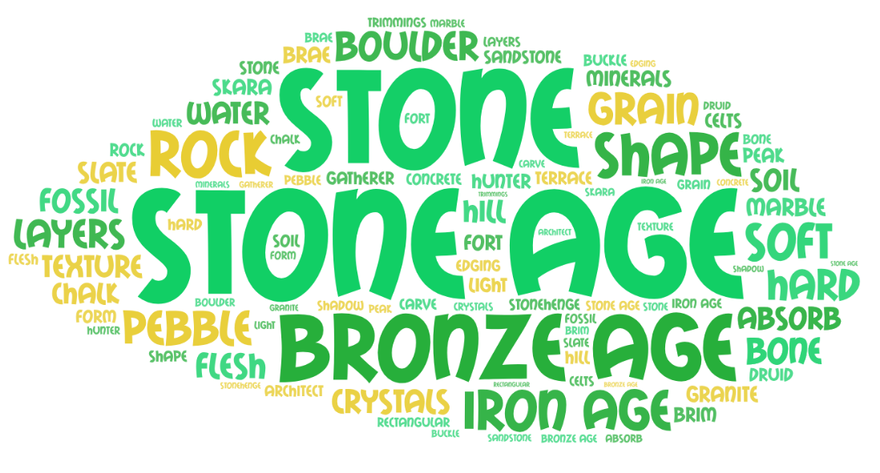  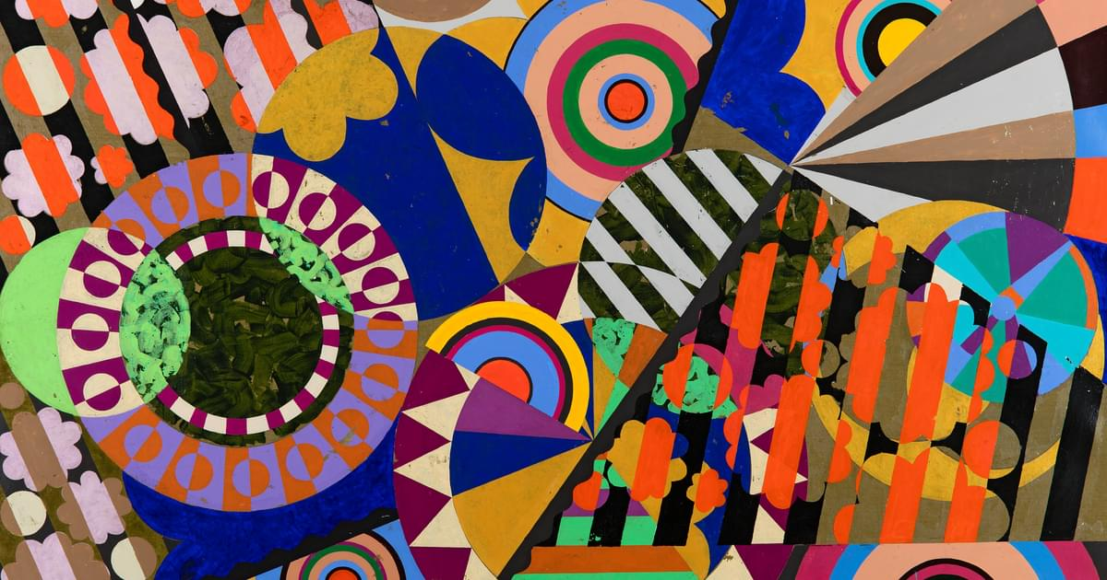  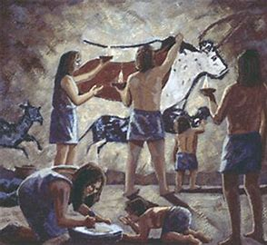 |  |  |  | This term promises to be an exciting term with our big question: Hidden behind the picture is? Our Year 4 topic is called Stone Age.  In History we will be exploring the world from the Stone Age to the Iron Age. In Art we will be designing, making and evaluating 3D sculpture.  The children will take part in fortnightly ‘Learning in Nature’ sessions and PE continue to take place twice weekly (Monday and Wednesday).  Key dates for the diary:  30th October – New term and school photos  2nd November – Hook Day: dressing up as an artist  10th November – Break the Rules Day!  15th November – PSHE workshop for parents  17th November – Children in Need Day  25th November – 3rd December – National Tree week  7th December – Christmas Panto in school  8th December – Christmas Jumper Day  13th December – Christmas lunch  18th December – A Christmas Wish Year 3, 4, 5 performance  20th December – End of Term  8th January – Back to School Term 3
At Gagle Brook, learning will be driven by:
Knowledge & Skills | Enquiring Minds |  | Language Rich | Values & One Planet Principles
Our learning is carefully sequenced to ensure that the children consolidate the knowledge and skills previously learnt and new skills are carefully steadily built upon in small, incremental steps. The children will take their learning deeper before covering new content. | 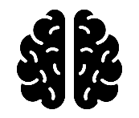  We care about our learning and the children will demonstrate this through having enquiring minds and asking questions. There are no limits to curiosity, questioning and challenge, whether children are actively learning inside or in our extensive outdoor classroom environment whilst building resilience, independence and a ‘can do’ attitude. |  | We will provide the children with a school environment which is rich in opportunities for exploring language and acquiring new language skills. Key vocabulary will be displayed in the classroom and children will make use of this within their learning. We will immerse children in high quality texts across the curriculum and continue our ‘Reading for Pleasure’ ethos. | Our values and one planet principles sit at the heart of our school community. Each term we choose a key figure who represents our values, and the children learn about them.  Our Value this term is:  Equality  Our Key Figure this term is:  Beatriz Milhazes  Our One Planet Principle is:  Sustainable Water & Zero Carbon
Core Learning Skills |  | As Successful Learners… | Core Learning Skills
As Writers and Readers… |  | We will be immersing ourselves into the One Planet Living Principles, focusing on just a few so children can really understand the impact they can make on the planet through the decisions they make.  We will also be learning about Beatriz Milhazes this term:  Full name: Beatriz Milhazes  Born: 1960  Hometown: Rio de Janeiro, Brazil.  Occupation: Artist.  Best known for: She is known for her work juxtaposing Brazilian cultural imagery and references to western Modernist painting.  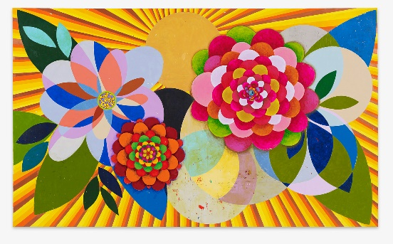 | As Historians… | As Theologists… |  | As Technologists…
This term our core text is ‘Stone Age Boy’ by Satoshi Kitamura. We will start the term imagining what it would be like to be in the Stone Age, leading up to us innovating the story of Stone Age Boy. Then we will move onto writing a newspaper article about the Stone Age.  Guided Reading, spellings, handwriting and grammar will continue to be taught as part of the English curriculum.  At Gagle Brook we emphasise the importance of reading widely and are passionate about reading. This term the children will explore a variety of texts linked to our core texts, giving contextual knowledge and developing their reading skills using retrieval and inference.  Please do try to hear your child read daily and use their reading diary to record the reads in. We will also listen to the children read weekly in school. |  |  | Children will learn about how Britain changed from Stone Age through to Iron Age. We will look at over 6000 years for History and how the people of Britain changed from nomadic groups, to settled farmers making intricate tools and homeware.  We are learning:  - What life was like in Stone Age Britain 8000 years ago.  - How life changed when man started to farm and why they did so.  - What life was like in Bronze Age Britain around 4000 years ago.  - The move to the Iron Age and how life changed in Britain some 2000 years ago.  - What evidence has been left behind from this period and how we can interpret this evidence to build up a picture of life at this period in time. | The children will be learning about the meaning behind different signs and symbols.  We are learning:  - About signs and symbols that are important to us  - About signs and symbols in places of worship  - Signs and symbols and what they represent |  | We always begin our computing learning by discussing our SMART rules – focusing on M for Meeting. We will also be considering Technology in our Lives, it’s impact both positive and negative.  We are learning:  - How digital devices work  - How parts make up a digital device  - How digital devices can help us  - How we are connected  - How computers are connected  - How our school is connected.
As Mathematicians… |  |  | As Scientists…
As mathematicians we will be spending the first three weeks of term working on Multiplication and Division, building the 6 and 7 multiplication tables, and using both the multiplication and division facts to solve problems. These tables a particularly important for the children. We will then move onto four weeks of Addition and Subtraction, looking at mental methods to work out the answers to questions.  In our maths meetings we will be recapping several mathematical concepts from Year 3 to help the children remember and move forward in their learning. This will include starting our work on multiplication bonds, which are a key area of learning in Year 4. |  |  | Working Scientifically  We are learning:  - To make a series of careful observations.  - To gather, record, classify and present data in a variety of ways to help in answering questions. | Rocks  Rock is a naturally occurring material. There are different types of rock e.g. sandstone, limestone, slate etc. which have different properties. Rocks can be hard or soft. They have different sizes of grain or crystal. They may absorb water. Rocks can be different shapes and sizes (stones, pebbles, boulders). Soils are made up of pieces of ground down rock which may be mixed with plant and animal material (organic matter). The type of rock, size of rock pieces and the amount of organic matter affect the property of the soil. Some rocks contain fossils. Fossils were formed millions of years ago. When plants and animals died, they fell to the seabed. They became covered and squashed by other material. Over time the dissolving animal and plant matter is replaced by minerals from the water.
 |  | PHSE
Celebrating Difference
Judging by appearances
Understanding influences
Understanding bullying
Problem-solving
Special me
Celebrating differences: how we look

 |  |  | As Artist and Design Technologists… | As Athletes… | As Musicians…
 |  |  | We are learning the art of sculpture with a focus on Stone Henge.  We are learning:  - Can I develop my own design and form ideas?  - Can I use scoring, slip and blending to join and assemble clay?  - Can I order the four stages of my planning ready to sculpt?  - Can I use different techniques to create a sculpture using clay?  - Can I add detail to my design to enhance it further?  - Can I evaluate my design  We will also be designing our own Christmas Cards in Design Technology using levers and hinges. | Football  We will be learning to control a football with our feet, including stopping, kicking and dribbling; looking at ways to beat a defender 1v1; and how to play as part of a team.  Dance (Eco-warrior)  We will be looking how our energy, strength, space around us and different stimuli affect the dance we produce. | We will be enjoying improvisation through Investigating how music can tell a story.
 |  | Values for life
The value for Term 1 is: Equality
Our key figure this term is:
Beatriz Milhazes

