APPLE CLASS 19/10/20
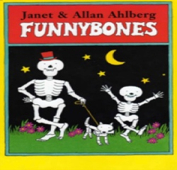

This week we will be focusing our learning around all things Halloween as this is something the children are very excited about and demand we count down to on our class calendar each day! 🎃

Here are some of the activities that we will be doing in school. If your child has to isolate at home this week, maybe you could try some of them at home too (providing you are all well enough).

Our focus story this week is ‘Funnybones’ which is a great story and series of stories to continue our learning of characters and story structure with. Watch the story (and many other Funnybones adventures) here:

https://m.youtube.com/watch?v=sJodPwWCClQ

Literacy

In Literacy this week, we will be learning some more about different story settings by:

*creating and labelling our own maps of the settings the skeletons visit in the story
*working as a small group to plan a new Funnybones adventure where the skeletons visit a new setting
*Making a collage picture to show the dark, dark night and the bright stars, colourful houses etc
*learning some new words to describe a setting by looking at different pictures e.g. a spooky night, a dazzling ocean etc.
*Exploring alliteration as we look at objects and items that could be in different settings e.g the fantastic ox, the scary skeleton, the curious clown.

Maths

In Maths we will be drawing together our knowledge of what numbers look like and how to count objects accurately as we practise counting out a set amount to match a numeral. We will do this by:

*Counting out toy spiders, rats tails, bogeys and eye balls to make a magic potion
*Hammering the correct number of golf tees into a pumpkin
*Playing spooky bowling and then counting how many skittles we have knocked down- you could do this with toilet roll at home
*Playing Witches hat hoopla- can the children identify what number their hat has landed on?
*Adding the correct number of pieces to the pumpkin https://www.abcya.com/games/make_a_pumpkin

