APPLE CLASS 02/11/20
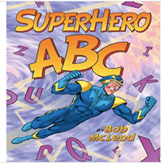

This week in school, we will be starting our new topic ‘Superheroes’ which the children have voted for. We will also be discussing bonfire night and firework safety. In Literacy we will be focusing on ‘alliteration’ and will be sorting lots of objects and pictures by their initial sounds. We will also be continuing to practise our phonics skills and letter formation as we begin to write simple labels. In Maths we will continue to focus on our numeral recognition and counting skills and will begin to learn how to count out a set amount from a larger group.

Here are some of the learning activities that we will be doing in school (some of which you could also have a go of at home if isolating)

Here is an online version of the story for you to listen to watch at home:

https://www.youtube.com/watch?v=C6wqIlt4jJI

Literacy

*Designing, drawing and labelling a new alliterative superhero
*sorting the superheroes mixed up objects e.g. giving the Batman figure all of the objects that start with ‘b’ and the Spiderman figure all of the objects that start with ‘s’.
*playing the Super Smoothie alliteration game www.phonicsplay.co.uk/supersmoothie
*Playing ‘I spy alliteration’, finding objects that begin with the first letter of our names
*Exploring the play food/ train set / farm set etc and listening to the grown-ups say alliterative tongue twisters e.g. scrummy sizzling sausages, perfect pineapple pizza etc
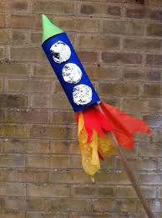
Maths

*Making our own fireworks- adding tissue paper streamers to match the numeral
*counting sets of gift bows/pipe cleaners/ triangular blocks to match a numeral-
We will be pretending these are fireworks but you could count sets of anything!
*playing simple board games
* Exploring number and amount puzzles
*decorating a firework picture with a given number of spots/ stripes etc
*Making rocket towers using Duplo with a paper cone top

