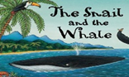
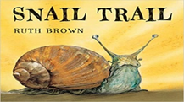
Topic: MINIBEASTS This week’s focus story is: ‘Snail Trail’ and ‘The Snail and the Whale’
Apple Class Home Learning: 29/06/20
Please listen to these each day in order to familiarise yourself with the stories:
 | Monday | Tuesday | Wednesday | Thursday | Friday
Physical Development | Complete some of your favourite Go Noodle Kidz Bop dances (parents this is free to sign up to):  https://www.gonoodle.com | Join the Dough Disco queen Shonette for a live dough disco session. If you don’t have any play dough you can use some imaginary dough:https://www.youtube.com/watch?v=_ZIVqHIBQW8&list=PLtw-7Jf06an1IfIIonfs44FpzuCv7g1ZB | Can you do the snail dance?  https://www.youtube.com/watch?v=Qff-4niJ1-s | Practise your letter formation using and letter names as you say and write each sound: https://www.youtube.com/watch?v=wduPhJLeBhA | Complete some of your favourite Go Noodle Kidz Bop dances (parents this is free to sign up to):  https://www.gonoodle.com
Literacy | Listen to this today’s story ‘snail Trail’ https://www.youtube.com/watch?v=XsCgl6DobN4- can you draw a picture of your own snail and then label it? ‘shell, body’, antannae’, ‘trail’ ?  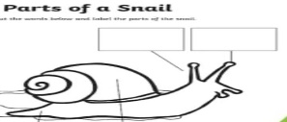 | Listen to today’s story ‘snail Trail’ https://www.youtube.com/watch?v=XsCgl6DobN4- Play hide and seek with your grown up. Can you draw a trail map of where you hid? Did you hde in the garden? Behind the couch? Next to the shed? Under the table? Etc. Label the parts of your picture.  Go to Tapestry for further ideas. | Listen to today’s story ‘The Snail and the Whale’ https://www.youtube.com/watch?v=3ZAtKDaFU6c This story is a rhyming words story. Can you make ‘spiral dangler’ using rhyming words from the story? Check Tapestry for further ideas. | Snail fun factcaption  https://www.youtube.com/watch?v=dqU-vrZeKCs Listen to this Snail song for your reading session today then draw a picture of a snail. Can you write an interesting fact about snails as your caption? | Listen to this week’s story ‘The Snail and the Whale then check out today’s literacy challenge on Tapestry.  ’https://www.youtube.com/watch?v=3ZAtKDaFU6c
Phonics | Digraph qu  Today you revisiting the digraph . Watch today’s lesson here: https://www.youtube.com/watch?v=kQgsxc71gKk&list=PLm2RM2K7CuCTXpyyW1IfnScIWuSKkMC8T&index=8  and then check out Tapestry for another challenge using this sound. | Digraph ch  Today you will revisit the digraph ch. Watch the lesson here:  https://www.youtube.com/watch?v=7pkNCLMzGfI&list=PLm2RM2K7CuCTXpyyW1IfnScIWuSKkMC8T&index=9  and then check out Tapestry for another challenge. | Diagraph y,z,zz,qu,ch  Today you will revisit y,z,zz,qu,ch. Watch the lesson here then check out Tapestry for another challenge.  https://www.youtube.com/watch?v=gfgpFd7R60I&list=PLm2RM2K7CuCTXpyyW1IfnScIWuSKkMC8T&index=10 | Diagraph sh  Today you will revisit sh. Watch the lesson here the check out for your challenge on Tapestry.  https://www.youtube.com/watch?v=tFVQEppqXCA&list=PLm2RM2K7CuCTXpyyW1IfnScIWuSKkMC8T&index=11 | Tricky word the  Today you will be revisiting the! Watch the lesson here:  https://www.youtube.com/watch?v=vii5dywgyac  and then have a go at counting the number of ‘the’s’ you can spot in your books. How many have you spotted?  Have a look at Tpestry for a fun challenge!
Maths | Hide and Seek  Play hide and seek with your grown up and test their positional language. Hide in as many places as possible either inside or outside. Which words did you use? Try and use the following words: Behind, under, over, above, on top of, etc. | Position Mathseeds  Log on to your Maths seed account to learn more about position and to help Dizzy find his ball. | Measure snail trail  Use various objects around the house to create a snail trail. You could use your colour pencils, shoes, lego, etc. How long is your snail trail? Count the number of objects to find out. | Subtraction chocolate snails  Check Tapestry for today’s subtraction activity. | Maths seeds-subtraction  Find the difference by logging onto your account on Mathseeds.
Reading | Either read one of your school books or choose one on this free site to read.  https://home.oxfordowl.co.uk (parents you will need to set up an account but it is free to do so) | Listen to the fun song about ‘the Snail and the Whale’ here https://www.youtube.com/watch?v=a9hmHFQlXXs | Either read one of your school books or choose one on this free site to read.  https://home.oxfordowl.co.uk (parents you will need to set up an account but it is free to do so) | SNAIL FACTS https://www.youtube.com/watch?v=dqU-vrZeKCs  Listen to this snail song to learn some interesting facts about snails. | Either read one of your school books or choose one on this free site to read.  https://home.oxfordowl.co.uk (parents you will need to set up an account but it is free to do so)
Topic | Pasta snail shells  Paint some pasta snail shells then hide them in different places. Where did you hide it? Under the bowl? Behind the sofa? Etc.  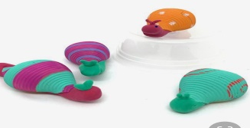 | Minibeast hunt outside  Go for a mini beast hunt in your garden or at your local park? Can you spot any different creatures now that it is warmer? Are they all the same size? Which is your favourite mini beast? Can you draw a picture of your favourite mini beast? | Save the ocean poster  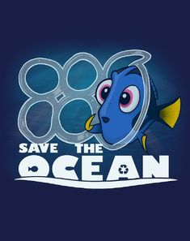  What can we do to save our environment? Can you think of ways that we can keep the under water creatures safe? Draw a poster to share your idea. | Write a thank you card for of a time someone helped you.  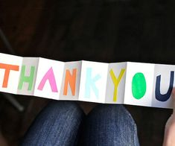  Don’t forget to upload a picture of your card on Tapestry. | VIRTUAL TOUR-MINIBEASTS WITH JESS  Learn more about snails in this virtual tour.  https://www.youtube.com/watch?v=a0Q-zFLAvPE
Remember we would love to see any photos of work or activities that you complete. You can upload them to TAPESTRY or email them at reception@gca.herts.sch.ukHave fun and keep safe! Miss Njihia,Miss Kane, Miss Nichols and Mrs O’Gorman

