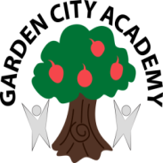

**Literacy**

Developing our pencil grip and control. Practising writing our names/ surnames.

Looking at and discussing familiar real life signs and logos.

Learning about nonfiction books and using these to find information.

Learning about story characters, events and settings as we enjoy the favourite stories: Funny bones, Elmer and Peace at Last.

**Personal, Social and Emotional Development**

Learning how to use our new classroom and outdoor learning environment.

Talking about my own and others feelings and exploring these through games and stories.

Becoming more independent within the environment- learning how to independently choose and select resources and then tidy them away.

Playing turn taking games with my peers and beginning to develop storylines with them in the small world and role-play areas.

**Reception**

**Apple Class**

**Medium Term Plan**

**Autumn 2018 1stHalf Term**

**Magical Me**

**Footprints**

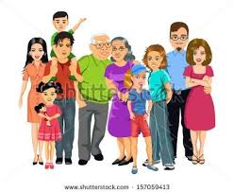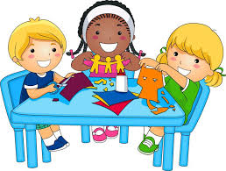

**Communication and Language**

Talking about our families, friends and objects that our special to us.

Practising our listening skills as we complete Phase One Phonics activities.

Following instructions as we complete an obstacle course involving positional language.

Listening to an increasing range of books, including nonfiction books.

**Expressive Art and Design**

Exploring colour mixing linked to the story of Elmer.

Engaging in real life role play- the supermarket, home corner, and doctor’s surgery.

Exploring texture as we use the sense of touch to explore different materials such as wet and dry sand, corn flour and water, smooth and rough objects.

**Physical Development**

Experimenting with different ways of moving during our play and in PE lessons.

Developing spatial awareness when working in the hall.

Learning about how to keep our bodies healthy- including taking about hygiene and healthy and unhealthy foods.

Developing our pencil control skills as we practise writing our names.

Using one handed tools and equipment such as scissors, tweezers and hole punches as we create pictures using different tools.

**Understanding the World**

Talking about the things that we are good at and things that make us unique.

Drawing self-portraits and discussing the similarities and differences between our peers and ourselves.

Learning about different types of families and discussing our own.

Using our five senses to explore the world around us.

Discussing the changes we notice to the environment during autumn.

**Mathematics**

Exploring conkers & leaves – sorting, counting, shapes, size, colours, matching, weighing conkers with balance scales

Completing a height chart and measuring the length and width of our foot and handprints using cubes.

Learning to count objects 1-1 when they are in a line.

Exploring sharing objects into groups fairly