Garden City Academy
Positive Behaviour Policy

Audience: | Parents  School staff  Local Governing Bodies
Approved: | Local Governing Body | December 2020
 | Headteacher | October 2020
Other Related Policies: | Anti–Bullying Policy  Safeguarding Children/Child Protection Policy  Staff Code of Conduct Policy  Equality Policy  Restrictive Physical Intervention Policy  Whistleblowing Policy
Policy Owner: | Rachael Stevenson  Anna Butler
Review: | Annually
Version number: | 1

Introduction
All young people, staff and other members of our school community have the right to feel safe at all times whilst in school. Good teaching and learning promote good behaviour and good behaviour promotes good learning. All children have the right to learn and to achieve their potential and all staff have the right to teach.

At Garden City Academy we have the responsibility to operate an effective policy that encompasses preventative strategies for tackling inappropriate or harmful behaviour. All staff need to have an understanding of what challenging behaviours might be communicating; behaviour is a form of communication.

Principles
All staff at Garden City Academy are committed to adopting a therapeutic approach to behaviour, which is underpinned by Hertfordshire STEPS, owned by Herts County Council (Integrated Services for Learning.) It is our intention to promote behaviour that enables all children to achieve their potential and develop academically, socially and emotionally, thereby approaching the child’s development with a holistic mind-set. We have high expectations of all our children, both in relation to their education, as well as their behaviour. Staff will support this through positive learning experiences, promoting self-esteem through recognition of potential and effort, development of positive relationships with the children and use of positive behaviour management strategies to promote pro-social behaviours. Our strong Trust ethos and values system underpins everything we do at Garden City Academy and we encourage all children and adults to be kind to themselves and others, caring, supportive and demonstrate our values at all times. We provide our children with a safe, enabling environment where they feel valued, supported and heard. Children at Garden City Academy ‘Believe and Achieve’.

Aims
- to ensure there is a culture within Garden City Academy that values all pupils; allowing them to feel a sense of belonging where children are able to seek emotional and wellbeing support
- to ensure that every pupil at Garden City Academy is given opportunity to develop socially, to learn and to develop from life experiences and exceptional opportunities
- to help our children make pro-social behaviour choices, subsequently learning responsibility and to be accountable for their actions;
- to encourage consideration for others by promoting our Trust vales of Learning, Enjoyment, Responsibility, Inspiration, Inclusion, Integrity and Leadership
- to develop self-belief in their own ability and pride in the school through effort as well as achievement
- to ensure that pro-social behaviours are taught, encouraged and positively acknowledged
- to use protective and educational consequences to support an understanding of prosocial choices and the consequence of anti-social actions. These will be evaluated so that further support can be given to the child where identified
- to enhance our positive working relationship with parents where both parties collaborate to support the needs of the children
- to create a calm and safe learning environment where children feel empowered to believe in themselves and strive to be the best they can be. Children ‘Believe and Achieve’.

Objectives
- Staff will provide equal access to learning, through the adaption of the curriculum to meet the needs of each child.
- Children are given the opportunity to recognise and develop pro-social behaviours through teaching, peer-interactions and teacher/child relationships and understand the impact of their behaviour upon others.
- Our holistic approach to teaching and learning is underpinned through our school values allowing children the opportunity to internalise pro-social behaviour choices, working with the children’s own experiences and feelings in order to promote positive self-worth and an internalised discipline, resulting in long-term change.
- All stakeholders to agree and follow a positive Home/School Learning Agreement.
- Pro-social interactions between children, staff and parents ensure a positive working relationship between all those working around the child.
- A therapeutic approach to behaviour management encompassing protective and educational consequences using the 3Rs (Reflect, Repair and Restore) is embedded.
- Where necessary, protective and educational consequences to be delivered and evaluated so that further support can be given to the child where identified.
- All staff understand and recognise that positive emotional well-being leads to positive emotional engagement and attainment.
- If required, de-escalation strategies are used by all staff following the STEPS script and supportive physical intervention is utilised in accordance with STEPS guidelines if a child puts themselves or others at significant risk.
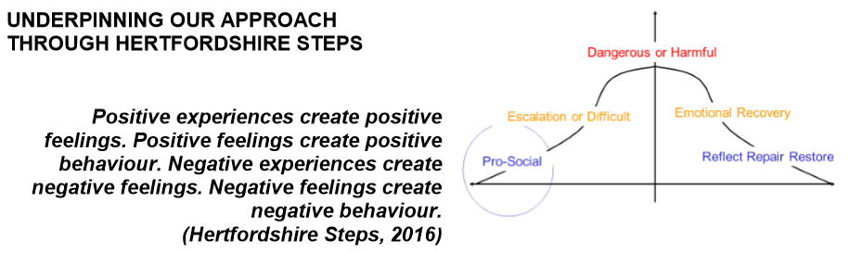
We plan for three phases of behaviour progression: Pro-social, Escalation or Difficult and Dangerous or Harmful (see diagram above.) When pupils are engaged and learning, we need to ‘catch them getting it right.’ This can be by recognising and rewarding their efforts through praise, certificates, or anything that has meaning for the individual pupil. Pupils should also be made aware that their pro-social behaviour can be rewarding in itself and brings about positive experiences and feelings in others.

External discipline may suppress anti-social behaviour but long term behavioural change comes from developing internal discipline. We believe that children ‘learn behaviour’ and make positive behaviour choices through:
- Positive relationships with adults and peers
- Role models, patterning and copying
- Positive phrasing and reminding
- Scripts, routines, repetition and structure
- Consistent, clear and agreed boundaries
- Praise, reward and positive reinforcement
- Comfort and forgiveness

THERAPEUTIC CONTINUUM
This illustration shows a continuum of interventions for behaviour.

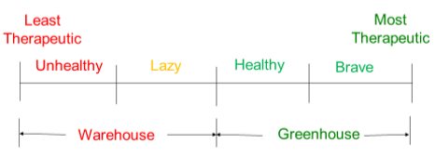

The most therapeutic structure is one that works to internalise pro-social behaviour by focusing on the experiences and feelings of everybody within the dynamic. As a result, the pro-social behaviour of the individual is based within his or her own values, motivations and feelings.

If behaviour is controlled, the individual becomes dependent on the staff or system that controls them; this approach can be described as WAREHOUSING (storing the student). If the individual controls the behaviour, they grow towards the independence they will need in later life e.g. secondary school or further education. This approach can be described as GREENHOUSING (growing the student).

What is Pro-Social behaviour?
Pro-social behaviours are any actions that benefit others around them or society as a whole.

For example:
- establishing and maintaining positive relationships and interaction with peers and adults (tone of voice; body language)
- acknowledging own feelings, communicating this to elicit positive support (‘I am feeling anxious; I need space’ or ‘I’m feeling cross’)
- identifying, understanding and accepting mistakes as learning opportunities, and using a Growth Mindset to persevere and challenge themselves to complete the task
- identifying, reflecting and repairing anti-social behaviour choices
- respecting the right of themselves and others to learn and their responsibility to ensure their behaviour choices don’t negatively impact upon this.

Pro-social behaviour acts as a strong motivator in education as it provides students with a purpose beyond themselves and the classroom. This allows the individual to become part of something bigger than themselves. When pro-social behaviours are not demonstrated and reinforced, children can struggle to make connections with others, which can subsequently lead to a disconnection, which can negatively influence a child’s learning, motivation, and attitude towards themselves, others and their education. When teachers make space for prosocial behaviour in education and social learning, then they can illustrate that what children are learning will have a direct impact on the world that they live in. Pro-social behaviours in a classroom are intimately connected with a purpose towards a greater cause, deepening the learning itself.

Teaching and Promoting Pro-Social behaviours
Our emphasis is on teaching and promoting pro-social behaviour. It is important to show appreciation of the children who always display pro-social behaviours. The whole school community aims to promote pro-social behaviour through praise and unexpected reward. At Garden City Academy, praise is given to the action or effort and recognises pro-social behaviours and avoids phrases such as, ‘good boy/girl’ as this does not fully expand on what it is that is ‘good’.

Anti-Social Behaviour
Anti-social behaviour is any behaviour that has a negative impact on the child, their peers, school staff, the school environment, our families and society as a whole.

Sexual language and behaviour is included as anti-social and will not be tolerated. It will be dealt with in line with our behaviour and safeguarding policies.

Relationships
We recognise the importance of creating positive relationships and knowing our pupils as individuals. Staff are encouraged to build caring and empathetic relationships to create sustained pro-social feelings within our children. This is achieved through daily, positive interactions with all members of the Garden City community as well as specific activities such as circle time, assemblies, PSHE, reflection time, etc.

Role Modeling
Staff will set examples of behaviour and conduct themselves in order to encourage our pupils to do the same. All children have the right to be treated with respect and dignity and it is the responsibility of the school staff to model these expectations. All staff will use a calm and measured tone of voice and positive phrasing when interacting with pupils and each other. Raised voices will only be used when necessary i.e. to prevent a danger or harm.

Positive Phrasing
At Garden City Academy, we disempower challenging behaviour by offering positive phrasing, limited choices, and appropriate consequences but with limited language. Positive phrases are clear, uncomplicated, unambiguous instructions delivered with clarity.

It is often beneficial to support a positive phrase with a ‘please’ or ‘thank you’. Using ‘please’ will suggest an element of choice so should be reserved for low-level behaviours. Using ‘thank you’ suggests you expect the child to comply:
- Stand next to me
- Put the pen on the table
- Walk in the corridor
- Switch the computer screen off
- Walk with me to the library
- Stay seated in your chair

Neither please nor thank you would be used in a high level, dangerous situations. The positive phrase would be delivered assertively but without aggression. An example would be, ‘Put the chair down on the floor.’

Limited Choices
Limited choices often follow directly from positive phrases; e.g. ‘Peter we are going inside. Do you want to walk on your own or with me? On your own or with me, Peter?’ Other examples include:
- Where shall we talk, here or in the library?
- Put the pen on the table or in the box.
- I am making a drink, orange or lemon?
- Are you going to sit on your own or with the group?
- Are you starting your work with the words or a picture?

Scripts and Routines
At Garden City Academy, we use agreed words and actions that are likely to be most effective in achieving the desired outcome for an individual. The de-escalation script is designed to ‘remove heat’ from a situation and create space and time. In order to disempower the behaviour we use the de-escalation script (Appendix 1):
- Child’s name …
- I can see something has happened
- I am here to help
- Talk and I will listen
- Come with me and…………

A copy of the script is in every member of staffs lanyard as well as being displayed in every classroom and office.

Zones of Regulation
At Garden City, we teach, ‘The Zones of Regulation’ which is geared toward helping pupils gain skills in consciously regulating their actions, which in turn leads to increased control, problem solving abilities and pro-social behaviours. This helps children to recognise when they are in different states called “zones,” with each of four zones represented by a different colour. Through teaching, children learn how to use strategies or tools to stay in a zone or move from one to another. Pupils explore calming techniques, cognitive strategies, and sensory supports so they will have a toolbox of methods to use to move between zones.

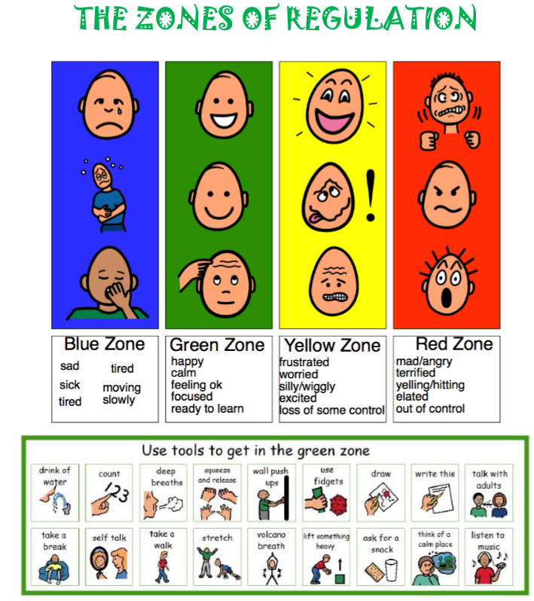

Consistency
Consistency is integral to our therapeutic approach to behaviour. All staff are expected to follow the behaviour policy. Pupils benefit from a consistent approach as it means, regardless of the behaviours, they will get the same calm and predictable reaction from any member of staff. This helps to create a calm, safe and secure environment.

At Garden City Academy, we achieve consistency through:
- Shared beliefs
- Shared values
- Shared aims
- Shared actions
- Shared responses
- Shared policy and practice

Planning
We make sure that responses to likely negative behaviours are planned for in advance to ensure that staff know what to do and are not taken by surprise. We use the following planning tools to inform and plan appropriate responses:

- Anxiety Mapping (Appendix 2)
- Roots and Fruits (Appendix 3)
- Conscious/sub conscious Checklist (Appendix 4)
- Risk Assessment Calculator (Appendix 5)
- Risk Reduction Management Plans (Appendix 6)
- Individual Risk Reduction Plan (Appendix 7)
- ABC (Antecedent, Behaviour and Consequence) (Appendix 8)

All of the above documents can be found in the Appendices with accompanying guidance.

The important principle is that we ANALYSE children’s behaviour and not MORALISE about it. We ask ourselves the question, ‘What is the behaviour telling us?’ Finding out why a child acts in a particular way is the key to supporting them in learning how to change it by using consequences that are designed to create understanding in the child.

Rewards and Positive Reinforcement
Our emphasis is on promoting pro-social behaviour. Garden City Academy whole school community aims to promote pro-social behaviour through praise and unexpected reward.

We aim to promote pro-social behaviour through recognition including:
- giving verbal praise and positive feedback
- communication with parents/carers to highlight pro-social behaviours
- role modelling to peers throughout the school
- allocation of responsibilities and roles
- acknowledgement of demonstrating school values
- celebration and sharing of learning in whole school assembly
- incidental rewards and praise including the use of motivators, stickers, notes home and certificates

Motivators
At Garden City Academy motivators are used to reward children. The two most motivated class each week are announced in assembly on a Thursday and are allowed to wear non-uniform on the Friday. Motivators should be limited to one or two. Three can be given for exemplary work.

Celebration Assembly
From each class a child is nominated by their Class Teacher, each week to celebrate prosocial behaviours, learning behaviours and personal achievements. During the whole school assembly, the nominated children are invited out to the front (this is not an expectation if a child does not feel comfortable) so that achievements can be celebrated. Each child is given a certificate to celebrate their achievements.

Feedback and Recognition
It is essential that all staff give children feedback about their behaviour and recognition is given to the pro-social behaviours they display.

For example, ‘Thank you for holding open the door’; ‘You have shown lovely manners, thank you’; ‘I liked the way you segmented that word and blended phonics to read it.’

Reflect, Repair and Restore
Staff and pupils will have the opportunity to revisit situations and where necessary and appropriate to help ‘repair’ any of the damage done resulting from any episode of challenging behaviour taking into account the age, understanding, and competence of the individual pupil. Any protective or educational consequence should have social validity and have natural consequentiality so that the pupil can be helped to understand the link between behaviour and its consequences.

Once the child is calm, relaxed and able to be reflective, the experience can be re-visited with an adult by re-telling and exploring the incident with a changed set of feelings. The adult will ask the child questions to determine (Appendix 9):
- What happened? (tell the story)
- What were people thinking and feeling at the time?
- Who has been affected and how?
- How we can repair relationships?
- What we have learnt so we are able to respond differently next time?

This is an important phase to enable forgiveness of the behaviour and to help the child to understand the link between the behaviour and its consequences. Also, to help the child to understand how to respond to stressful situations differently in the future. Restorative activities such as: supported thinking, social stories, role play, discussions around emotions or using a ‘Roots and Fruits’ tree will complete the therapeutic process. This knowledge is intended to help adults and the child to consider the underlying causes of negative behaviour choices, which need to be understood rather than suppressed.

Comfort and Forgiveness
Once the Reflect, Repair and Restore process is complete, it is important that the child is forgiven and s/he is given another opportunity to ‘get it right.’

Unstructured Playtime Procedures
Playtime can be a difficult time for some children and we aim to make it as positive and stimulating as possible, whilst encouraging children to play independently in order to build and develop skills of collaboration and negotiation. Children will be reminded regularly of expectations of pro-social behaviour whilst on the playground and when they are in the care of staff.

Adults on duty actively promote prosocial behaviours, encouraging pupils to interact positively with each other. Following an incident, staff may put in place a protective consequence by the removal of a freedom. This must be linked to the anti-social behaviour. This may be, for example, that the child cannot play with a particular peer or with a ball for a given length of time or on a particular playground. For behaviour on the playground the staff ‘on duty’ will decide upon an appropriate protective consequence. For physically aggressive behaviour or extreme verbal aggression the behaviour teaching assistant or senior staff will decide on protective and educational consequences. Incidents of physical and verbal aggression will be recorded on CPOMs. If deemed appropriate, parents will also be informed, especially if a child has been physical or hurt as a result of physical aggression. The SLT must be informed of bullying, racist, homophobic or violent behaviour via CPOMs. Bullying will be recorded in accordance to the procedures set out in the Anti-bullying Policy.

To support the children to be ‘ready to learn’ before going into classroom after an unstructured break, all staff come out promptly to the playground to collect classes. After break and lunchtime the whistle will be blown. All pupils will stand still quietly until asked to line up. Children should then walk quietly and calmly to the place their class lines up. The expectation is that a class is lined up quietly and calmly, facing the class teacher. Once children have met these expectations, they will come into the school building in the same quiet and calm fashion. Teaching and support staff will also help and support pupils with that transition in the cloakroom until they have reached their classrooms so they arrive ready to learn.

Educational Consequences
These are consequences put in place by staff to teach the child to rehearse and learn about their actions to aid internalisation of pro-social actions to avoid repetition. It is important that any educational consequence that is taken matches the context and anti-social behaviour shown.

These may include:
- third person role play to understand peer/adult feelings
- home/ school communication
- social stories
- behaviour related research to understand how and why actions have impacted others.
- restorative meetings with child and parent/carer (if appropriate)
- completing or redoing tasks to the expected standard for the child
- modelling pro-social behaviours to younger peers

Protective Consequences
These are actions taken by staff to ensure all children and adults feel safe in the school environment.

These may include one or more of the following:
- an increased staff ratio
- limited access to outside space
- specific staff support given at break and lunchtimes
- differentiated teaching space or learning
- work requiring completion to be sent home, and supported by parents/carers
- adaptation of access to school trip, residential or extra-curricular activity
- calm room/space
- exclusion from an area or school

It is important that any protective consequence matches the context and anti-social behaviour shown. For example, if a child hurts other children whilst playing football, s/he would not be given permission to play football until they show desired pro-social behaviour during a monitored and phased return to the activity.

Protective consequences are further supported through the 3Rs (Reflect, Repair and Restore) which provide an opportunity for the children to learn from the experience. This time may also be used to further understand the triggers behind anti-social behaviour choices using various behaviour analysis tools (Roots and Fruits; Anxiety Mapping, Conscious & Sub-conscious Checklist etc. Refer to Appendices for resources)

Differentiated Response
We recognise that there are times when a differentiated response is needed. If children find it hard to adhere to the pro-social behaviour model, we have a flexible approach depending on individual circumstances. We recognise that difficult or dangerous behaviour patterns may arise because of poor self-image, possibly because the child is not succeeding socially or academically. To predict and prevent escalation of difficult or dangerous behaviour, we use a range of behaviour strategies to help support the individual child to adhere to the pro-social behaviour model.

Strategies may include:
- Regular meetings between teacher and parents/carers
- Home – School diary
- Meetings with a member of the SLT
- Roots and Fruits exercise • Anxiety Mapping
- Sub-conscious and conscious behaviour checklist
- ABC Form and CPOMs to log behaviour and analyse patterns
- Risk Management Assessment Calculator
- Risk Reduction Management Plan
- Involvement of external agencies
- Pastoral Support Programme for children at risk of exclusion and on a part-time timetable

It may be necessary to seek guidance from specialist educational agencies to formalise strategies that differ from policy. These may include a RRP (Risk Reduction Plan) or a reduced timetable.

External agencies might include:
- North Herts Primary Support Service (behaviour support)
- Educational Psychologist
- School nurse
- Child and Adult Mental Health Team (CAMHS) (STEP2)
- NESSIe
- Art Therapy

All school staff have received ‘Step On’ behaviour training from members of the SLT who are trained by advisors from Hertfordshire STEPS, owned by Herts County Council (Integrated Services for Learning.). This enables all staff to follow strategies to recognise, divert or deescalate incidents and support children who may find themselves in a crisis situation.

Children with Educational Needs
We expect all children to be aware of and respect the Garden City Academy Values. As much as possible, we expect children with special educational needs to follow the school behaviour policy. However, this will be more difficult for some children at certain times. In order to support children with behaviour difficulties on the SEN Register to meet these expectations, additional measures may include:
- Regular meetings between teacher and parents/carers
- Home – school contact book
- Setting specific targets to reduce incidents of anti-social behaviour
- Meetings with the Inclusion Lead to discuss progress
- Roots and Fruits exercise
- Anxiety Mapping
- ABC Form/CPOMs to log behaviour and analyse patterns
- Sub-conscious and conscious behaviour checklist
- Risk Management Assessment Calculator
- Risk Reduction Management Plan
- Involvement of external agencies
- Pastoral Support Programme for children at risk of exclusion

Some pupils may not comprehend the rules and structures of the school and be unable to meet expectations even with additional support. In these cases, individual adaptations maybe made in consultation with the child, the class teacher, SENCo and parents/carers.

For some children it may be that the school will request an appropriate outside agency to support a child and offer the school advice. It is important to note that we have a duty of care to all pupils; therefore, if despite support, behaviours impact adversely on the safety and well-being of other pupils or adults, the Head Teacher and Governors reserve the right to exclude pupils who put others at risk.

Recording and Reporting Anti-Social Behaviours
A Pastoral Support Plan (PSP) is a school-based programme, which is meant to help a child to improve their social, emotional and pro-social skills. The PSP will identify precise and specific targets for the child to work towards and should include the child and parents in the process.

When a PSP is thought to be required a PSP meeting should be held, led by behaviour teaching assistant or lead. The teachers and the child's parents will consider whether the child should be present for the whole meeting or only part of it. At the end of the meeting everyone should be clear about what needs to be done, by whom and by when.

PSPs are usually reviewed every 2-4 weeks and usually run for about 16 weeks. If the child has other existing plans then the PSP should be integrated with these and not used in isolation.

A PSP may be necessary if a child’s behaviour at school means that they are “at risk” of permanent exclusion. “At risk” means that the child is not responding to the school’s normal range of strategies and support and several short term exclusions may be indicative of this. A PSP will be needed in particular for those children whose behaviour is deteriorating rapidly.

Behaviour Incidents
Children should report any incidents of hurtful and anti-social behaviour to the most readily available adult who might be. Some children may need support to do this or be taught what to do:
- the adult on duty
- their class teacher
- a member of the support staff or office staff
- a member of the Senior Leadership Team
- an older child who they trust who will support them to immediately tell an adult

Information about the incident should be shared with the class teacher who will establish the seriousness of the incident. At this point, the incident could be dealt with using an educational or protective consequence but if, in their judgment, they need further information an initial investigation will be conducted. Parents/carers will be informed of all significant incidents that involve harm/hurtful behaviour and they will be provided with sufficient information to enable them to support their child appropriately while investigations are ongoing. All incidents and investigations should be recorded on CPOMs.

Communicating Anti-social Behaviours
The SLT and Class Teachers will decide when parents are informed about incidents. Parents will need to be informed if:
- A child is consistently displaying the same anti-social behaviours
- A child has been physically marked or significantly hurt another
- A child has used inappropriate language e.g. swearing, violence, hurtful comments
- A child has damaged school property
- There are any allegations of racism, homophobia, bullying etc

Staff have received ‘Step On’ behaviour training from a Hertfordshire County Council recognised provider. This enables all staff to follow strategies to recognise, divert or deescalate incidents and support children who may find themselves in a crisis situation.

Staff Statement
After a serious incident, staff will be asked to document what happened in a staff statement. Statements should be factual and should not give an opinion. Staff should describe only what they said and heard. All statements must be handwritten dated and signed (Appendix 12 Staff Statement of Serious Incident).

Exclusions
The Headteacher may decide to exclude a pupil for a fixed term or permanently in line with this policy and DfE guidance, taking into account all the circumstances, the evidence available and the need to balance the interests of the pupil against those of the whole school community.

Physical Intervention and Positive Touch
All school staff have received ‘Step On’ behaviour training from members of the SLT. They have been trained by advisors from Hertfordshire STEPS, owned by Herts County Council (Integrated Services for Learning.). This enables all staff to follow strategies to recognise, divert or de-escalate incidents and support children who may find themselves in a crisis situation or if they put themselves or others at the risk of harm.

‘Positive touch’ means that staff members are able to physically guide, touch or prompt children in appropriate ways at the appropriate times. It is extremely important that staff understand and appreciate the reasons why we may choose to hold/touch children and the appropriate ways in which we do so. All staff have been trained using the Hertfordshire ‘Step On’ training (see Appendix 10.)

Why Do We Use Touch? We may choose to touch children for a variety of reasons, but in general, we would normally do so to either comfort or to congratulate. We may also need to physically touch, guide or prompt students if they require personal care, assistance with writing, eating, dressing etc.

How Do We Use Touch?

Hugging
At this school, we encourage staff who are using touch for comfort or reward to use a ‘school hug’. This is a sideways on hug, with the adult putting their hands on the child’s shoulders. This discourages ‘front on’ hugging, and the adult’s hands on the shoulders limits the ability of the child to turn themselves towards the adult. This can be done either standing or sitting.

Hand holding
We recognise that children sometimes enjoy being able to hold hands with adults around them. This is perfectly acceptable when the hand holding is compliant. However, if the handholding is being used by an adult as a method of control to move children, this can become a restraint. Therefore, we encourage the use of the ‘school hand-hold’. This is done by the adult holding their arm out, and the child is encouraged to wrap their hand around the adult’s lower arm. The adult’s other hand can then be placed over the child’s for extra security if it is required. In summary, it is generally deemed appropriate to touch others on the upper arm, which would appear to be regarded as a neutral zone in most cultures.

Lap-sitting
At our school, we actively discourage sitting on laps. Children should be taught to accept comfort/ attention through other means, e.g. the school hand hold or hug. If a child attempts to sit on a staff member’s lap, they must explain to them that this is not what is done at school. The staff member can ask the child to sit next to them if it is appropriate. At times, children maybe in such crisis or distress that they hold staff members in a way which is not described as above (e.g. ‘front on’ hug/lap-sitting). If this should happen, staff members should inform a senior member of staff. Staff may be asked to make a note of this. This will be in order to record and monitor the amount of times the student is doing this to staff to see whether this is a ‘controlling’ behaviour, or whether the child is displaying distressed behaviour regularly.

Please note that, although we believe that positive touch can be a positive experience for the children that we care for, this does not mean that you have to touch children, and it should also be realised that some children will not want to be touched. Please respect this.

Pastoral Care for School Staff
The Governors would expect the Headteacher to draw on and follow the advice in the ‘Dealing with Allegations of Abuse against Teachers and Other Staff’ guidance when setting out the pastoral support that school staff can expect to receive if they are accused of misusing their powers. In addition, the Bullying and Harassment Policy and Safeguarding Children/Child Protection Policy sets out the disciplinary action that will be taken against children who are found to have made malicious accusations against school staff.

Inclusivity and Equality
As an inclusive school, we believe in equality and in valuing the individual. We believe all members of the school community (children, parent/carers, Teachers, Teaching Assistants, non-teaching Support Staff and Governors) should be free from discrimination, harassment and bullying. These will not be tolerated in any form. Measures to counteract bullying and discrimination will be consistently applied and monitored for their effectiveness. All members of the school community have a right to be listened to and responded to.

The school’s legal duties in order to comply with the Equality Act 2010 and which are described in the School’s Single Equality Scheme will be further reinforced through the Behaviour and Anti-Bullying policies and seek to safeguard vulnerable pupils. We recognise some pupils may need additional support to meet behaviour expectations. Children will be supported to positively develop their social, emotional and behaviour skills.

The school will identify those children who may require extra support due to circumstances out of their own, or the school’s direct control. Where appropriate, the school staff should work positively with outside agencies.

Restrictive Physical Intervention
Restrictive interventions are only used in an unforeseen emergency where there is potential risk/damage to others, self or property. For pupils with known needs, a Risk Reduction Management Plan is written. Staff should also refer to the ‘Restricted Physical Intervention Policy’.

Staff have a duty of care towards all students in their care. Therefore, if a student is likely to be at risk from harm if a staff member does not physically intervene in an emergency, they must take action. The action they take will be dependent on the dynamic risk assessment that they take at that moment in time.

Members of staff take steps in advance to avoid the need for restrictive physical intervention. The use of restrictive physical interventions is only appropriate in the following circumstances:
- to prevent a child from injuring self or others
- to prevent or stop a child from causing serious damage to property
- to prevent a child from committing a criminal offence.

All staff at Garden City Academy are given advice on de-escalation and behaviour management techniques. There is a statutory duty to record and report all significant incidents including all use of force.

Anti-Social Behaviour Outside of School
Teachers have the power to challenge pupils for misbehaving outside of the school premises “to such an extent as is reasonable” as prescribed by Department for Education Guidance. This means that under the behaviour policy teachers may discipline pupils for misbehaviour when the pupil is:
- being educated off site
- taking part in any school-organised or school-related activity
- travelling to or from school
- wearing school uniform or
- in some other way identifiable as a pupil at the school.

Or misbehaviour at any time, whether or not the conditions above apply, that:
- could have repercussions for the orderly running of the school
- poses a threat to themselves, another pupil, member of staff or member of the public or could adversely affect the reputation of the school.

Home/School Agreement (See Appendix 11)
The Home/School Agreement will be an important part of communicating our approach to positive behaviour, so that parents/carers can be encouraged support their child. The responsibilities of children, parents/carers and all school staff, with respect to their and their children’s behaviour, outlines in the Home School Agreement. This Agreement should be signed by the children, parents/carers and teachers when a pupil joins the school. This is an undertaking by every member of the School Community to adhere to the principles of prosocial behaviour.

Monitoring and review
This policy will be reviewed annually by the Behaviour Lead and the Governing Body, and will be publicised to parents and carers via the schools’ website. All staff will be made aware of the policy at least annually and will be expected to be familiar with all related practices and procedures in relation to maintaining positive behaviours for learning and in the use of physical interventions as a last resort. Staff will be asked to sign that they have read the policy and whether they need further training.

Appendices
De-escalation Script (Appendix 1)

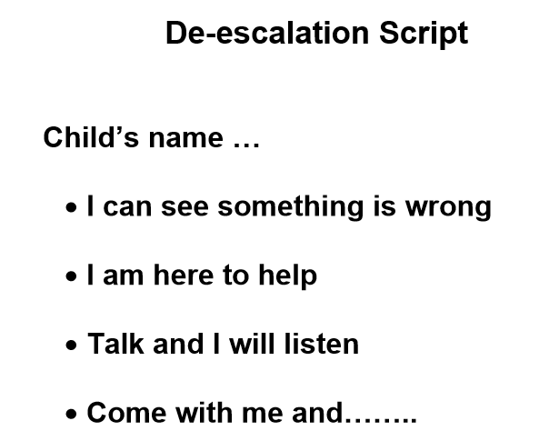
Anxiety Mapping (Appendix 2)

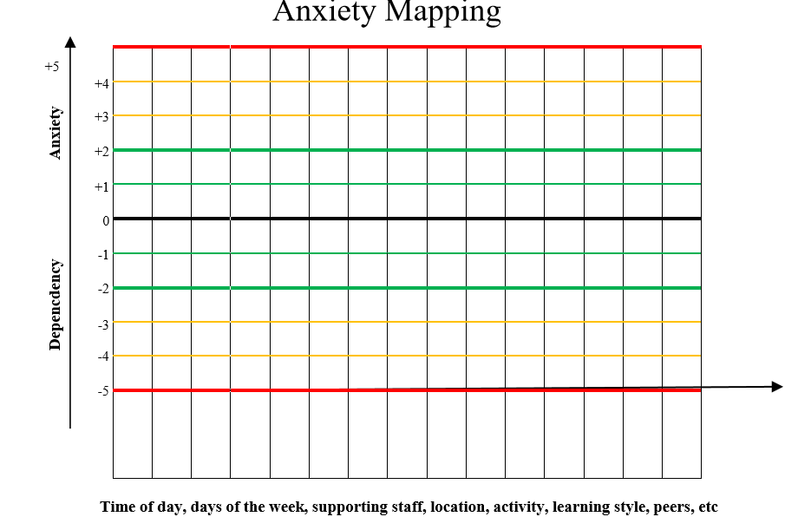

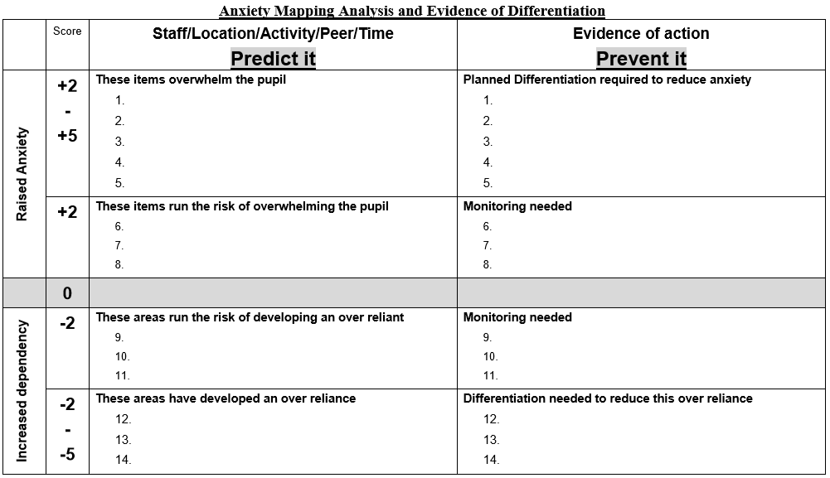

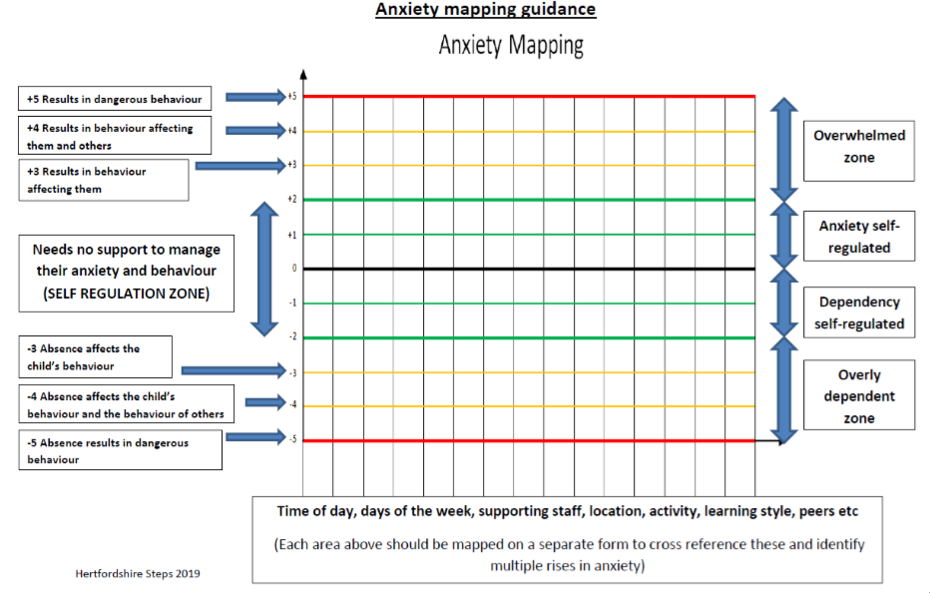
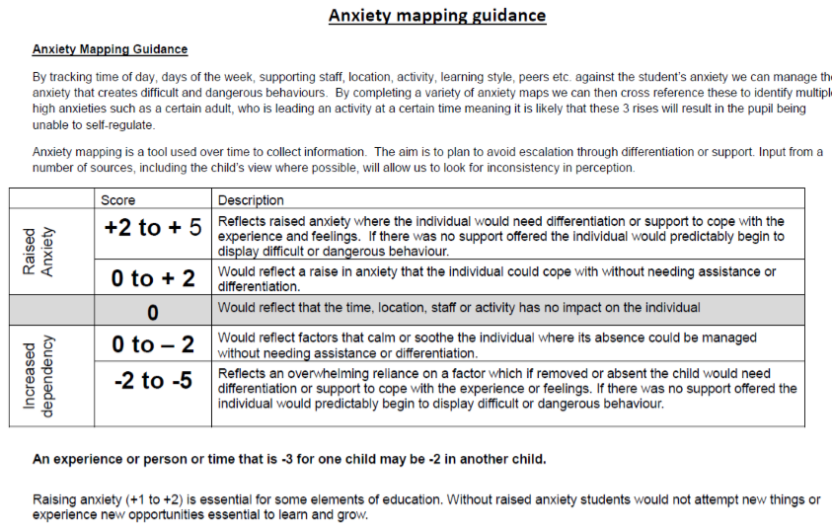

Roots and Fruits (Appendix 3)
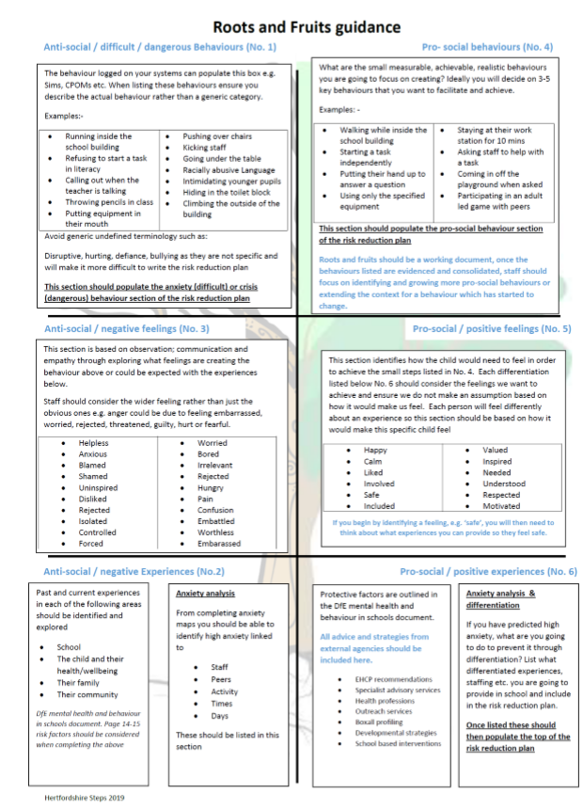
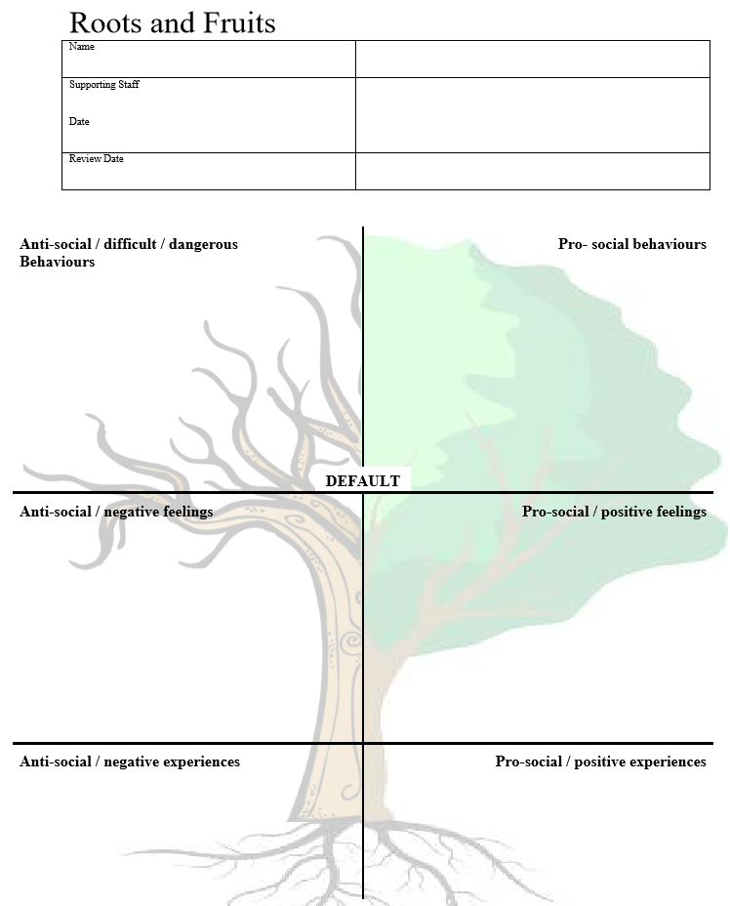

Conscious/sub conscious Checklist (Appendix 4)
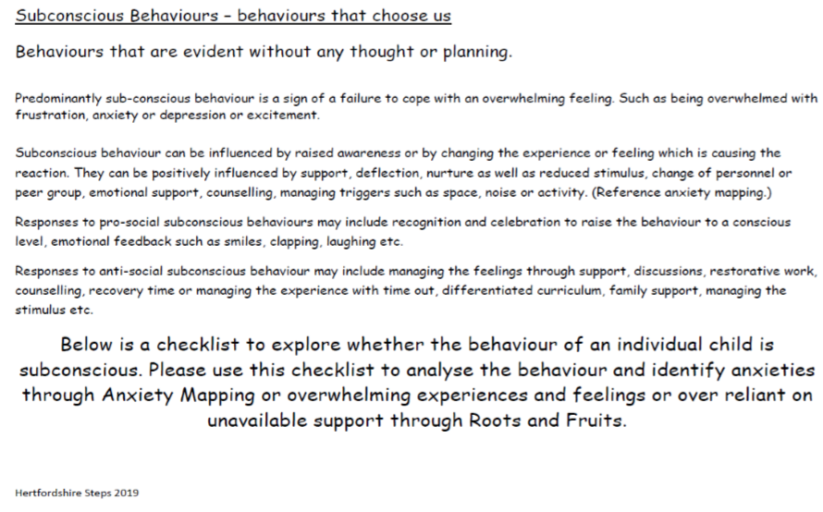
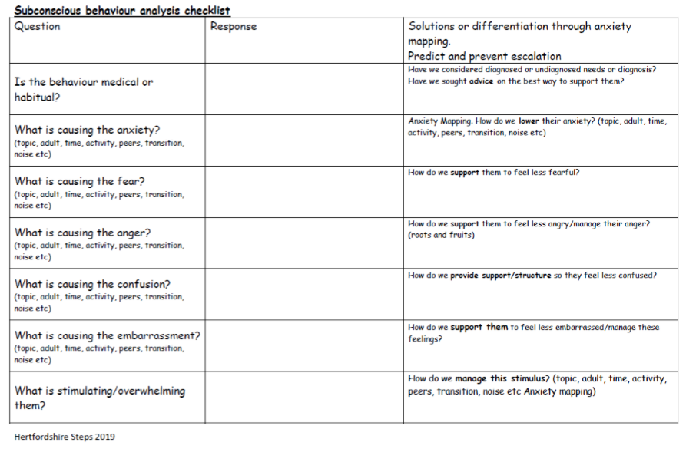
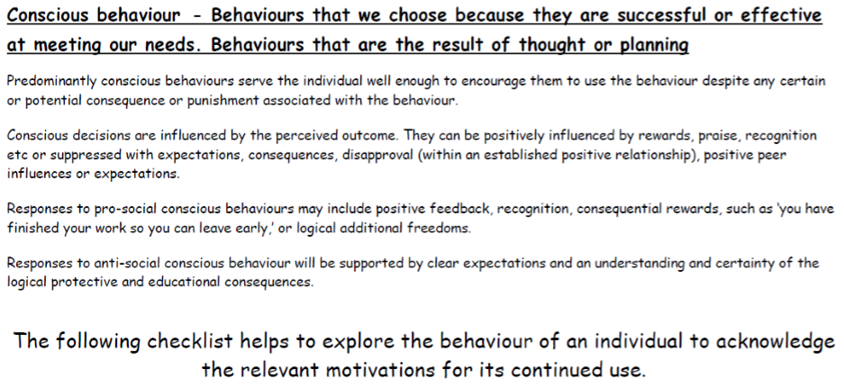
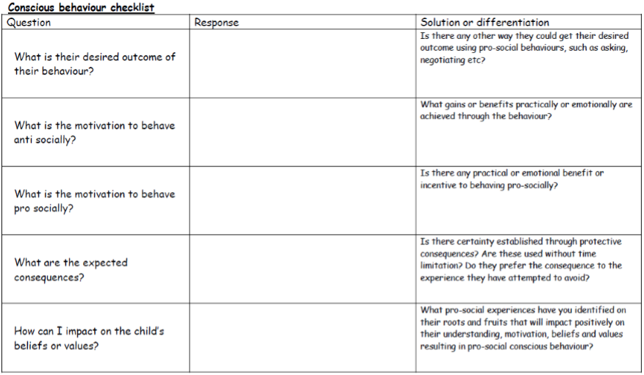
Risk Assessment Calculator (Appendix 5)
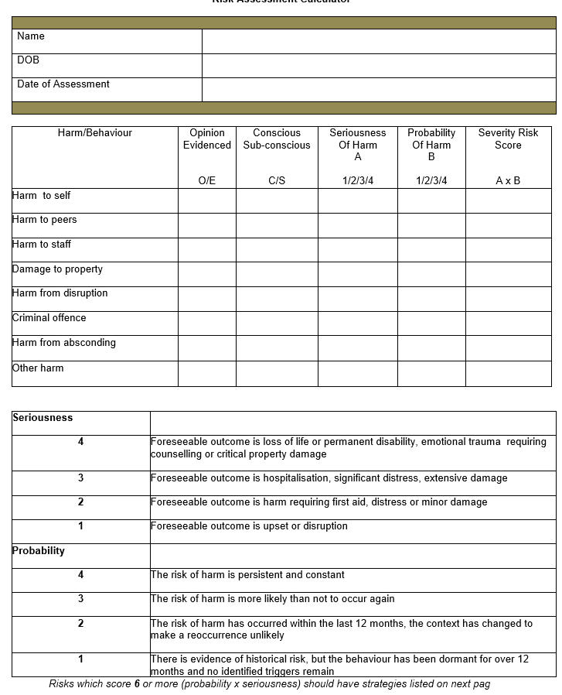

Risk Reduction Management Plans (Appendix 6)
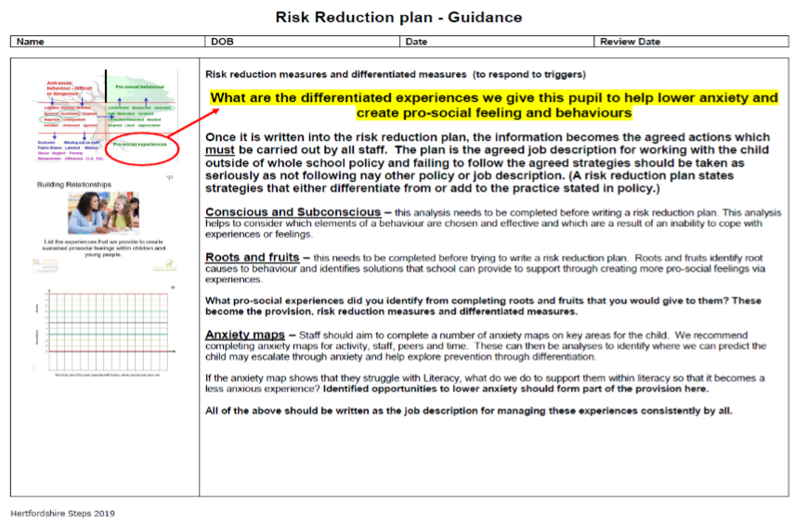
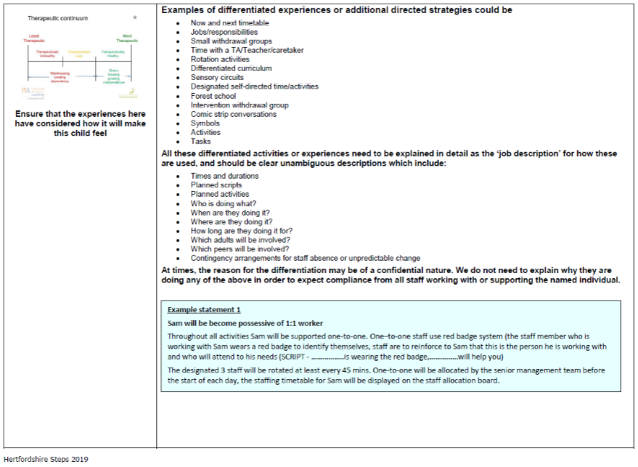

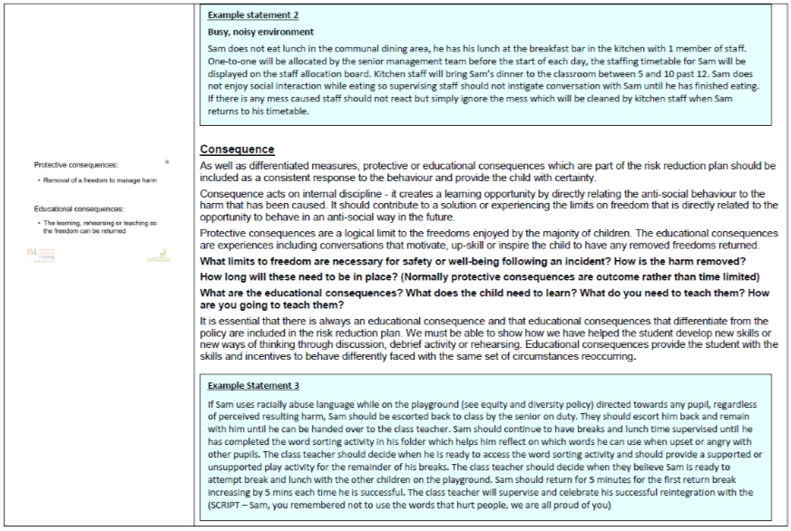
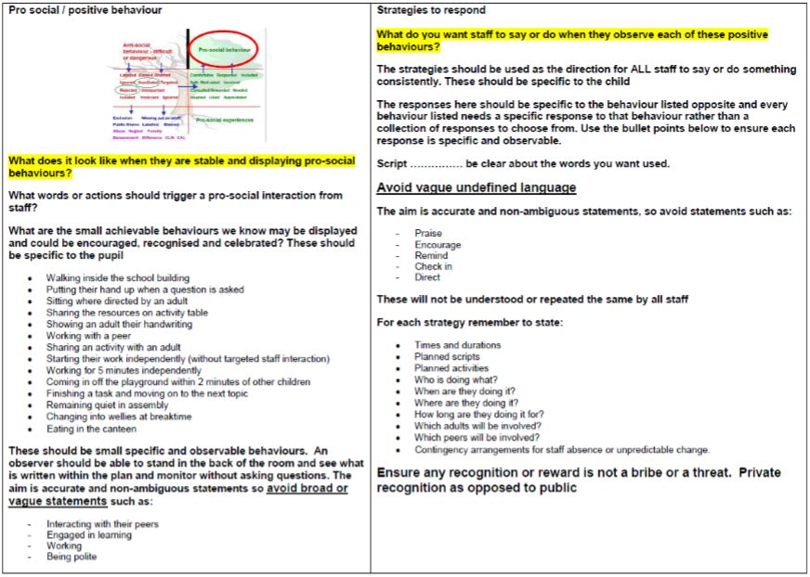
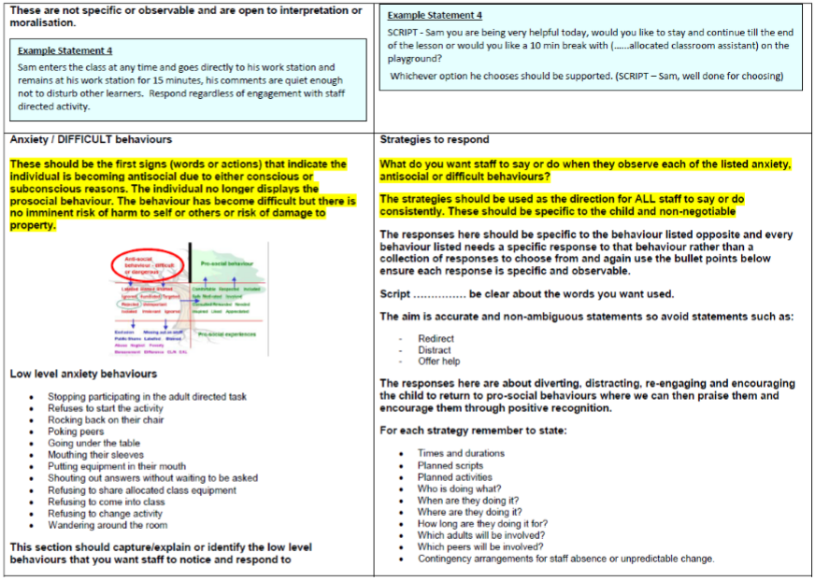

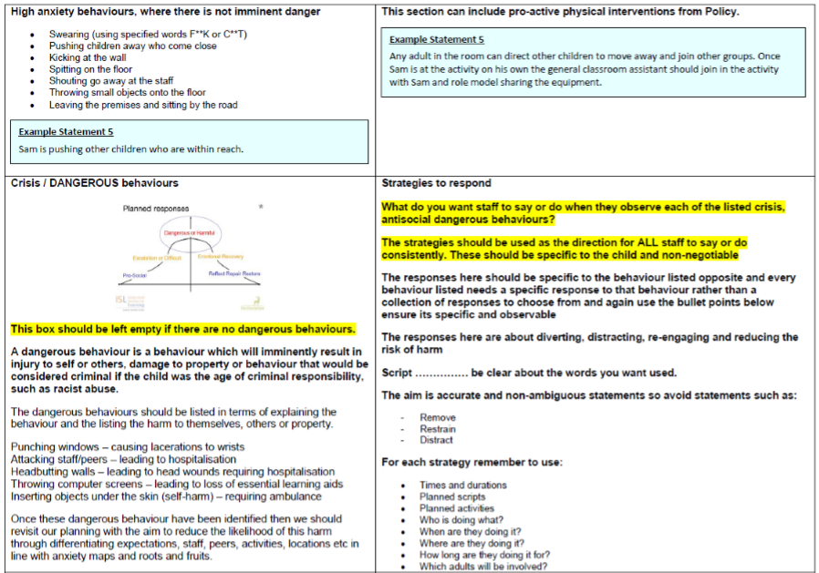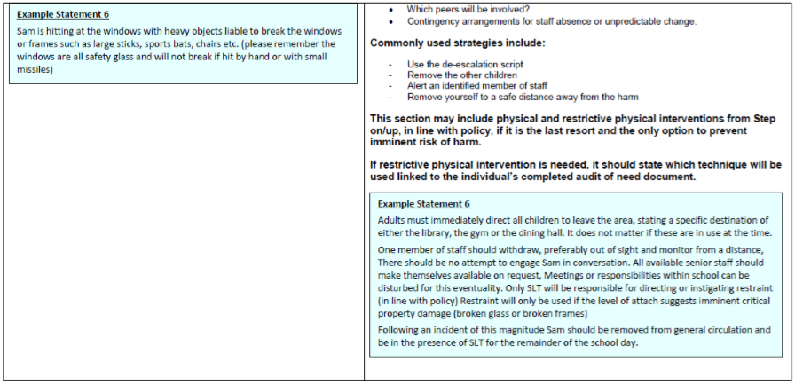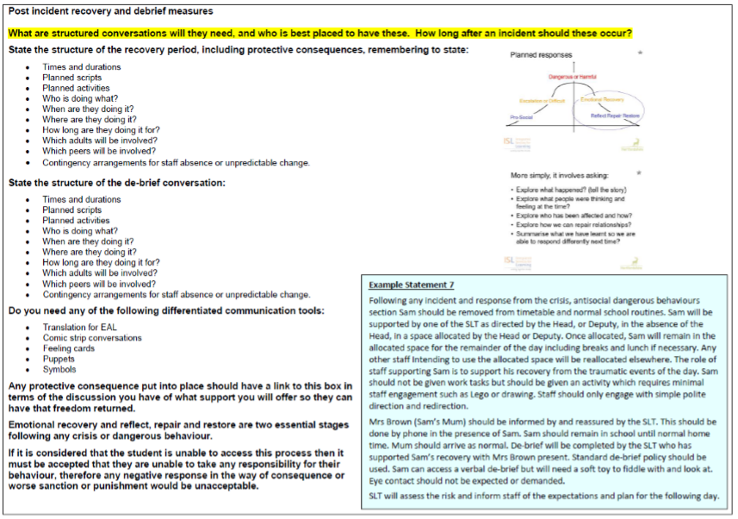

Individual Risk Management Plan (Appendix 7)
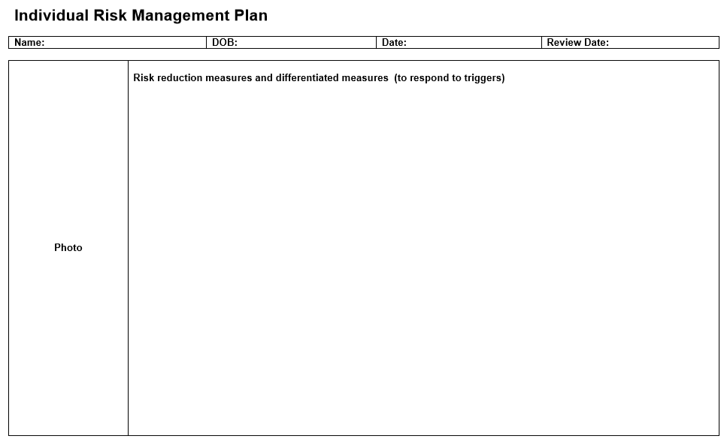

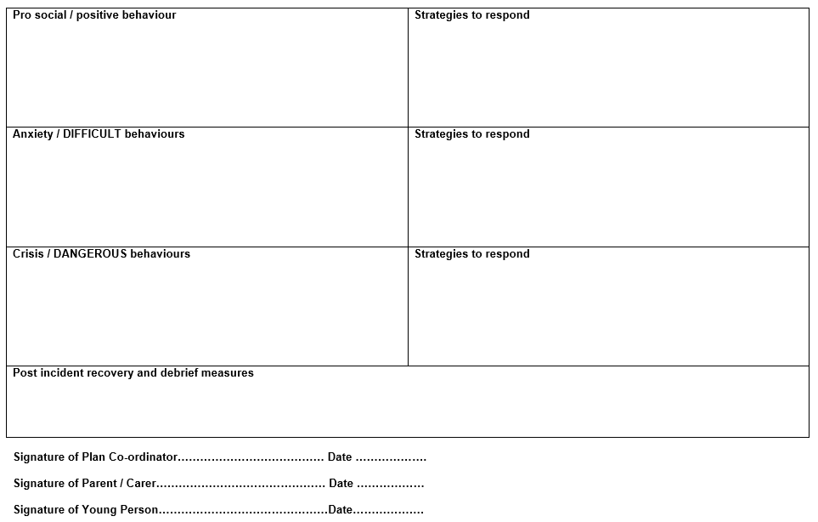

ABC Monitoring Chart (Appendix 8)
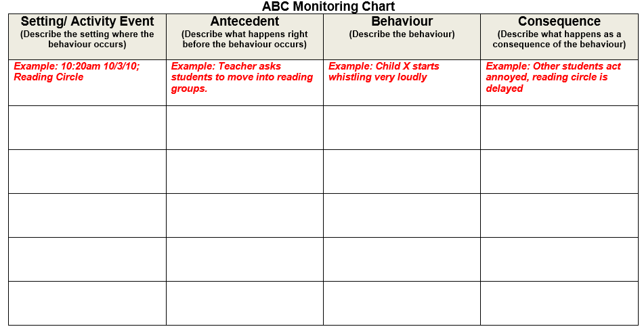
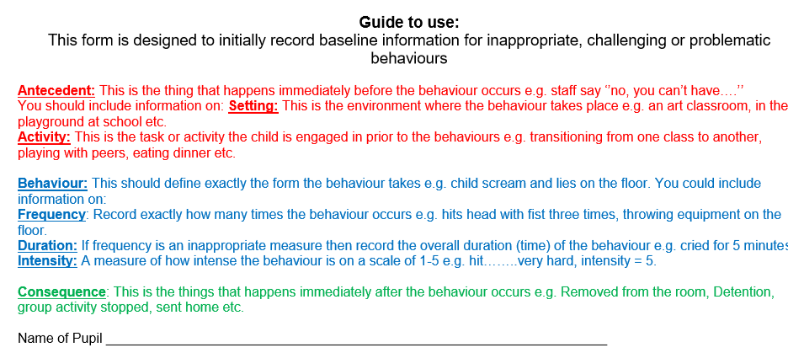

Repair and Rebuild Convesation (Appendix 9)

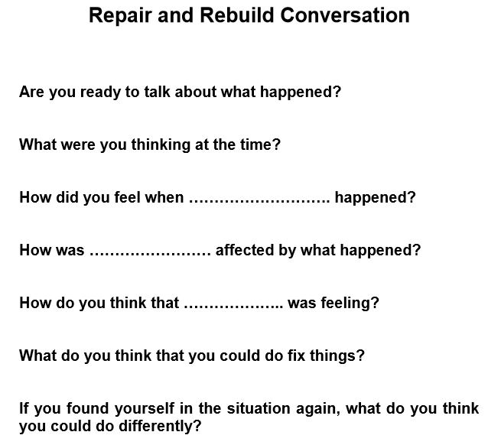

Physical Intervention and Positive Touch (Appendix 10)
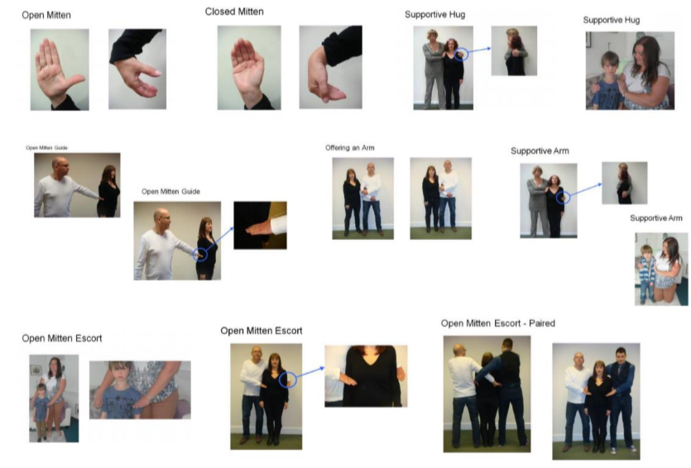

Home School Agreement (Appendix 11)

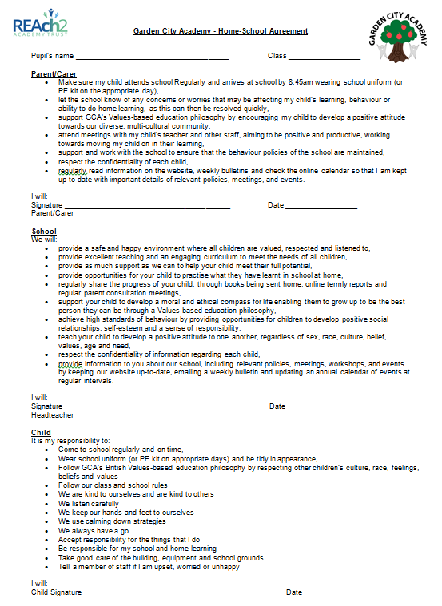

Staff Statement of Serious Incident (Appendix 12)
