GCA Reading for Fluency – progression in borrowing and independent fluency practice.

Key principles
Borrowing and independent reading is a key part of the school’s reading curriculum and integral to fostering great reading habits in the children. The books chosen by children should have two main aims: engendering a love of reading as a leisure activity and developing their reading fluency. As such children can borrow two books at a time, with these aims in mind.

Reception and KS1 (whilst learning to decode)
Whilst children are developing their phonic knowledge and decoding skills, they are taught using the Little Wandle Letters and Sounds SSP. This programme has decodable books matched to each phase, published by Collins. These books are used by the children to develop their reading fluency through repeated reading and practice of sounds they have learnt during lessons. The book they have read that week in class is allocated at the end of the week on Collins Hub for children and parents to access at home to continue to practice and build their fluency.
Children are also able to borrow a book of their choosing from the class or school library to be shared with someone at home. It is not an expectation that children will be able to independently read this book to themselves, but that it can be read to them, to develop their enjoyment of stories and interest in texts.

KS1 and LKS2 (progression from phonics books)
Once children have secured their phonic knowledge and progressed from the SSP, they will move from the Collins decodable phonics books, to independently reading levelled fluency books from the Little Wandle Fluency Programme. Teachers use a reading fluency assessment to establish each child’s fluency level, and uses the information to assign them to a fluency band, so that the books they read independently are supportive of their developing fluency skills. Fluency books are read in school and allocated to children electronically to read at home via the Collins Hub app. Children also have the opportunity to borrow a book of their choosing to enjoy at home either by themselves if they want to or, preferably, with a family member or friend. Children are also able to borrow physical books from a range of reading schemes in school. Children will be assessed once a term at a minimum using the Collins Fluency Assessments, which will give them a book band colour to read from.

KS2 (progression from reading schemes and free reading)
When children are into KS2, they should be developing good independent reading habits. They will be exposed to rich, challenging texts during their daily class reading lesson, and we aim for them to progress to becoming ‘free’ readers. Using the fluency assessment and their discretion, teachers can deem a child a ‘free’ reader if they are achieving a 95% accuracy rate on the ‘Ruby’ fluency assessment, and have good reading habits whereby they read regularly and make good choices about what to read, i.e. varied material that is not too challenging so that it stymies fluency.

Fiction banding in the library
In addition to the phonically decodable texts and reading scheme books provided, we have colour banded the fiction in the school library to support children in choosing books that they can be confident in reading. This system uses the Accelerated Reader ATOS readability formula to assign a complexity level to each text. We have used this as a guide and assigned a colour to our fiction books signifying the year group this might be most appropriate for, given typical fluency development. This is intended as guidance to support children and teachers in their choices, not to be used in the same way as a reading scheme.

Teacher Guidance
95% accuracy on Ruby assessment +
Teacher discretion based on reading habits
Children can choose freely from the library
Teachers to provide guidance using fiction colour bands if necessary
Teachers use the Collins fluency assessment to allocate books
Children complete the Little Wandle Letters and Sounds Programme

Using the Reading Assessments to allocate reading scheme books.

Little Wandle Fluency Programme
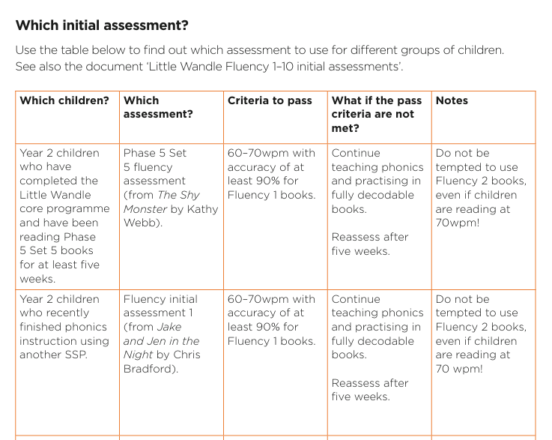
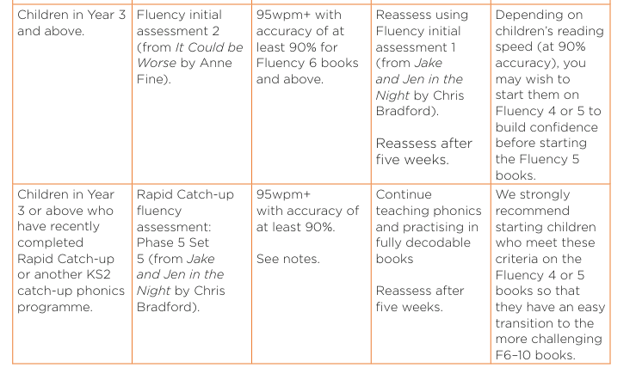

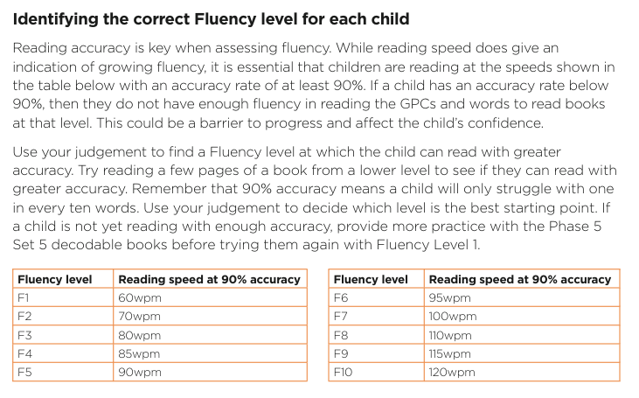

Collins Fluency Assessments for coloured banded books
Up to Lime, the assessments match our books across all reading schemes.
The first fluency assessment post-phonics should be done with the turquoise text and moved on accordingly from there.
Above 90% on Topaz is a Grey book.
Above 95% Topaz up to 94% Ruby is Grey.
Once a child is securely fluent at Ruby level (above 95%) they could become a ‘free’ reader.
Any score on the Copper assessment suggests a Brown book.
Above 95% on Copper/ below 90% on Topaz is still Brown.
Age | Key Stage | Year | Phonics Phase | Book Band/ Colour | Collins  Big  Cat
Up to 5 | EYFS |  | 1 | 0 Lilac | 0 Lilac
Up to 5 |  |  | 2 | 1 Pink | 1 Pink
Up to 5 |  |  | 3 | 2 Red | 2 Red
5 - 6 |  |  | 3/4 | 3 Yellow | 3 Yellow
5 - 6 | Key Stage 1 | Year 1 | 4/5 | 4 Blue | 4 Blue
5 - 6 | Key Stage 1 | Year 1 | 5 | 5 Green | 5 Green
6 - 7 | Key Stage 1 | Year 1 | 5/6 | 6 Orange | 6 Orange
6 - 7 | Key Stage 1 | Year 2 | 5/6 | 7 Turquoise | 7 Turquoise
6 - 7 | Key Stage 1 | Year 2 | 6 | 8 Purple | 8 Purple
 |  |  |  | 9 Gold | 9 Gold
6 - 7 | Key Stage 1 | Year 2 |  | 10 White | 10 White
 |  |  |  | 11 Lime | 11 Lime
7 - 8 | Key Stage 2 | Year 3 |  | 12 Brown | 12  Copper
13
Topaz
 |  |  |  | 13 Grey | 13  Topaz
14
Ruby
8 – 9 | Key Stage 2 | Year 4 |  | 13 Grey | 14  Ruby
 |  |  |  | 14 Dark Blue | 15  Emerald
9 – 10 | Key Stage 2 | Year 5 |  | 14 Dark Blue | 16  Sapphire
 |  |  |  | 15 Dark Red | 16  Sapphire
10 - 11 | Key Stage 2 | Year 6 |  | 15 Dark Red | 17  Diamond
18
Pearl

