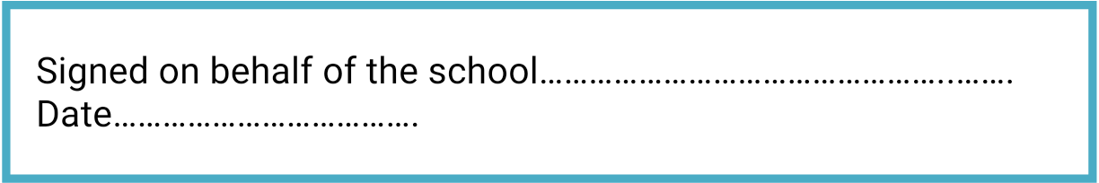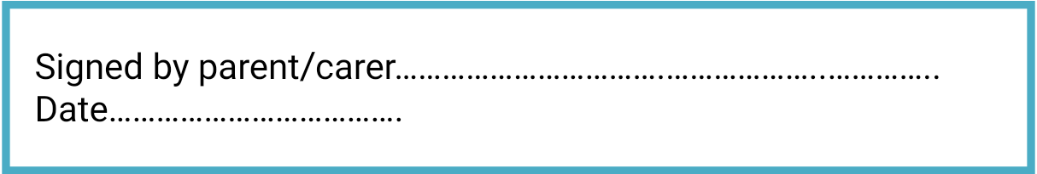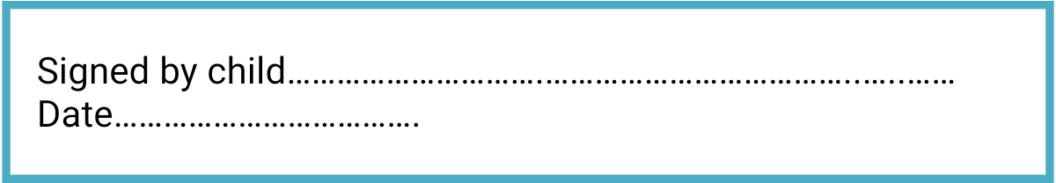

**To help my child at school, I know and understand that:**

1. If my child, or anyone in my household, shows symptoms of COVID-19, I will not send them to school, we will self-isolate for 14 days as a family, I will get them tested and I will let the school know as soon as possible via telephone;
2. If my child shows symptoms of COVID-19 at school, I will collect my child from school immediately. I will get them tested and I will let the school know as soon as possible via telephone;
3. On my commute, and when dropping my child off and picking them up, I will adhere to the 2 metre social distancing rules.
4. When dropping off and picking up, I will strictly stick to the school timings for my child;
5. When dropping off, my child will remove any disposable face mask they are wearing, placing disposable ones in the bin/double bag a fabric one which I will take away with me.
6. My child will not bring any items into school with them or take items home from school;
7. I will not be allowed into the school without a pre- arranged appointment – make appointments via telephone or email;
8. I need to support all staff in their efforts to create an ‘as safe as possible’ environment during this time:
9. I will read all letters/messages/emails that are sent home;
10. I will inform the school of any changes to parents/carer and emergency contacts details.
11. I will follow social distancing rules at all times, and understand if there is evidence that I have not followed social distancing, my child may lose their place at school.
12. If my child is deemed unsafe, he/she will be sent home and I will ensure that they understand they will only be allowed in school if they can be safe.

**The school will do its best to:**

1. Provide an environment which has been risk assessed in response to the COVID-19 infection and Trust Risk Assessment
2. Adhere to the social distancing rules as set out by the government as much as we reasonably can;
3. Provide a curriculum that meets the needs of your child’s well-being, mental health and academic needs;
4. Contact parents/carers if your child displays symptoms of COVID-19;
5. Inform you if staff or children in your child’s ‘bubble’ test positive for COVID-19 as this will mean you will all need to self-isolate for at least 14 days.
6. Continue our clear and consistent approach to rewards and sanctions for children as set out in the Behaviour Policy as well the expectations outlines in this agreement;
7. Communicate between home and school through notices, newsletters, text, email and the school website.

**I will do my best to:**

1. Follow the Bubble rules that keep me safe
2. Wash my hands as soon as I go into school
3. Tell an adult if I feel unwell
4. Not bring things into school from home, or take things home from school
5. Only use the equipment in my pack
6. Not mix with any other children in the school
7. Only enter and exit the school building from the designated gate
8. Follow the catch it-bin it-kill it rules coughing and sneezing into elbow or tissue
9. Regularly wash my hands using soap and water for 20 seconds
10. Follow the rules at all times to maintain the safety of myself and others
11. Follow these expectations and know that if I don’t, I could be sent home and will not be able to come back into school until I can be safe.



**COVID-19**

**Home School Agreement**

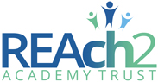

**Garden City Academy**



|  |
| --- |
|  |
|  |