Saplings Nursery – Week Commencing 22/06/2020
Hi to everyone in Nursery! We hope you are all well! This week we have organised a ‘Zoom’ Scavenger hunt for us all to join in with on Thursday! So we can all enjoy some shared activities we will continue to post some ideas linked to our theme of the week which is ‘Lost and Found’ We have loved seeing what you are doing at home on Tapestry so keep posting pictures of what you are getting up to or check in with us by e mail Nursery@gca.herts.sch.uk Mrs Braybrook, Mrs O’Gorman and Mrs Estes Patel
MONDAY | TUESDAY | WEDNESDAY | THURSDAY | FRIDAY
Today Mrs Estes Patel will be reading the story ‘Tiddler’ by Julia Donaldson. All about a fish who gets lost!  Listen to Mrs Estes Patel and see if you can remember the days of the week in order as talked about in the book.  Grown-ups: After the story is read you could watch and follow this lesson from the Oak National Academy about Daily routines.  https://classroom.thenational.academy/lessons/talking-about-your-daily-routine  Send us some pictures of your child joining in with the lesson and carrying out some of their daily routine activities throughout the week.  This will really help those children returning to Nursery on the 29th June.  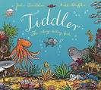 | Today Mrs Braybrook will read the story of Tiny Rabbit Goes to the Park by John Wallace. All about a rabbit who loses his favourite toy.  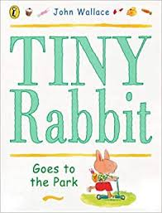  Grown ups:  Today we would like you to help your child think about positional language and describing position.  Can they find their favourite toy and hide it in different places? Encourage them to talk about where they hid it using words like ‘in, ‘on’, ‘under’, ‘beside’, ‘next to’. Then, can you hide their toy and they have to ask questions about where it might be? E.g. “is it…under the….? Is it behind……..”  Here is a number themed game to play this week on BBC Bitesize.  https://www.bbc.co.uk/games/embed/education-ivor-starting-school?exitGameUrl=https%3A%2F%2Fbbc.co.uk%2Fbitesize%2Farticles%2Fzd4b382  You could have a go at some phase 1 phonics games this week.  https://www.phonicsbloom.com/uk/game/list/phonics-games-phase-1 | Today Mrs Estes Patel will read ‘Puffin Peter’ by Petr Horacek about a puffin who loses his best friend.  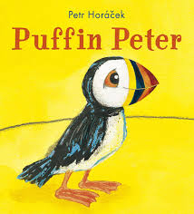  Grown ups: Today you could help your child to draw a map to find something they have lost. Maybe some treasure or a favourite toy they have hidden. Talk about drawing the important things/features that they can see onto their map. You could draw a map of somewhere inside like their bedroom, or outside in the garden, or even an imaginary map to find pirates treasure.  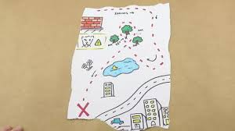  Take a photo of your map and send it to us on Tapestry or e mail it to nursery@gca.herts.sch.uk | Today we are trying something new! A Zoom Scavenger Hunt. We will split the class into two groups so it will be more manageable (one group at 10:00am and the second group at 11:00).  The Zoom will be run by Mrs Braybrook and Mrs Estes-Patel and there will be objects for your child to find and bring back to show us. AN ADULT will be needed to support AT ALL TIMES for safeguarding purposes during the Zoom activity.  You will be e mailed a Zoom meeting code and password from the Nursery e mail account prior to the day to join the Scavenger hunt, either at 10am or 11am. You will need to download the zoom.us app on your device to access this activity.  Grown ups After the scavenger hunt you could have your own scavenger hunt when ‘out and about.’ We will send a few suggested lists of things to find on Tapestry but you could make your own!  Here is a lovely story to end the day about Percy the Park Keeper’s Treasure hunt.  https://www.youtube.com/watch?v=m7nY4577_SM  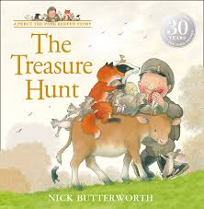 | Today Mrs Braybrook will read the story ‘Who’s Taken it?’ by Andrew Green. A funny story about a hippo who has his toilet roll stolen!  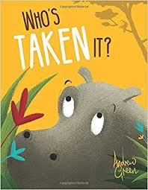  Grown-ups: Mrs O’ Gorman will make a toilet roll craft today. She is going to make some binoculars and use them for spying some birds and animals while out and about. We will add a bird watching sheet to Tapestry today – which birds can you spot?  There are some lovely activities linked to nature on the RSPB website if you click on the link below.  https://www.rspb.org.uk/fun-and-learning/for-families/family-wild-challenge/activities/go-birdwatching/  Have fun outdoors and send us some pictures on Tapestry or via e mail nursery@gca.herts.sch.uk  Join in with cosmic yoga today too!  How about a Bear hunt!  https://www.youtube.com/watch?v=KAT5NiWHFIU

