Saplings Nursery – Week Commencing 06/07/2020
Hi to everyone in Nursery! We really enjoyed learning about dinosaurs last week so we thought that we would continue with some more dinosaur themed activities at home and at school. So we can all enjoy some shared activities we will continue to post some ideas linked to our story of the week which is ‘Dinosaurs Love Underpants! We have loved seeing what you are doing at home on Tapestry so keep posting pictures of what you are getting up to or check in with us by e mail Nursery@gca.herts.sch.uk Mrs Braybrook, Mrs O’Gorman and Mrs Estes Patel
MONDAY | TUESDAY | WEDNESDAY | THURSDAY | FRIDAY
Today listen to the story of Dinosaurs Love Underpants on youtube.  https://www.youtube.com/watch?v=beumdWOm0z0  Listen to the story and maybe you could draw a funny picture of a dinosaur wearing some underpants!  Grown-ups: After the story is read you could go on to BBC Bitesize and play a dinosaur game.  https://www.bbc.co.uk/bitesize/topics/zdp4382/articles/znc3y9q  This week we are going to be learning the ‘a’ sound.  https://www.youtube.com/watch?v=1MuG-XjItWM  Can you find some ‘a’ objects at home and make a collection? | Today you could make a Box model dinosaur like Mr Maker.  https://www.bbc.co.uk/cbeebies/makes/mister-maker-box-dinosaur  Grown ups:  Today we would like you to help your child think about different textures like those of the pants in Dinosaurs Love Underpants.  Get some paper and wax crayons and go on a texture hunt and make rubbings of the different textures you find.  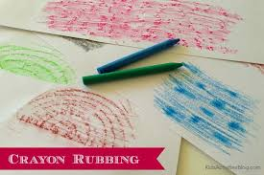 | Today you could play the Andy’s Dinosaur Adventures game on Cbeebies.  https://www.bbc.co.uk/cbeebies/games/andys-dinosaur-adventures-game  Grown ups: Help your child make a dinosaur hat.  https://www.bbc.co.uk/cbeebies/makes/presenters-velociraptor-hat  Send us a picture on Tapestry of your child wearing their hat! Or you could e mail it to us Nursery@gca.herts.sch.uk  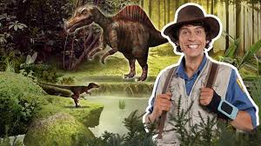 | Today we will upload a Dough disco for you to join in with Mrs O’Gorman. Maybe you could make some sausages and some ‘a’ letter shapes with your dough when you have finished watching her?  Grown ups There are some great activity ideas on the Natural History Museum website for families.  https://www.nhm.ac.uk/events/dinosaur-activities-for-families.html  Also there is a nice Cbeebies radio story about going to the museum with dinosaurs.  https://www.bbc.co.uk/cbeebies/radio/woolly-and-tig-the-museum | Today Mrs Estes Patel will play us some songs and rhymes on ‘Guitar Friday’!  Grown-ups:  Today you could complete something from the dinosaur Home learning challenge sheet attached on Tapestry today.  Perhaps you could do some exploring and ‘research’ about your child’s favourite dinosaur.  Can you find out any fascinating facts? You could record your child telling us about a dinosaur and post it to Tapestry.  We will post a picture of dinosaurs today for you to talk about with your child.

