Saplings Nursery – Week Commencing 13/07/2020
Hi to everyone in Nursery! It’s the last week so we thought that we would have a Summer holiday theme at home and at school. So we can all enjoy some shared activities we will continue to post some ideas linked to our stories about Kipper by Mick Inkpen this week. We have loved seeing what you are doing at home on Tapestry so keep posting pictures of what you are getting up to or check in with us by e mail Nursery@gca.herts.sch.uk Mrs Braybrook, Mrs O’Gorman and Mrs Estes Patel
MONDAY | TUESDAY | WEDNESDAY | THURSDAY | FRIDAY
Today we are going to listen to a story about Kipper going to the  Seaside.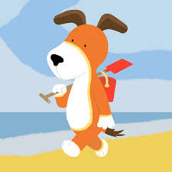  https://www.youtube.com/watch?v=ZF4spySUhiw  Talk about what you would need take to take for a day at the seaside.  Kipper enjoys drawing in the sand. Put sugar, salt or sand in a tray and explore making shapes, lines and drawing pictures.  During this week have a go a keeping a weather diary. Look out for the different types of holiday weather Kipper has in each story this week. | Today story is about Kipper and his friend having a picnic.  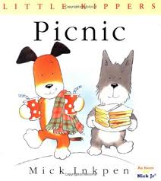  https://www.youtube.com/watch?v=YUsY3cNMcCU  How about a picnic at the park or in your garden. Talk about what sandwiches you are going to make and what else you would like in you picnic.  Talk about what living things you can see. Have any bugs tried to get your food?  At the end of the story Kipper enjoys eating the apples. If you’ve got some paint at home have a go at printing with some apples  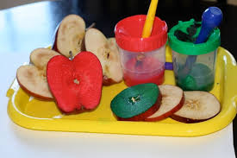 | Today Kipper is getting his paddling pool out. I hope the weather stays nice.  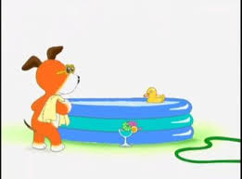  https://www.youtube.com/watch?v=JXS8Uj3SVGk  Dr Ranj is going to sing us a song about being careful in the sun. Click on the link and sing a long:  https://www.bbc.co.uk/cbeebies/watch/get-well-soon-fun-in-the-sun  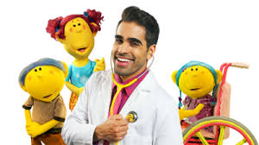  Hot sunny days are good days to make some ice lollies. Have a look at these recipes, the banana ones are my favourite. Click on the link to see recipes.  https://www.bbcgoodfood.com/howto/guide/5-best-ice-lollies-kids  Talk about why and how things are cold. What do we do to make something cold? How do things change as they get colder and freeze? | Today Kipper is off with his friend camping.  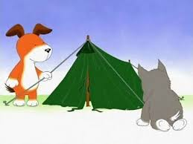  https://www.youtube.com/watch?v=8I3mHr4Y_VI  Kipper and his friend look at the starry sky. Have a go at making your own starry night. Click on the link and see  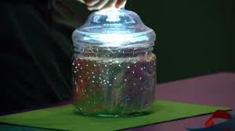  https://www.bbc.co.uk/cbeebies/makes/the-lets-go-club-starry-nightlight-jar?collection=the-lets-go-club-craft-activities  In the story Kipper puts up a tent how many things around your house can you find at begins with the letter sound “t “?  Why don’t you have a go at building your own tent with blankets and other things you’ve got at home. What sort of things will you need in your tent? | Guitar Friday, lets sing some songs with Mrs Estes-Patel.  Have a go at creating your own music by making a water xylophone. Click on the link to see:  https://www.bbc.co.uk/cbeebies/makes/the-lets-go-club-water-xylophone  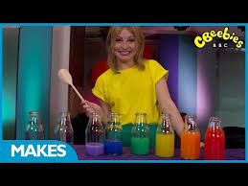  Talk about how full the glass containers are, are they half full, nearly full ? How much more would you need to put in to fill it to the top? How would you measure how much you’ve put in.  Lets wind down at the end of the week with some cosmic yoga on a beach on an island  https://www.youtube.com/watch?v=5y3gCrL_XIM

