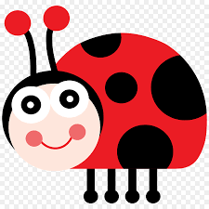
Saplings Nursery – Week Commencing 01/06/2020
Hi to everyone in Nursery! We know that some of you will have started coming into Nursery this week and some of you may still be at home. So we can all enjoy some shared activities we will continue to post some ideas linked to our story for the week ‘What the Ladybird Heard’ by Julia Donaldson. We have loved seeing what you are doing at home on Tapestry so keep posting pictures of what you are getting up to or check in with us by e mail Nursery@gca.herts.sch.uk Mrs Braybrook, Mrs O’Gorman and Mrs Estes Patel
MONDAY | TUESDAY | WEDNESDAY | THURSDAY | FRIDAY
Today Mrs O’Gorman will be reading the story ‘What the Ladybird Heard’ by Julia Donaldson. All about a plot to steal a prized cow!  Listen to Mrs O’Gorman read the story on Tapestry and see if you can name the farm animals and talk about what sounds they make.  Grown-ups: After the story is read you could help your child draw a large ladybird on paper or card and colour/paint/or use red paper to decorate it. Leave the labybird blank and find some buttons/beads/cut out black circle counters to count and share spots on the ladybirds wings. Can you put the same number of spots on each wing? Can you make one with lots/a few spots?  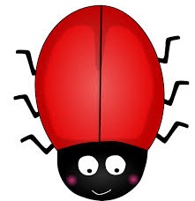  You could talk about simple doubles and halves like 1 spot and 1 spot makes 2 spots, 2 and 2 makes 4, 3 and 3 makes 6 to extend your child in their understanding of number. | Today you could listen to the story of What the Ladybird Heard on You Tube  https://www.youtube.com/watch?v=Eu9mPX7DuLA  Grown ups: Have a look at the website  https://www.topmarks.co.uk/learning-to-count/ladybird-spots  Have a go at the ladybird spots game. Can you count and match the number of spots on the ladybird?  Today you could go on a walk and look for laybirds! How many spots do they have? Can you count? Which ladybird has the most spots? Encourage your child to talk about being kind and gentle with living creatures.  Another activity on your walk or in your garden is to make a ‘map’ drawing pictures of all of the things that you see. Can you make a map like the robbers in the What the Ladybird Heard story?  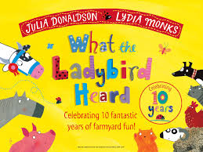 | Today Mrs Braybrook will read another story about farm animals on Tapestry.  Grown ups: In the story we saw a cow being milked and eggs being collected on the farm. Perhaps you could use milk or eggs in a cooking activity today. You could make a boiled egg and soldiers for lunch or scrambled egg on toast? What about a milkshake or smoothie with milk? | Today we will post a farmyard themed dough disco on Tapestry led by Mrs O Gorman.  You might like to join in with her disco moves to develop your finger strength and control.  Grown ups Have a look at the website  Phonicsplay.co.uk  Access free resources for Phase 1 phonics  Username: march20  Password: home  Have a go at the Super Smoothie activity in phase 1 phonics. This encourages listening for words that start with the same sound ‘alliteration’  Have a sound hunt in your house/garden. Can your child find objects that all start with the ‘s’ sound? If you find any send a picture to us on Tapestry or e mail us on Nursery@gca.herts.sch.uk | Hooray it is Friday and Mrs Estes Patel is going to sing us some songs and rhymes with her guitar today!  Join in with the songs and actions. She might even have some farm animals in her songs!  Grown-ups: Today you could make an animal from the story of What the Ladybird Heard. Maybe a sheep, cow, pig or hen?  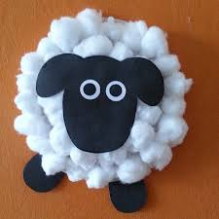  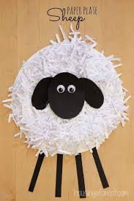  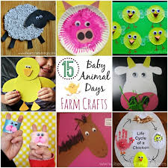  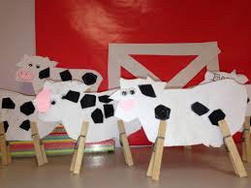  Join in with cosmic yoga today too!  https://www.youtube.com/watch?v=qIT-9Nnlvn0

