Saplings Nursery – Week Commencing 04/05/2020
Hi to everyone in Nursery! We are missing you lots! Last Friday it was National Space Day and so we thought that this week we would do some great Space themed home learning activities! We will be continuing to post on Tapestry daily and will add these activities and other links and resources there. We love to see what you are doing so keep posting pictures of what you are getting up to or check in with us by e mail Nursery@gca.herts.sch.uk Mrs Braybrook, Mrs O’Gorman and Mrs Estes Patel x
MONDAY | TUESDAY | WEDNESDAY | THURSDAY | FRIDAY
Today Mrs Braybrook will be reading the story of Whatever Next by Jill Murphy. All about a little bear who wants to go to the moon!  Listen to Mrs Braybrook read the story on Tapestry and see if you can tell your grown up anything you know about the moon and space.  Grown-ups: After the story is read see what your child can remember about it. Can they think about what they would pack in their bag if they went to the moon? What would they need? What would it be like on the moon?  Have a go at making a telescope to look at the moon using toilet rolls and other junk modelling things at home. | Today you could listen to the story of Whatever Next on You Tube  https://www.youtube.com/watch?v=Nn73STXrPP0  Perhaps today you could make a rocket for Baby Bear using junk modelling boxes, glue/tape and decorate it? Or you could design a rocket for Baby Bear and draw a picture of it.  Grown ups: Have a look at the website  Phonicsplay.co.uk  Access free resources for Phase 1 phonics  Username: march20  Password: home  Have a go at the SOUND STARTERS activity with your child and listen and talk about sounds. | Today why not have a go at scrunching up some tinfoil into different sized balls to be moon rocks.  Float these ‘rocks’ in a bowl of water or even in your bath. Can you tweeze them out and count them using eyebrow tweezers, salad tongs or even a tea spoon.  Grown ups: Help your child build a dark den using blankets or their duvet, can they make shadows using a torch and different objects?  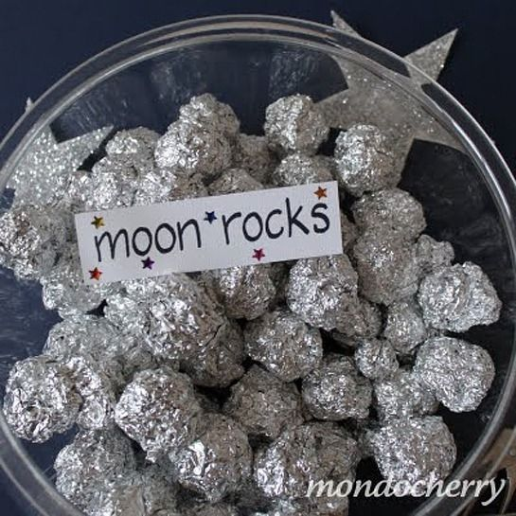 | Today we will post a space themed dough disco on Tapestry led by Mrs O Gorman.  You might like to join in with her disco moves to develop your finger strength and control.  Today you might like to make some star shaped biscuits. We will post a recipe on Tapestry today. Send us a picture of your yummy creations on Tapestry or Nursery@gca.herts.sch.uk  Have a go at this space themed cosmic yoga to relax today!  https://www.youtube.com/watch?v=d85dw-AcAaU | Hooray it is Friday and Mrs Estes Patel is going to sing us some songs and rhymes with her guitar today!  Join in with the songs and actions. She might even teach us a space themed song!  Today is the VE day bank holiday to celebrate the 75th anniversary of Victory in Europe day and the end of WW2.  Grown-ups: Help your child to cut out some red white and blue triangles and join them to make a string of bunting to hang up at home.

