Saplings Nursery – Week Commencing 27/04/2020
Hi to everyone in Nursery! We are missing you lots and thought it would be nice to share some fun activities linked to stories each week. You can choose which ones you like, do one each day or indeed do them all! We realise that this is such a challenging time and so do not feel under pressure to do everything! We will be continuing to post on Tapestry daily and will add these activities and other links and resources there. We love to see what you are doing so keep posting pictures of what you are getting up to or check in with us by e mail Nursery@gca.herts.sch.uk Mrs Braybrook, Mrs O’Gorman and Mrs Estes Patel x
MONDAY | TUESDAY | WEDNESDAY | THURSDAY | FRIDAY
Today Mrs Braybrook will be reading the story of The Very Hungry Caterpillar by Eric Carle. You may have this at home too!  Listen to Mrs Braybrook read the story on Tapestry and see if you can say the names of the days of the week in order.  Grown-ups: After the story is read see what your child can remember about it. Can they talk about what happened to the caterpillar? What did he eat? What is your child’s favourite fruit? Perhaps this week you could taste some of the fruits from the story. | Today you could listen to the story of The Very Hungry Caterpillar on You Tube  https://www.youtube.com/watch?v=75NQK-Sm1YY  Perhaps you would like you to go on a BUG HUNT either in your garden or on your daily walk.  We will post a Bug hunting sheet on Tapestry today if you want to print one out, if not you could make your own.  You could look for, bees, wasps, ladybirds, snails, slugs, woodlice, worms, flies, and lots of other minibeasts.  Grown-ups: Youcould encourage your child to make a simple ‘tally’ to count the minibeasts they find. | Do you remember some of the fruits that the Hungry caterpillar ate?  Perhaps today you could make a fruit salad or fruit kebab.  Ask a grown up to help you to chop some fruit and either mix it up in a bowl or add it to small kebab skewers or cocktail sticks.  Can you say which is our favourite fruit and why? Have you managed to try a new fruit today? | Today we will post a dough disco on Tapestry led by Mrs O Gorman. Here is a simple dough recipe.  https://www.youtube.com/watch?v=oAIAm6BF0fs  You might like to join in with her disco moves to develop your finger strength and control.  Today you might like to draw or paint a picture of the Hungry Caterpillar or a beautiful butterfly. Send us a picture of your work on Tapestry or Nursery@gca.herts.sch.uk | Hooray it is Friday and Mrs Estes Patel is going to sing us some songs and rhymes with her guitar today!  Join in with the songs and actions. She might even teach us a new song about a caterpillar on a leaf!  Here is a great listening game to try at home today.  https://www.youtube.com/watch?v=h0Kp_J9kvNM  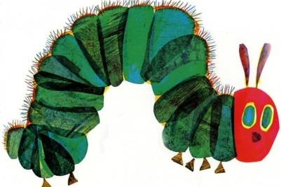  Grown-ups: perhaps you could focus on listening to sounds in the environment on your daily walk today?

