Saplings Nursery – Week Commencing 29/06/2020
Hi to everyone in Nursery! We hope you are all well! This week we are looking forward to welcoming some of you back to Nursery! So we can all enjoy some shared activities we will continue to post some ideas linked to our story of the week which is ‘Dinosaur Roar! We have loved seeing what you are doing at home on Tapestry so keep posting pictures of what you are getting up to or check in with us by e mail Nursery@gca.herts.sch.uk Mrs Braybrook, Mrs O’Gorman and Mrs Estes Patel
MONDAY | TUESDAY | WEDNESDAY | THURSDAY | FRIDAY
Today Mrs Braybrook will be reading the story ‘Dinosaur Roar!’ by Paul and Henrietta Stickland. All about lots of different kinds of dinosaurs.  Listen to Mrs Braybrook and see if you can talk about the different dinosaurs you see in the pictures. Have you got any dinosaur books at home? Maybe you could find out some dinosaur facts and pictures on the internet with your grown up?  Grown-ups: After the story is read you have a think about the ‘opposites’ in the story. You could play an opposites game with your child. You say a word and they have to think of a word that is ‘opposite’ to it. For example, wet/dry,clean/dirty, soft/hard, big/small. | Today you could listen to Dinosaur Roar being read again on You Tube.  https://www.youtube.com/watch?v=5MMiiXlFNZA  Grown ups:  Today we would like you to help your child think about describing words. Find some items of different textures and hide them in a bag/pillowcase. Encourage your child to put their hand in and ‘describe’ what they can feel. They may find this hard at first so you may need to model it by describing a few objects yourself. Can you describe them and they guess what they are? | Today we are going to introduce some of the first letter sounds. Watch them be introduced here….  https://www.bbc.co.uk/bitesize/topics/zf2yf4j/articles/z4ycrj6  Grown ups: Encourage your child to think about the first sound ‘S’. You could watch the ‘S’ alphablocks clip here.  https://www.youtube.com/watch?v=IaNo0YV4MTU  Afterwards you could have a ‘S’ sound hunt. Can you find some objects beginning with the sound ‘S’ and make a collection of them? Send us a picture on Tapestry or e mail it to us Nursery@gca.herts.sch.uk  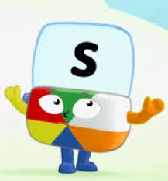 | Today we will upload a Dough disco for you to join in with with Mrs O’Gorman. Maybe you could make some sausages and some ‘S’ letter shapes with your dough when you have finished watching her?  Grown ups  Today you could have a go at making some salt dough dinosaur fossils.  https://www.littlepassports.com/blog/craft-diy/make-dinosaur-fossils-using-salt-dough/  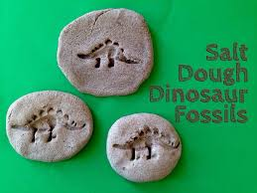  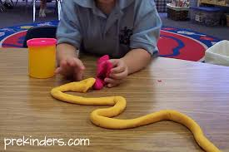 | Today Mrs Estes Patel will play us some songs and rhymes on ‘Guitar Friday’!  Grown-ups:  Today you could make some cornflour and water slime or gloop. Mix water into cornflour in a washing up bowl or shallow tray to make a sticky and slimy mixture. You could even add some food colouring to the mixture. This is great for building up strength in little fingers as they manipulate the mixture. You could add some toy dinosaurs and make a dinosaur swamp!  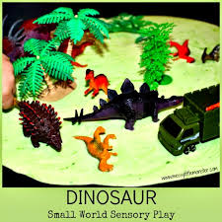  Join in with some dinosaur cosmic yoga today too!  https://www.youtube.com/watch?v=rnlDBKD2S78

