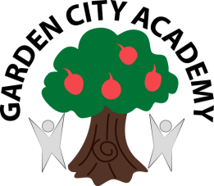


Headteacher: Mrs Samantha Ruck

Radburn Way Letchworth Garden City Herts SG6 2JZ
(Phone: 01462 621800 / Fax: 01462 621802 / email: admin@gca.herts.sch.uk)

12th December 2024

Dear Parents and Carers,
I know that the recent news about the Cherry Tree nursery has caused concern amongst some of you and I wanted to take this opportunity to share our thinking behind it, and to offer reassurance that there will be a place available for your child at our Garden City Academy nursery from next September.
Cherry Tree nursery has leased space from us since 2022 as a private nursery. As you know, we also run the Garden City Academy nursery for 3–4-year-olds on the same site. All the research highlights the critical importance of early years education when it comes to children getting the best start in life, and we have taken the decision to extend our school offer to include 2-year-olds, so that we can form relationships with families even earlier and work together to make sure children get that great start to education.
From September, we will be offering:
- Fifteen FTE 30-hour places for 2–3-year-olds as a minimum. This will increase if demand is there for places. There will be the option of 5 mornings, 5 afternoons or full time places.
- Twenty-eight 30-hour places for 3 – 4-year-olds. There will be the option of mornings if you require 15 hours or five full days for 30 hours.
We have extended the lease for Cherry Trees until 4 July, allowing time for renovation work to take place over the rest of the summer before we open in September. Should Cherry Trees decide to depart before this date, and this leaves you without childcare please do contact me directly to discuss this as we do not want any child to be left for a period without the right provision in place.
I appreciate you may have questions about the new nursery offer at Garden City and I would welcome the opportunity to meet with you in person to tell you more about our vision from September. If you would like to meet, please do get in touch via admin@gardencityacademy.org.
Yours sincerely,
Mrs Samantha Ruck
Headteacher
Garden City Academy

