



Friday 16th July 2021

Dear Parent/Guardian,

**Arrangements for September 2021**

On Tuesday 6th July 2021, the Government announced that as part of Step 4 of the roadmap, from September 2021 it is proposing to reduce a number of Covid-19 restrictions, which have been in place in schools for the last 18 months. This decision has been made by the Government to reduce the disruption to children’s education – particularly as the clinical risks to children from COVID-19 are low and every adult has been offered a first vaccine and the opportunity for 2 doses by September. The lifting of COVID-19 restrictions in school is in line with the proposed general removal of restrictions in England.

This move is welcomed by REAch2 and our school as the priority is to deliver face-to-face, high quality education for your children. However, we also recognise that it is important that the school continues to play its part in controlling the spread of the virus through protective measures. On the next page, you will find details of the COVID-19 measures which are being removed in September 2021 in schools and those which remain in place following the Department for Education published guidance.

**COVID-19 Symptoms**

Please note it is imperative that if your child has, or is showing symptoms of COVID-19;

* High temperature
* New, continuous cough
* Loss of, or change to, sense of smell or taste

they must not attend school and should remain at home in line with Stay at Home: guidance for households with possible or confirmed coronavirus (COVID-19) infection – Gov.uk.  They should take a PCR test within 2 days and only return to school if the test result is negative.  Parents should follow the NHS Test and Trace process.  Whilst awaiting the PCR result, your child should continue to self-isolate.

If the PCR test is taken within 2 days of a positive lateral flow test, and is negative, it overrides the self-test LFD test and your child can return to school, as long as they don’t have COVID-19 symptoms.

**Children who are identified as a close contact of someone who tests positive for COVID.**

Under the current arrangements, if a child is identified as a close contact of someone who tests positive for COVID they are required to self-isolate. However as of the **16th August**, children and those members of staff who are fully vaccinated will not be required to isolate if they are identified as a close contact.  Instead, they will be advised to take a PCR test. They will not be required to isolate whilst they await the results of the PCR test.

Please note that self-isolation will continue for those who have tested positive for COVID or who display symptoms.

I will be in contact with further details and reminders of our normal operating systems before the end term.

Yours faithfully

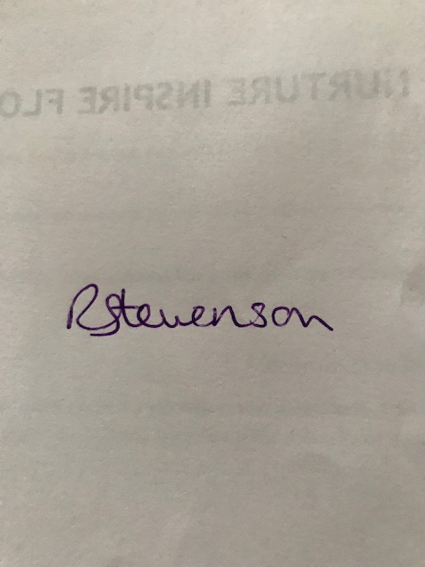

Headteacher

|  |
| --- |
| **Protection measures being removed in September 2021** |
| Year group bubbles, social distancing and zoned areas |
| Staggered breaks/lunches/start and end of school times – school will return to normal day structure, including Year 5 and 6 being able to start at 8:30am (however we have taken on feedback from children about breaks and lunches and will continue to split children for breaks and lunchtime. Years 1-3 and then Years 4-6) |
| 10 days isolation for close contacts of a confirmed case and adults fully vaccinated |
| Wearing face coverings in school (however if you are coming in for a meetings with others from different agencies in a small area you may be asked to wear a mask) |
| Restrictions on school trips (except international), drama, music, sporting activities, parents sessions/events and clubs – these will return to normal |
| One-way system in school and drop off for Year 2 will be back in their classroom (we will continue to operate entry at the front of the school and exit at the back for Years 1-6 as this has worked well) |
| Assemblies will resume with a blended of approach with some in class and some via zoom as this has worked very well – we will restart our end of half term celebration with winners parents invite |

|  |
| --- |
| **Protection measures in place in September 2021** |
| School will continue to follow public health advice on testing, self-isolation and managing confirmed cases |
| Good personal hygiene – regular hand washing/sanitising |
| Good respiratory hygiene – ‘catch it, bin it, kill it’ |
| Ventilation of occupied rooms/assemblies |
| Regular cleaning regime |
| Positive cases or anyone with symptoms (high temperature, new continuous cough, loss/change to smell or taste) must not come to school and must self-isolate. Anyone in school with symptoms, will be sent home. A PCR test must be taken within 2 days. If the PCR test results in negative, the child/staff member can return to school. If the PCR test result is positive they MUST self-isolate and follow NHS Test and Trace advice.  *(If a parent/carers insists on a pupil attending school, leaders can take the decision to refuse the pupil, if in the leader’s reasonable judgement, it is necessary to protect other pupils and staff from possible infection with COVID-19.)* |
| Close contacts will be identified by NHS Test and Trace. Close contacts DO NOT need to self-isolate and can attend school, but should take a PCR test |
| School Contingency Plan for any outbreak |
| Lateral flow home testing by all staff till the end of September (awaiting further DfE guidance) |
| Use of staff personal protective equipment (PPE) in school for anyone with symptoms. |
| Remote Education to be provided to all children self-isolating having tested positive.  (*FSM hampers will be provided to any child who is eligible for benefits-related free school meals and who is learning at home during term-time due to a positive test result).* |
| Continued focus on children’s well-being |

|  |
| --- |
| **Stepping Measures up or down** |
| An outbreak management plan will be in place, outlining how the school will operate if there were a COVID-19 outbreak in the school or local area (Several confirmed cases within a 14 day period) |
| Leaders will call the dedicated advice service who will escalate the issue to the local health protection team where necessary and they will advise school leaders should there be any additional action required |