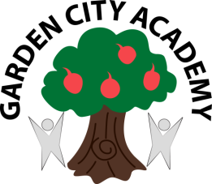


Headteacher: Mrs Rachael Stevenson

Radburn Way Letchworth Garden City Herts SG6 2JZ
(Phone: 01462 621800 / Fax: 01462 621802 / email: head@gca.herts.sch.uk)

13th April 2021

Dear Parents and Carers,

Pyjamarama Day

On Friday 14th May 2021, we will be celebrating Pyjamarama day! Pyjamarama Day, is an event when schools around the country spend the day in pyjamas to help raise money for BookTrust, so that more children and families can share stories.

We are kindly asking that every child in pyjamas brings £1 to school in order to support the fundraising event. Children should come to school in comfortable but appropriate pyjamas and will spend the day undergoing lots of fun, book related activities! We have a passion for reading at GCA and we are always extremely dedicated to making reading experiences exciting for our children.

As we know, reading together improves language and confidence, helping children achieve so much more. Therefore, we can’t wait to participate in this event!

Yours sincerely,
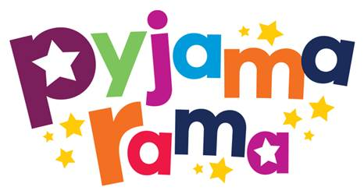
Miss Tatum McIntyre

English Lead




