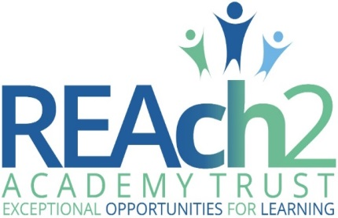

Safeguarding and child protection policy – for academies

Audience: | Parents • Academy staff and volunteers • Local Governing Bodies • Trust central staff • Cluster boards • Trustees • Local Authorities
Ratified:
Other related policies: | Safeguarding and child protection (for central staff) • Attendance • Behaviour • Code of conduct • Disciplinary • Health and safety • Information and records retention • Missing pupils • Online safety • Recruitment • Relationships, health and sex education • Whistleblowing
Policy owner: | Helen Beattie, Head of Safeguarding
Review frequency: | Annual

REAch2 safeguarding and  child protection policy | 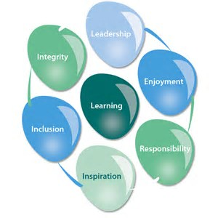

At REAch2, our actions and our intentions as school leaders are guided by our Touchstones:

Integrity | We recognise that we lead by example and if we want children to grow up to behave appropriately and with integrity then we must model this behaviour
Responsibility | We act judiciously with sensitivity and care. We don’t make excuses, but mindfully answer for actions and continually seek to make improvements
Inclusion | We acknowledge and celebrate that all people are different and can play a role in the REAch2 family whatever their background or learning style
Enjoyment | Providing learning that is relevant, motivating and engaging releases a child’s curiosity and fun, so that a task can be tackled and their goals achieved
Inspiration | Inspiration breathes life into our schools. Introducing children to influential experiences of people and place, motivates them to live their lives to the full
Learning | Children and adults will flourish in their learning and through learning discover a future that is worth pursuing
Leadership | REAch2 aspires for high quality leadership by seeking out talent, developing potential and spotting the possible in people as well as the actual
Contents

 | Page
POLICY OVERVIEW | 3
POLICY PRINCIPLES IN DETAIL | 4 – 7
IMPLEMENTATION | 8
REVIEW | 8
ANNEXES
Annex 1 – types of abuse | 9 – 13
Annex 2 – contact information | 14
Annex 3 – recording safeguarding concerns | 15
Annex 4 – local agency procedures | 21-23
Annex 5 – managing allegations | 24-26
Annex 6 – COVID-19 self-isolation | 27-29

POLICY OVERVIEW

Overarching principles
We recognise that academies and academy personnel are in a unique position in their care of children. The responsibility for all staff to safeguard pupils and promote their welfare, as stated in Section 175 of the Education Act (2002), is one that is central to our ethos, our policies and our actions. All children are deserving of the highest levels of care and safeguarding, regardless of their individual characteristics or circumstances, and we are committed to applying this policy to ensure effective levels of safeguarding and care are afforded to all of our pupils. It is essential that all actions are taken first and foremost in the best interest of our pupils. This policy sets out guidance and procedures that our academy will take to ensure appropriate action is taken in a timely manner to safeguard and promote the welfare of our pupils. Its contents are intended to be in accordance with all relevant Government guidelines and legislation, as well as the inter-agency procedures provided by Hertfordshire County Council safeguarding partners.

Intended impact
- To enable all pupils to feel safe and cared for whilst at our academy, and to ensure that they have a safe place and safe people to whom they can turn.
- To enable all adults involved with our academy to be fully equipped to fulfil their responsibilities in effectively promoting the safeguarding and welfare of all of our pupils.

Roles & responsibilities
- Pupils will: adhere to academy rules regarding conduct and safe behaviour; report anything that worries them to a trusted adult.
- Parents/carers will: work collaboratively with academy staff to promote the safety of their children and of other pupils; support our academy to teach pupils about keeping safe by reinforcing key safety messages; report any safeguarding concerns regarding their own children or another pupil to the academy.
- The academy will: ensure that all pupils have a safe learning environment and are taught about how to keep safe; train and support all adults involved with our academy to appropriately identify and respond to any pupil at risk of harm; work collaboratively with parents and professional agencies to safeguard our pupils.
- Governors will: ensure this policy is applied robustly throughout the academy; review it regularly (annually at a minimum) to ensure the effectiveness and rigor of safeguarding practice at our academy.
- REAch2 central staff will: know, understand and follow the safeguarding procedures for each academy within which they work; undertake relevant regular training and updates to ensure their skills and knowledge support them to meet their safeguarding responsibility.
- REAch2 safeguarding team members will: advise and challenge academies and their staff to support them in deploying best practice to meet their statutory safeguarding responsibilities.

How this relates to national guidance & requirements
Statutory safeguarding and child protection practice for schools and academies is outlined in the following legislation and documents, with which this policy intends to be in accordance:
- Legal: Section 175, Education Act (2002); Section 26, Counter Terrorism and Security Act (2015)
- Government: Working Together to Safeguard Children (2018); What to do if you’re worried a child is being abused (2015); Keeping children safe in education (2021); Children missing education (2016); Sexual violence and sexual harassment between children in schools (2018); The designated teacher for looked after and previously looked after children (2018); Information Sharing, Advice for practitioners providing safeguarding services (2018); Teaching online safety in schools (2019); Relationships education, relationships and sex education, and health education (2019)
- Ofsted: Inspecting safeguarding in early years, education and skills settings (2019)

Key definitions
Safeguarding and promoting the welfare of children is defined in Keeping Children Safe in Education (2021) as: ‘protecting children from maltreatment, preventing impairment of children’s mental and physical health or development, ensuring that children grow up in circumstances consistent with the provision of safe and effective care, and taking action to enable all children to have the best outcomes.’
Policy principles in detail

The role and responsibilities of the Designated Safeguarding Lead
- We will appoint a senior member of staff from our academy’s leadership team to act as our Designated Safeguarding Lead (DSL) This person will coordinate all safeguarding and child protection procedures at our academy, including those related to online safety, and will take lead responsibility for this area, which will be specified in their job description.
- We will also appoint one or more Deputy Designated Safeguarding Leads, who will be trained to the same level as the Lead, will have their Deputy DSL role included in their job description, and to whom activities may be delegated.
- During school hours, the Designated Safeguarding Lead or their Deputy will be available to discuss any safeguarding concerns, either in person or, in exceptional circumstances, via phone or other modes of communication.
- The Designated Safeguarding Lead and their Deputy will undergo suitable training, including Prevent training, to equip them with the skills and knowledge required to undertake their role, which will be updated at a minimum every two years; in addition, their skills and knowledge will be refreshed at regular intervals, annually at a minimum.
- The Designated Safeguarding Lead and their Deputy will ensure that all staff know and understand the safeguarding and child protection procedures at our academy, as well as knowing, and working effectively with, the local inter-agency procedures for assessment of early help needs and for referrals of suspected cases of abuse.
- The Designated Safeguarding Lead will encourage amongst staff a culture of listening to children and taking into account their wishes and feelings to help protect them.
- The Designated Safeguarding Lead and their Deputy are expected to oversee and manage all referrals of suspected abuse that are made to Social Care, Police, Channel, and other agencies, and will also support and liaise with any academy staff who have either been involved in making such referrals or who have concerns about a pupil which may subsequently require a referral. All referrals will be followed up within one working day of them being submitted, if the school have not received feedback from the agency to whom the referral was made.
- The Designated Safeguarding Lead and their Deputy will maintain detailed and secure records on our electronic system of any concerns and referrals, and all subsequent follow up actions and communications. Records will be actioned and updated within one working day of the event taking place.

Induction and training
- We will train all academy staff, volunteers and the Chair of Governors and safeguarding Governor (as a minimum) in line with local safeguarding partnership procedures to equip them with the necessary skills and knowledge to support them to fulfil their safeguarding responsibilities, including those related to online safety. This will take place upon induction, no later than 1 month after employment commences, and will be refreshed regularly, no less than annually, throughout the course of their work with our academy.
- Training and refresher sessions will reinforce understanding of the types of abuse, including specific safeguarding issues; the adult’s role in recognising and responding to abuse; and the academy’s processes for recording and following up on any concerns. Policies, policy updates, and statutory information will also be shared during induction and refresher sessions (see page 8, ‘Implementation’, for further information)

Types of abuse and specific safeguarding issues
- We recognise that adults working in our academy are in a unique position to recognise and respond to signs of abuse, and that these can take place and manifest in a variety of ways, including abuse that takes place online, and abuse that takes place between peers.
- Induction training and regular refresher sessions will equip staff and volunteers to understand the different types of abuse, including specific safeguarding issues such as Female Genital Mutilation and radicalisation, and support them to know how to respond to any concerns.
- Annex 1, pages 9 – 12, details our approach to dealing with the risks posed by abuse, and how we identify and respond to any signs of abuse.

Contextual safeguarding
- Children are subject to possible risk at home, in the academy and in their local community and environment, and we recognise that in order to effectively safeguard our pupils and promote their welfare that we need to understand any specific issues arising in the local area that can affect the risk posed to them.
- We will work with local partners, including Social Care and Police, to ensure that we stay alert to any emerging contextual risks, and to ensure that assessment of risk for any of our pupils includes appropriate reference to their local community and environment.
- Further information to support staff in understanding contextual safeguarding can be found via the Contextual Safeguarding Network: https://www.contextualsafeguarding.org.uk/

Processes, procedures, and inter-agency liaison
- Our academy has a clear procedure for recording any possible signs of abuse, using a standardised safeguarding concerns form on our online system (see Annex 2, page 12) This will be explained to all staff and volunteers at induction. Training and refresher sessions will reinforce effective techniques for recording concerns, and will highlight the importance of accurate written records.
- All new safeguarding concerns records, and any other documentation of a safeguarding nature, are held in our online system, separately from any other pupil information, and are stored securely with access limited only to those who have received DSL training; namely, the Designated Safeguarding Lead, their Deputy, and the Headteacher. N.B. historic files, and those received from previous settings, may still exist in paper form.
- Pupil safeguarding files on our online system will contain any relevant information and documentation related to the pupil’s safety and welfare. Their contents will be logically organised, and will allow for easy access to key events and information regarding the pupil. Should the pupil leave the academy, a copy of their safeguarding file, separate to their main pupil file, will be transferred to the new school within 5 working days of the academy receiving confirmation of the pupil having started at the new school, from whom confirmation of receipt will be required.
- Upon receiving a concern which indicates a suspicion of abuse, the Designated Safeguarding Lead or their Deputy will follow local inter-agency procedures, local information sharing protocols and statutory/legal expectations in deciding if a referral to an external agency is warranted. It is important to note that whilst a referral would typically be made by the Designated Safeguarding Lead or their Deputy, any member of staff can make a referral, and appropriate information will be signposted to all staff to support them to do so.
- In the case of a referral being made due to risk of significant harm, the referrer will make a detailed written record of their actions, including: dates and times of any conversations; the name and role of any professionals that were spoken to; the outcome of the referral; any actions that the referrer and the agency receiving the referral have agreed to.
- Any disagreements between the referrer and a professional or agency will be appropriately voiced and discussed, with the referrer following appropriate escalation procedures if they remain dissatisfied and if the circumstances warrant. Any disagreements or escalation will be recorded in writing by the referrer.
- The Designated Safeguarding Lead or their Deputy will be a proactive contributor to any strategy meeting, Child Protection conference/review, and core group, and will attend professionals’ meetings where requested, providing appropriate written and/or verbal education and welfare reports related to the pupil and their family as requested by agencies and in line with statutory information sharing guidance.
- Records of all safeguarding work will be made on the pupil’s safeguarding record. Any actions arising from a concern will be followed up and documented, and records of any communication with academy staff, external agencies and parents related to safeguarding will be documented on the pupil’s record within 24 hours.
- Minutes and action plans of meetings will be retained on a pupil’s safeguarding record, with relevant actions being fed back to the appropriate members of the team, and any progress towards meeting required actions and outcomes also recorded.

Early Help
- We recognise that early intervention when a child or family is starting to show signs of concern can be critical to ensure that the right help and support is sourced, preventing any further escalation of issues or a decline in the child’s safety and wellbeing.
- We recognise that partnerships with parents and carers is crucial in identifying the need for early help and for effective collaboration to improve the life chances for pupils. We work proactively with parents and carers to develop effective relationships between home and the academy, and to promote the benefits of early help and intervention to support their child.
- Any child can benefit from early help, but we are particularly alert to the needs of: SEND pupils, including those with physical and/or mental health needs; young carers; pupils vulnerable to anti-social behaviour, gangs, abuse, exploitation and radicalisation; pupils currently in or recently returned from care or those being privately fostered; pupils misusing drugs or alcohol or living in households where drugs or alcohol are being misused; pupils living in households with domestic violence or parental mental health concerns; pupils who are persistently absent.
- In a case where a concern about a pupil does not suggest a risk of significant harm but they remain in need of additional support, the Designated Safeguarding Lead or their Deputy will liaise with parents and, with their permission, follow local Early Help Assessment guidelines in order to source the most appropriate support.
- The Designated Safeguarding Lead or their Deputy will be a proactive instigator and/or contributor to any Early Help Assessment and subsequent Team Around the Family meeting and, as above, will lead or attend professionals’ meetings where requested, providing appropriate written and/or verbal education and welfare reports related to the pupil and their family as requested by agencies.

Mental health
- We recognise that mental health problems can be an indicator that a child has suffered or is at risk of suffering abuse, neglect and, equally, that having experienced abuse or neglect can significantly impact on a child’s mental health.
- In their role of seeing pupils day to day, our staff are well placed to observe their behaviours and to identify any concerns relating to a pupil’s mental health.
- Where a staff member has a concern about a pupil’s mental health that also reflects a safeguarding concern, this will be reported and responded to in line with the guidelines above.
- The Designated Safeguarding Lead or their Deputy, or a suitable alternative staff member, i.e. SENDCO, will be a proactive instigator and/or contributor to any assessment of a pupil’s mental health, and will work in collaboration with other agencies, as required, to best meet the pupil’s needs.

Safer recruitment and the Single Central Record
- We recognise that it is critical to ensure that our pupils are taught and supported by adults who are safe to do so, and that we are responsible for promoting a culture of safety within our academy environment by preventing unsafe adults from having access to it.
- In line with expected practice for safer recruitment, a minimum of one member of academy staff will undertake REAch2 training in ‘Safer Recruitment’, and will be present on any interview panel.
- Our School Business Manager/Office Manager will maintain a Single Central Record, detailing the required and relevant recruitment and vetting checks undertaken on all academy employees, volunteers, Governors, agency workers and third-party staff.
- The Headteacher will oversee the SCR and be accountable for its accuracy, checking it regularly and termly as a minimum, making a record of the check and any subsequent actions that arise. The designated governor will check the SCR prior to every full Governing Body meeting, also making a record of the check and any subsequent actions that arise.
- The Single Central Record will be supported by files containing appropriate supporting evidence for recruitment and vetting checks, held in line with Data Protection legislation.
- Please see our Recruitment policy for further detail regarding our adherence to safer recruitment principles for adults in our academy.

Teaching pupils to stay safe
- We recognise the importance of teaching our pupils how to stay safe, and that opportunities to do so form an integral part of a broad and balanced curriculum.
- Learning opportunities will take the form of: PSHE lessons (in line with statutory requirements for the Relationships and Heath curriculum and accompanying DfE-recommended resources), Computing lessons, sex education, assemblies, circle time, class/form time, and visiting speakers, as well as smaller group and focussed intervention for particular vulnerable pupils as needed.
- The ethos of our academy and its curriculum will support the promotion of British Values, which is designed to build resilience to exploitation and radicalisation.
- We will model and teach safe behaviour and appropriate language (including how to stay safe online), and will promote a culture of safety within our academy where everyone’s opinion is valued and everyone has someone safe to whom they can turn.
- It is important that pupils feel that we take seriously any concerns that they have. We will actively collect feedback from our pupils, and will regularly engage with Pupil Voice to seek the views of pupils on their experiences of feeling safe at our academy and within their communities.

Implementation

This policy applies to all adults involved with our academy, including paid staff, volunteers, including Governors, and visitors. It will be publically available on our academy website, and will be available in paper form upon request from the office. We will also make available and/or signpost all relevant legislation, statutory and non-statutory safeguarding and child protection guidance, and relevant academy policies to staff and volunteers for their reference.

At the beginning of the academic year all academy staff and volunteers who work directly with pupils will be issued with a copy of this policy, along with a copy of the academy’s Code of Conduct, whistleblowing policy, behaviour policy, anti-bullying policy, online safety, acceptable use & social media policy/ies, attendance policy and any additional information about responding to children missing in education (CME), together with Part 1 and Annex B of Keeping Children Safe in Education (2021) They will be required to sign a confirmation that they have received, read and understood these documents, and that they agree to abide by their contents.

Any new staff and volunteers who join our academy subsequent to the annual policy issue, and who work directly with pupils, will receive a specific safeguarding induction, where this policy, plus our academy’s Code of Conduct, whistleblowing policy, behaviour policy, anti-bullying policy, online safety, acceptable use & social media policy/ies, attendance policy and any additional information about responding to children missing in education (CME), together with Part 1 and Annex B of Keeping Children Safe in Education (2021) will be shared and discussed. These staff will also be required to sign a confirmation that they have received, read and understood these documents, and that they agree to abide by their contents.

Any staff and volunteers working in our academy who do not work directly with pupils may be issued with a copy of Annex A of Keeping Children Safe in Education (2021), as an alternative to the above-named documents, in order to provide a better basis for these individuals to understand how to safeguard and promote the welfare of children. This decision will be made at the discretion of the Designated Safeguarding Lead. In addition, temporary and short-term visitors to our academy will be made aware of our safeguarding procedures in line with our Visitor’s policy.

The implementation of this policy will be reviewed on a regular basis by the academy Senior Leadership Team and also by Governors, led by the named academy Safeguarding Governor, to assess the effectiveness and impact of the academy’s processes and procedures in safeguarding pupils and promoting their welfare.

Additionally, the REAch2 safeguarding team will support REAch2 academies in their implementation of this policy through the REAch2 safeguarding strategy. This will include, amongst other areas, scrutiny of safeguarding pupil files, of actions taken by the Designated Safeguarding Lead or their Deputy in response to safeguarding concerns, and of the quality and impact of staff safeguarding training. All members of the REAch2 safeguarding team have received Designated Safeguarding Lead training, and have been assessed to have the knowledge, skills and experience required to undertake this role.

Failure by any staff member or volunteer to implement this policy will be considered an act of misconduct, and will be dealt with in line with relevant academy policies. Any concerns about compliance with this policy should be raised as a concern, in line with Annex Five of this policy.

POLICY REVIEW

The content of this policy will be reviewed by REAch2 Trustees annually as per statutory requirements, or sooner if required, i.e. in the case of a mid-year update to statutory guidance in Keeping Children Safe in Education.

ANNEX 1 – types of abuse

We are aware that all children are potentially vulnerable to abuse. It can take place at home, in the academy environment, in the wider community and online; be committed by adults and by other children; be inflicted by people known to the child and by strangers; be a consequence of an act of deliberate harm and from failing to take necessary steps to prevent the child from coming to harm.

The four main types of abuse referred to in Keeping Children Safe in Education (2021), and a summary of their definitions, are:
- physical: may involve hitting, shaking, throwing, poisoning, burning or scalding, drowning, suffocating or otherwise causing physical harm to a child; physical harm may also be caused when a parent or carer fabricates the symptoms of, or deliberately induces, illness in a child
- emotional: the persistent emotional maltreatment of a child such as to cause severe and adverse effects on the child’s emotional development; may involve conveying that they are worthless or unloved, inadequate, or valued only insofar as they meet the needs of another person, not giving them opportunities to express their views, deliberately silencing them or ‘making fun’ of what they say or how they communicate, age or developmentally inappropriate expectations being imposed, interactions that are beyond their developmental capability as well as overprotection and limitation of exploration and learning, or preventing them from participating in normal social interaction, seeing or hearing the ill-treatment of another, serious bullying (including cyberbullying), causing them frequently to feel frightened or in danger, or exploitation or corruption
- sexual: forcing or enticing a child or young person to take part in sexual activities, not necessarily involving a high level of violence, whether or not the child is aware of what is happening; may involve physical contact, including penetrative or non-penetrative acts, non-physical contact, grooming a child in preparation for abuse, and online sexual abuse
- neglect: the persistent failure to meet a child’s basic physical and/or psychological needs, likely to result in the serious impairment of the child’s health or development; may involve failure to provide adequate food, clothing and shelter, failure to protect a child from physical and emotional harm or danger, failure to ensure adequate supervision, failure to ensure access to appropriate medical care or treatment, and failure to meet a child’s basic emotional needs

High quality training, which is regularly updated, ensures all adults involved with our academy are familiar with the definitions of abuse, actions that constitute each of the four categories, and the signs of each type of abuse, including online, so that pupils who may be in need of help or protection are appropriately identified. Safeguarding training will be integrated and aligned with our academy-wide plan for training and curriculum.

In addition to the above, we recognise that there are a number of specific safeguarding issues that require special consideration due to their complex nature. All staff and volunteers working directly with pupils will be issued with a copy of Part 1 and Annex B of Keeping Children Safe in Education (2021), containing the full outline of specific safeguarding issues, and their accompanying guidance documents and resources, with which they are expected to be familiar.

Children potentially at greater risk of harm
- We recognise that children who have a Social Worker may have needed this due to abuse, neglect, and complex family circumstances, and that this potentially leaves them vulnerable to further harm. We also recognise that research shows that children who have a Social Worker, or have had a Social Worker, are at risk of lower educational outcomes than their peers.
- When we are alerted to a pupil in our academy having a Social Worker, the Designated Safeguarding Lead will inform other staff in the academy on a case-by-case basis in order to ensure the best interests of the pupil are being considered with regards to their safety, welfare and educational outcomes. This may include classroom staff, pastoral and support staff, and/or admin staff.
- The welfare and educational needs of our pupils with Social Workers, and those who have historically had a Social Worker, will be regularly reviewed by the Designated Safeguarding Lead to support teaching staff to provide additional academic support, as required, to promote their academic achievement. The safeguarding team attend three-weekly inclusion meetings, whereby all vulnerable children/families are discussed and any further actions required, to ensure the safety/support of these children, are put in place. These are updated on our online school safeguarding records during the meeting and the DSL is responsible for ensuring these are implemented. In the following meeting, a review of those actions are discussed and next actions put in place to allow a robust monitoring system.

Peer on peer abuse
- Some children may abuse their peers, which can manifest in many ways, including bullying, physical abuse, sexual abuse/harassment/violence, ‘sexting’, upskirting, and initiation/hazing. Peer on peer abuse of all types can take place inside and outside of our academy, and can be face to face or online.
- Harmful or abusive behaviour, including that which is of a sexualised nature, between pupils in our academy is not tolerated: we do not believe that it is to be expected, or to be accepted. We recognise that peer on peer abuse, particularly that which is sexual, is more likely to see boys as perpetrators and girls as victims; staff will be alert to this, but will ensure that all incidents of peer on peer abuse are taken equally seriously, regardless of the nature, identity or gender of the perpetrator and victim/s.
- With regards to peer on peer sexual abuse, we are aware of the outcomes of Ofsted’s 2021 rapid review, and understand the importance of adopting an attitude of ‘it is happening here’ amongst our leaders and staff, regardless of whether there have been any specific reports from our pupils, in order to promote and embed a culture of constant awareness and vigilance. Part Five of Keeping Children Safe in Education (2021), Child On Child Sexual Violence and Sexual Harassment, will be made available for all staff, and they will receive training to recognise and respond to any incidents or reports of incidents.
- Any report of peer on peer abuse will be swiftly investigated, recorded and responded to in line with the academy’s behaviour and anti-bullying policies, and, in the case of sexual abuse, in line with Part Five of Keeping Children Safe in Education (2021) Where appropriate, this may include sanctions, separation or change of class, exclusion, referral to Early Help, Social Care and/or Police. Victim/s will be reassured, and both victim/s and perpetrator/s will receive appropriate support and guidance to safeguard and protect them and to ensure that their wellbeing is being promoted.
- We will use our curriculum to minimise the risk of peer on peer abuse taking place in our academy. This will help pupils understand, age-appropriately, what abuse is, and what the academy’s policy and expectations are of their behaviour and conduct to each other, reassuring them that any concerns they have will be taken seriously and encouraging them to tell a trusted adult if someone is behaving in a way that makes them feel uncomfortable or unsafe.

Gangs, youth violence, and serious violent crime
- We recognise that children are vulnerable, at any age, to being drawn into a gang environment and/or being targeted as perpetrators or victims of violence to others. Risk factors for such activity, including frequent absence from school and exclusion, will be considered in our application of our academy’s attendance and behaviour policies.
- We understand the positive impact that education, and spotting and responding to early warning signs of gang behaviour and violence, can have on affecting a positive outcome for a child and for building resilience to gang culture.
- We will be vigilant to any signs of our pupils being drawn into, or affected by, gangs, youth violence, and serious violent crime, and will work with local agencies to safeguard any perpetrators and/or victims.

Exploitation, including child criminal exploitation (CCE) and child sexual exploitation (CSE)
- It is understood that any child of any age is vulnerable to the risks of exploitation, including child criminal and child sexual exploitation, and that this risk is not limited to older children or adolescents. Children can be exploited by adults, but children can also be used to exploit other children. Exploitation can take place online as well as face to face. We recognise that both girls and boys can be exploited, both criminally and sexually, and that the experience of girls and boys, as well as the indicators of the risk they are facing, may differ.
- We are alert to the signs and indicators of a pupil becoming at risk of, or subject to, all forms of exploitation, including but not limited to: gang and violence-related activity; criminal and anti-social behaviour; going missing from education; underage and/or illegal sexual activity; risky behaviour, including behaviour online.
- In addition, we are alert to the signs and indicators of a pupil becoming at risk of, or subject to, exploitation for the purposes of county lines, a term used to describe exportation of illegal drugs by criminal networks between different locations in the UK. This includes, but is not limited to: going missing from education; awareness, knowledge and use of alcohol and illegal substances.
- The Designated Safeguarding Lead is the academy’s named professional for issues related to exploitation, and will work with local agencies as required to safeguard pupils at risk of, or subject to, exploitation.

Children with family members in prison, and children in the court system
- We recognise the significant impact that a parent being in prison can have on a child’s outcomes, academically, emotionally and financially.
- We also recognise that children can be required to give evidence in court, either as victims or as witnesses, and that this is an experience likely to have a significant impact on them.
- Both of the above issues require bespoke support to ensure that the impact on the child’s wellbeing is minimised. We will seek appropriate professional support for any of our pupils who are in these circumstances, and ensure that pastoral provision actively supports and monitors their progress.

Domestic abuse
- Seeing, hearing or experiencing domestic abuse, defined as controlling, coercive, threatening, violent and abusive behaviour between partners, ex-partners and family members, poses a serious risk to children, and we recognise the serious and long-lasting impact it can have on their wellbeing. Children experiencing domestic abuse are now recognised in law as victims.
- We will train our staff to know and understand the types of domestic abuse, including physical, emotional, and financial, its risks, regardless of whether the child has been physically injured or not, and to recognise any incident of domestic abuse witnessed or experienced by our pupils as a potential safeguarding issue. Where necessary, we will work with local agency professionals to respond to any reported incidents of domestic abuse.

Homelessness
- We recognise that homelessness, and the risk of homelessness, places a child’s welfare at significant risk, being at risk of poverty, exploitation, and becoming missing from education, amongst others.
- Timely intervention when a risk of homelessness is first identified is critical in preventing a situation from escalating and homelessness becoming a reality. We will work closely with families identified to be at risk, and with professional from relevant local agencies, to put appropriate measures into place to minimise the risk of homelessness.

‘Honour based’ abuse, including Female Genital Mutilation, Breast Ironing and Forced Marriage
- ‘Honour based’ abuse refers to actions committed under a belief of protecting or defending the honour of a family or community. Regardless of the motivation or circumstances, we recognise that these acts are illegal and abusive, and should be responded to as such.
- We are aware of, and will adhere to, the legal duty placed on teachers to notify the Police of any confirmed cases of Female Genital Mutilation carried out on a girl under the age of 18.
- We are alert to the signs and indicators of a pupil being at risk of ‘honour based’ abuse, and will work with local agencies as required to safeguard these pupils.

Radicalisation
- Under the Counter Terrorism and Security Act (2015) academies are required to have ‘due regard to the need to prevent people from being drawn into terrorism’, otherwise known as the ‘Prevent duty’.
- We are alert to the signs and indicators of a pupil showing signs of radicalisation and of being at risk of being drawn into terrorism, and will work with local agencies and the Channel programme as required to safeguard these pupils.
- The Designated Safeguarding Lead is our named professional for radicalisation, who has an appropriate knowledge of the risks associated with the local area and is aware of the local referral processes for raising a Prevent concern.
- We recognise that a broad and balanced curriculum will support pupils in developing resilience to extremist ideology; therefore, learning opportunities will promote pupils’ spiritual, moral, cultural, mental and physical development, prepare them for the opportunities, responsibilities and experiences of life, promote community cohesion and British values, and provide a safe space in which they can understand, discuss and learn to challenge sensitive topics.

Children Missing Education
- We recognise that a child missing from education can be an indicator of abuse or neglect, including a risk of exploitation, ‘honour based’ abuse and radicalisation, as outlined above.
- Robust procedures are in place for monitoring and responding to pupil attendance, as outlined in our academy’s Attendance policy, including, where possible, recording more than one emergency contact for each pupil.
- In line with Children Missing Education (2016) and Hertfordshire County Council procedures, we will work with local agencies and make timely referrals as required to ensure that circumstances where children are missing from education are swiftly and appropriately responded to.

Elective Home Education
- We are alert to the possible risks posed to children if they are removed from school roll by their parents to be educated at home, especially if they are vulnerable, have a Social Worker or have SEND.
- We will work with parents and colleagues in our Local Authority and other relevant local agencies to ensure that due consideration has been given by all to what is in the best interests of the child.
- We will follow Local Authority procedures to notify of any child who is removed off school roll where a parent has indicated their decision to home educate.

Online safety
- Technology has become a significant risk factor in safeguarding children, and we recognise our responsibility to protect our pupils from the risks of inappropriate content and contact from inappropriate people, as well as educating them about how to conduct themselves safely online.
- Staff are alert to the risks posed to pupils via their use of technology, typically referred to as ‘the four Cs’ (content: harmful or illegal content; contact: harmful online interaction with other users; conduct: personal online behaviour that causes harm or increases the risk of harm; commerce: risks such as online gambling or phishing) Staff receive appropriate training to support them in ensuring that any online risks are swiftly identified and responded to, in line with our behaviour policy as required, and escalated to local agencies for additional support as required.
- Our Computing curriculum, together with assemblies and other learning opportunities, will equip our pupils with the necessary knowledge and skills to take best advantage of the many opportunities that technology brings whilst acting safely and responsibly whilst using technology. It will take into account all of the guidance contained within Annex D of Keeping Children Safe in Education (2021) to ensure that pupils are sufficiently protected and educated with regards to online safety.
- Please see the Academy’s online safety/Acceptable Use/Computing policies for further information, including internet filtering and agreements for the acceptable use of technology.

Children with Special Education Needs and Disabilities (SEND)
- We recognise that pupils with SEND, including those with physical and mental health conditions, face additional challenges in keeping safe, and that they may be subject to increased risk by virtue of their special need or disability. Their physical and emotional needs, behaviour, mood, difficulties with communication, and proneness to isolation and to bullying all make them more vulnerable to abuse, and more vulnerable to abuse being overlooked or ascribed to a different cause.
- Staff working with pupils with SEND who are non-verbal or have limited communication will be particularly vigilant of potential signs of abuse, such as changes in mood and behaviour, suspicious marks, etc, and will promptly respond to these signs by following the safeguarding procedures detailed above.
- We ensure that pupils with SEND receive appropriate pastoral provision, which, if necessary, may be additional to that provided to non-SEND pupils, and that they are taught in a way that is appropriate to their developmental stage about keeping safe and about sharing any worries or concerns with a trusted adult.
- Use of ‘reasonable force’, referring to use of physical contact to control or restrain a pupil, is sanctioned in schools when it is being used to safeguard. The additional vulnerabilities of pupils with SEND in the use of reasonable force is known and understood, and we are committed to reducing the risk posed to these pupils and limiting the need for use of reasonable force through our pastoral support and behaviour management systems.
- From time to time, pupils with SEND may need to receive additional support, or part-time/full-time education, from an Alternative Provision so that their needs can best be met. We will take responsibility for assuring ourselves that the policies and procedures for keeping children safe at the Alternative Provision, including those relating to safeguarding and to safer recruitment, are sufficiently robust and are in line with statutory expectations.
- Please see the Academy’s SEND/Inclusion and behaviour policies for further information.

Looked After Children, and previously Looked After Children
- Children are most commonly taken into care following abuse or neglect; consequently, pupils who are Looked After or previously Looked After, including those who have been adopted from care or are subject to care orders, can be vulnerable as a result of their historical experiences, as well as with their current care arrangements.
- We will appoint a Designated Teacher, who is responsible for monitoring the progress and wellbeing of all Looked After Children, and for liaising with both academy staff and professionals from external agencies to ensure appropriate provision to meet their academic, developmental and welfare needs. The Designated Teacher will also be responsible for monitoring the progress and wellbeing of all previously Looked After Children, ensuring that they have appropriate provision to meet their needs.
- The Designated Teacher will be responsible for ensuring that a Looked After Child’s PEP is available, up to date and regularly reviewed to ensure it is having an impact on the pupil’s attainment and wellbeing.
- The Designated Teacher will also be responsible for establishing effective partnerships with the child’s carers.

ANNEX 2 – contact information

Name of Designated Safeguarding Lead | Anna Butler
Role of Designated Safeguarding Lead | Deputy Headteacher, SENco, DSL
Contact details for Designated Safeguarding Lead | 01462 621800  abutler@gca.herts.sch.uk

Name of Deputy Safeguarding Lead/s | Lora Churchill, Cara Judd
Role of Deputy Safeguarding Lead/s | Deputy Safeguarding Lead & Inclusion Manager, Deputy Safeguarding Lead and Family Support Worker
Contact details for Deputy Safeguarding Lead/s | 01462 621800  lchurchill@gca.herts.sch.uk  cjudd@gca.herts.sch.uk

Name of Deputy Director of Education | Jenny Redgrove
Contact details for Deputy Director of Education | Jenny.redgrove@reach2.org

Name of Chair of Governors | Sue Marr
Contact details for Chair of Governors | chair@gca.herts.sch.uk

Name of Safeguarding Governor | Sue Marr
Contact details for Safeguarding Governor | chair@gca.herts.sch.uk

Hertfordshire County Council Children’s Services Social Care contact details | 0300 123 4043
Hertfordshire County Council Children’s Services Social Out of hours Social Care contact details | 0300 123 4043

Hertfordshire County Council Children’s Services LADO name | Paula Hayden
Hertfordshire County Council Children’s Services LADO contact details | 07811 822057

Hertfordshire Prevent agency name | Sophie Lawrence
Hertfordshire Prevent  agency contact details | Sophie.lawrence@hertfordshire.gov.uk  0777309489  Anti Terrorist Hotline-0800 789 321  Local Police 101-ask for Prevent team or if case of emergency, call 999

ANNEX 3 – recording safeguarding concerns

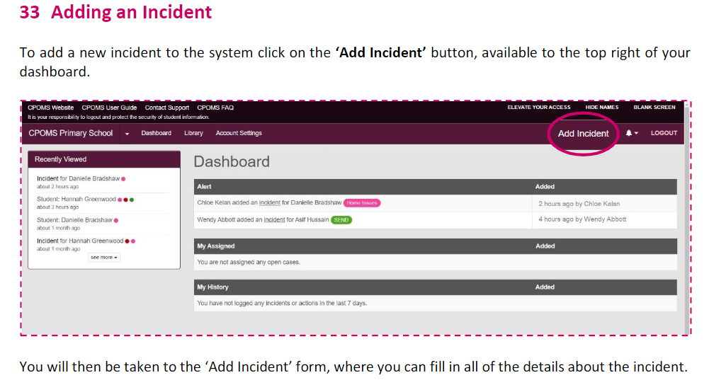

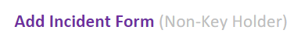
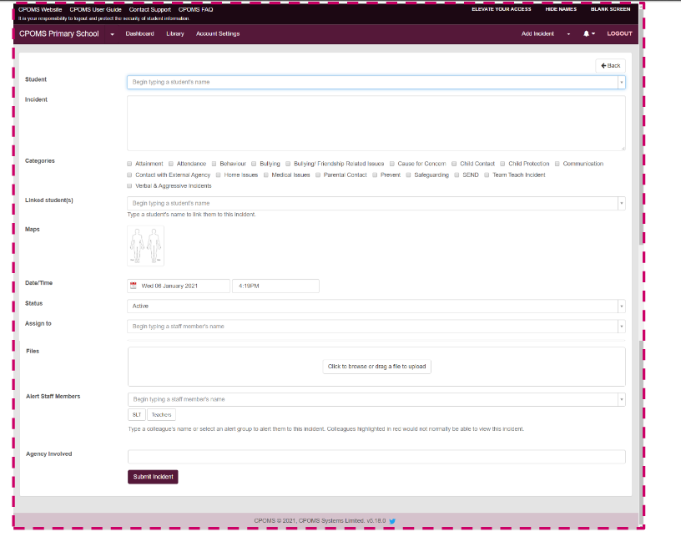

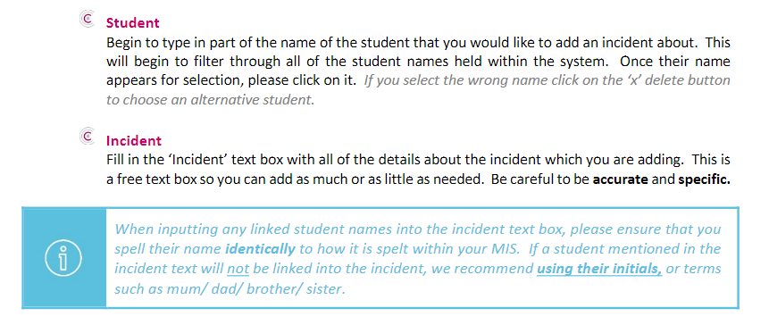

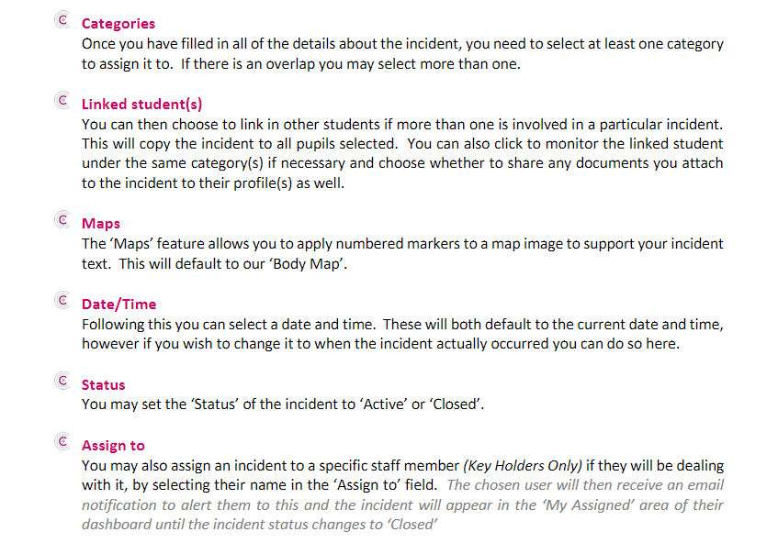
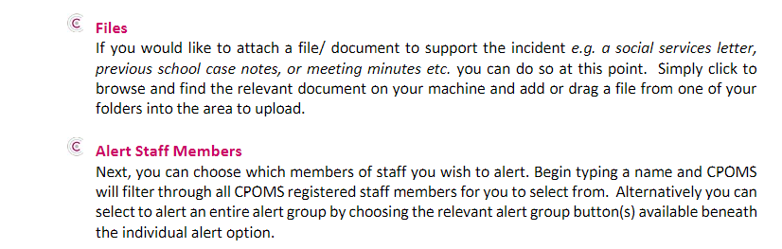

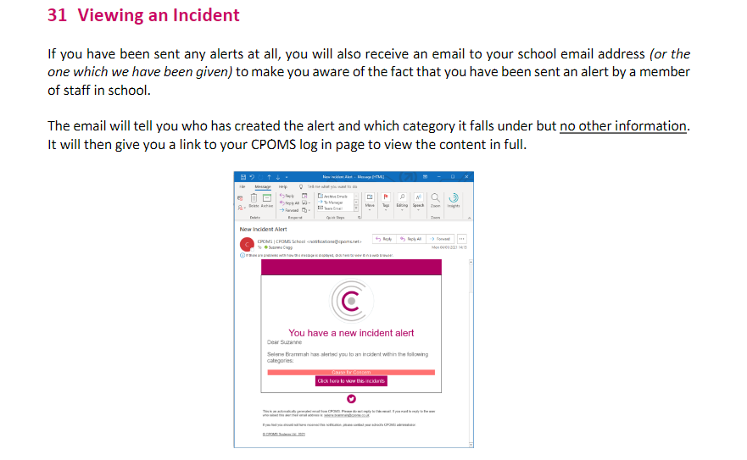
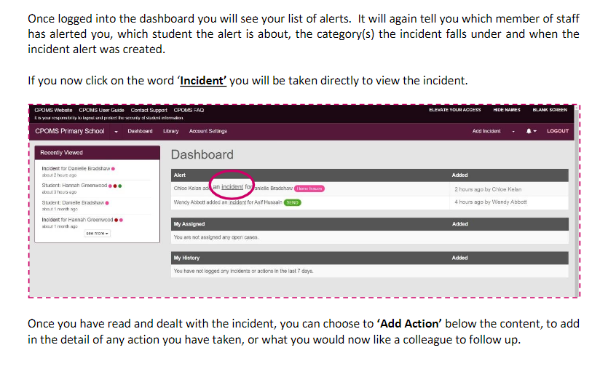
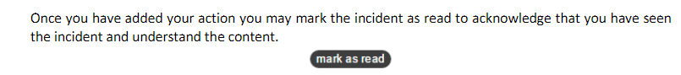

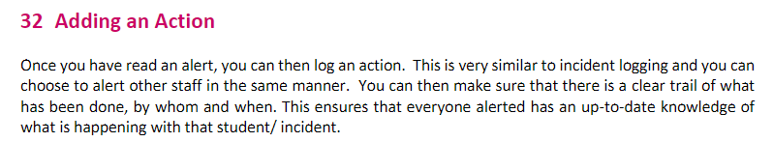
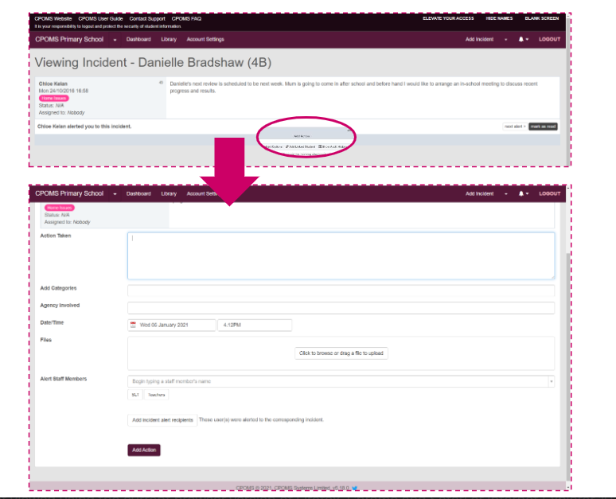
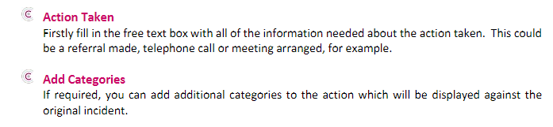
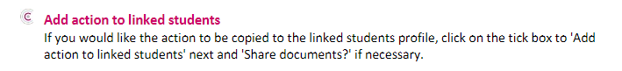
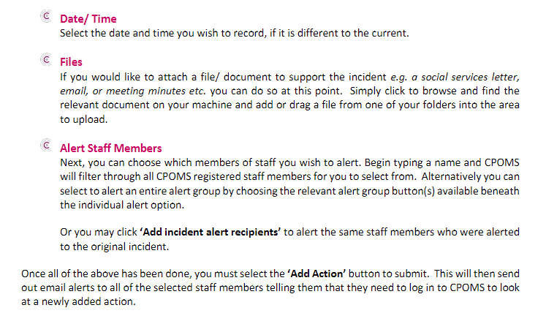

ANNEX 4 – local agency procedures

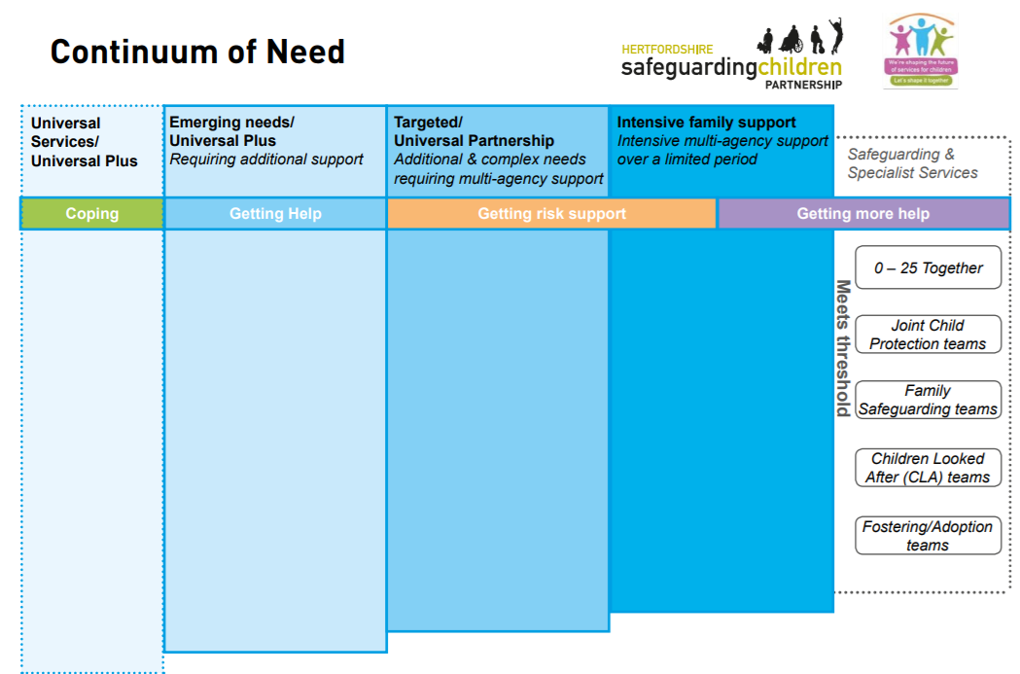

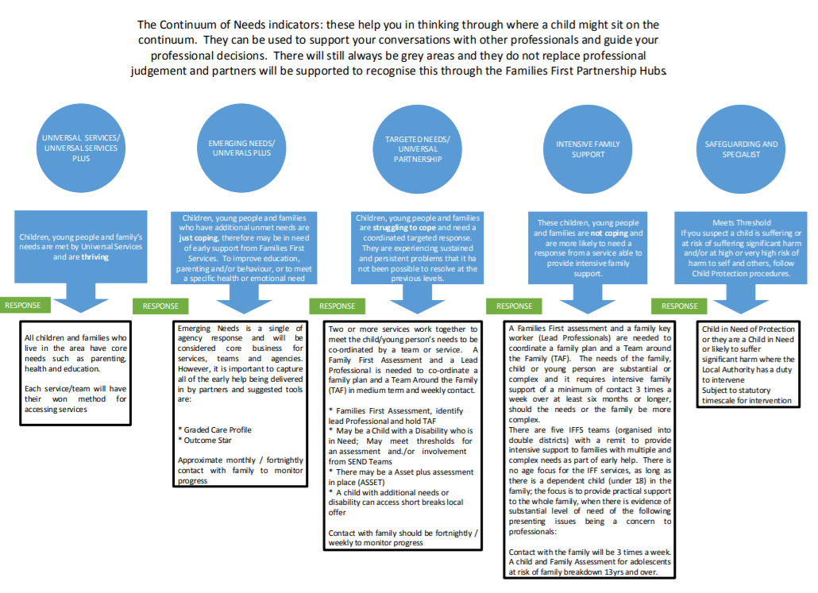

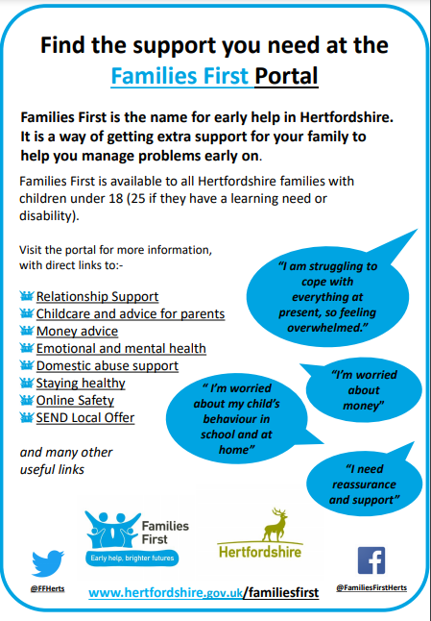
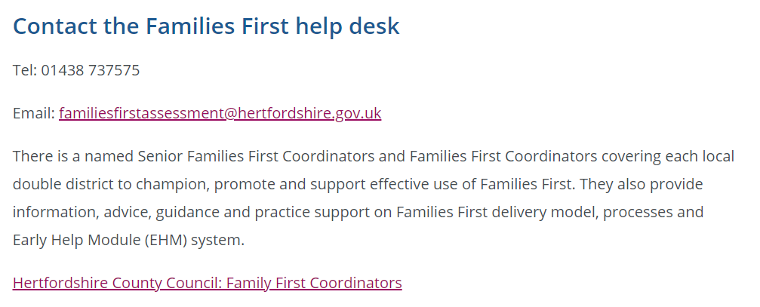

ANNEX 5 – managing allegations

Keeping Children Safe in Education (2021) defines an allegation of abuse against an adult in a school or academy as any case in which it is alleged that an adult (including employed staff, supply staff and volunteers) has:
- behaved in a way that has harmed a child, or may have harmed a child
- possibly committed a criminal offence against or related to a child
- behaved towards a child or children in a way that indicates he or she would pose a risk of harm to children
- behaved or may have behaved in a way that indicates they may not be suitable to work with children

This policy is designed to work in full accordance with the statutory guidelines set out within Part Four, Keeping Children Safe in Education (2021), as well as with local guidelines issued by Hertfordshire Local Authority, both of which describe the expected process for managing allegations in detail. Headteachers, members of the Senior Leadership Team, Deputy Directors of Education and the Chair of Governors will familiarise themselves with both of these documents; however, key principles are summarised below.

Staff awareness
- All staff and volunteers (including Governors) will be issued with our academy’s Code of Conduct, and with this policy, which are intended not only to support them in adopting safe practice in their work with children but also to advise on how to report any concerns about the conduct of a colleague or any practice in our academy which they feel is unsafe for our pupils.
- Staff will also be issued with a copy of our whistleblowing policy; this refers more to concerns of a non-safeguarding nature, but its principles support those of this policy.
- Additionally, all staff and volunteers are signposted to the Ofsted Whistleblower Helpline, 0300 123 3155, and to the NSPCC Whistleblowing Advice helpline, 0800 028 0285.
- Visitors to the academy, including contractor and agency staff, will be provided with relevant information in line with the Visitors’ policy.

Low level concerns
- We recognise that, at times, a concern about an adult’s conduct towards pupils may not be serious enough to be considered as an allegation, but that it nonetheless indicates a concern.
- For the purposes of this policy, a low-level concern is defined as a concern relating to behaviour that is inconsistent with our academy’s Code of Conduct, but does not meet the threshold for an allegation of abuse, as outlined in Keeping Children Safe in Education (2021) and copied above.
- We understand the importance of creating a culture of openness and transparency, where any concern, no matter how small, is shared and dealt with appropriately. Such a culture supports us to identify and address any emerging or inappropriate behaviour at an early stage, minimising the risk of abuse and reinforcing clear professional boundaries.
- Our staff will be trained to recognise appropriate and potentially inappropriate adult conduct, in line with our academy’s Code of Conduct, and they will be required to report any low-level concern about the conduct of any adult working in our academy to the Headteacher. In the event that the concern is about the Headteacher, this should be reported to the Deputy Director of Education and Chair of Governors.
- Staff will be encouraged to recognise any occasion where their own behaviour may be seen as a low-level concern by others, and to make a self-report accordingly.
- Upon receipt of a low-level concern, the Headteacher will take timely and proportionate action to discuss and address this with the person concerned in order to correct the issue at an early stage. The Trust safeguarding and HR teams are available to support with this process if required. If at any stage the Headteacher assesses that there is a risk of harm to pupils, they will follow the process outlined below for reporting a safeguarding concern.
- The Headteacher will keep a written record of all low-level concerns, detailing the nature of the concern and the action taken to address it. The record will be clearly demarcated as a low-level concern, in order to avoid confusion or misunderstanding. Records of low-level concerns will not be referred to in employer references unless they form part of a substantiated allegation.
- The Headteacher will regularly review all low-level concerns received, in order to identify any emerging patterns of concerning behaviour related to individual(s) or to identify any weaknesses in academy culture where revision of policy or additional training may be a requirement.

Reporting a safeguarding concern
- If any adult working in our academy has a safeguarding concern about another adult, or has concerns about another adult posing a risk to children, they should report these concerns. This duty is applied regardless of whether the person about whom there are concerns is an academy staff member, volunteer (including Governors), central staff member or external visitor, i.e. supply teacher.
- All reports of safeguarding concern about academy staff, an academy volunteer (including Governors) or external visitor must be made directly to the Headteacher. Exceptionally, in the Headteacher’s absence, the report may be made to the next senior member of staff who is acting as the Headteacher in their place.
- Where the safeguarding concern relates to the Headteacher, or to the person acting as the Headteacher in the Headteacher’s absence, it must be reported to the Deputy Director of Education and to the Chair of Governors. Please see Annex 2 for the contact details for these individuals.
- All reports of safeguarding concern about a member of the central team must be made directly to the Headteacher, who will inform the REAch2 Head of Safeguarding. Where the safeguarding concern relates to the Head of Safeguarding, the concern must be reported to the Director of Excellence and Standards.
- If the report of safeguarding concern is made verbally, it must be followed up in writing by the person reporting the concern, as directed by the person to whom the concern has been reported.
- On occasion, we may receive safeguarding concerns from individuals outside of our academy. In this instance, the person to whom the report is made must share the concern in line with processes outlined above. Safeguarding concerns received from external sources will be responded to in the same way as a concern being received from inside the academy.

Referral process
- The Headteacher, members of SLT (in case of the Headteacher’s absence), Deputy Director of Education and Chair of Governors (in case of an allegation being against the Headteacher) will know the name and contact details for the Local Authority Designated Officer (LADO), with whom contact will be made as soon as possible upon receipt of an allegation against a member of staff or volunteer at our academy, and always within one working day.
- If further investigation or action is required, the person referring the concern to the LADO will then be nominated as the ‘case manager’. If the specific circumstances warrant, or if the case is unusually complex, the case manager role may be taken on by a professional independent to our academy, i.e. a colleague from within REAch2 Academy Trust.
- In the event of a safeguarding concern being raised about an adult not directly employed by the academy, i.e. a supply teacher, the same process will be followed to contact the LADO. Additionally, the Headteacher will liaise with the individual’s employer subsequent to the referral to ensure full cooperation and involvement with any process required to investigate and resolve the concern that has been raised.
- In the event of any referral to LADO being made, the referrer will immediately inform their REAch2 safeguarding lead, who will support with the subsequent process. If the referral relates to the Headteacher, the REAch2 Head of Safeguarding will be immediately informed.

Information sharing
- When directed to by the LADO, the case manager will inform the accused person of the allegation and will give as much information as possible about its nature. We have a duty of care to our employee/volunteer, and will provide effective support to anyone in this situation, as well as ensuring that the matter is dealt with quickly, fairly and consistently.
- As directed by the LADO, the case manager will also tell the parents of the child or children involved of the allegation (if they are not already aware) and will keep them informed as to the progress and outcome of the process.

Managing the situation
- As directed by the LADO, and in consultation with the REAch2 HR and/or safeguarding teams, we will assess the possible risk posed by the accused individual if they are to continue in their role. This assessment may result in suspension if the risk is considered sufficient and if all suitable alternative options have been considered.
- If a member of staff or volunteer who is judged to be unsuitable to work with children resigns or their services cease to be used, we will assess the situation against the published DBS criteria, and, in the case of teachers, Teaching Regulation Agency criteria, and will follow up with a referral to either or both regulatory bodies where necessary. A compromise or settlement agreement will not be used in cases where this would prevent a referral to DBS being made, as to do so could result in a criminal offence and is non-compliant with our legal duty.
- One-off and/or repeated allegations of malicious, false, unfounded or unsubstantiated conduct will not be referred to in employer references.
- Where an allegation has been found to be malicious, we will consider whether to take further action, either via the Behaviour policy (in the case of a pupil) or via discussion with the Police (in the case of a parent or other adult)

Record keeping
- Full details of each stage of the allegations process will be recorded in writing by the Case Manager.
- Where an allegation has been found to be malicious, i.e. the allegation is disproved and there has been a deliberate attempt to deceive, all details and records will be removed from the person’s personnel file.
- For allegations found to be substantiated, false, unfounded or unsubstantiated, details of the allegation and the investigation process, including the outcome, will be kept as per the Disciplinary policy, but usually separately and confidentially to the person’s personnel file, with a copy also provided to the person concerned.
- Records will be retained for a period of 10 years from the date of the allegation, or until the accused has reached pension age (if this is sooner)

Learning lessons
- As soon as is practicable, all involved parties (including academy leaders, members of the Trust HR and/or safeguarding teams, and LGB members, as appropriate) will convene to review the facts of the case, reflect on any lessons to be learned, and implement any needed changes to policy and/or procedure. Where applicable, this will include reference to any feedback given by the LADO.

ANNEX 6 – COVID-19 self-isolation

During the ongoing challenges of the COVID-19 pandemic, safeguarding will continue to operate in line with statutory expectations outlined in Keeping Children Safe in Education (2021) This annex outlines the specific actions that our academy will take, in addition to the main safeguarding and child protection policy, to safeguard pupils in the event of self-isolation.

We are committed to ensuring the safety and wellbeing of all of our pupils. We will continue to be a safe space for all pupils to attend and flourish. Senior Leaders will ensure that appropriate staff are on site for the operation of our provision. Our staff to pupil ratio numbers are in line with Government and DfE requirements, as well as being appropriate to the number, age and understanding of the pupils who are attending. This includes staff designated to undertake First Aid, and those supporting pupils with EHC plans.

To promote good physical health, we will refer to the Government guidance for education and childcare settings on maximum safe group size, how to implement social distancing, and continue to follow the advice from Public Health England on handwashing and other measures to limit the risk of spread of COVID-19. The specific measures we are taking to promote good physical health, in line with DfE and Public Health England guidance, is detailed in our academy risk assessment, completed as part of the REAch2 risk management process.

We recognise that, for any pupils who are required to access education remotely during the period of self-isolation, new safeguarding concerns may have arisen that have previously been unknown due to the lack of face to face contact between pupils and staff during the time away from school. The current circumstances may also affect a child’s mental health, and this may be displayed in a number of different ways. The DSL and Deputy DSLs are alert to any changes in a pupil’s behaviour, presentation and mood, and will support them, in collaboration with their parents, to manage any worries or anxieties that they may have. They will also support and train staff, as required, prior to pupils returning to ensure that any potential safeguarding concerns are recognised and reported, and they will support staff to ‘check in’ with pupils as they return to school and thereafter on a regular basis. Where necessary, bespoke additional input from academy staff or from specialist staff/support services will be arranged, and the DSL and Deputy DSLs will continue to co-ordinate with children’s social care, local safeguarding partners and other agencies and services to safeguard pupils as required.

Attendance
If any pupil does not return to school as expected following a period of self-isolation appropriate enquiries will be made to ascertain the pupil’s whereabouts, in line with the attendance policy. This may involve referral to the Local Authority, Social Care and/or to the Police to check the pupil’s welfare. Parents are requested to inform the academy as soon as possible if their child is not attending school and the reasons for their absence.

We are aware that a very small number of pupils will still not be able to attend school due to being classed as clinically extremely vulnerable and having received a shielding letter. Absence in these circumstances will be authorised. We will continue to provide remote education to pupils who are unable to attend school for reasons of shielding, which will include pastoral support. If a pupil with a Social Worker is unable to attend school, the Social Worker will be informed.

We recognise that a number of parents and pupils may be anxious about their children coming to school during the pandemic. We will share all available information with families to reassure them of the actions we are taking to minimise infection risk, and to encourage the pupil’s return to school. We will work closely with other professionals, including Social Care and the Hertfordshire Attendance Service to promote daily attendance at school, in line with our attendance policy. If a pupil with a Social Worker does not return to school or does not attend regularly, the Social Worker will be informed.

Safeguarding pupils who are not in school due to self-isolation
We will continue to follow DfE guidance in ensuring our pupils are maintained in consistent groups, or ‘bubbles’, in order to reduce the risk of infection transmission, and to move quickly and easily identify those who need to self-isolate in the case of a positive COVID-19 test. If a positive COVID-19 test does occur for a pupil or staff member, we are aware that, upon advice from the DfE and Public Health England, this bubble will need to self-isolate at home for 10 days and will not be able to attend school during this time. One or more of our pupils may also be required to self-isolate at any time due to contact with an infected person outside of school. Our safeguarding responsibilities for these pupils whilst isolating at home remains our highest priority.

A minimum of one person from the safeguarding team, as listed earlier in this policy, will be designated to be responsible for safeguarding of pupils who are unable to attend school due to self-isolation. They will typically be available in person at the academy or, in exceptional circumstances, remotely. Staff working in the academy will be aware of the name and location of the designated safeguarding person on duty, and their contact details (phone and email) will be shared, as required.

The Designated Safeguarding Lead and their Deputy will continue to liaise closely with the Local Authority, Social Work teams, Early Help and Family Support teams, and the Virtual School, as applicable, to support any vulnerable pupil who is self-isolating. Any professionals’ meetings, i.e. core groups, child protection conferences, will be attended remotely where the facility from the Local Authority and the academy allows; in the event that this is not possible, a written report will be submitted. If a pupil with a Social Worker is self-isolating, the Social Worker will be informed.

To support and safeguard pupils known to be vulnerable whilst they are not attending school due to self-isolation, the following procedures have been put in place, as a minimum:

- Review the vulnerable pupil list and identify those for whom self-isolation and a lack of face-to-face contact with academy staff would pose most risk, allocating each child to a member of the DSL team
- Ensure pupil contact details are up to date and are remotely accessible by all DSLs
- Ensure all DSLs have remote access to email and CPOMS
- Make regular (no less than weekly) phone contact with each identified pupil to check safety and wellbeing; where possible, speaking to the pupil and not just the parent
- Record a summary of conversation on CPOMS
- Monitor CPOMS and emails daily, and respond as required in line with the main safeguarding and child protection policy and Local Authority thresholds

Where contact with a vulnerable pupil who is self-isolating is difficult to achieve or maintain, every effort will be made to contact parents through all available means of communication, i.e. phone, text, email. At the discretion of the Headteacher, a home visit may also be considered. In all cases, this will follow a clear COVID-19 risk assessment, including instructions to staff to promote good hygiene and maintain social distancing. If there are concerns about the welfare of a pupil where contact has not been established, we will follow our Local Authority Social Care referral processes.

We recognise that school is a protective factor for our pupils, and that self-isolation may affect the mental health of these pupils, as well as their parents. All staff will be aware of this in setting expectations of pupils’ work to be completed at home, and in any other communications with parents and pupils. Any concerns for either parents or pupils related to mental health will be recorded and responded to in line with the main safeguarding and child protection policy.

Reporting a concern
If staff have a safeguarding concern about a pupil who is self-isolating, they should follow the usual process as per the main safeguarding and child protection policy. In the event that staff working remotely do not have access to the necessary device or systems for recording their concern, they must contact the named person responsible for safeguarding on the day in question via phone in order to make a verbal report. Staff are reminded of the need to report any concern immediately and without delay; where a concern is urgent and high risk, a verbal report must be made first, either in person or via phone, and followed up in writing as soon as possible thereafter. CPOMS will be monitored by the DSL team regularly, no less than daily, and actions will be completed and recorded in line with the main safeguarding policy and Local Authority thresholds, including those for Early Help.

Online safety
Our academy will support the learning of pupils who are self-isolating via Seesaw. Any staff member who is communicating with parents and/or pupils on this platform has been issued with guidance regarding safe, acceptable and professional behaviour when interacting with pupils online, in line with our academy’s code of conduct. Staff must only use approved devices and platforms to communicate with pupils, and a record of all interactions (excluding scheduled lessons) must be kept, with a record of the date, time, length and purpose/nature of the interaction.

Advice for parents regarding keeping their child safe online while at home has been shared via letter/parent mail/social media, which will be regularly updated to ensure it remains high profile for our parents. This will also include sources of support for pupils themselves, at an age and stage appropriate level.

It is important that all staff continue to look out for signs a pupil may be at risk when online. Any such concerns will be dealt with as per the main safeguarding and child protection policy, and, where appropriate, referrals will be made in line with Local Authority thresholds.

Safeguarding support
The REAch2 safeguarding team will provide remote support as required to academies, DSLs and other academy leaders to enable safeguarding to operate effectively. This may involve secure remote access to files and record keeping for the purposes of quality assurance, guidance and direction. Support to DSLs in the event of concerns about the practice or decision making of external agencies with regards to the safeguarding of a pupil will be provided in line with Trust guidance on safeguarding escalation.

Review
This annex will be reviewed by REAch2’s Head of Safeguarding in line with any updates issued by DfE to ensure it remains compliant with Government expectations.

