Dear Parents and Carers,

This afternoon the children enjoyed a whole school assembly online discussing GCA’s involvement in Red Nose Day this year. Do have a chat with them about what they have learnt: of special interest, we learnt about a 9-year-old boy called Ethan who suffers from cerebral palsy and attends a support centre once a week funded by Red Nose Day.

This year on Friday 19th March, our children will be participating in an afternoon activity to fund raise money for Red Nose Day. Led by their School Council representative, each Bubble will agree their own activity. Decisions will be made about what this activity will be over the forthcoming days and your child’s teacher will let you what the children have agreed. We are excited to find out what they choose to do! After the event we will share with the whole school what the individual bubbles have been up to.

In the meantime, the children will be bringing home a ‘Help get the UK smiling’ poster. We are asking the children to kick-start a wave of smiles from their class bubble to the next, and onwards all around GCA. We are inviting them to add their favourite joke to their poster, and decorate it with smiles for entry into a competition. School Council have risen to the challenge and are going to judge the competition. To enter we would like the children to make a small contribution of a minimum 50p. Please ensure entries are returned to school by no later than Wednesday 17th March to allow them to be judged.

Given current times, we are giving parents the option of donating through our Just Giving Page for Red Nose Day 2021. Alternatively, children can bring in cash, preferably in a sealed, named envelope

The link is as follows; https://www.justgiving.com/fundraising/garden-city-academy-rednoseday21-c856a2b7-dec4-45e7-897e-1d9d818d5c63

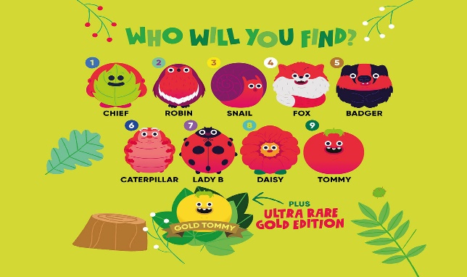

Finally, we will be selling at school for a minimum cost of £1.50 red noses. The children have today been learning that after some lobbying of Red Nose Day, all noses will be environmentally friendly this year. These have taken over 18 months to develop, following extensive research and testing into suitable plastic-free alternative materials. In keeping with the environmentally friendly theme, the Noses will be available in 10 different characters representing the great outdoors for the public to collect, including a squirrel, fox, badger and more. We do require cash only for these as the school have had to pay for them in advance. Unfortunately, you cannot pay using our Just Giving page.

The red noses will be taken around the Bubbles at allocated times and again, your child’s teacher will let you know when.

We look forward to enjoying Red Nose Day with the children, especially in these challenging times, and as we have today told the children we cannot make the country smile without everyone at GCA smiling too!

Thank you for your continued support.

Mrs. Sara Allen

