Relationships and Health Education policy

Audience: | REAch2 Staff  Local Governing Bodies  Trustees  Parents
Ratified: | By Local Governing Body
Other related policies: | Anti-bullying policy  Behaviour policy  Safeguarding and child protection policy  SEND/Inclusion policy
Policy owner: | Gill Ellyard
Review: | July 2027, in line with national curriculum review  Every three years thereafter

At REAch2, our actions and our intentions as school leaders are guided by our Touchstones.

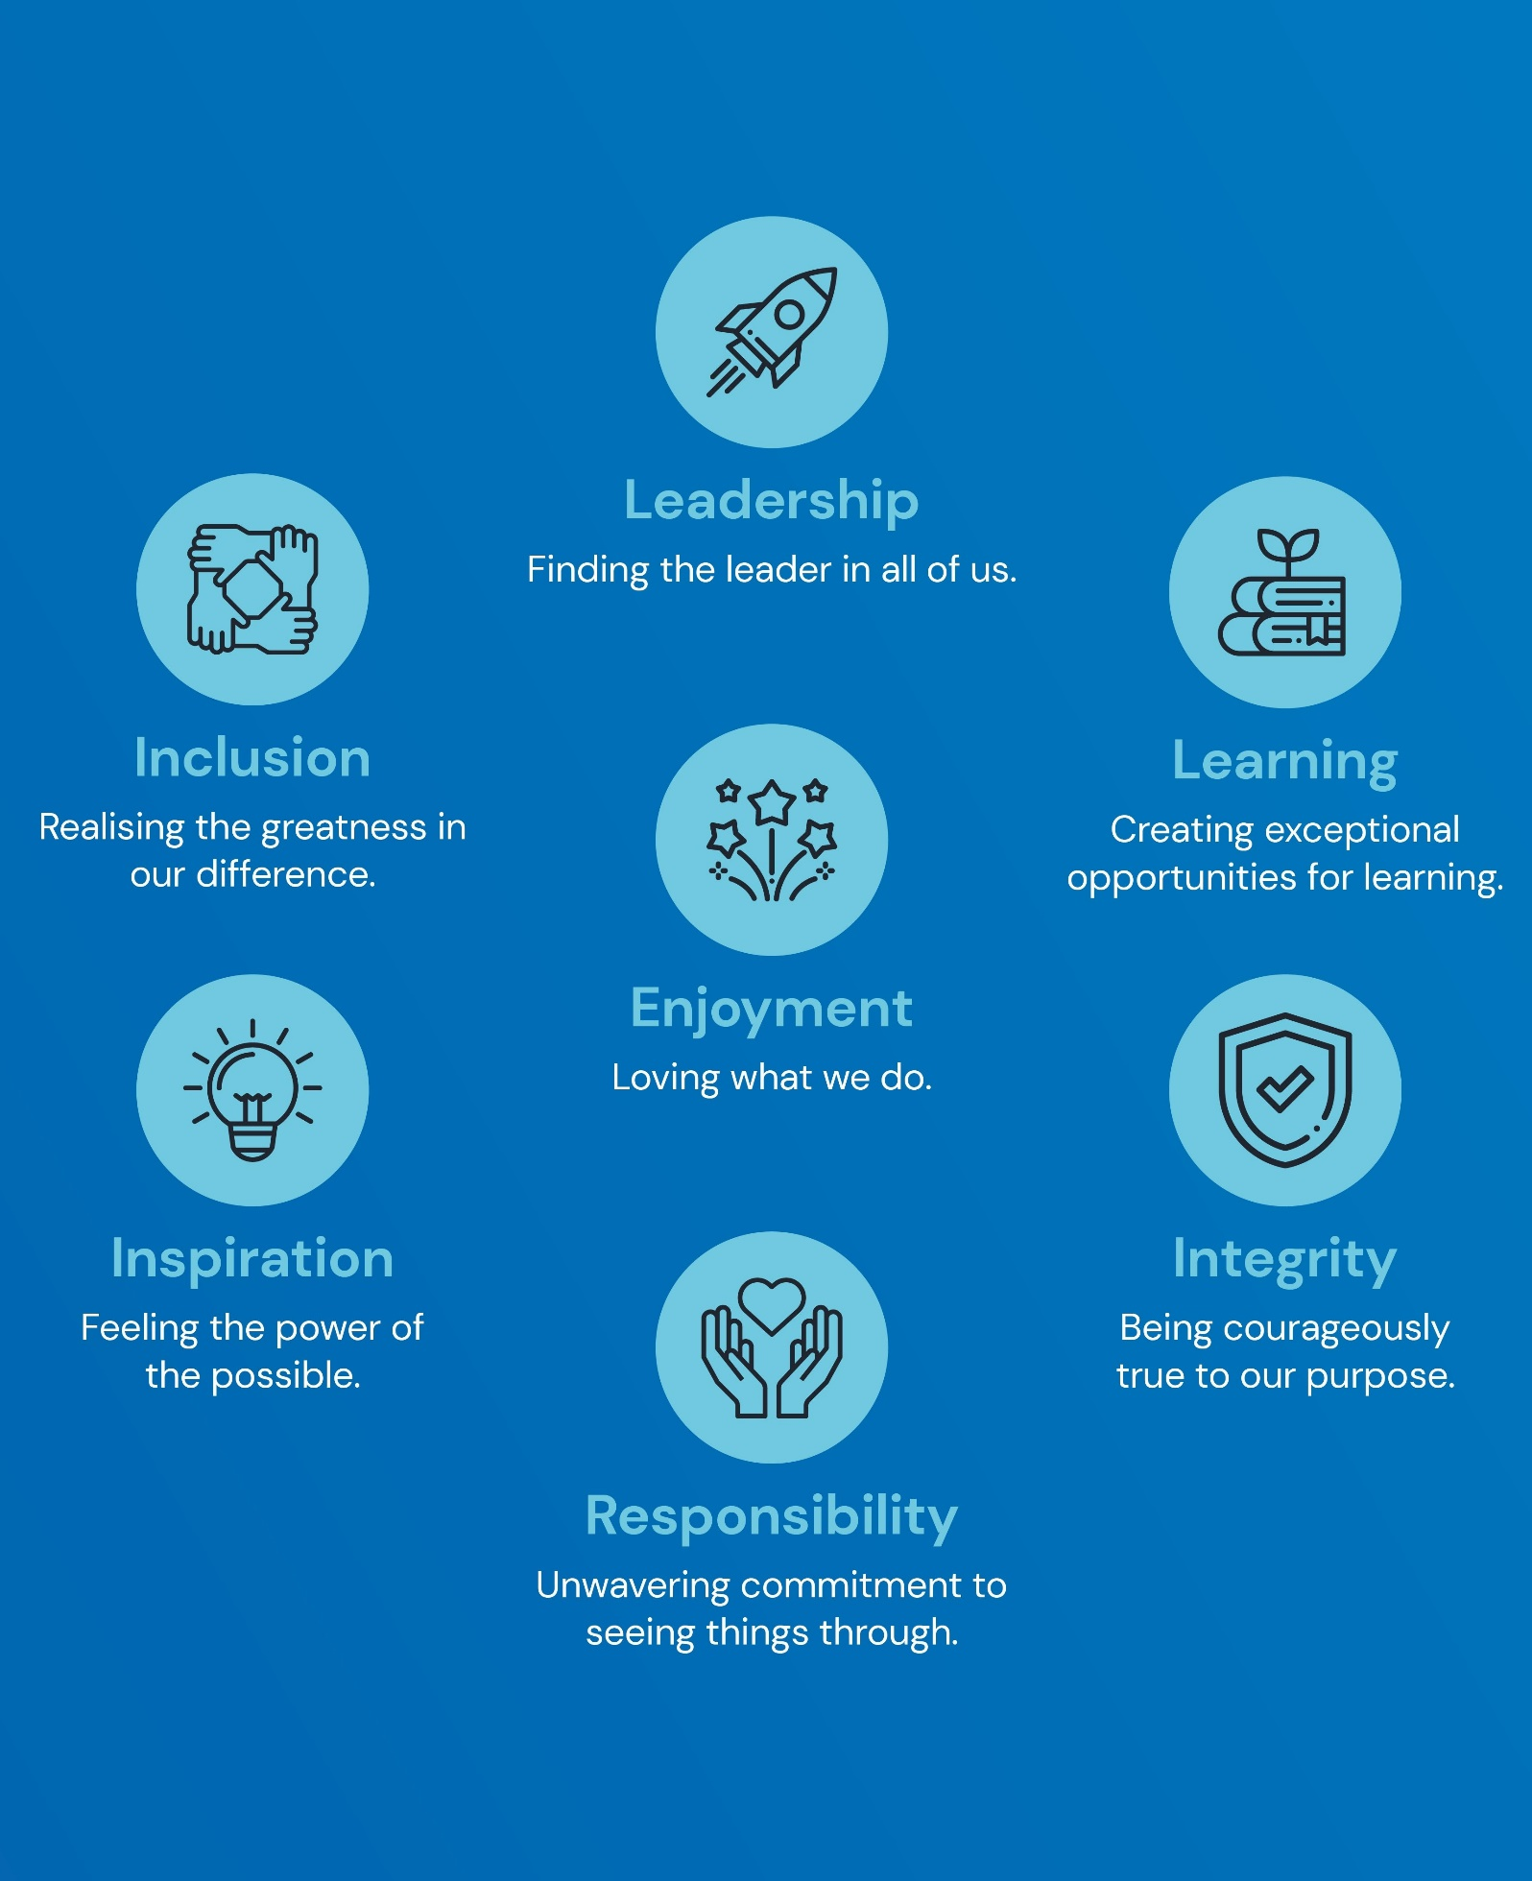

Policy Overview 4
Overarching principles 4
How this relates to national guidance and statutory requirements 4
Roles and responsibilities 4
Policy In Detail 6
Organisation of the curriculum 6
Equality and accessibility 7
Sex education 8
Consultation with parents 8
Withdrawing from the subjects 9
Working with external experts 9
Staff training 10
Confidentiality 10
Policy Review 10
Appendix 1a, statutory curriculum content - relationships education 11
Appendix 1b, statutory curriculum content – health education 14
Appendix 2a, our curriculum design for relationships education 17
Appendix 2b, our curriculum design for health education 18
Appendix 3, our curriculum design for sex education (non-compulsory content) 19

Policy Overview

Overarching principles

Pupils must be provided with an education that prepares them for the opportunities, responsibilities and experiences of adult life. A key part of this is relationships education, which must be delivered to every primary-aged pupil. Relationships education focusses on the knowledge pupils need to make informed decisions about their wellbeing, health and relationships, and to build their self-efficacy. State-funded primary schools are also required to teach health education. Health education focusses on equipping pupils with the knowledge they need to make good decisions about their own health and wellbeing.
We understand our responsibility to deliver a high-quality, age-appropriate and evidence-based relationships and health curriculum for all our pupils. This policy sets out the framework for our relationships and health curriculum, how it is informed, organised and delivered.

How this relates to national guidance and statutory requirements

This policy has due regard to all relevant legislation and statutory guidance including, but not limited to, the following:
  - Section 80A of the Education Act 2002
  - Children and Social Work Act 2017
  - The Relationships Education, Relationships and Sex Education and Health Education (England) Regulations 2019
  - Equality Act 2010
  - Relationships Education, Relationships and Sex Education (RSE) and Health Education (DfE)
  - Science programmes of study: key stages 1 and 2 (DfE)
  - Teaching about relationships, sex and health (DfE)
  - Keeping children safe in education (DfE)

Roles and responsibilities

The governing board is responsible for:
  - Ensuring all pupils make progress in achieving the expected educational outcomes
  - Ensuring the curriculum is well led, effectively managed and well planned
  - Evaluating the quality of provision through regular and effective self-evaluation
  - Ensuring teaching is delivered in ways that are accessible to all pupils with SEND
  - Providing clear information for parents on subject content and their rights to request that their children are withdrawn
  - Making sure the subjects are resourced, staffed and timetabled in a way that ensures the school can fulfil its legal obligations

The headteacher is responsible for:
  - The overall implementation of this policy
  - Ensuring staff are suitably trained to deliver the subjects
  - Ensuring that parents are fully informed of this policy
  - Reviewing requests from parents to withdraw their children from the subjects
  - Discussing requests for withdrawal with parents
  - Organising alternative education for pupils, where necessary, that is appropriate and purposeful
  - Reporting to the governing board on the effectiveness of this policy
  - Reviewing this policy on an annual basis

The relationships and health education subject leader is responsible for:
  - Overseeing the delivery of the subjects
  - Ensuring the subjects are age-appropriate and high-quality
  - Ensuring teachers are provided with adequate resources to support teaching of the subjects
  - Ensuring the school meets its statutory requirements in relation to the relationships and health curriculum
  - Ensuring the relationships and health curriculum is inclusive and accessible for all pupils
  - Working with other subject leaders to ensure the relationships and health curriculum complements, but does not duplicate, the content covered in the national curriculum
  - Monitoring and evaluating the effectiveness of the subjects and providing reports to the headteacher

All teachers are responsible for:
  - Delivering a high-quality and age-appropriate relationships and health curriculum in line with statutory requirements
  - Using a variety of teaching methods and resources to provide an engaging curriculum that meets the needs of all pupils
  - Ensuring they do not promote personal views or beliefs when delivering the programme
  - Modelling positive attitudes to relationships and health education
  - Responding to any safeguarding concerns in line with the safeguarding and child protection policy
  - Acting in accordance with planning, monitoring and assessment requirements for the subjects
  - Liaising with the SENCO to identify and respond to individual needs of pupils with SEND
  - Working with the relationships and health education subject leader to evaluate the quality of provision

The SENCO is responsible for:
  - Advising teaching staff how best to identify and support pupils’ individual needs.
  - Advising teaching staff on the use of support staff in order to meet pupils’ individual needs.

Policy In Detail

Organisation of the curriculum

Every primary school is required to deliver statutory relationships education and health education. Relationships education is defined in DfE guidance as ‘the skills and knowledge that form the building blocks of all positive relationships, supporting children from the start of their education to grow into kind, caring adults who have respect for others and know how to keep themselves and others safe.’ Health education is defined in DfE guidance as ‘the benefits and importance of physical activity, good nutrition and sufficient sleep, and support to develop emotional awareness.’
Our relationships and health curriculum has been organised in line with the statutory requirements outlined in the DfE statutory guidance. Please see appendix 1 for the statutory requirements in full.
The content of relationships education and health education strongly link with one another and will be delivered as part of the school’s PSHE curriculum. We have organised our curriculum so that it is appropriate for the age and developmental stages of pupils within each year group, taking into account the backgrounds, needs and experiences of all pupils and their families so that the topics that are covered are taught appropriately. A progressive curriculum has been planned, in which topics build upon prior knowledge taught in previous years as pupils progress through school, with a view to providing a smooth transition to the next stage of education. We are committed to ensuring our curriculum meets the needs of our community; therefore, it is informed by issues in the school and wider community to ensure it is tailored to pupils’ needs. Please see appendix 2 for more information on our school’s curriculum content.
Teaching of the curriculum reflects requirements set out in law so that pupils understand what the law does and does not allow, and the wider legal implications of the decisions they make. Pupils will be taught the facts and the law about sex, sexuality, sexual health and gender identity in an age-appropriate, inclusive and respectful way. We will endeavour to support all pupils to feel that the content is relevant to them and their development. When pupils are being taught about relationships, a full range of family and structures and types of relationship will be reflected in the lesson content. This will be fully integrated into the curriculum, rather than delivered as a standalone unit or lesson.
Any resources or materials used to support learning will be formally assessed by the relationships and health education subject leader before use to ensure they are appropriate for the age, development and needs of pupils. Throughout every year group, appropriate diagrams, videos, books, games, discussion and practical activities will be used to assist learning. Pupils will be prevented from accessing inappropriate materials when using the internet to assist with their learning, in line with our safeguarding and child protection policy.
Our curriculum will aim to reduce any stigma and encourage openness through discussion activities and group work. Teachers will ensure a focus on challenging any perceptions of pupils linked to protected characteristics through exploration of, and developing mutual respect for, those different to themselves. We will ensure that pupils’ views are listened to and will encourage them to ask questions and engage in discussion. Questions will be answered sensitively, honestly and in a manner appropriate to the pupil’s age. Pupils will be encouraged to participate respectfully in class discussions of sensitive issues. Teachers will stop class discussions in the event that pupils begin to reveal personal, private information related to sensitive issues. If teachers feel concerned about anything shared by a pupil, they will follow the safeguarding and child protection policy to respond to this.
We will seek opportunities to draw links between relationships and health education and other curriculum subjects wherever possible to enhance pupils’ learning. Relationships and health education will be linked to the following subjects in particular:
  - Science – pupils learn about the main external parts of the body and changes to the body as it grows from birth to old age, including puberty.
  - Computing and ICT – pupils learn about online safety, including how to use technology safely, responsibly, respectfully and securely, how to keep personal information private and how to access help and support.
  - PE – pupils explore various physical activities, are physically active for sustained periods of time, engage in competitive sport and understand how exercise can lead to healthier lifestyles.
  - Citizenship – pupils learn about the requirements of the law, their responsibilities and the possible consequences of their actions.
  - PSHE – pupils learn about respect and difference, values and characteristics of individuals.

Whilst there are no formal assessments for the relationships and health curriculum, informal assessments will be undertaken to determine pupil progress. These may include tests, quizzes, written tasks, group work, projects and presentations.

Equality and accessibility

We understand our responsibilities in relation to the Equality Act 2010, specifically that it must not unlawfully discriminate against any pupil because of their protected characteristics. These include:
  - Age
  - Sex or sexual orientation
  - Race
  - Disability
  - Religion or belief
  - Gender reassignment
  - Pregnancy or maternity
  - Marriage or civil partnership
We are committed to making reasonable adjustments wherever possible to promote accessibility and inclusivity of the curriculum. We understand that pupils with SEND or other needs, such as those with social, emotional or mental health needs, are entitled to learn about relationships and health education, and the programme will be designed to be inclusive of all pupils. Teachers will understand that they may need to be more explicit and adapt their planning of work and teaching methods in order to appropriately deliver the programme to pupils with SEND or other needs.
Provisions under the Equality Act 2010 allow us to take positive action, where it can be evidenced to be proportionate, to respond to particular disadvantages affecting a group because of a protected characteristic. For example, we could consider taking positive action to support girls if there was evidence that they were being disproportionately subjected to sexual violence or sexual harassment. When deciding whether support is necessary to support pupils with a particular protected characteristic, we will consider our pupils’ needs, including the gender and age range of our pupils.
We understand that relationships and health education may include topics which are triggers for teaching staff, and could relate to historic, recent, or current trauma. We encourage staff to approach their line manager to discuss this.

Sex education

All pupils must be taught the required content linked to sex education outlined in the national curriculum for primary science. This includes teaching about the main external parts of the human body, how it changes as it grows from birth to old age, including puberty, and the reproductive process in some plants and animals.
Sex education, beyond what is required of the national curriculum, is not compulsory for primary age pupils; however, it is recommended by the DfE for pupils in Yr 5 and Yr 6 in line with content about conception and birth.
We do teach non-compulsory sex education in Yr 5 and Yr 6, in line with government recommendations. Please see appendix 3 for more information on our curriculum content.

Consultation with parents

We understand the important role parents play in enhancing their children’s understanding of relationships and health. We also understand how important parents’ views are in shaping the curriculum. We work closely with parents to ensure their views are fully heard and considered by establishing open communication, and opportunities for consultation and feedback.
We will consult parents upon implementation of this policy and during any period of policy review. Consultation may take the following forms:
  - Questionnaire or survey
  - Focus group
  - Meeting
  - Training session
  - Newsletter

At appropriate points throughout the school year, parents will be provided with information about the content of the relationships and health curriculum, what is being taught in their child’s year group, the resource that will be used to support the curriculum, and the right to withdraw from certain content. We will be transparent about the content, resources and materials used in the delivery of the relationships and health curriculum. A representative sample of these will be viewable by parents during meetings, and all materials are available to be viewed upon request. We will engage openly with all parents to hear their feedback and take on board any concerns. Parents are not able to determine or dictate what curriculum materials are used, or when content is taught.
Any parent wishing to provide feedback about the curriculum outside of designated meetings can do so at any time during the academic year by requesting a meeting with the class teacher.
The statements above regarding parental consultation also apply to our school’s curriculum content for non-compulsory sex education.

Withdrawing from the subjects

The content of relationships and health education are statutory, and parents do not have the right to withdraw their child from delivery of this.
As sex education is not compulsory at primary level, other than what must be taught as part of the science curriculum, parents have the right to request to withdraw their child from all or part of the non-compulsory sex education curriculum. The headteacher will automatically grant a parent’s request to withdraw their child from non-compulsory sex education. Prior to doing so, we will discuss the request with the parent and, if appropriate, their child, to ensure that their wishes are understood, to clarify the nature and purpose of the curriculum, and to highlight the benefits of receiving this important education alongside any adverse effects that withdrawal may have on the pupil, for example, social and emotional effects of being excluded. The headteacher will keep a record of the discussion and the parent will receive a written confirmation and response to their request. Where a pupil is withdrawn from non-compulsory sex education, the headteacher will ensure that the pupil receives appropriate alternative education.

Working with external experts

External experts may be invited to assist with the delivery of the programme. The intended use of external experts is to enhance the curriculum delivered by teachers, rather than as a replacement for teachers. They will be expected to comply with the provisions of this policy. Before delivery of any session by an external expert, we will:
  - Ensure the lesson the external expert has planned fits with the planned curriculum and this policy
  - Ensure the expert’s credentials are checked before they are able to participate in delivery of the curriculum to ensure they are a suitable adult to work with children
  - Discuss the details of the expert’s lesson plan and ensure that the content is age-appropriate and accessible for the pupils
  - Ask to see the materials the expert intends to use, as well as a copy of the lesson plan, to ensure it meets all pupils’ needs, including those with SEND
  - Agree with the expert the procedures for confidentiality, ensuring that the expert understands how safeguarding reports should be dealt with in line with the safeguarding and child protection policy

Staff training

Members of staff responsible for teaching the subjects will undergo training on a regular basis to ensure they have the knowledge, skills and confidence to create a safe and supportive environment and to facilitate participative and interactive education. Training of staff will also be scheduled around any updated guidance on the programme and any new developments or concerns that may need to be addressed via the curriculum.

Confidentiality

Confidentiality within the classroom is an important component of relationships and health education, and teachers are expected to respect the confidentiality of their pupils as far as is possible. Teachers will, however, share any concerns about pupils in line with the safeguarding and child protection policy. Pupils will be aware of the school’s responsibilities in terms of confidentiality and will be sensitively informed of what action may be taken if a concern is shared.

Policy Review

This policy will be reviewed by the REAch2 Trust Board or designated committee no later than Jul 2027, in line with the expected publication of the national curriculum review. Thereafter, it will be reviewed every 3 years, or sooner if required to take into account any changes to government guidance. In addition, it will be reviewed at school level on an annual basis to incorporate any feedback from staff, pupils or parents. Any changes made to this policy will be communicated to all relevant stakeholders.

Appendix 1a, statutory curriculum content - relationships education

Families and people who care for me
Curriculum content:
1. That families are important for children growing up safe and happy because they can provide love, security and stability.
2. The characteristics of safe and happy family life, such as commitment to each other, including in times of difficulty, protection and care for children and other family members, the importance of spending time together and sharing each other’s lives.
3. That the families of other children, either in school or in the wider world, sometimes look different from their family, but that they should respect those differences and know that other children’s families are also characterised by love and care.
4. That stable, caring relationships are at the heart of safe and happy families and are important for children’s security as they grow up.
5. That marriage and civil partnerships represent a formal and legally recognised commitment of two people to each other which is intended to be lifelong.
6. How to recognise if family relationships are making them feel unhappy or unsafe, and how to seek help or advice from others if needed.

Caring friendships
Curriculum content:
1. How important friendships are in making us feel happy and secure, and how people choose and make friends.
2. That healthy friendships are positive and welcoming towards others, and do not make others feel lonely or excluded. Pupils should learn skills for developing caring, kind friendships.
3. That not every child will have the friends they would like at all times, that most people feel lonely sometimes, and that there is no shame in feeling lonely or talking about it.
4. The characteristics of friendships that lead to happiness and security, including mutual respect, honesty, trustworthiness, loyalty, kindness, generosity, trust, sharing interests and experiences, and support with problems and difficulties.
5. That most friendships have ups and downs, and that these can often be worked through so that the friendship is repaired or even strengthened.
6. How to manage conflict, and that resorting to violence is never right.
7. How to recognise when a friendship is making them feel unhappy or uncomfortable, and how to get support when needed.

Respectful, kind relationships
Curriculum content:
1. How to pay attention to the needs and preferences of others, including in families and friendships. Pupils should be encouraged to discuss how we balance the needs and wishes of different people in relationships and why this can be complicated.
2. The importance of setting and respecting healthy boundaries in relationships with friends, family, peers and adults.
3. How to communicate effectively and manage conflict with kindness and respect; how to be assertive and express needs and boundaries; how to manage feelings, including disappointment and frustration.
4. Pupils should have opportunities to discuss the difference between being assertive and being controlling, and conversely the difference between being kind to other people and neglecting your own needs.
5. That they can expect to be treated with respect by others, and the importance of respecting others, including those who are different (for example, physically, in character, personality or backgrounds), or make different choices, or have different preferences or beliefs.
6. Practical steps they can take and skills they can develop in a range of different contexts to improve or support their relationships.
7. The conventions of courtesy and manners.
8. The importance of self-respect and how this links to their own happiness. Pupils should have opportunities to think about how they foster their own self-esteem and build a strong sense of their own identity, including through developing skills and interests.
9. The different types of bullying (including online bullying), the impact of bullying, responsibilities of bystanders (primarily reporting bullying to an adult), and how to get help.
10. What a stereotype is, how stereotypes can be unfair, negative, destructive or lead to bullying and how to challenge a stereotype.
11. How to seek help when needed, including when they are concerned about violence, harm, or when they are unsure who to trust.

Online safety and awareness
Curriculum content:
1. That people should be respectful in online interactions, and that the same principles apply to online relationships as to face-to-face relationships, including where people are anonymous. For example, the importance of avoiding putting pressure on others to share information and images online, and strategies for resisting peer pressure.
2. How to critically evaluate their online relationships and sources of information, including awareness of the risks associated with people they have never met. For example, that people sometimes behave differently online, including pretending to be someone else, or pretending to be a child, and that this can lead to dangerous situations. How to recognise harmful content or harmful contact, and how to report this.
3. That there is a minimum age for joining social media sites (currently 13), which protects children from inappropriate content or unsafe contact with older social media users, who may be strangers, including other children and adults.
4. The importance of exercising caution about sharing any information about themselves online. Understanding the importance of privacy and location settings to protect information online.
5. Online risks, including that any material provided online might be circulated, and that once a picture or words has been circulated there is no way of deleting it everywhere and no control over where it ends up.
6. That the internet contains a lot of content that can be inappropriate and upsetting for children, and where to go for advice and support when they feel worried or concerned about something they have seen or engaged with online.

Being Safe
Curriculum content:
1. What sorts of boundaries are appropriate in friendships with peers and others (including online). This can include learning about boundaries in play and in negotiations about space, toys, books, resources etc.
2. The concept of privacy and its implications for both children and adults; including that it is not always right to keep secrets if they relate to being safe.
3. That each person’s body belongs to them, and the differences between appropriate and inappropriate or unsafe contact, including physical contact.
4. How to respond safely and appropriately to adults they may encounter (in all contexts, including online), including those they do and do not know.
5. How to recognise when a relationship is harmful or dangerous, including skills for recognising who to trust and who not to trust.
6. How to report abuse, concerns about something seen online or experienced in real life, or feelings of being unsafe or feeling bad about any adult and the vocabulary and confidence needed to do so.
7. How to ask for advice or help for themselves or others, and to keep trying until they are heard. Where to get advice e.g. family, school and/or other sources.

Appendix 1b, statutory curriculum content – health education

General wellbeing
Curriculum content:
1. The benefits of physical activity, time outdoors, and helping others for health, wellbeing and happiness. Simple self-care techniques, including the importance of rest, time spent with friends and family, as well as hobbies, interests and community participation.
2. The importance of promoting general wellbeing and physical health.
3. The range and scale of emotions (e.g. happiness, sadness, anger, fear, surprise, nervousness) that they might experience in different situations. Pupils should understand that worrying and feeling down are normal, affect everyone at different times, and are not in themselves a sign of a mental health condition.
4. How to recognise feelings and use varied vocabulary to talk about their own and others’ feelings.
5. How to judge whether what they are feeling and how they are behaving is appropriate and proportionate.
6. That isolation and loneliness can affect children, and the benefits of seeking support.
7. That bullying (including cyberbullying) has a negative and often lasting impact on mental wellbeing and how to seek help for themselves or others.
8. That change and loss, including bereavement, can provoke a range of feelings, that grief is a natural response to bereavement, and that everyone grieves differently.
9. Where and how to seek support (including recognising the triggers for seeking support), including who in school they should speak to if they are worried about their own or someone else’s mental wellbeing or ability to control their emotions (including issues arising online).
10.That it is common to experience mental health problems, and early support can help.

Wellbeing online
Curriculum content:
1. That for almost everyone the internet is an integral part of life. Pupils should be supported to think about positive and negative aspects of the internet.
2. Pupils should be supported to discuss how online relationships can complement and support meaningful in-person relationships, but also how they might be in tension, and the reasons why online relationships are unlikely to be a good substitute for high quality in-person relationships, looking at the pros and cons of different ways of using online connection.
3. The benefits of limiting time spent online, the risks of excessive time spent on electronic devices and the impact of positive and negative content online on their own and others’ mental and physical wellbeing.
4. How to consider the impact of their online behaviour on others, and how to recognise and display respectful behaviour online.
5. Why social media, some apps, computer games and online gaming, including gambling sites, are age restricted.
6. The risks relating to online gaming, video game monetisation, scams, fraud and other financial harms, and that gaming can become addictive.
7. How to take a critical approach to what they see and read online and make responsible decisions about which content, including content on social media and apps, is appropriate for them.
8. That abuse, bullying and harassment can take place online and that this can impact wellbeing. How to seek support from trusted adults.
9. How to understand the information they find online, including from search engines, and know how information is selected and targeted.
10. That they have rights in relation to sharing personal data, privacy and consent. 11. Where and how to report concerns and get support with issues online.

Physical health and fitness
Curriculum content:
1. The characteristics and mental and physical benefits of an active lifestyle.
2. The importance of building regular physical activity into daily and weekly routines and how to achieve this; for example, walking or cycling to school, a daily active mile or other forms of regular, moderate and/or vigorous physical activity.
3. The risks associated with an inactive lifestyle, including obesity.
4. How and when to seek support including which adults to speak to in school if they are worried about their health.

Healthy eating
Curriculum content:
1. What constitutes a healthy diet (including understanding calories and other nutritional content).
2. Understanding the importance of a healthy relationship with food.
3. The principles of planning and preparing a range of healthy meals.
4. The characteristics of a poor diet and risks associated with unhealthy eating (including, for example, obesity and tooth decay) and other behaviours (e.g. the impact of alcohol on diet or health).

Drugs, alcohol, tobacco and vaping
Curriculum content:
1. The facts about legal and illegal harmful substances and associated risks, including smoking, vaping, alcohol use and drug-taking. This should include the risks of nicotine addiction, which are also caused by other nicotine products such as nicotine pouches.

Health protection and prevention
Curriculum content:
1. How to recognise early signs of physical illness, such as weight loss, or unexplained changes to the body.
2. About safe and unsafe exposure to the sun, and how to reduce the risk of sun damage, including skin cancer.
3. The importance of sufficient good quality sleep for health, the amount of sleep recommended for their age, and practical steps for improving sleep, such as not using screens in the bedroom. The impact of poor sleep on weight, mood and ability to learn.
4. About dental health and the benefits of good oral hygiene, including brushing teeth twice a day with fluoride toothpaste, cleaning between teeth, and regular checkups at the dentist.
5. About personal hygiene and germs including bacteria, viruses, how they are spread and treated, and the importance of handwashing.
6. The facts and scientific evidence relating to vaccination and immunisation. The introduction of topics relating to vaccination and immunisation should be aligned with when vaccinations are offered to pupils.

Personal safety
Curriculum content:
1. About hazards (including fire risks) that may cause harm, injury or risk and ways to reduce risks.
2. How to recognise risk and keep safe around roads, railways, including level crossings, and water, including the water safety code.

Basic first aid
Curriculum content:
1. How to make a clear and efficient call to emergency services if necessary, including the importance of reporting incidents rather than filming them.
2. Concepts of basic first aid, for example dealing with common injuries and ailments, including head injuries.

Developing bodies
Curriculum content:
1. About growth and other ways the body can change and develop, particularly during adolescence. This topic should include the human lifecycle, and puberty should be discussed as a stage in this process.
2. The correct names of body parts, including the penis, vulva, vagina, testicles, scrotum, nipples. Pupils should understand that all of these parts of the body are private and have skills to understand and express their own boundaries around these body parts.
3. The facts about the menstrual cycle, including physical and emotional changes, whilst the average age of the onset of menstruation is twelve, periods can start at eight, so covering this topic before girls’ periods start will help them understand what to expect and avoid distress.

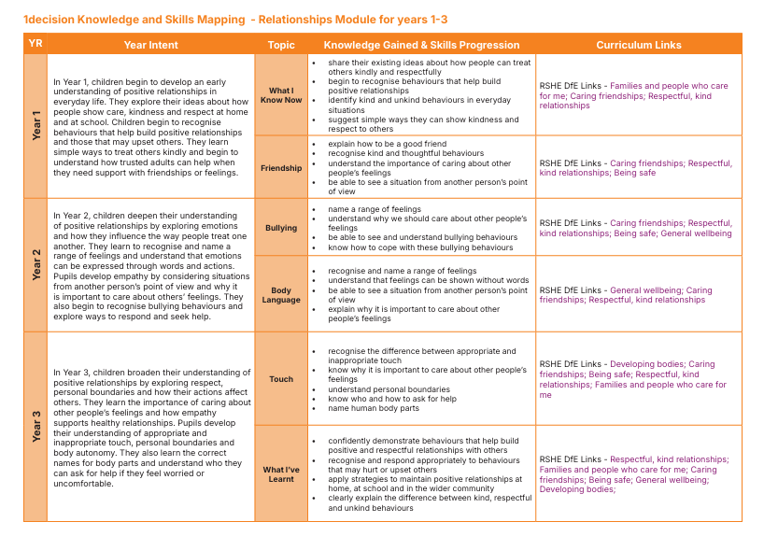
Appendix 2a, our curriculum design for relationships education

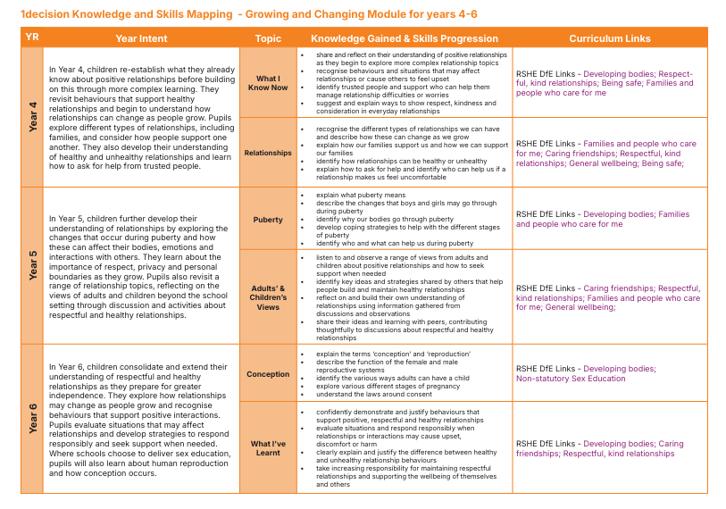

Appendix 2b, our curriculum design for health education
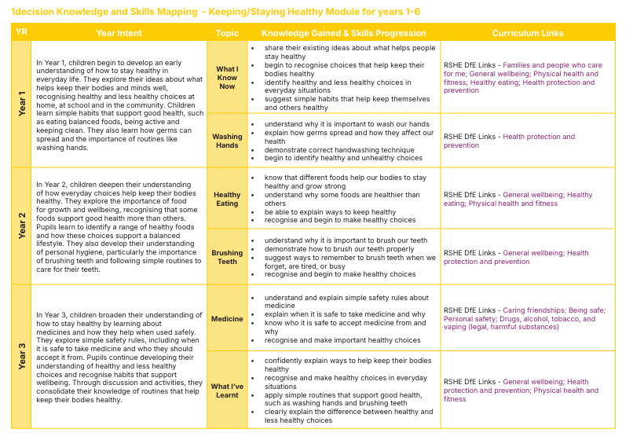

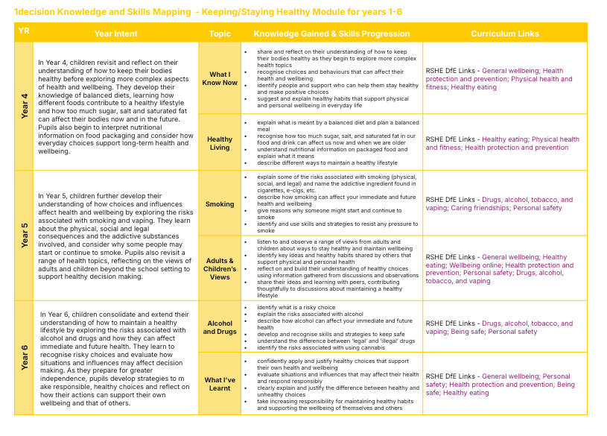

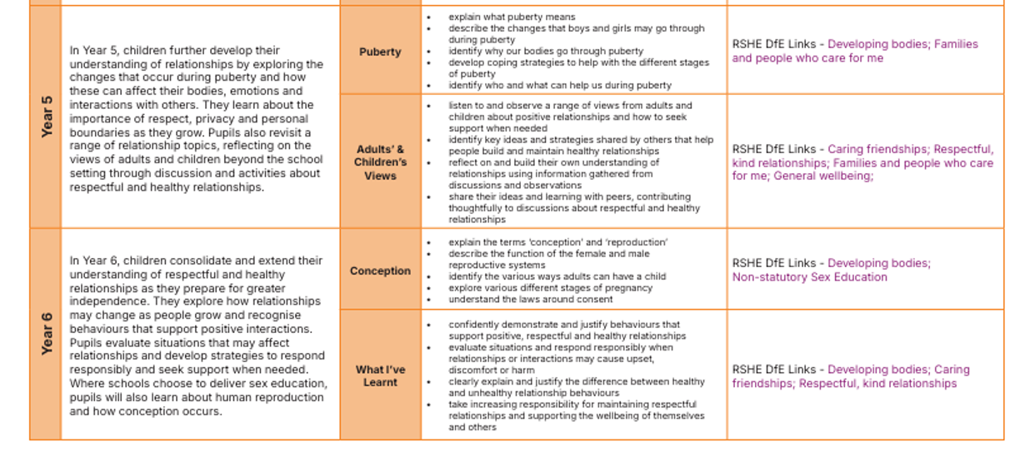
Appendix 3, our curriculum design for sex education (non-compulsory content)

