Restrictive interventions policy

Audience: | REAch2 Staff  Local Governing Bodies  Trustees  Parents
Ratified: | March 2026 (Executives)
Other related policies: | Behaviour  Health and Safety  Safeguarding and child protection  SEND/Inclusion
Policy owner: | Gill Ellyard, Director of Transformation
Review: | Every three years from date of implementation

At REAch2, our actions and our intentions as school leaders are guided by our Touchstones.

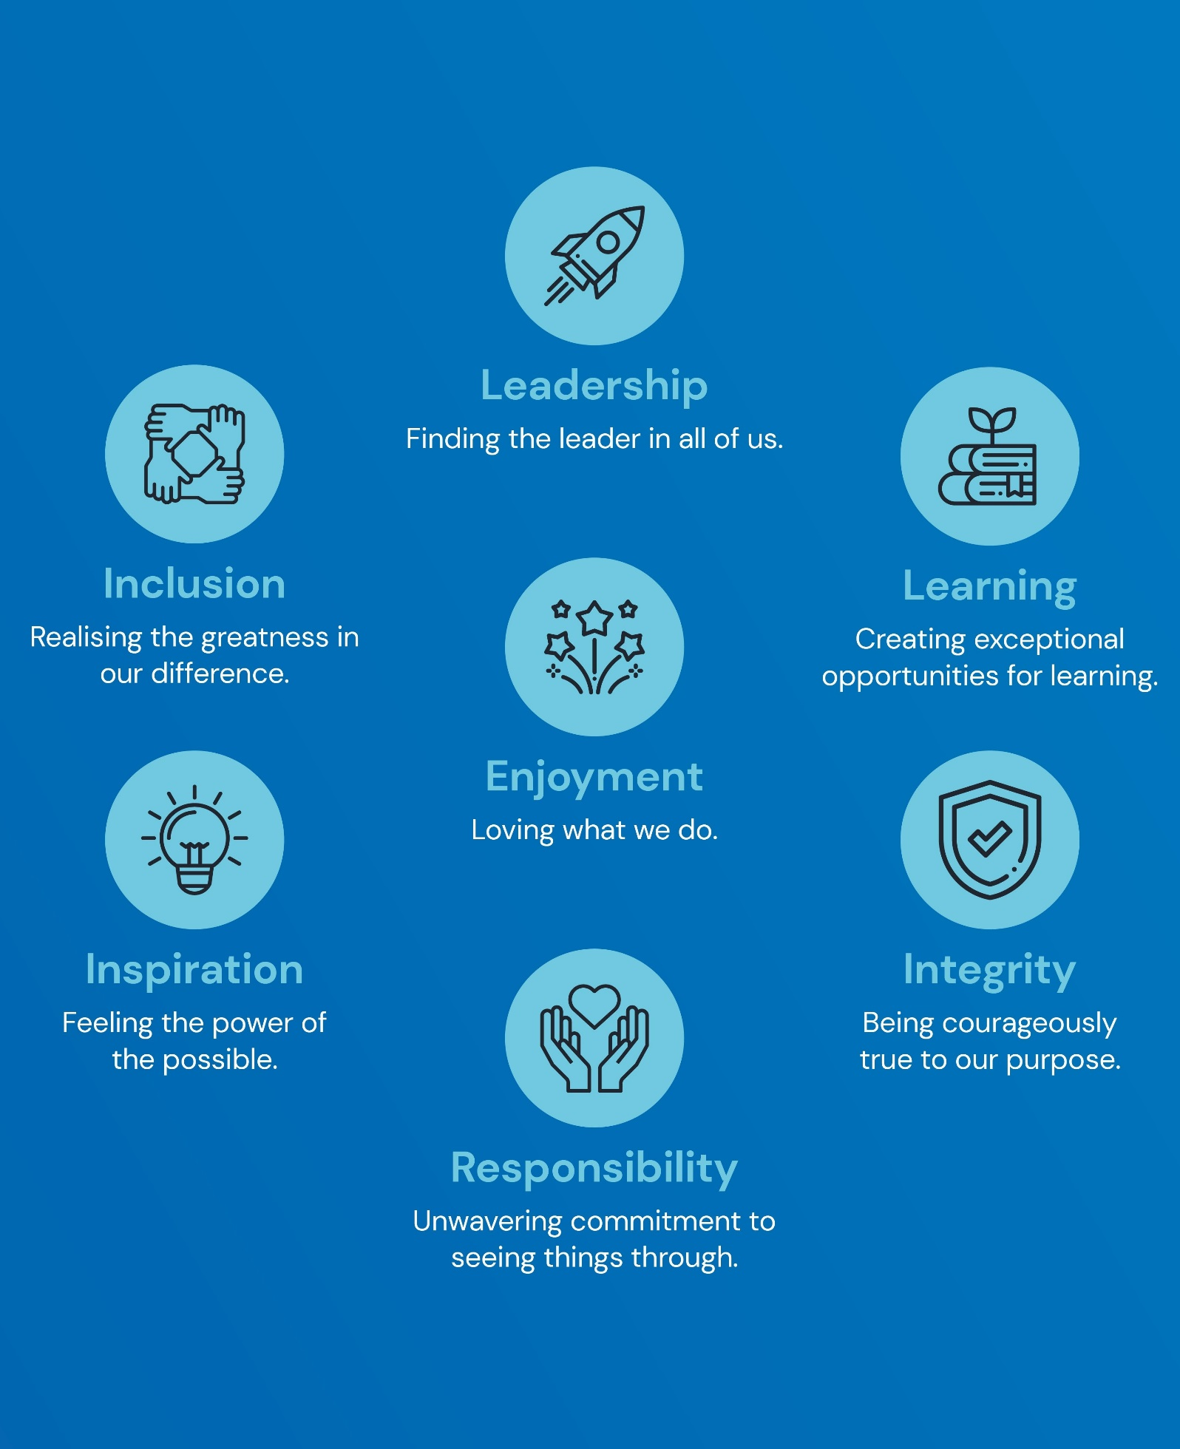

Policy Overview 4
Policy statement 4
Legislation, national guidance and statutory requirements 4
Definitions 4
Policy In Detail 5
Prevention and de-escalation 5
Staff training 5
Use of restrictive interventions 6
Pupils with Special Educational Needs and Disabilities (SEND) 6
Equality implications 7
Statutory power to use reasonable force (Education and Inspections Act 2006) 7
Unacceptable use of physical interventions 7
Other physical contact 8
Reasonable force for searching pupils 8
Seclusion 9
Recording and reporting 9
Recording of significant incidents 9
Reporting of significant events 10
Post incident support and review 11
Governance and oversight 12
Policy Review 12
Appendix: example recording template for restrictive intervention 13

Policy Overview

Policy statement

This policy sets out our academy’s approach to restrictive interventions, including the use of reasonable force, restraint and seclusion. We recognise that restrictive interventions can have a significant physical and psychological impact on pupils and staff. They will therefore only ever be used when necessary, proportionate and lawful, and where less restrictive measures have been attempted or assessed as inappropriate in the circumstances.
Our academy is committed to:
- safeguarding the welfare, dignity and human rights of pupils
- preventing and minimising the need for restrictive interventions
- supporting staff to manage behaviour safely and confidently
- meeting statutory recording and reporting duties
- using data to continuously improve practice

Legislation, national guidance and statutory requirements

This policy is intended to be in full accordance with the following:
- Education and Inspections Act 2006 (sections 93 and 93A)
- Schools (Recording and Reporting of Seclusion and Restraint) (No. 2) (England) Regulations 2025
- Equality Act 2010
- Human Rights Act 1998
- Health and Safety at Work etc. Act 1974
- DfE guidance: Restrictive interventions, including use of reasonable force, in schools (April 2026)
- DfE guidance: Keeping Children Safe in Education (September 2025 and subsequent updates)

Definitions

- Restrictive intervention: any action that prevents, restricts or subdues a pupil’s movement, including physical and non‑physical interventions
- Reasonable force: physical force used by staff to prevent injury, damage, criminal behaviour or serious disorder, which must be the minimum force necessary for the least amount of time
- Restraint: a non‑disciplinary intervention that immobilises or limits a pupil’s movement, with or without physical contact
- Seclusion: a non‑disciplinary safety measure involving keeping a pupil in a place away from others and preventing them from leaving
Where this policy uses the word ‘must’, this indicates a legal requirement.

Policy In Detail

Prevention and de-escalation

Our academy prioritises proactive strategies to minimise the need for restrictive interventions, including:
- positive behaviour support approaches
- consistent routines and expectations
- trauma‑informed practice
- adaptations to the classroom, school and learning environment
- early identification of triggers
- effective communication strategies
- strong and trusted relationships between staff and pupils
Individual support may include behaviour support plans, reasonable adjustments, sensory strategies and joint working with parents and external professionals.
Please see our Positive Behaviour and Relationships Policy for more information on our academy’s approaches and strategies to prevention and de-escalation.

Staff training

Our academy recognises that staff training is a critical component of preventing the need for restrictive interventions and ensuring that, where they are used, they are applied safely, lawfully and proportionately.
In line with Department for Education guidance (2026), staff who are likely to work in situations where restrictive interventions may be required will receive appropriate training in behaviour support, prevention and de-escalation strategies, and the safe and lawful use of reasonable force and other restrictive interventions.
Training will reflect the principles of this guidance and will support staff to assess necessity and proportionality, understand risks to physical and psychological wellbeing, recognise the impact of trauma and SEND, and make defensible professional judgements, including in situations where decisions must be taken quickly.
Our academy will ensure that training needs are informed by our pupil cohort, patterns and trends in incidents, and risk assessments. As an employer, we will take reasonably practicable steps to ensure the health, safety and welfare of staff, including providing training and refresher training where required, access to advice and support, and additional guidance where staff regularly work with pupils who present a higher level of risk.

Use of restrictive interventions

Restrictive interventions, including the use of reasonable force, restraint and seclusion, may only be used in exceptional circumstances where they are lawful, necessary and proportionate, and where other less restrictive measures have been attempted or assessed as inappropriate in the circumstances.
In line with Department for Education guidance (2026), restrictive interventions must only be used to prevent a pupil from:
- causing injury to themselves or others
- committing a criminal offence
- causing serious damage to property
- causing disorder among pupils at the school
The decision to use a restrictive intervention is a matter of professional judgement and will always be based on the specific circumstances at the time. Before using, or continuing to use, a restrictive intervention, staff will, wherever practicable, consider the following factors, which are drawn directly from the guidance.
Necessity
Staff will consider whether a restrictive intervention is required to reduce an immediate risk of harm and whether other less restrictive strategies, including de-escalation, redirection or support from other staff, are likely to be effective. Where a restrictive intervention is unlikely to successfully reduce risk, or is likely to escalate the situation further or cause more harm than the behaviour itself, it will not be used.
Proportionality
Any restrictive intervention will be the least restrictive option available, using the minimum amount of force for the least amount of time necessary to reduce the risk. If an intervention is not reducing risk or is escalating the situation, staff will reconsider their approach and seek to reduce or cease the intervention as soon as it is safe to do so.
Pupil welfare and dignity
Staff will consider the impact of any restrictive intervention on the pupil’s physical and psychological wellbeing. Where possible, staff will seek to maintain the pupil’s dignity, including consideration of the environment in which the intervention takes place, and will communicate calmly and clearly with the pupil about what is happening and why. Where a pupil has difficulties with speech, language and communication, appropriate adaptations will take place to support their understanding and response.

Pupils with Special Educational Needs and Disabilities (SEND)

We recognise the risks that pupils with SEND could be disproportionately subject to the use of restrictive interventions in situations where their response to unmet needs or stressful situations includes behaviours that may harm themselves or others. Staff will have regard to the individual needs and circumstances of the pupil, including any special educational needs, disabilities, medical conditions, communication needs, sensory sensitivities, past trauma or other vulnerabilities. These factors may affect how a pupil experiences an intervention and will inform decision-making before, during and after any restrictive intervention. As above, we will work with pupils, parents and other relevant professionals to agree appropriate prevention and de-escalation strategies to reduce the likelihood of restrictive interventions being required.

Equality implications

Staff must consider relevant duties under the Equality Act 2010, including the need to avoid discrimination, make reasonable adjustments and ensure that responses do not disproportionately impact pupils who share protected characteristics.
Restrictive interventions must never be used as a punishment, as a disciplinary sanction, or for the purpose of compliance or convenience. They must only be used as a last resort safety measure and must cease as soon as the immediate risk has reduced.
Following any restrictive intervention, staff must ensure that appropriate post-incident actions are taken in line with this policy, including recording and reporting, medical checks where appropriate, reflection and review.

Statutory power to use reasonable force (Education and Inspections Act 2006)

Under section 93 of the Education and Inspections Act 2006, all members of school staff have a statutory power to use reasonable force in limited circumstances to prevent a pupil from causing injury to themselves or others, committing a criminal offence, damaging property, or causing disorder.
This power applies while staff are lawfully in charge of pupils and extends to situations both on and off our academy’s site, including educational visits. Section 93 provides the legal basis for the use of reasonable force in schools, and any such use must be reasonable in the circumstances, meaning that it must be necessary and proportionate to the risks presented at the time.
In addition, section 93A of the Act places a statutory duty on proprietors to ensure that arrangements are in place for recording and reporting significant incidents involving the use of force. In the context of our academy, proprietors refers to the Board of Trustees for REAch2 Academy Trust. This policy reflects both the legal power under section 93 and the statutory recording and reporting duties under section 93A, and must be implemented in a way that is consistent with wider safeguarding, equality, human rights and health and safety obligations.

Unacceptable use of physical interventions

Restrictive interventions will never be used as a punishment, a disciplinary sanction, or for the purpose of compliance, convenience or to manage behaviour where there is no immediate risk of harm. Any use of force or restrictive practice for these purposes is unlawful.
Staff will not use any techniques or approaches that may restrict or interfere with a pupil’s airway, breathing or circulation. This includes, but is not limited to, applying pressure to the neck, throat, chest or abdomen, covering the mouth or nose, or positioning a pupil in a way that compromises respiration. Such practices present a serious and potentially fatal medical risk and are strictly prohibited.
The use of restrictive interventions carries inherent physical and psychological risk, particularly where they occur on the ground. Ground restraint will therefore be avoided wherever possible. Where a pupil is unintentionally brought to the ground, staff will take immediate steps to reduce risk by repositioning or releasing holds as soon as it is safe to do so and moving to a safer alternative or standing position.
Any restrictive intervention that presents, or begins to present, a medical risk will stop immediately. Where a pupil has been restrained, particularly where there has been any impact to breathing, circulation, consciousness or physical injury, staff will seek medical assessment and treatment as soon as practicable.
Staff will also be mindful that restrictive interventions can cause significant psychological distress. Interventions that humiliate, degrade, intimidate, threaten or deliberately cause emotional harm are unacceptable. All responses will seek to preserve the pupil’s dignity and wellbeing, even in high-risk situations.
Any incident involving unacceptable practice, or where there is concern that an intervention may have compromised a pupil’s safety, will be reported immediately in line with our academy’s safeguarding and child protection policy.

Other physical contact

Other physical contact, for example, administration of first aid or instruction as part of the PE curriculum, is lawful, appropriate and sometimes necessary. Guiding, which for the purposes of this policy can be defined as a positive intervention to direct movement, provide reassurance or maintain safety, may also be used as an appropriate form of physical contact.
This is not an exhaustive list of examples. Staff will use professional judgement and consider safeguarding context, pupil age, gender, SEND needs, vulnerability and alternative strategies before making physical contact with pupils, as well as to necessity, proportionality, and pupil welfare and dignity.

Reasonable force for searching pupils

Under statutory powers, the headteacher and staff authorised by the headteacher may search a pupil or their possessions where they have reasonable grounds to suspect that the pupil is in possession of a prohibited item. Prohibited items are those set out in legislation and include, for example, knives or weapons, alcohol, illegal drugs, stolen items and any article that has been or is likely to be used to commit an offence, cause personal injury or damage to property.
Where a lawful search is taking place for a prohibited item, staff may use such force as is reasonable in the circumstances to conduct that search. Any use of force in this context must be necessary, proportionate and for the shortest possible time, and must be consistent with the principles set out in this policy. Where force is used during a search, this will be treated as a restrictive intervention and must be managed in line with this policy, including consideration of the pupil’s welfare, dignity, vulnerabilities and any SEND or medical needs. Any significant incident involving the use of force during a search must be recorded and reported in accordance with statutory duties.
Reasonable force must not be used to search for items that are banned only under our own academy’s rules.

Seclusion

Seclusion is defined in statutory guidance as a non-disciplinary, short-term safety measure where a pupil is confined to a place away from others and prevented from leaving. It will only be used where a pupil is experiencing high levels of emotional or behavioural dysregulation and there is a serious and immediate risk of harm to the pupil or to others. Seclusion must never be used as a punishment, a sanction, a planned behaviour management strategy, or as a response to deliberate non-compliance where there is no immediate risk.
Seclusion must only ever be used to reduce an immediate risk of harm and must not be used to coerce, threaten or control a pupil. It should not be implemented through the threat of punishment or the suggestion that negative consequences will follow if a pupil attempts to leave.
Where seclusion is used, the place in which the pupil is confined must be safe, suitable and non-threatening, taking account of the pupil’s age, needs, vulnerabilities and sensory sensitivities. The environment must not present a risk to the pupil’s physical or psychological wellbeing and should allow the pupil to calm and regain regulation.
A pupil who is secluded must be continuously supervised at all times by a member of staff. Supervision must be active and purposeful, enabling staff to monitor the pupil’s physical and emotional wellbeing, communicate appropriately, and respond immediately if the pupil becomes distressed, unwell or at risk.
Seclusion must end as soon as the immediate risk of harm has reduced. It must not continue beyond the point at which it is necessary to manage risk, and pupils must be supported to rejoin others safely when they are able to do so.
Any incident involving seclusion must be treated as a significant incident, and must be recorded and reported in line with statutory duties (see below).
Following any use of seclusion, appropriate post-incident actions must take place, including welfare checks, reflection, support and review of preventative strategies.

Recording and reporting

Our academy recognises that any incident involving restrictive interventions, including reasonable force, restraint (regardless of whether physical contact or force is used) and seclusion are considered significant incidents in legislation and DfE guidance. Implementation of this policy ensures that clear procedures are in place for the recording and reporting of all significant incidents, in line with legal requirements.

Recording of significant incidents

All significant incidents involving the use of restrictive interventions including reasonable force, restraint and seclusion must be recorded in writing as soon as practicable after the event, and by no later than the end of the working day. Records will be stored in line with our Positive Behaviour and Relationships policy via CPOMS.
Records must be completed by each staff member involved and provide a clear, factual account of the incident. Please see the appendix for our recording template. As a minimum, records will include:
- the name of the pupil and the names of staff directly involved
- the date, time, location and approximate duration of the incident
- an account of what happened, including any known context, antecedents, triggers and behaviours of concern
- details of any preventative or de-escalation strategies attempted prior to the use of force
- where relevant, the type of reasonable force used, the degree of force applied and the duration
- an explanation of why the use of force was assessed as necessary at the time
- details of any physical injuries, distress or welfare concerns
- details of any immediate and ongoing post-incident support, including medical attention if applicable
The requirement to record applies even where the use of restrictive interventions has been agreed within a behaviour support plan.

Reporting of significant events

Parents must be informed in writing of each significant incident involving the use of restrictive interventions including reasonable force, restraint and seclusion as soon as practicable after the incident, unless a statutory exception applies. For the purposes of this policy, parent is inclusive of carers and any other person who has parental responsibility.
Reports to parents will include, as a minimum:
- the date, time, location and approximate duration of the incident
- a brief account of why the intervention was assessed as necessary
- a brief description of what type of force was used and the degree of force applied
- details of any physical injuries or welfare concerns, where applicable
We will endeavour to provide the report to parents by no later than the end of the working day. If this is separate to the record of the incident made by staff, the written report will be stored alongside the incident record via CPOMS, and will confirm the date and time that the written report was provided to parents.
Alongside the written report, we will typically invite parents to meet with staff to discuss the incident, including any relevant triggers, the effectiveness of preventative strategies, and whether any behaviour support plans or risk assessments require implementation or review.
In the context of our academy, the exception to the duty to report applies only where it has been assessed by senior staff that informing a particular parent would be likely to result in serious harm to the pupil. In such cases, the incident will be reported to any parent to whom it can safely be reported.
The requirement to report applies even where the use of restrictive interventions has been agreed within a behaviour support plan.

Post incident support and review

Following any restrictive intervention, we will ensure that appropriate and timely actions are taken to safeguard the physical and emotional wellbeing of all those involved, to understand what happened and why, and to reduce the likelihood of future incidents. Details of these actions will be recorded alongside the incident record and report to parents on CPOMS.
Immediate welfare and medical checks
As soon as practicable after the incident, staff will check the pupil and any staff involved for signs of injury, distress or illness. Where appropriate, first aid will be administered and medical assessment or treatment sought. Any injuries or health concerns will be recorded in line with our academy’s health and safety procedures and reported to the Health and Safety Executive where required.
Emotional wellbeing and safeguarding
Our academy recognises that restrictive interventions can be distressing. Consideration will therefore be given to the emotional wellbeing needs of the pupil, any staff involved, and any pupils who may have witnessed the incident. Support may include access to pastoral staff, counselling services, trusted adults or other appropriate support mechanisms.
Reflective debrief and learning
We will hold reflective debrief conversations following incidents involving restrictive interventions. These discussions are intended to support wellbeing, enable learning and improvement, and reduce future risk. Where appropriate, debriefs will include:
- a factual review of what happened and why
- reflection on early warning signs and triggers
- consideration of what preventative and de-escalation strategies were used and their effectiveness
- identification of any alternative approaches that may reduce the likelihood of recurrence
Where possible, debriefs will be facilitated by a member of staff who was not directly involved in the incident, and may include the pupil and their parent where appropriate.
Review of support and risk management
Following any restrictive intervention, we will review relevant behaviour support plans, risk assessments and reasonable adjustments. Changes will be made where necessary to better support the pupil, address underlying needs, and strengthen preventative measures.
Repairing relationships and reintegration
Our academy is committed to repairing and rebuilding relationships following incidents involving restrictive interventions. Where appropriate, restorative approaches will be used to support the pupil’s reintegration, rebuild trust between pupils and staff, and promote a sense of safety, dignity and belonging.
Monitoring and escalation
Leaders will monitor incidents and post-incident actions to identify patterns, emerging risks or training needs. Where restrictive interventions occur repeatedly or where concerns arise, this will trigger further review, multi-agency engagement where appropriate, and escalation for further support through safeguarding or SEND processes.

Governance and oversight

REAch2 Academy Trust recognises that the use of restrictive interventions is a significant matter and will provide appropriate oversight to our academy to ensure that practice is lawful, proportionate and focused on prevention.
Responsibility for oversight and scrutiny of the effective implementation of this policy in our academy has been delegated to the Local Governing Body (LGB). In fulfilling this responsibility, the LGB will:
- ensure that this policy is implemented and reviewed regularly
- assure itself that statutory recording and reporting duties are being met
- receive and consider information about the use of restrictive interventions, including emerging patterns or trends
- be mindful of any disproportionate impact on pupils with special educational needs and disabilities or other identified vulnerabilities
- use information from incidents to inform discussion about prevention, training and support
- ensure that staff are appropriately supported and trained
- ensure that learning from incidents contributes to the ongoing development of practice
In addition, aggregated Trust data reporting the rate and frequency of significant incidents across all academies will be regularly submitted to the Trust Board, highlighting any trends or patterns in incident rate and actions taken to mitigate risk to pupils.

Policy Review

This policy will be reviewed every three years, or sooner if required in order to take into account any changes to legislation or government guidance. Any changes made to this policy will be communicated to all relevant stakeholders.

Appendix: example recording template for restrictive intervention
This form needs to be completed for every ‘significant incident’ involving restrictive intervention, as defined by DfE statutory guidance.
Child’s name |  | Child’s class
Staff name |  | Staff role
Date and time |  | Location

Reason for restrictive intervention
Prevent injury to self or others |  | Prevent serious damage to property
Prevent a criminal offence |  | Prevent disorder among pupils

Description of incident, including type of restrictive intervention used (reasonable force, restraint and/or seclusion)
Include in your description any known triggers to the incident, details of any harm/damage caused by pupil, a description of the specific restrictive actions/techniques applied and for how long, and any additional/contributing factors

De-escalation techniques used
Verbal advice and support |  | Offering services of other staff
Calm talking |  | Informing of consequences
Distraction |  | Non-threatening body position
Reassurance |  | Step away
Humour |  | Clear instruction / warning
Negotiation |  | Use of physical location and presence
Offering choices and options |  | Diversion

Names of staff witnesses | Names of pupil witnesses

Post incident support and review – indicate those that apply and give brief description
Immediate welfare and medical checks (injuries sustained and First Aid required)
Emotional wellbeing and safeguarding (additional wellbeing support offered/provided)
Reflective debrief and learning (date, time, participants and summary of discussion)
Review of support and risk management (implementation/review of behaviour support plan)
Repairing relationships and reintegration (date, time, participants and summary of discussion)
Monitoring and escalation (further support required to manage risk)

Upon completion in full, this form needs to be uploaded to CPOMS alongside any other relevant documents and records.

In line with statutory guidance, parents must be informed in writing of the use of restrictive intervention, unless a statutory exception applies (see policy for detail). A copy of the written report also needs to be uploaded to CPOMS, confirming the date and time that it was provided to parents.

