

Restrictive Physical Intervention in School Policy

This policy is to be used in conjunction with our Behaviour Policy

HERTFORDSHIRE COUNTY COUNCIL (ADAPTED MODEL POLICY)

RESTRICTIVE PHYSICAL INTERVENTION IN SCHOOL

Context

The majority of pupils behave well and conform to the expectations of our school. We have responsibility to operate an effective behaviour policy that encompasses preventative strategies for tackling inappropriate behaviour in relation to the whole school, each class, and individual pupils.

All school staff need to feel that they are able to manage inappropriate behaviour, and to have an understanding of what challenging behaviours might be communicating. They need to know what options are available for managing behaviour, and they need to be free of undue worries about the risks of legal action against them if they use appropriate physical intervention.

Parents need to know that their children are safe with us, and they need to be properly informed if their child is the subject of a Restrictive Physical Intervention, including the nature of the intervention, and the rationale for its use.

Acceptable Forms of Physical Intervention at Garden City Academy

“Physical intervention” (PI) is the term used to describe contact between staff and pupils where no force is involved. There are occasions when it is entirely appropriate and proper for staff to have contact or physical intervention (PI) with children, however, it is crucial that they only do so in ways appropriate to their professional role and in relation to the pupil’s individual needs. There are occasions when staff may have cause to have physical intervention (PI) with pupils:

• To comfort a pupil in distress (so long as this is appropriate to their age)

• To gently direct a pupil

• For curricular reasons (for example in PE, Drama, etc)

• First aid and medical treatment

• In an emergency to avert danger to the pupil or pupils

• In rare circumstances, when Restrictive Physical Intervention is warranted (See

Below)

Not all children feel comfortable about certain types of physical contact; this should be recognised and, wherever possible, adults should seek the pupil’s permission before initiating contact and be sensitive to any signs that they may be uncomfortable or embarrassed. Staff should acknowledge that some pupils are more comfortable with touch than others and/or may be more comfortable with touch from some adults than others. Staff should listen, observe and take note of the child's reaction or feelings and, so far as is possible, use a level of contact and/or form of communication which is acceptable to the pupil.

It is not possible to be specific about the appropriateness of each physical contact, since an action that is appropriate with one pupil, in one set of circumstances, may be inappropriate in another, or with a different child.

In all situations where physical contact between staff and pupils takes place, staff must consider the following:

• The pupil’s age and level of understanding

• The pupil’s individual characteristics and history

• The duration of contact

• The location where the contact takes place (it should not take place in private without others present)

Physical contact must never be used as a punishment, or to inflict pain. All forms of corporal punishment are prohibited. Physical contact shall not be made with the pupil’s neck, breasts, abdomen, genital area, or any other sensitive body areas, or to put pressure on joints. It must not become a habit between a member of staff and a particular pupil.

Physical intervention should be in the pupil’s best interest and should only be used with an awareness of the need to differentiate the attachment to staff from the attachment to key adults such as parents and siblings.

Safer working practice

To reduce the risk of allegations, all staff should be aware of safer working practice and should be familiar with the guidance contained in the:

* staff handbook
* school code of conduct
* staff behaviour policy
* Safer Recruitment Consortium document Guidance for safer working practice for those working with children and young people in education settings (September 2015) <http://www.thegrid.org.uk/info/welfare/child_protection/allegations/safe.shtml>

Definition of Restrict Physical Intervention

“Restrictive Physical Intervention” (RPI) is the term used to describe interventions where the use of force to control a person’s behaviour is employed using bodily contact. It refers to any instance in which a teacher or other adult authorised by the Headteacher has a duty to use “reasonable force” to control or restrain pupils in circumstances that meet the following legally defined criteria.

* To prevent a pupil from committing a criminal offence (this applies even if they are below the age of criminal responsibility)
* To prevent a pupil from injuring self or others
* To prevent or stop a pupil from causing serious damage to property (including their own property)

There is no legal definition of “reasonable force”. However, there are two relevant considerations:

* The use of force can be regarded as reasonable only if the circumstances of an incident warrant it
* The degree of force must be in proportion to the circumstances of the incident and the seriousness of the behaviour or consequences it is intended to prevent

The definition of Restrictive Physical Intervention also includes the use of mechanical devices (eg splints on the pupil prescribed by medical colleagues to prevent self-injury), forcible seclusion, use of locked doors or changes to a pupil’s environment.

It is important for staff to note that, although no physical contact may be made in the latter situations, this is still regarded as a Restrictive Physical Intervention.

Legal defence for the use of force is based on evidence that the action taken was:

• Reasonable, proportionate and necessary

• In the best interest of the young person

This document takes into account DfE Guidance on Use of Reasonable Force July 2013

<https://www.gov.uk/government/publications/use-of-reasonable-force-in-schools>

When the use of Restrictive Physical Interventions may be Appropriate at Garden City Academy

Restrictive Physical Interventions will be used when all other strategies have failed, and therefore only as a last resort. All staff should focus on de-escalation and preventative strategies rather than focusing solely on reactive strategies.

However, there are other situations when physical handling may be necessary, for example in a situation of clear danger or extreme urgency. Certain pupils may become distressed, agitated, and out of control, and need calming with a brief Restrictive Physical Intervention that is un-resisted after a few seconds.

The safety and well-being of all staff and pupils are important considerations. Under certain conditions this duty must be an over-riding factor.

Who may use Restrictive Physical Interventions at Garden City Academy

The following staff (as well as the teachers employed at the school) are authorised by the Headteacher to have control of pupils, and must be aware of this Policy and its implications. However, non-inclusion on this list does not mean that an adult is necessarily barred from using physical intervention. If the Head has lawfully placed an adult in charge of children then that adult will be entitled to use restrictive physical intervention

* Senior leadership team
* Teachers
* All support staff, including family support workers and office staff
* Caretaker

We take the view that staff should not be expected to put themselves in danger and that removing other pupils and themselves from risky situations may be the right thing to do. We value staff efforts to rectify what can be very difficult situations and in which they exercise their duty of care for the pupils.

Planning for the use of Restrictive Physical Interventions in Garden City Academy

Staff will use the minimum force needed to restore safety and appropriate behaviour.

When considering the use of restrictive physical intervention there are only 3 components that can be judged as wrong.

• A negative impact on the process of breathing

• Pain as a direct result of the technique

• A sense of violation

Elevated risks - The following can result in a sense of violation, pain or restricted breathing

• The use of clothing or belts to restrict movement

• Holding a person lying on their chest or back

• Pushing on the neck, chest or abdomen

• Hyperflexion or basket type holds

• Extending or flexing of joints (pulling and dragging)

The following can result in significant injury:

• Forcing a child up or down stairs

• Dragging a child from a confined space

• Lifting and carrying

• Seclusion, where a person is forced to spend time alone against their will (requires a court order except in an emergency)

The principles relating to Restrictive Physical intervention are as follows:-

* Restrictive Physical Intervention is an act of care and control, not punishment. It is never used to force compliance with staff instructions
* Restrictive Physical Intervention will only be used in circumstances when one or more of the legal criteria for its use are met
* Staff will only use it when there are good grounds for believing that immediate action is necessary and that it is in the pupil’s and/or other pupils’ best interests for staff to intervene physically.
* Staff will take steps in advance to avoid the need for Restrictive Physical Intervention through dialogue and diversion. The pupil will be warned, at their level of understanding, that Restrictive Physical Intervention will be used unless they cease the unacceptable behaviour
* Staff will use the minimum force necessary to ensure safe outcomes
* Staff will be able to show that the intervention used was a reasonable response to the incident
* Every effort will be made to secure the presence of other staff, and these staff may act as assistants and/or witnesses
* As soon as it is safe, the Restrictive Physical Intervention will be relaxed to allow the pupil to regain self-control
* A distinction will be maintained between the use of a one-off intervention which is appropriate to a particular circumstance, and the using of it repeatedly as a regular feature of school policy
* Escalation will be avoided at all costs, especially if it would make the overall situation more destructive and unmanageable
* The age, understanding, and competence of the individual pupil will always be taken into account
* In developing a risk reduction plan, consideration will be given to approaches appropriate to each pupil’s circumstance
* Procedures are in place, through the pastoral system of the school, for supporting and debriefing pupils and staff after every incident of Restrictive Physical Intervention, as it is essential to safeguard the emotional well-being of all involved at these times.

Developing a Risk Reduction Plan in Garden City Academy

If a pupil is identified, for whom it is felt, that Restrictive Physical Intervention may be a likely result, then a Risk Reduction Plan will be completed. This Plan will help the pupil and staff to avoid difficult situations through understanding the factors that influence the behaviour and identifying the early warning signs that indicate foreseeable behaviours that may be developing.

The plan will include:-

• Involving parents/carers and pupils to ensure they are clear about what specific action the school may take, when and why

• A risk assessment to ensure staff and others act reasonably, consider the risks, and learn from what happens

• A record to be kept in school of risk reduction options that have been examined and discounted, as well as those used

• Techniques for managing the pupil’s behaviour i.e. strategies to de-escalate a conflict, and stating at which point a Restrictive Physical Intervention may be used

• Identifying key staff who know exactly what is expected. It is best that these staff are well known to the pupil

• Ensuring a system to summon additional support

• Identifying training needs

Guidance and Training for Staff

Guidance and training are essential in this area. We need to adopt the best possible practice in St. Garden City Academy and recognise that it is essential that it is arranged for all staff at a number of levels including:-

• Awareness of issues for governors, staff and parents,

• Behaviour management techniques for all staff

• Managing conflict in challenging situations - all staff

Recording and reporting

The use of a Restrictive Physical Intervention, whether planned or unplanned (emergency) must always be recorded as quickly as practicable (and in any event within 24 hours of the incident) by the person(s) involved in the incident, using our Restrictive Physical Intervention Report Form (appendix 1).

The written record should indicate:

• The names of the staff and pupils involved

• The reason for using a Restrictive Physical Intervention (rather than another strategy)

• The type of Restrictive Physical Intervention employed

• How the incident began and progressed, including details of the pupil's behaviour, what was said by each of the parties, the steps taken to defuse or calm the situation, the degree of force used, how that was applied, and for how long

• The date and the duration of the intervention

• Whether the pupil or anyone else experienced injury or distress and, if they did, what action was taken.

Training in practical techniques of Restrictive Physical Intervention may be required for staff where there is a significant likelihood of them needing to intervene physically due to the nature of the pupil (or pupils) that they are working with. Where there is an identified need for such training, staff will be trained by an accredited Hertfordshire Steps trainer.

(NB there is no legal requirement for staff to be trained in the use of practical techniques so staff may exercise their legal right to physically intervene even if they have not had such training. However, they would still need to demonstrate that their intervention was reasonable and proportionate).

Acceptable Forms of Physical Intervention at Garden City Academy

There are occasions when staff will have cause to have physical intervention

(PI) with pupils for a variety of reasons, for example:

* to comfort a pupil in distress (so long as this is appropriate to their age);
* to gently direct a pupil;
* for curricular reasons (for example in PE, Drama, etc);
* First aid and medical treatment
* in an emergency to avert danger to the pupil or pupils;
* in rare circumstances, when Restrictive Physical Intervention is warranted.

In all situations where physical contact between staff and pupils takes place, staff must consider the following:

* the pupil’s age and level of understanding;
* the pupil’s individual characteristics and history;
* the location where the contact takes place (it should not take place in private without others present).

Physical contact is never made as a punishment, or to inflict pain. All forms of corporal punishment are prohibited. Physical contact will not be made with the participants neck, breasts, abdomen, genital area, other sensitive body parts, or to put pressure on joints. It will not become a habit between a member of staff and a particular pupil.

[Should a pupil appear to enjoy physical contact this must not be sought via Restrictive Physical Intervention.]

Complaints

It is intended that by adopting this policy and keeping parents and governors informed we can avoid the need for complaints. All disputes which arise about the use of force by a member of staff will be dealt with according to Child Protection and Safeguarding policies.

Appendix 1

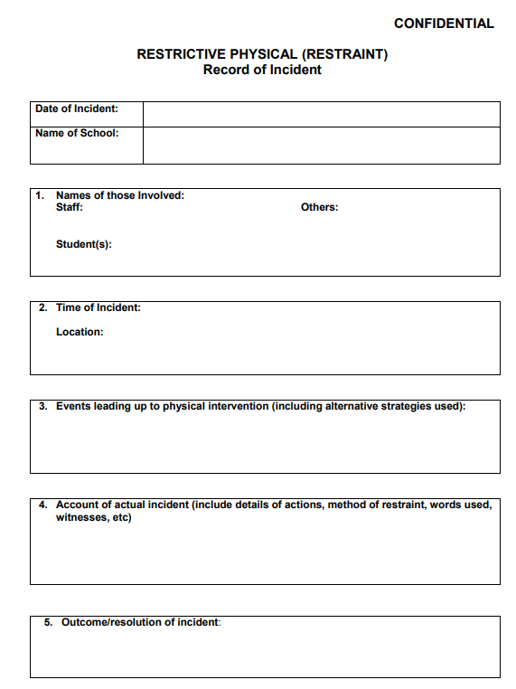

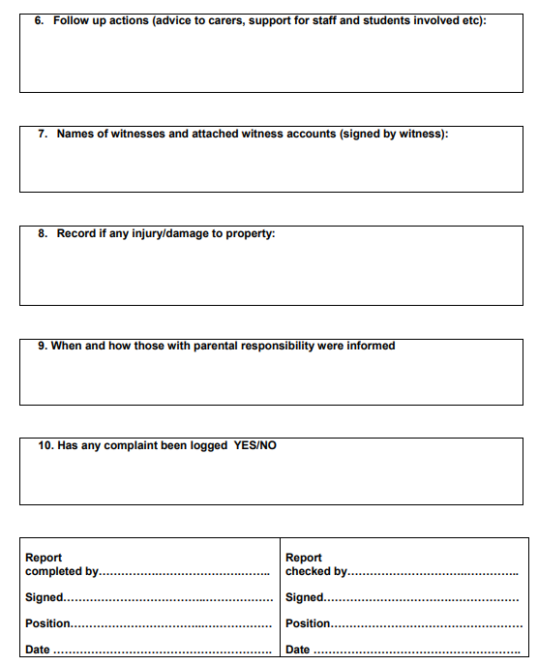

This policy should be reviewed at least every two years

Written by/~~Reviewed by~~ : Rachael Stevenson

Headteacher

November 2020

Ratified by Governors: 2/12/2020

Review date: November 2022