Staying safe when learning at home
We have put together some guidance to help you with learning at home. It can help you to understand our expectations whilst you are learning from home, provide you with information about how to stay physically and mentally well, and give you some useful tips for staying safe online.
If you need some more help, please ask your parents to contact us for you on your year group email address
Learning at home
Even if you cannot attend school, we want to make sure that you can keep learning. We have made a work plan for you so that you know how much work we expect you to do, how long you should spend on each task, and how to submit your work at the end of each day. Please see www.gardencityacademy.co.uk for your year groups plans.
Before you begin learning from home, we will make sure you are able to access all of the resources and the equipment you need to do this. If you are worried that you will be unable to access remote learning, speak to your class teacher as soon as possible.
Whilst you are learning from home, we expect you to:
- Complete the tasks each day
- Tell your parents if you need help with a task
- Send in any work you have completed at the end of each day

It is also important that you:
- Take regular breaks from schoolwork (e.g. every hour, take a ten-minute break).
- Make yourself a plan for your school day and stick to it if you can – don’t worry if you stray off path!
- Set some small goals for the day.
- Keep a school routine – you could start and finish at a certain time every day.
- Avoid doing schoolwork in your bedroom.
- Make it as much like a school day as possible – you could take your lunch and breaktime at the same times as you would at school.
- Avoid background distractions, e.g. the TV – this will make you more productive!
- Ask your parents to contact us on your behalf via email if you are struggling with your schoolwork.

How to stay well
It is important to make sure you look after your physical and mental health.
To avoid any unnecessary aches and pains, you should make sure you have a sensible place set up to learn from. If possible, you should sit at a table or desk, ensuring your back is supported, rather than laying on your bed or the sofa. If you think you are missing any important equipment or a suitable space to work, make sure you speak to your class teacher before you start learning from home.
If you ever feel unwell or unable to complete the work set, you should tell your parents and make sure you let your class teacher know as soon as possible, ideally before the start of the day.
Support with mental health and wellbeing:
- Talk to someone if you have any worries or concerns – you can also find a whole list of places that can help if you don’t want to speak to your family here: https://www.mind.org.uk/information-support/for-children-and-young-people/useful-contacts/
- Childline has a website called ‘Toolbox’, where you can find games, videos and methods to help you with your worries. There is even a ‘Calm zone’ for helping you let go of your worries. All of this can be found here: https://www.childline.org.uk/toolbox/
Staying safe online
If you are spending all day at home, you will likely be spending more time online. Whilst there are many positive aspects of using the internet, such as keeping in contact with those you can’t see and staying entertained, you must also remember to use it sensibly.
While you are spending more time at home, you should consider the ways you can stay safe and maintain a healthy relationship with the internet by doing the following:
- Having tech-free mealtimes
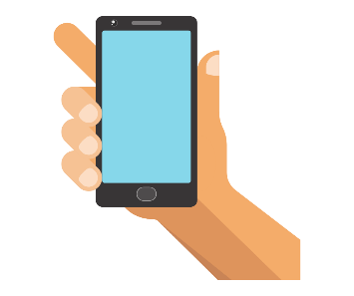
- Not keeping your phone or tablet in your bedroom
- Before contacting any friends using a device, ensuring you have asked your parents and that they have made sure the right settings have been applied to your account to keep you safe
- If you are contacting anyone by phone or video, make sure you do it in a family space
- Making sure you have the right settings applied to the apps and websites you use, so you don’t see anything you don’t want to and can limit who can contact to you
- Making sure you know how to report anything on the apps you use – most of the popular apps have a reporting function. If you need help with this, please ask your parents
- If you need to report something that you’ve seen online, ensuring you use Child Exploitation and Online Protection command (CEOP) (https://www.ceop.police.uk/safety-centre/) and the UK Safer Internet Centre (https://www.saferinternet.org.uk/our-helplines)
- Telling your parents if you are worried about anything you have seen online
- If you want to discuss any worries with someone else, contacting Childline (https://www.childline.org.uk/), Kooth (https://kooth.com/), or any of the contacts listed here: https://www.mind.org.uk/information-support/for-children-and-young-people/useful-contacts/
What to do if you’re worried
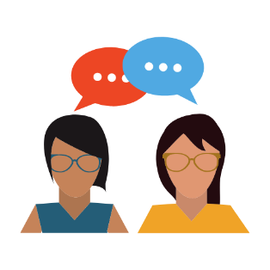
There may be times when you’re feeling worried or concerned about something. You should always tell someone if you feel this way – even if it doesn’t seem like an important thing. There are lots of different people you can talk to whilst you’re at home, including:
- Parents, carers or someone else in your family.
- Teachers or members of school staff.
- Doctors, nurses or online counsellors.
If you are finding it difficult to speak to anyone, you can start the conversation with something small, like telling someone what you had for lunch, or what you learnt that day.
Some people find it helpful to write things down in a letter. Childline have a really handy letter builder you can find here: https://www.childline.org.uk/info-advice/bullying-abuse-safety/getting-help/asking-adult-help/#Writesomeonealetter.
We will stay in touch with you whilst you are learning from home; this will be via your parent’s phone number. If there’s something that’s worrying you, or you want to talk to a specific member of staff who you feel more comfortable with, you can discuss this on the phone call – remember, every worry is relevant, whether it is big or small.
If you are worrying about something relating to a classmate, this is also a very relevant concern. You should always tell a member of staff in this case and we will do what we can to help. We will always let you know if we need to share what you tell us with anyone.
Remember, you can get in touch with any of the organisations listed in the ‘How to stay well’ section of this handout.
If you experience any technical issued while learning at home, you should let your class teacher know as soon as possible so that we can get these sorted for you.

