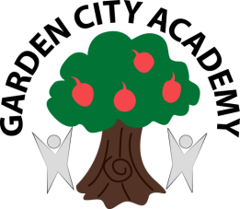
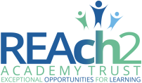

Headteacher: Mrs Rachael Stevenson

Radburn Way Letchworth Garden City Herts SG6 2JZ
(Phone: 01462 621800 / Fax: 01462 621802 / email: head@gca.herts.sch.uk)

11th February 2020

WORLD BOOK DAY & SCHOLASTIC BOOK FAIR!

Dear Parents and Carers,

On March 5th 2020, we are celebrating World Book Day and we would like to celebrate an enthusiasm for reading and a love of books by asking all children to dress up as a book character on this day. We will be judging the fancy dress and there will be a prize awarded to the best dressed in Foundation stage, Key Stage One and Key Stage Two. Also, on World Book Day every child will receive a National Book Token which can be used locally to discount a book or towards a book at the Scholastic book fair.

The Scholastic Book Fair will be in school from Wednesday 26th to Wednesday 4th March 2020. Although World Book day is on the 5th March, Children are still able to use their World Book Day tokens at The Book Fair. All the children will be given an opportunity to browse the books on sale during school time and then will be able to purchase them throughout the week with either yourselves after school or from the order form provided as before. The book fair will be open from Wednesday 26th-Tuesday 3rd March, from 3.15-3.45pm.

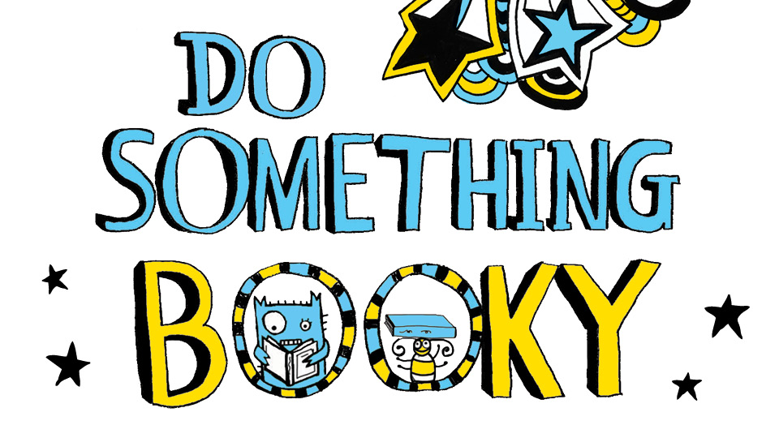
Yours sincerely,

Miss Tatum McIntyre
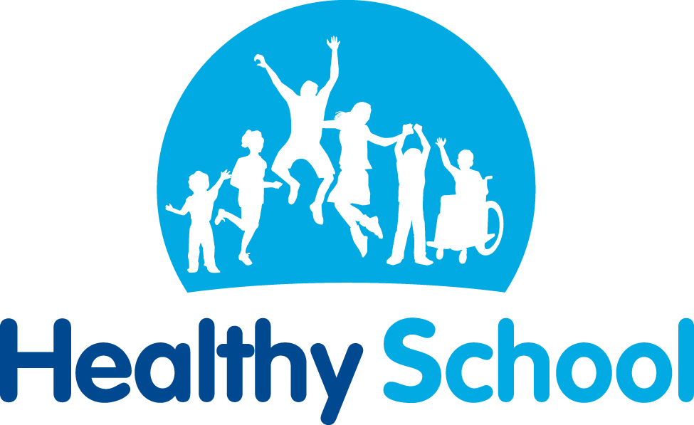
Reading Lead

