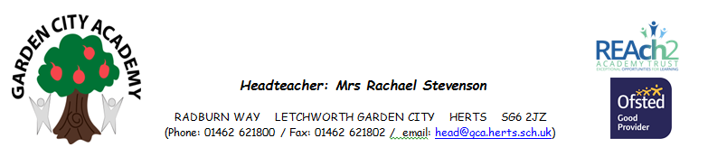
Monday 18th May 2020

Hello Year 6,
We have enjoyed keeping in touch with you via e mail, telephone call and video (the latter thanks to Mr Bryan and Miss Thompson - which we know you have enjoyed from your comments!!) to find out what you have been up to both as to school work and other activities and also just to say a ‘hello’, to know that you are safe and well. It has been lovely to see your photographs and read your stories. Many of you have both continued with existing interests and explored new hobbies such as, fact finding, story writing, DIY skills, baking, arts and crafts, learning a new language and partaking in scout activities. You should all be very proud of yourselves. We, at GCA, and your families certainly are.
We appreciate that not all of the past weeks since we said goodbye will have been easy for you but we hope that you have been enjoying time with your families and that you will now be looking forward to hopefully spending some time back at GCA before the summer holidays. We are certainly hoping to see you all again very soon.
With this in mind, you will also no doubt be thinking about your transition to secondary school in September. We appreciate that this is an exciting time but many of you will also be experiencing other feelings such as being a little nervous and overwhelmed by the thought. All these feelings are perfectly normal! This is why we are writing to you today.
Included with this letter is a secondary school Transition Activity work booklet. This is for you to work through at your own pace at home. You may want to complete all of the activities or just some of them. This is your choice. Hopefully you will be able to follow the instructions but if not then please ask an adult at home or alternatively ask the adult to get in contact with us and we can help you. We have tried to make the booklet easy to follow but please do not worry if you are unsure. It is simply something for you to do to get you thinking about your transition to your new school in September. Hopefully, if we return to GCA we will take some time to discuss some of the things addressed in the booklet.
It is really important that if you are feeling anxious that you try to talk through your worries with somebody. If you are unable to do this, or don’t feel comfortable then why not try keeping a ‘mood diary.’ It is a useful tool to try and keep in control of your feelings. Simply write down all your worries, feelings and anxieties that you are experiencing day to day. Is there a pattern? What could you to help prevent these thoughts? Your adults at home and we, at GCA, are here to help you with this.
In the meantime, keep e mailing us, sending us your thoughts, photos and stories. We do so love to read and reply to them. We very much hope to see you all very soon.
Sending you all our thoughts and best wishes.

Mr Bryan, Miss Thompson, Mrs Bruce and Mrs Allen
‘The Year 6 Team’

