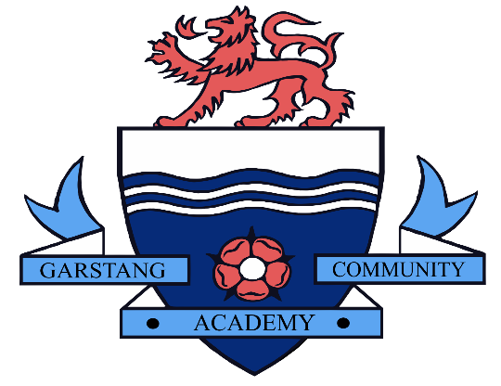

Remote Learning:

Guidance for Pupils and Parents for accessing work and support from home.

Remote Learning at Garstang Community Academy
At Garstang Community Academy, our remote learning will provide immediate, accessible work for students who are not able to attend school.
All students and parents have access to School Synergy. When logged on to Synergy, students can access their timetable, classwork and homework.
We aim to support our pupils with their learning by giving them a structured routine. Work will be set exclusively via Synergy and will be monitored by subject staff; however, the onus is on parents to ensure the completion of work. Our expectation is that your son/daughter follows their normal timetable using School Synergy.

Instructions for accessing work
Individual or Small Groups of Isolating Students:
Students who are unable to attend school due to Covid related reasons must follow the instructions below providing they are well enough to do so.
- Follow your timetable on Synergy as if you were at school
- Click on each lesson to access your classwork
- Complete the classwork for each lesson and submit this to your teacher on Synergy. This can be done by completing the work electronically (e.g. on Microsoft Word) and then uploading the file or accessing Synergy on your phone and uploading a picture of your work.
Year Group Bubble or Larger Student Groups:
In the event of a large group of students, or even whole year group bubbles being asked to work from home temporarily students must follow the instructions below.
- Follow your timetable on Synergy as if you were at school
- Click on each lesson to access your classwork.
- You will be set a classwork assignment for each lesson. Complete the classwork and submit this to your teacher on Synergy when requested do to so. This can be done by completing the work electronically (e.g. on Microsoft Word) and then uploading the file or accessing Synergy on your phone and uploading a picture of your work.
Year 7 & 8
For each timetabled period of Maths, English or Science there will be approximately 30-40 minutes of Directed Learning. All other subjects will set approximately 30 minutes of Directed Learning tasks. Our expectation is that pupils complete the work set and associated Independent Learning tasks to the best of their ability, during each one hour timetabled period.
If pupils are completing work within the allocated time, they should access additional lessons on the ‘Oak National Academy Website’ or use the links to extra resources in appendix B, to complete independent learning and revision.

Year 9, 10 & 11
For each timetabled period of core and options subjects there will be approximately 50 minutes of Directed Learning set. Our expectation is that pupils complete the work set and associated Independent Learning tasks to the best of their ability, during each one hour timetabled period. If pupils are completing work easily within the allocated time, they should access additional lessons on the ‘Oak National Academy Website’ or use the links to extra resources in appendix B, to complete independent learning and revision.

Please notify school immediately if you have any concerns about your child’s ability to access the work set for any reason using info@garstangcommunityacademy.com
Support
School Synergy allows students to access help from their teachers via the ‘class discussion’ tool. If necessary, additional help can be accessed for a specific subject using the subject email address in appendix A. Questions or enquiries will be responded to by a subject teacher as soon as they are able to do so.

Parents of SEND pupils can access advice regarding workload and extra support via TA@garstangcommunityacademy.com

Live lessons

In the event of a whole year group bubble being asked to work from home temporarily your son/daughter may have access to some live lessons. Live lessons will be delivered via Microsoft Teams. All students have access to this app via their school Microsoft Office 365 account. Please ensure that you and your child has read and understood the ‘live lesson' safeguarding policy regarding live lessons. Students must only attend live lessons if parents agree to the terms and conditions in the safeguarding policy. (See appendix C)

Useful IT information

All pupils and parents should have login details allowing them full access School Synergy. The easiest way to access Synergy is by clicking on the link at the bottom of the school website homepage. Once on the School Synergy homepage, students must login via the Microsoft 365 button using their school email address and password.
Office 365 Access
All pupils have free access to Microsoft Office 365 allowing then to use many applications such as PowerPoint, Word and One Drive. To open Office 365, click the ‘Staff and Student Office 365’ link at the bottom of the school website, or go to www.office.com. Pupils can sign in using their school email address and their school computer password. The school email addresses use the following pattern: the year of enrolment at the school followed by surname, followed by first initial of name, followed by @student.garstangacademy.com
For example, Harry Potter who started year 7 in 2018…
18potterh@student.garstangacademy.com

Engagement: Rewards and Sanctions
Student engagement will be monitored by Progress Leaders and Subject Leaders, and our normal awards and consequences still apply. There will be ongoing awards for great work and great engagement; however, poor engagement will be subject to consequences which will then be implemented on return of the student to school - students who have not completed work will be given a catch-up plan for completion - much of this may need to be done in their own time, at lunchtimes and after school.
Appendix A
Contact Emails:
Science@garstangcommunityacademy.com
Maths@garstangcommunityacademy.com
English@garstangcommunityacademy.com
Humanities@garstangcommunityacademy.com
HSC@garstangcommunityacademy.com (Health & Social Care)
MFL@garstangcommunityacademy.com
CreativeArts@garstangcommunityacademy.com
DT@garstangcommunityacademy.com
PE@garstangcommunityacademy.com
IT@garstangcommunityacademy.com (also to be used for Business)
Progress@garstangcommunityacademy.com (for Progress Leaders)
slt@garstangcommunityacademy.com
TA@garstangcommunityacademy.com
inclusion@garstangcommunityacademy.com
info@garstangcommunityacademy.com (for general enquiries)

Appendix B
https://www.thenational.academy/
https://www.bbc.co.uk/bitesize/dailylessons
https://www.bbc.co.uk/bitesize/levels/z4kw2hv
https://www.senecalearning.com/
https://www.khanacademy.org/

Appendix C
Policy for using Microsoft Teams for live lessons
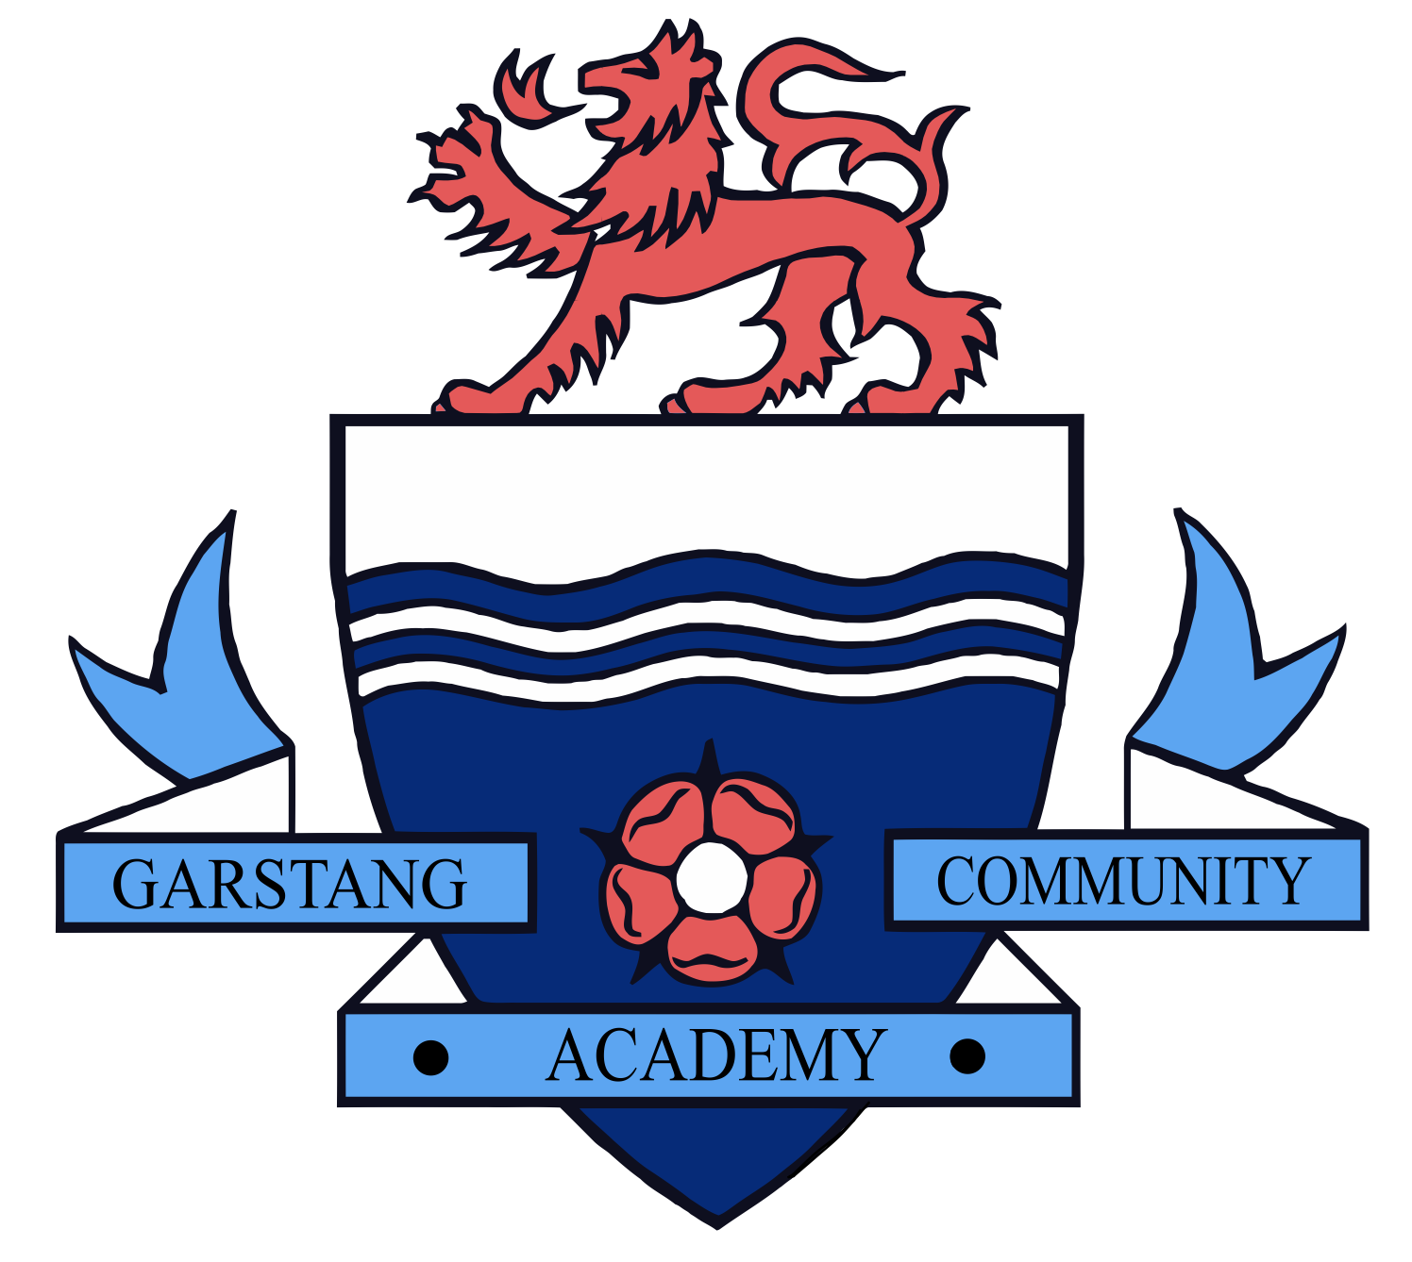
Safeguarding students
Terms and conditions for attending live lessons/ tutorials via Microsoft Teams

- Students must be punctual for live tutorials
- Students must be in a quiet, distraction-free location throughout the tutorial
- Students must not have their cameras on
- Students are not permitted to be on other social media whilst attending a live tutorial and must use the necessary equipment and computer programmes as intended
- Students must not record or take images of the live lesson/tutorial
- Students must not record, store, or distribute audio material without permission
- Students must not unmute themselves or use the chat/messaging feature unless instructed to do so by the teacher
- Students must use appropriate language when answering questions
- Students must have excellent behaviour at all times, contribute to the lesson in a positive manner and not be disruptive at any time. The school behaviour policy will be enforced during live tutorials.
- Students must show respect for everyone in the online classroom; anti-bullying policies apply during live tutorials
- Students must have a stable connection to avoid disruption to lessons

